The ARRIVE Guidelines Checklist
Animal Research: Reporting In Vivo Experiments
Carol Kilkenny¹, William J Browne², Innes C Cuthill³, Michael Emerson⁴ and Douglas G Altman⁵
¹The National Centre for the Replacement, Refinement and Reduction of Animals in Research, London, UK, ²School of Veterinary Science, University of Bristol, Bristol, UK, ³School of Biological Sciences, University of Bristol, Bristol, UK, ⁴National Heart and Lung Institute, Imperial College London, UK, ⁵Centre for Statistics in Medicine, University of Oxford, Oxford, UK.

 | ITEM | RECOMMENDATION | Section/  Paragraph
 |  |  |  | 1. Title
 |  |  |  | 2. Abstract
INTRODUCTION
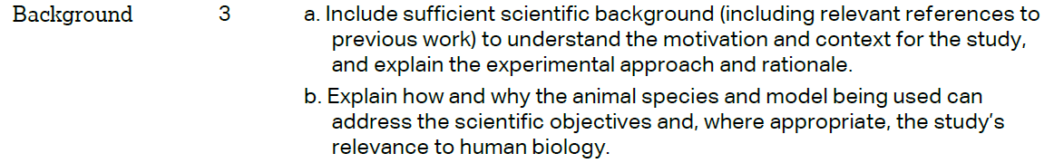 |  |  |  | 3a. Background, Paragraph 1  3b Background, Paragraph 2
 |  |  |  | 4. Objective, Last paragraph
METHODS
 |  |  |  | 5. Methods section, experimental animals’ subsection
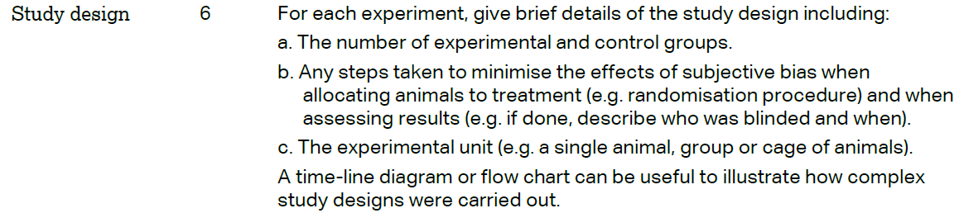 |  |  |  | 6a. Methods section, acute oral toxicity study subsection, study of sub-chronic oral toxicity subsection  6b. Methods section  - Acute oral toxicity study subsection  - Study of sub-chronic oral toxicity subsection  - Hematological parameters subsection  - Biochemical parameters subsection  - Histological analysis subsection  6c. Methods section  - Acute oral toxicity study subsection (5 females’ rats for the test group and 5 females’ rats for the control group)  - Study of sub-chronic oral toxicity subsection (4 groups of 8 animals per group: 4 females and 4 males).
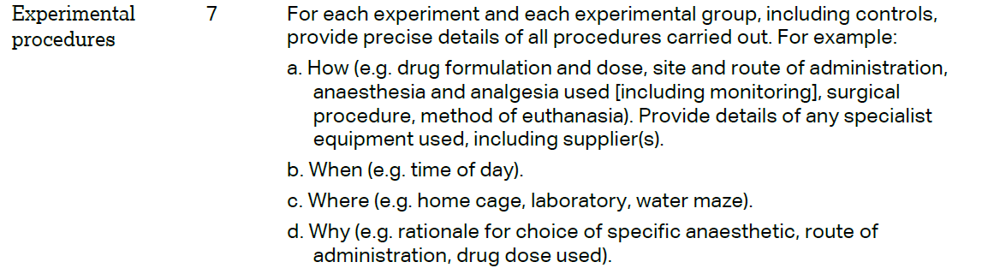 |  |  |  | 7a. Methods section  - Acute oral toxicity study subsection  - Study of sub-chronic oral toxicity subsection  7b. Methods section  - Acute oral toxicity study subsection  - Study of sub-chronic oral toxicity subsection  7c. Methods section, experimental animals’ subsection  7d. Methods section  - Acute oral toxicity study subsection  - Study of sub-chronic oral toxicity subsection
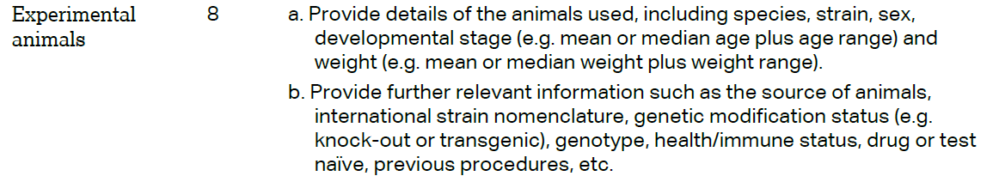 |  |  |  | 8a. Methods section  - Acute oral toxicity study subsection  - Study of sub-chronic oral toxicity subsection  8b. Methods section, Acute oral toxicity study subsection (animals)
The ARRIVE guidelines. Originally published in PLoS Biology, June 2010¹
 | 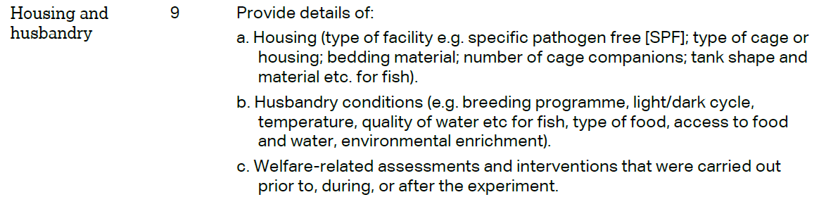 | 9a. Methods section  - Acute oral toxicity study subsection  - Sub-chronic oral toxicity study subsection  9b. Methods section, experimental animals’ subsection  9c. Methods section: Acute oral toxicity study subsection and Study of sub-chronic oral toxicity subsection
 | 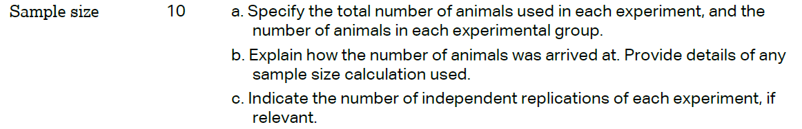 | 10a. Method section  - Methods section: Acute oral toxicity study subsection and Study of sub-chronic oral toxicity subsection  10b. Methods section  10c. Methods section  - Acute oral toxicity study subsection  - Study of sub-chronic oral toxicity  subsection
 | 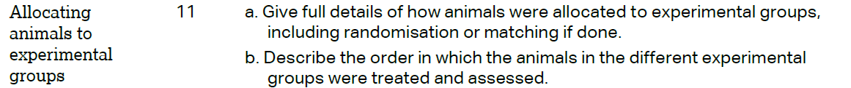 | 11a. Methods section  - Experimental animals  - Acute oral toxicity study subsection  - Study of sub-chronic oral toxicity subsection  11b. Methods section  - Acute oral toxicity study subsection  - Study of sub-chronic oral toxicity subsection
12. Methods section
- Acute oral toxicity study subsection
- Study of sub-chronic oral toxicity subsection
- Assessment of Hematological parameters subsection
- Assessment of Biochemical parameters subsection
- Histological analysis subsection
 | 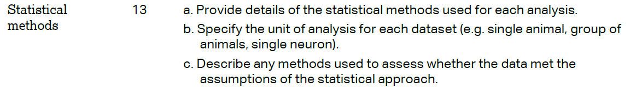 | 13a. Methods section: statistical analysis subsection  13b. Methods section: statistical analysis subsection  13c. Methods section: statistical analysis subsection
 | RESULTS
 |  | 14. Results section, Tables 2-6 (dose in mg/kg); Figures 2 and 3
15a. Throughout results Section
15b. Not applicable

 |  | 16. Results section, Tables 2-6; Figure 2-6
 |  | 17. Not applicable
 | DISCUSSION
 | 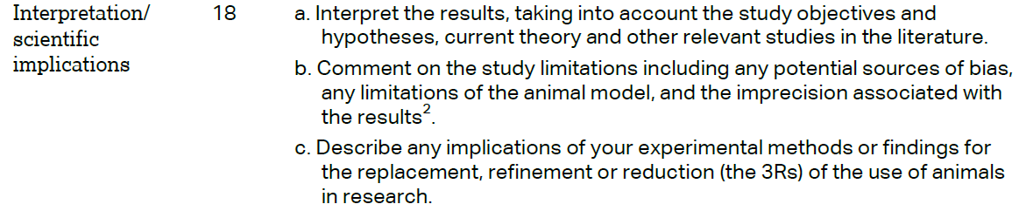 | 18. Throughout Discussion Section
 |  | 19. Not applicable
 |  | 20. No funding
