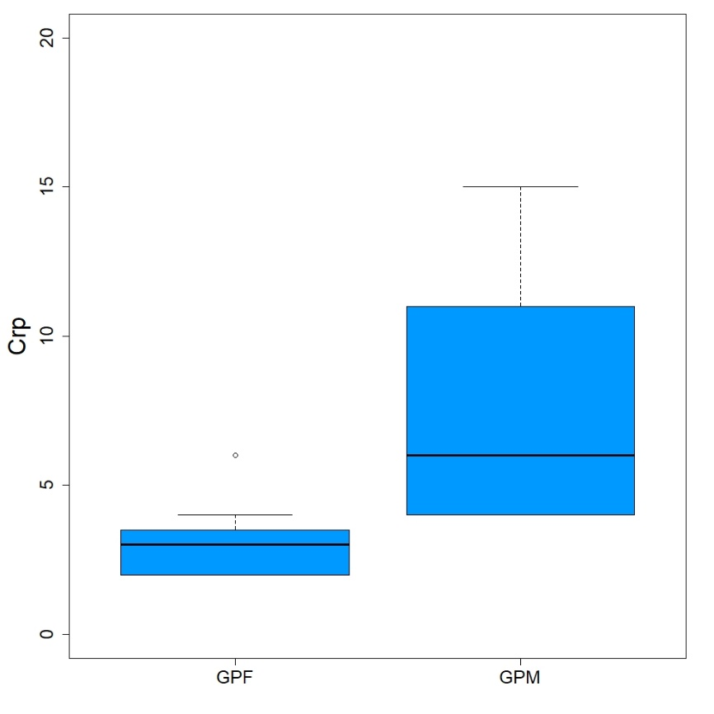
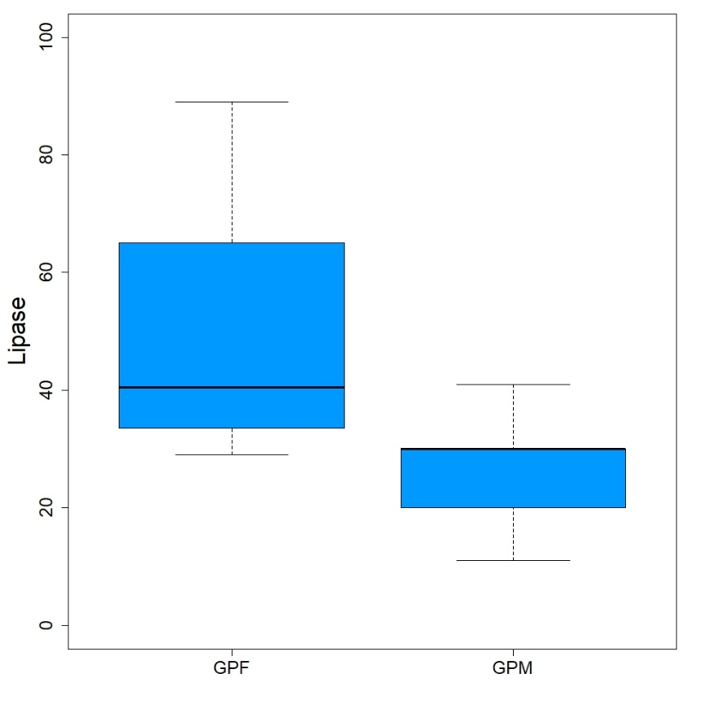

Figure 4S: Box plot of the significant haematological and biochemical parameters in positive dogs by gender. The box plot synthesize the data, providing the principal measures of central tendency and dispersion. Specifically, the diagram comprises a box with horizontal limits defining the upper and lower quantiles representing the interquartile range, with the median marked by a horizontal line within the box. The whiskers are vertical lines extending from the box as low as the 2.5th percentile and as high as the 97.5th percentile. Extreme values are indicated by dots.

