Supplemental material

Table A. Four breeding colonies of Purple martins (Progne subis) along with the number of GPS units (Lotek) deployed and retrieved at each site for spring migration tracking (2017-2020).
State/Province | Latitude | Longitude | # Deployed | # Retrieved
Florida | 28°21’34.92” N | 81°35’28.68” W | 10 | 2
Pennsylvania | 42°11’48.98” N | 80°14’53.59” W | 10 | 0
Texas | 35°02’23.01” N | 101°56’00.41” W | 62 | 9
Manitoba | 49°44’03.34’’ N | 97°07’53.00’’ W | 16 | 1

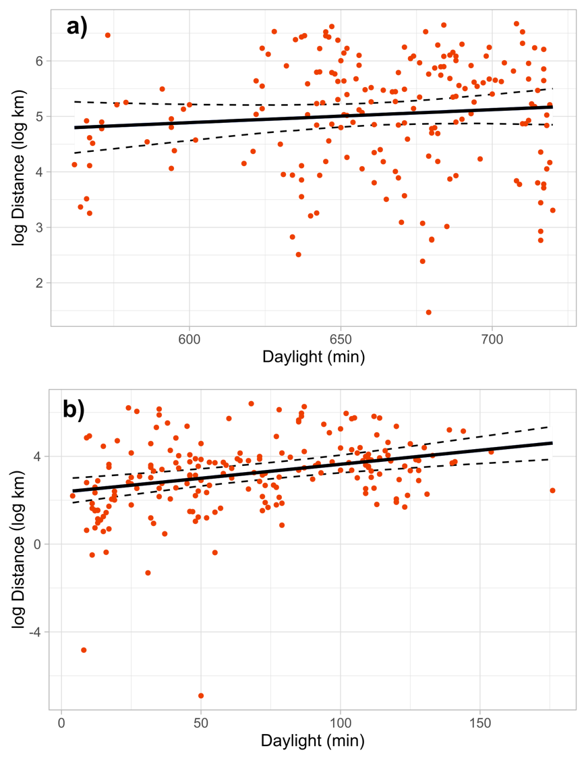
Figure S1. Relationship between distance traveled by Purple Martins and amount of daylight available in each 12hr tracking period. Daylight hours are defined as the time between sunrise and sunset, and the amount of daylight per track was calculated according to the GPS locations and fix times at the beginning and end of a track (i.e. time between sunrise/sunset at the bird’s start location and sunset/sunrise at the bird’s end location). During predominantly daytime flights, an increase in available daylight did not influence distances traveled (a), but there was a statistically significant effect during predominantly nighttime flights (b). Because the GPS tags collected locations on a fixed schedule, the amount of daylight that occurs during the tracking periods will vary as the season progresses and birds move long distances. These data indicate that some of the flight attributed to nighttime likely occurs during daylight hours.

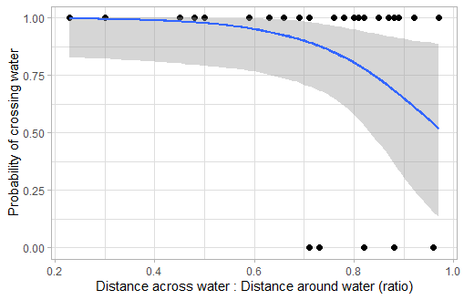
Figure S2. The probability of Purple Martins initiating a water crossing at the coast, rather than turning to circumnavigate over land, decreases as the potential savings in distance decrease. That is, when the distances of a water crossing and the alternative circumnavigation are similar, the birds are more likely to take the overland route than the overwater route. Actual data points are plotted for reference.

