Supporting Information. Fernández, L. D., C. V. W. Seppey, D. Singer, B. Fournier, D. Tatti, E. A. D. Mitchell, and E. Lara. 202X. Niche conservatism drives the elevational diversity gradient in major groups of free-living soil unicellular eukaryotes. Ecology.

Appendix S4 Results obtained from a high-throughput sequencing approach
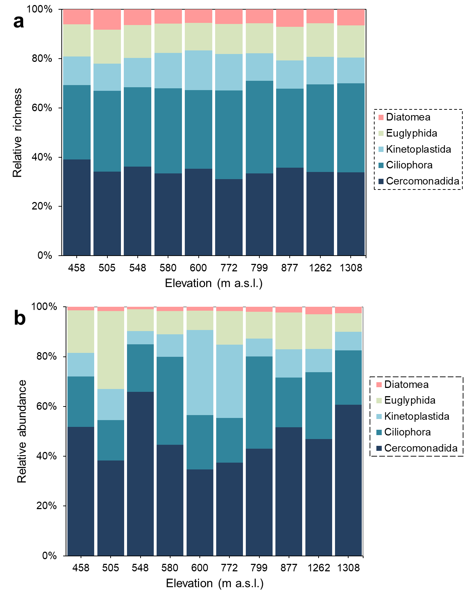

Fig. S1. Relative richness and abundance recorded for each eukaryotic microbial group studied at each elevational forest site.

