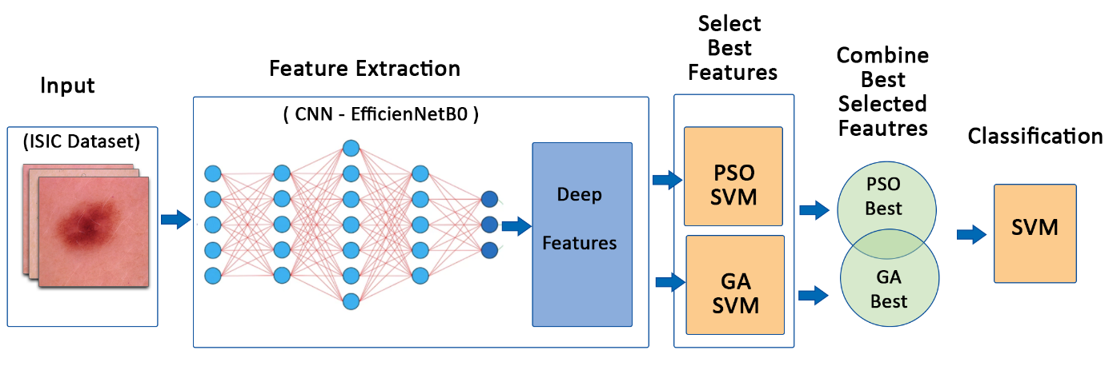
Figure 3. Skin Cancer classification Framework

