Table S1. Additional information about protected areas included in the study.
Protected area | Code | Area (ha)* | Country | Tropical region | Number of cameras | Number of Families** | Number of Species**
Barro Colorado Nature Monument - Soberania National Park | BCI | 4,890 | Panama | Neotropical | 60 | 15 | 24
Bukit Barisan | BBS | 295,000 | Indonesia | Indo-Malayan | 60 | 18 | 32
Bwindi Impenetrable Forest | BIF | 32,700 | Uganda | Afrotropical | 60 | 13 | 22
Caxiuanã National Forest | CAX | 317,945 | Brazil | Neotropical | 60 | 12 | 23
Central Suriname Nature Reserve | CSN | 1,600,000 | Suriname | Neotropical | 65 | 13 | 30
Cocha Cashu - Manu National Park | COU | 1,716,294 | Peru | Neotropical | 60 | 15 | 32
Korup National Park | KRP | 125,900 | Cameroon | Afrotropical | 60 | 11 | 17
Manaus | MAS | 1,198,944 | Brazil | Neotropical | 89 | 11 | 22
Nam Kading | NAK | 169000 | Laos | Indo-Malayan | 60 | 16 | 25
Nouabalé Ndoki | NNN | 423,870 | Republic of Congo | Afrotropical | 64 | 16 | 30
Pasoh Forest Reserve | PSH | 13,610 | Malaysia | Indo-Malayan | 60 | 18 | 34
Udzungwa | UDZ | 208,869 | Tanzania | Afrotropical | 61 | 15 | 24
Virunga Massif | VIR | 16,000 | Democratic Republic of the Congo | Afrotropical | 60 | 7 | 10
Volcán Barva (Brulio Carrillo National Park) | VB | 49,921 | Costa Rica | Neotropical | 60 | 13 | 22
Yanachaga Chimillen National Park | YAN | 122,000 | Peru | Neotropical | 63 | 14 | 25
Yasuni National Park | YAS | 1,030,070 | Ecuador | Neotropical | 60 | 13 | 28
*Areas were extracted from the World Database on Protected Areas (WDPA). Pasoh Forest Reserve, and Manaus were extrected from ⁶⁴
**Number of mammals families and species detected by camera traps and included in this study. Species with a body mass >=75 g, ground dwelling and scansorial species

Table S2. Candidate multinomial models ranked according to Akaike information criterion (AIC) for each biogeographic region. LR= Likelihood ratio, AIC=Akaike Information Criterion, N= sample size (number of independent events), and ΔAIC= delta AIC.
Region | Model | N | LR | AIC | ΔAIC
Afrotropics | trophic_guild * b_mass | 60704 | 51432.88 | 81979.44 | 0.00
Afrotropics | trophic_guild + b_mass | 60704 | 47502.84 | 85897.48 | 3918.04
Afrotropics | trophic_guild | 60704 | 45973.84 | 87422.48 | 5443.04
Afrotropics | b_mass | 60704 | 33151.42 | 100236.90 | 18257.46
Afrotropics | 1 | 60704 | 29969.28 | 103415.04 | 21435.60
Indo-Malayan | trophic_guild * b_mass | 8602 | 6102.54 | 12829.98 | 0.00
Indo-Malayan | trophic_guild + b_mass | 8602 | 5677.21 | 13243.32 | 413.33
Indo-Malayan | trophic_guild | 8602 | 5639.64 | 13276.88 | 446.90
Indo-Malayan | b_mass | 8602 | 5318.54 | 13589.99 | 760.01
Indo-Malayan | 1 | 8602 | 5299.85 | 13604.68 | 774.69
Neotropics | trophic_guild * b_mass | 57076 | 37722.82 | 87717.97 | 0.00
Neotropics | trophic_guild + b_mass | 57076 | 31624.34 | 93804.45 | 6086.48
Neotropics | trophic_guild | 57076 | 30988.40 | 94436.39 | 6718.42
Neotropics | b_mass | 57076 | 24355.06 | 101061.73 | 13343.76
Neotropics | 1 | 57076 | 24044.83 | 101367.96 | 13649.99

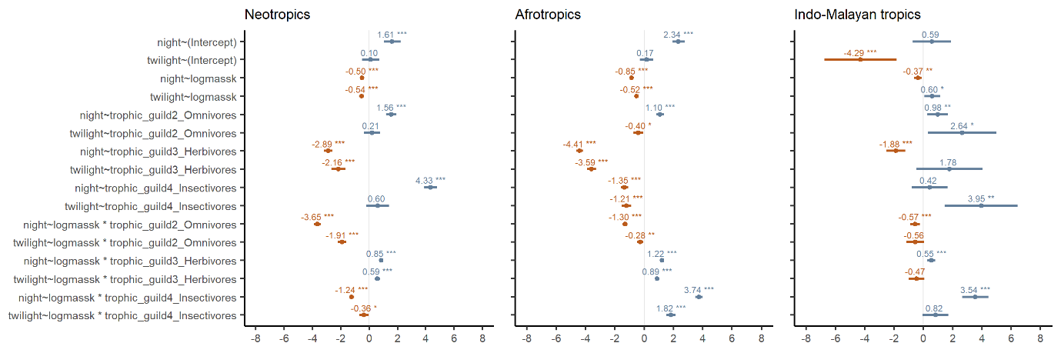
Figure S1. Multinomial model coefficient estimates by each region. The intercept (vertical line at 0) is represented with Carnivores as the reference group. Level of significance (p-value): * = 0.05, ** = 0.01, *** = 0.001.

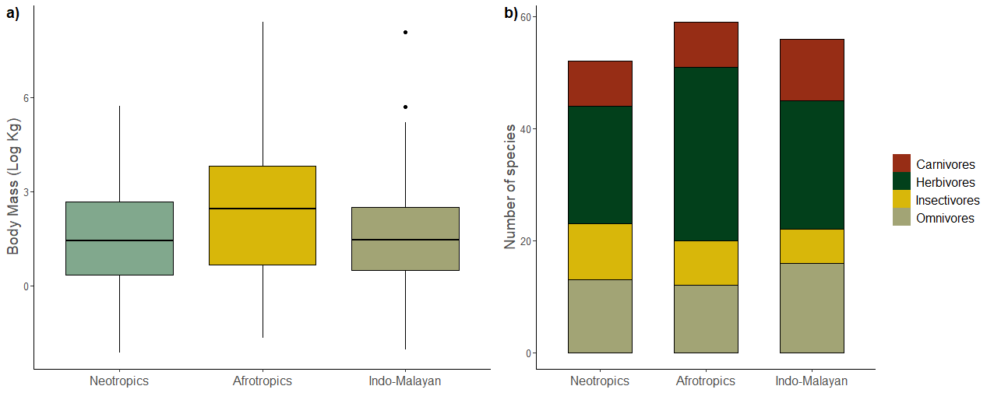
Figure S2. a) Distribution of body mass values (log scale kg) of ground-dwelling mammals for the three different biogeographic regions. b) Number of species in each trophic guild and each biogeographic region.

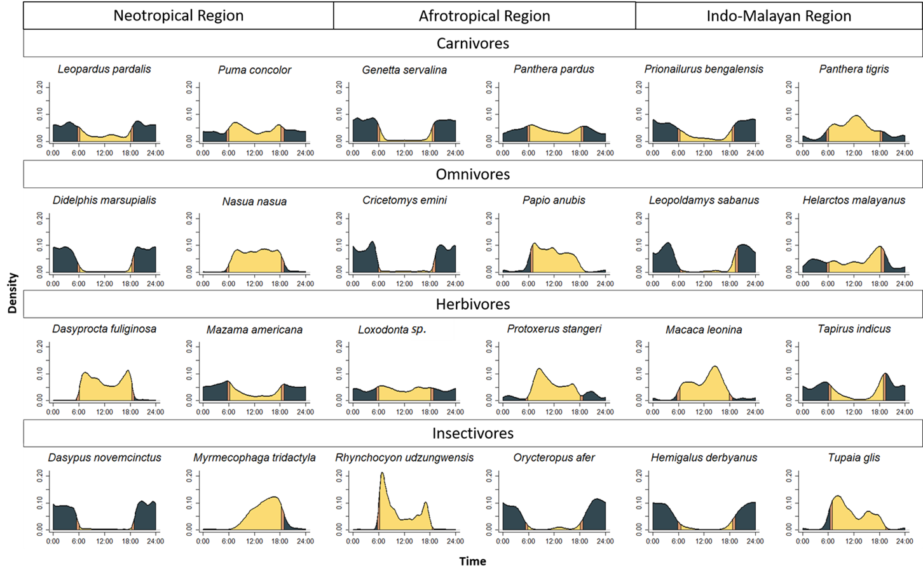
Figure S3. Examples of Kernel density activity of species by tropical region and trophic group.

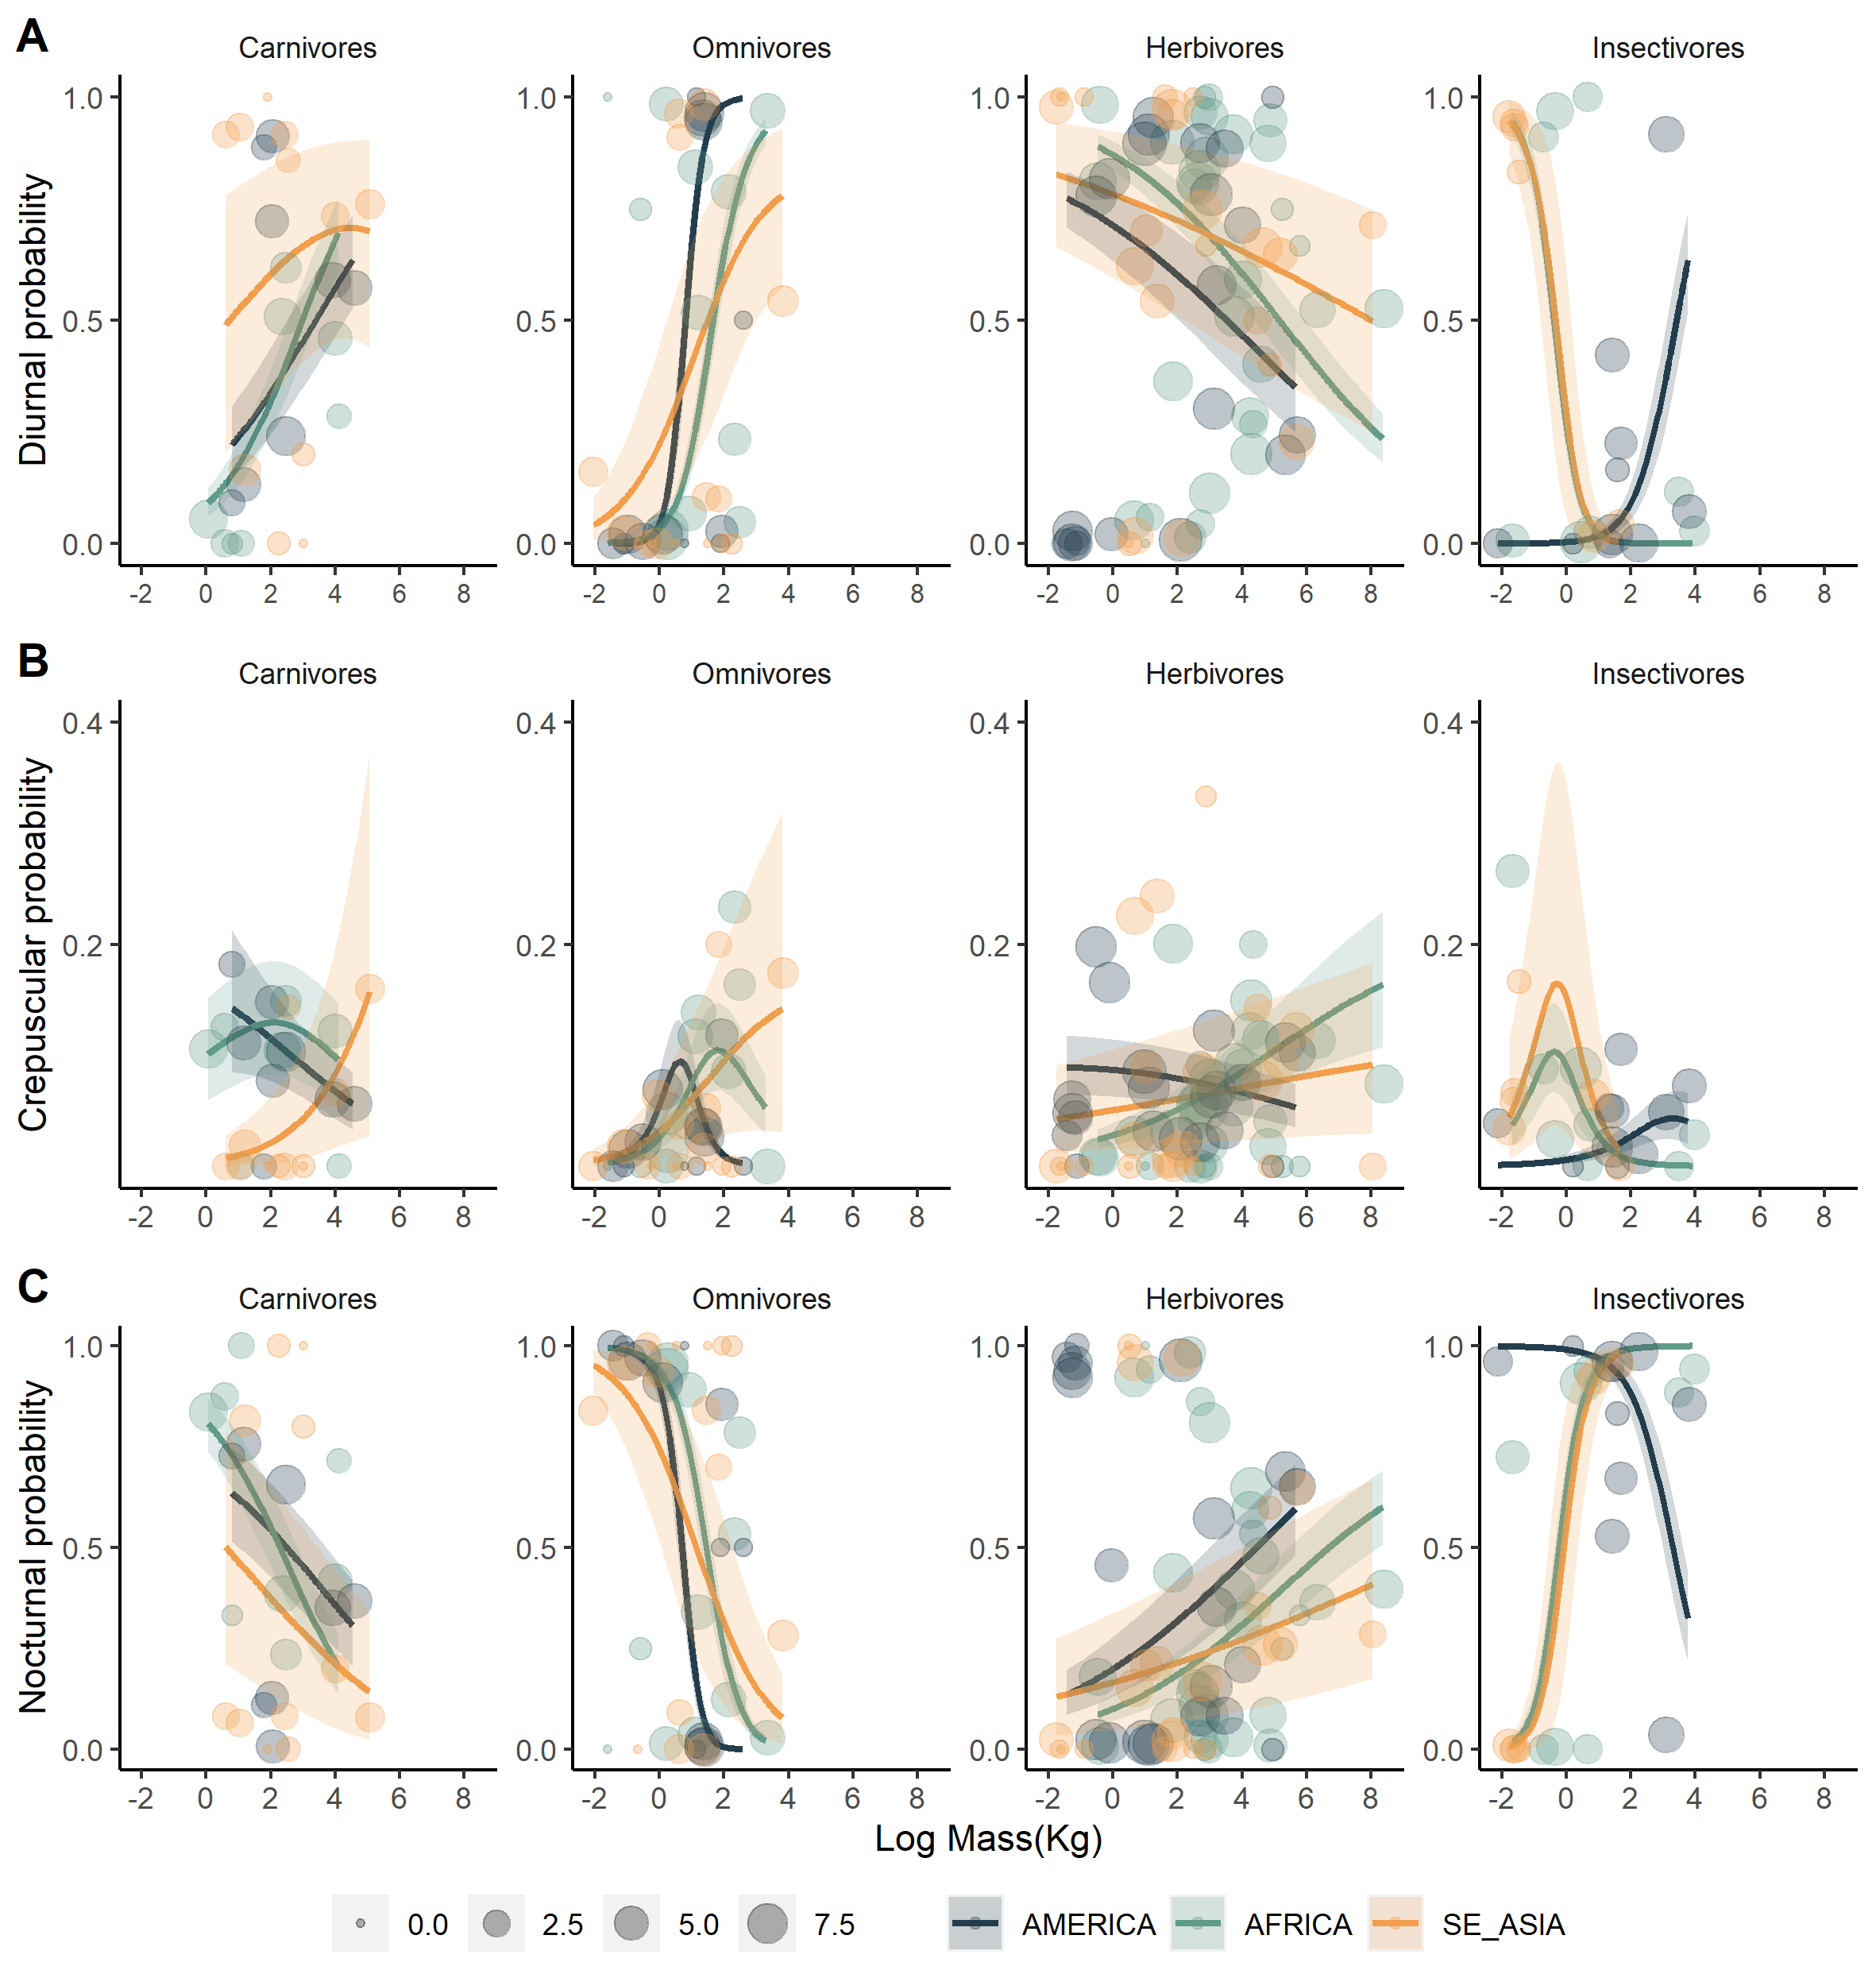
Figure S4. Extended predicted probability of being diurnal (A), crepuscular (B) and nocturnal (C) for a sequence of body mass values by trophic guild and continent. Lighter regions correspond to the upper and lower 95% confidence intervals. Circles represent raw proportions of diurnal, crepuscular, and nocturnal activity for species included in this study are based on the number of independent events (log-scaled), with the smallest circle corresponding to 1 and the biggest to 1055 events.

