Supplementary Data
Defining movement instabilities in yips golfers using motion capture and muscle synergies.
Gajanan S. Revankar¹, Issei Ogasawara², Noriaki Hattori¹, Yuta Kajiyama¹, Shingo Shimoda³, Alvaro Costa Garcia³, Yuki Uno², Tomohito Nakano¹, Yasufumi Gon¹, Sadahito Kawamura⁴, Ken Nakata² and Hideki Mochizuki^{1*}
¹Department of Neurology, Graduate School of Medicine, Osaka University, Osaka, Japan
²Department of Health and Sport Sciences, Graduate School of Medicine, Osaka University, Osaka, Japan
³Intelligent Behavior Control Unit, RIKEN Center for Brain Sciences, Nagoya, Aichi, Japan
⁴Department of Orthopedics, Graduate School of Medicine, Osaka University, Osaka, Japan

Supplementary Methodology and Results
Putting task:
The putting task was performed on an artificial putting surface in a room equipped with 12 motion tracking cameras. Two laser distance meters (Keyence optical systems, Japan) provided triggers to identify (i) back-swing – time point of start of initiation of swing from rest, (ii) downswing – time point of peak of back swing phase, (iii) ball impact - time point immediately preceding the initial increase in ball velocity as tracked by the distance meter (iii) and follow-through phase. The distance from the starting position to the hole was set to 2.2 meters. Before the experiment, each golfer completed a warm up with large dynamic movements and static stretches, and was able to adapt to the laboratory environment with 3 practice swings. For the experiment, 40 putting trials were performed by each golfer with a standard grip. Standard grip meant that in which the golfer suffered or complained of yips. The golfers were specifically instructed to try and putt all the shots. No explicit information or suggestions were provided regarding the success or failure of shots by the experimenter. To avoid habituation, a 2 to 5-minute break was enforced after every 10 shots. The entire experiment was videotaped using a high definition camera and after every shot, the golfers were requested to verbally communicate their observation or impression regarding their performance to the experimenter. Putting trials were then sorted and classified as yips-like and normal hits based on their subjective experience which was irrespective of their success in putting the shots. All videotaped trials were qualitatively assessed for tremors, jerks, twitches and for freezing of movements.

Motion tracking:
A 12 camera, 1.7 Megapixel, OptiTrack Prime 17W system (NaturalPoint, Inc, US) was used for motion capture with data recorded at a frame rate of 360 frames per second. Before data collection, static calibration of the club was conducted as follows. Two acryl plates with three reflective markers (diameter = 9 mm) were firmly attached to the mid-way of the club shaft and the club head face (Supplementary Figure-1A). The club coordinate system (a rotation matrix of the club relative to the global coordinate system) $A_{G}^{S}≡\left[e_{x}{,e}_{y},e_{z}\right]$, where the lower script G denotes global, was defined on the reflective markers on the shaft plate. The x-axis $e_{x}$was defined as a unit vector parallel to the club shaft, pointing upward. The y-axis $e_{y}$ was defined as a unit vector perpendicular to the club head face, pointing the swing direction, and the z-axis $e_{z}$ was defined as a unit vector mutually perpendicular to both $e_{x}$ and $e_{y}$. The angular velocity vector of the club $ω$ was calculated as $ω={\left[e_{z}∙\dot{e_{y}},{ e}_{x}∙\dot{e_{z}}, e_{y}∙\dot{e_{x}}\right]}^{T}$. In this representation, the angular velocity vector $ω$is represented with respect to the club coordinate system. For each trial, motion tracking data were epoched -1 second to +1 second with 0 as the time of ball impact. Each epoch represented a time window immediately prior to start of backswing, the backswing, the downswing till ball impact and the follow-through (Supplementary Figure-1C). Signal data were visually assessed and trials with obvious artifacts or noisy channels were removed appropriately in both motion tracking and sEMG analysis.

Supplementary Fig. 1
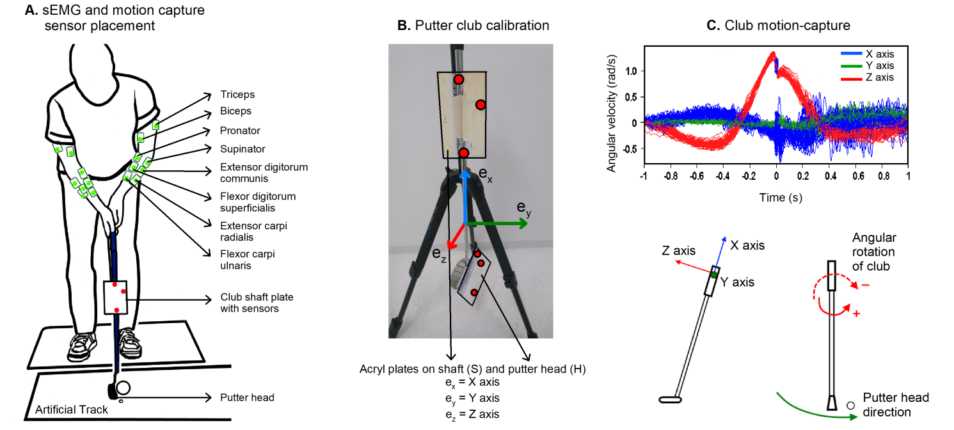
Supplementary Fig. 1 legend: (A) Graphical representation of wireless sEMG electrodes and motion capture system, (B) The club coordinate system consisted of three orthogonal unit vectors ${ e}_{x}$, ${ e}_{y}$ ,and ${ e}_{z}$ for X, Y and Z axis respectively which were calculated using acryl plates attached to shaft and putter-head. (C) Snapshot of putting swing for an individual participant with control axes shown on club. Of interest was Z-axis representing the angular rotation of club. Time ‘0’ = time of ball impact.

Supplementary Table-1: Downswing times for normal and yips shots
Subject ID | Normal shots | Yips shots |  | Subject ID | Normal shots | Yips shots
Subject 01 | 227 ±0.01 | 224 ±0.02 |  | Subject 09 | 260 ±0.01 | 260 ±0.02
Subject 02 | 416 ±0.01 | 421 ±0.02 |  | Subject 10 | 269 ±0.02 | 267 ±0.02
Subject 03 | 278 ±0.01 | 282 ±0.01 |  | Subject 11 | 385 ±0.04 | 378 ±0.01
Subject 04 | 366 ±0.01 | 372 ±0.01 |  | Subject 12 | 286 ±0.01 | 282 ±0.01
Subject 05 | 347 ±0.02 | 357 ±0.02 |  | Subject 13 | 338 ±0.01 | 341 ±0.01
Subject 06 | 343 ±0.01 | 346 ±0.01 |  | Subject 14 | 295 ±0.01 | 290 ±0.01
Subject 07 | 367 ±0.02 | 363 ±0.01 |  | Subject 15 | 289 ±0.01 | 291 ±0.01
Subject 08 | 263 ±0.02 | 264 ±0.02
Supplementary Table-1 legend: shows Mean and Standard deviation (SD) values of downswing time for all subjects. The time window of significant change in angular velocity of the putter club between Normal and Yips shots was characteristically present within the downswing phase. However the downswing time in itself remained similar within the subjects [Ns = 315.26 ms ±54.5, Ys = 315.87 ms ±55.9, paired t-test - t(14) = -0.49, p = 0.631].

sEMG recording:
Initially to observe stereotyped dystonic burst patterns, sEMG recordings were amplitude normalized using the peak values for each muscle, for each subject, under each trial, to reduce signal variance^{1,2}. We did not employ a normalization procedure that used maximal voluntary contraction since the putting swing movement did not generate high enough forces and the effect of crosstalk in the selected small groups of forearm muscles would prove counterproductive to our analysis. Furthermore, we aimed to compare the changes in short term interventions within an individual in the same session under the same experimental conditions without changes to the sEMG set-up ³.
Supplementary Fig. 2
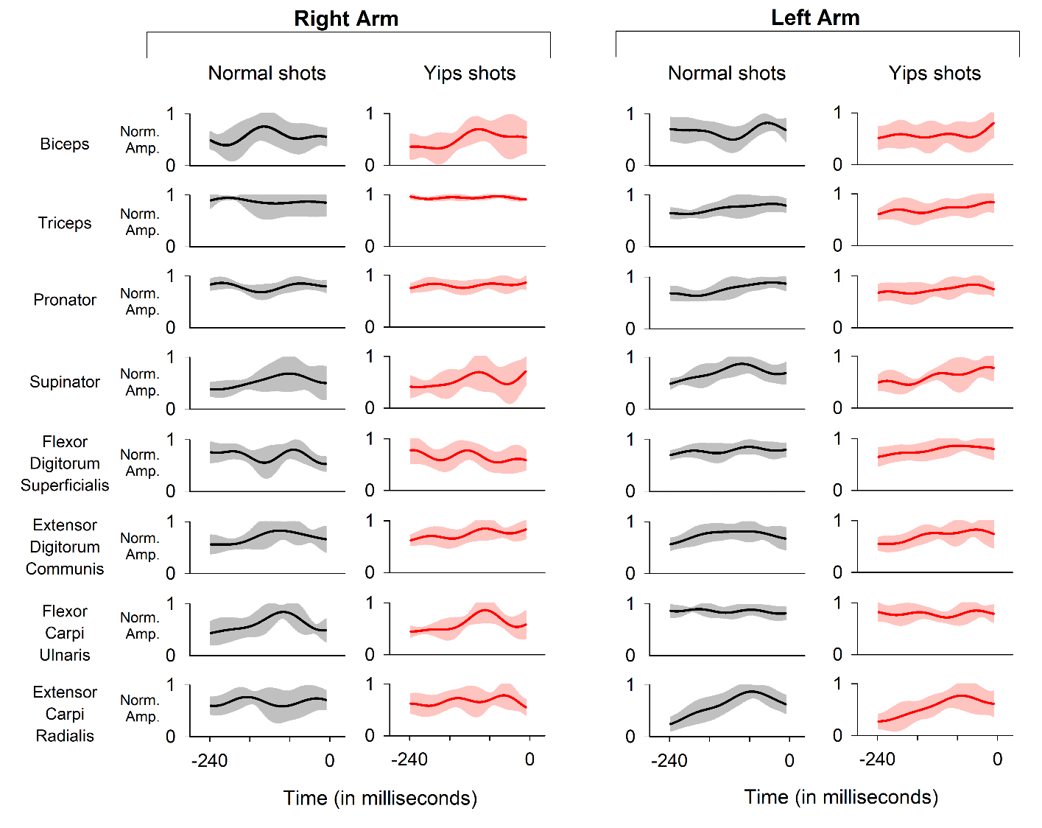
Supplementary Fig. 2 legend: Valid trials averaged mean (solid line) and standard deviation (shaded areas) sEMG curves for Subject01 during the downswing phase. X axis = downswing time, ‘0 ms’ = time of ball impact, Y axis = sEMG amplitudes normalized (Norm. Amp.) to their peak values.

Muscle synergy analysis supplement data:
Supplementary Table-2: Shows median and interquartile ranges of EMG reconstruction scores for each arm from 3 synergies for normal and yips shots.
Subject ID | Total yips trials | Right arm EMG_{reconstructed} R² |  | Left Arm EMG_{reconstructed} R²
 |  | Normal hits | Yips shot | Normal hits | Yips shots
Subject 01 | 8 | 0.92 (0.87, 0.94) | 0.93 (0.90, 0.95) | 0.92 (0.89, 0.94) | 0.93 (0.92, 0.95)
Subject 02 | 7 | 0.85 (0.81, 0.88) | 0.81 (0.76, 0.83) | 0.84 (0.78, 0.87) | 0.73 (0.66, 0.81)
Subject 03 | 8 | 0.78 (0.73, 0.80) | 0.81 (0.71, 0.85) | 0.71 (0.69, 0.75) | 0.75 (0.70, 0.80)
Subject 04 | 13 | 0.84 (0.81, 0.87) | 0.81 (0.75, 0.88) | 0.82 (0.76, 0.85) | 0.78 (0.73, 0.86)
Subject 05 | 8 | 0.86 (0.79, 0.92) | 0.86 (0.81, 0.9) | 0.84 (0.80, 0.87) | 0.80 (0.74, 0.87)
Subject 06 | 8 | 0.76 (0.70, 0.78) | 0.71 (0.66, 0.79) | 0.78 (0.68, 0.85) | 0.77 (0.75, 0.80)
Subject 07 | 7 | 0.91 (0.90, 0.93) | 0.92 (0.90, 0.95) | 0.97 (0.96, 0.97) | 0.96 (0.95, 0.96)
Subject 08 | 10 | 0.76 (0.73, 0.84) | 0.75 (0.70, 0.81) | 0.82 (0.76, 0.86) | 0.81 (0.78, 0.86)
Subject 09 | 9 | 0.77 (0.71, 0.84) | 0.75 (0.69, 0.81) | 0.92 (0.87, 0.93) | 0.92 (0.90, 0.95)
Subject 10 | 22 | 0.86 (0.82, 0.91) | 0.85 (0.79, 0.90) | 0.87 (0.78, 0.90) | 0.85 (0.81, 0.86)
Subject 11 | 8 | 0.78 (0.73, 0.85) | 0.81 (0.68, 0.84) | 0.87 (0.81, 0.91) | 0.85 (0.81, 0.87)
Subject 12 | 8 | 0.89 (0.79, 0.91) | 0.91 (0.84, 0.93) | 0.71 (0.64, 0.79) | 0.72 (0.69, 0.77)
Subject 13 | 9 | 0.77 (0.72, 0.84) | 0.70 (0.67, 0.80) | 0.76 (0.72, 0.82) | 0.78 (0.67, 0.83)
Subject 14 | 11 | 0.78 (0.67, 0.81) | 0.76 (0.63, 0.84) | 0.79 (0.70, 0.81) | 0.79 (0.77, 0.85)
Subject 15 | 15 | 0.75 (0.72, 0.82) | 0.75 (0.69, 0.80) | 0.85 (0.76, 0.87) | 0.80 (0.77, 0.85)
As shown in the Supplementary Table-2, the reconstruction scores were approx. 80% or higher when the number of synergies were 3. In fact, the threshold set for variance accounted for (VAF) invariably resulted in 2 synergies for each arm with a VAF > 90%, although the reconstruction percentage was low (between 44% and 62%). Addition of 3rd synergy improved the reconstruction scores to 80% or above and was thus used for statistical analysis.

Supplementary Fig. 3
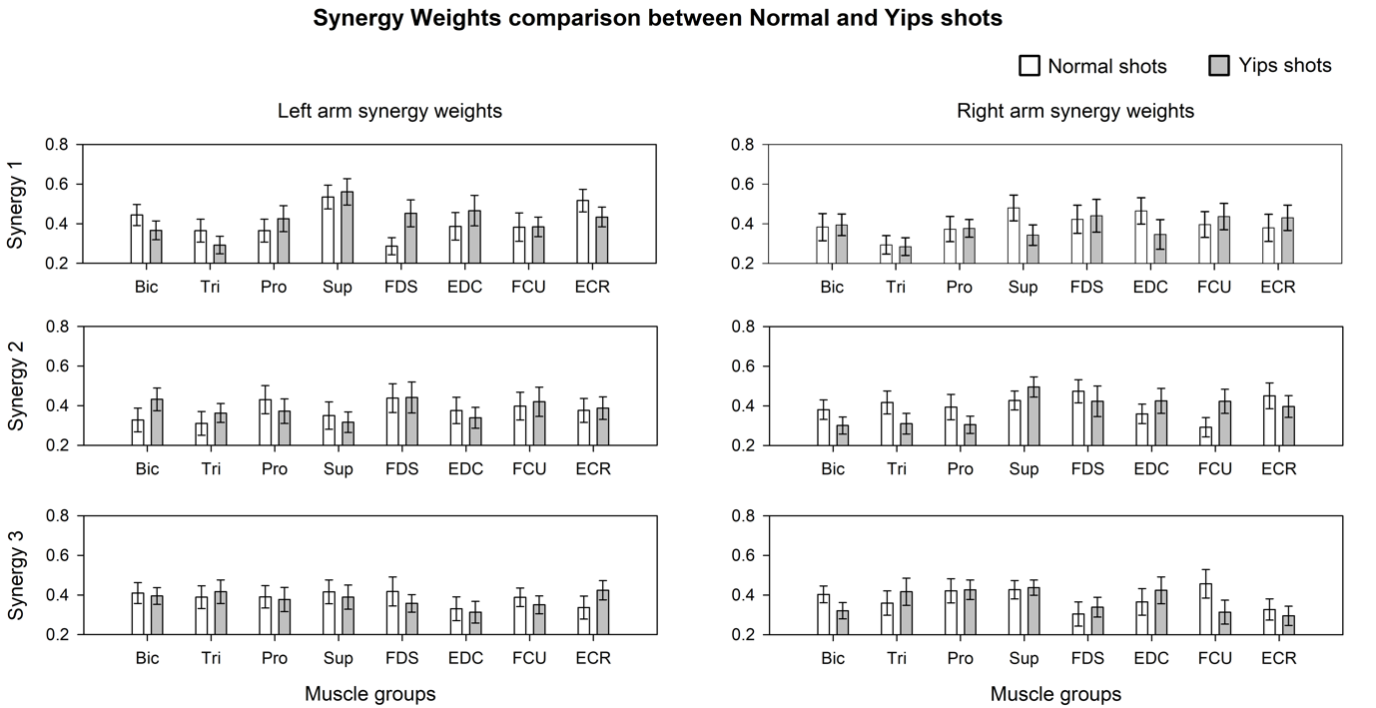
Supplementary Fig. 3 legend: Bar plot shows group mean and standard error of means from reconstructed synergy weights for 15 golfers. X axis shows muscle groups biceps (Bic), triceps (Tri), pronator (Pro), supinator (Sup), flexor digitorum superficialis (FDS), extensor digitorum communis (EDC), flexor carpi ulnaris (FCU) and extensor carpi radialis (ECR); whereas Y axes shows the synergy number. In general, the spatial synergies showed similar weighting patterns for normal and yips shots with no significant subject-level differences after Bonferroni corrections.

Cluster analysis:
Inputs for cluster level analysis included playing experience (categorized as moderate from > 15 to < 30 years, long between 30 to 40 years and very long for > 40 years), duration of yips symptoms (categorized as short for below 10 years, moderate from 10 to 20 years and long for those over 20 years), golfing rounds per year (categorized as few for < 50 rounds per year, average between 50 and < 100 rounds per year and frequent for > 100 rounds per year), SCA test (categorized as low, average and high levels as described above) and finally results from motion capture and muscle synergy analysis (labeled as significant or not significant) (Supplementary Table-3). Clustering was performed with k-medoids using the classical algorithm ‘pam’ (Partitioning Around Medoids), with distance metric set to ‘hamming’ and with 100 replicates to repeat clustering using new initial cluster medoid positions. The variable k for number of clusters was set to k = 2 to cluster the input data into Type-1 dystonia and Type-2 choking suggested by Smith et. al. ⁴. The best sum total sum of distance was 5 for the two clusters.
Supplementary Table-3: Categorical variables for cluster level analysis.
Golfer ID | Playing experience | Duration of yips symptoms | Golfing rounds per year | Competition anxiety test | Angular velocity of club rotation | Muscle synergy
S_01 | long | short | average | average | Sig. | Sig.
S_02 | long | short | average | average | not Sig. | not Sig.
S_03 | long | moderate | few | average | Sig. | not Sig.
S_04 | moderate | short | frequent | high | Sig. | Sig.
S_05 | very long | short | frequent | average | Sig. | Sig.
S_06 | long | moderate | frequent | high | not Sig. | Sig.
S_07 | very long | long | frequent | high | not Sig. | not Sig.
S_08 | very long | long | frequent | low | Sig. | Sig.
S_09 | moderate | short | frequent | average | Sig. | Sig.
S_10 | long | long | few | low | not Sig. | Sig.
S_11 | moderate | short | few | average | Sig. | Sig.
S_12 | long | moderate | average | average | not Sig. | Sig.
S_13 | very long | short | few | high | Sig. | Sig.
S_14 | moderate | moderate | frequent | high | Sig. | Sig.
S_15 | very long | long | average | average | not Sig. | not Sig.
Supplementary Table-3 legend: Sig. = Significant
References (Supplementary Data)
1. Frère, J. & Hug, F. Between-subject variability of muscle synergies during a complex motor skill. Front Comput Neurosci 6, 99 (2012).
2. Zelik, K. E., La Scaleia, V., Ivanenko, Y. P. & Lacquaniti, F. Can modular strategies simplify neural control of multidirectional human locomotion? J. Neurophysiol. 111, 1686–1702 (2014).
3. Halaki, M. & Ginn, K. Normalization of EMG Signals: To Normalize or Not to Normalize and What to Normalize to? in Computational Intelligence in Electromyography Analysis - A Perspective on Current Applications and Future Challenges 175–194 (2012). doi:10.5772/49957.
4. Smith, A. M. et al. The ‘yips’ in golf: a continuum between a focal dystonia and choking. Sports Med 33, 13–31 (2003).

