Supplementary Materials

Supplementary Methods
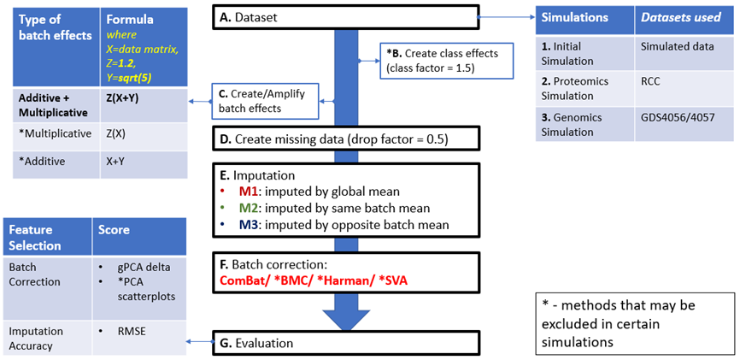

Figure 1. 1. Initial Simulation Pipeline A. Simulated dataset with normally distributed random numbers B. Simulated class effects C. Simulated batch effects D. Introduction of 50% missing values E. Imputation of missing values. 3 sub-conditions for the mean-based averaging imputation method: Global mean imputation (M1), Same batch mean imputation (M2), Opposite batch mean imputation (M3) F. Perform batch correction. 4 types of BECAs are used: ComBat, BMC, Harman, SVA G. Evaluate the outcome based on the estimation of remnant batch effects and imputation accuracy

2. Proteomics Simulation A. Renal Control dataset (RCC) with only 1 true sample class is used in this proteomics simulation. Data pre-processing of RCC such that the proteomics dataset has mean=5 and standard deviation (sd) =1 (values similar to our initial simulation), while maintaining original RCC distribution B. No class effects simulated C. Amplify batch effects for the first batch D. Introduction of 50% missing values E. Imputation of missing values. 3 sub-conditions for the mean-based averaging imputation method: Global mean imputation (M1), Same batch mean imputation (M2), Opposite batch mean imputation (M3) F. Batch correction with ComBat. G. Evaluation of outcome based on the estimation of remnant batch effects and imputation accuracy

3. Genomics Simulation A. A combination of ER+ HER-2 normal breast cancer RNA dataset from 2 cohorts: GDS4056 & GDS4057 is used in this genomics simulation such that genomics dataset only comprises 1 true sample class: ER+. Data pre-processing of GDS4056/4057 such that the genomics dataset has mean=5 and standard deviation (sd) =1(values similar to our initial simulation), while maintaining original GDS4056/4057 distribution B. Class effects is created only when analysing power C. Amplify batch effects for the first batch D. Introduction of 50% missing values E. Imputation of missing values. 3 sub-conditions for the mean-based averaging imputation method: Global mean imputation (M1), Same batch mean imputation (M2), Opposite batch mean imputation (M3) F. Batch correction with ComBat. G. Evaluation of outcome based on the estimation of remnant batch effects and imputation accuracy

Supplementary Figures
A.
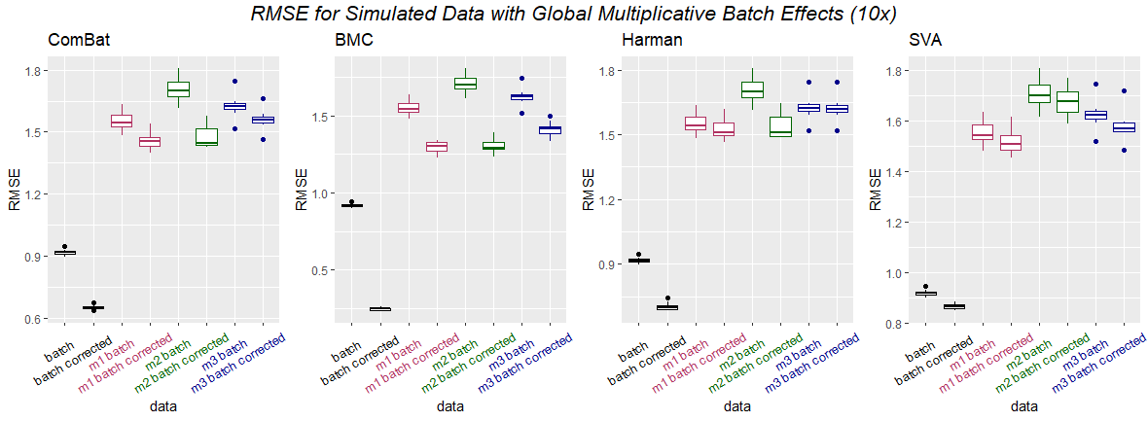
B.
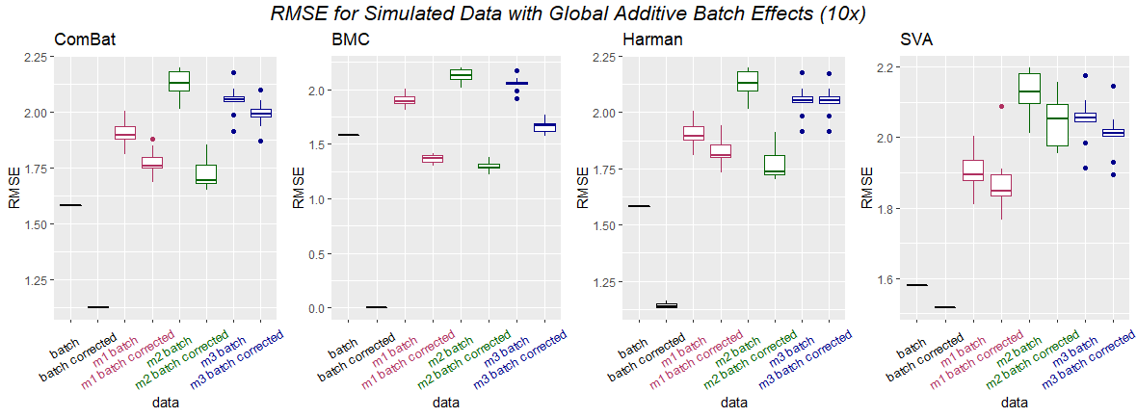
Figure S1. RMSE for Initial Simulations with A. multiplicative only and B. additive only batch effects have no strong differences with results with mixed batch effects (Additive + Multiplicative).

A.
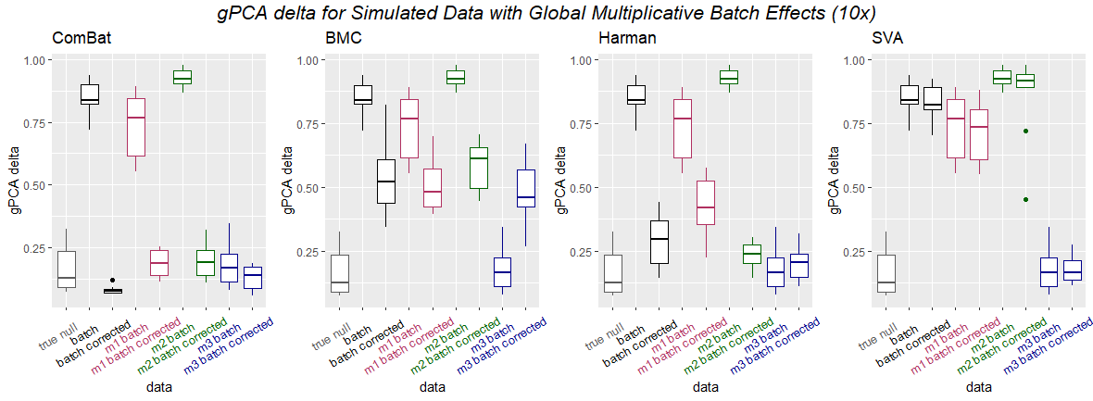
B.
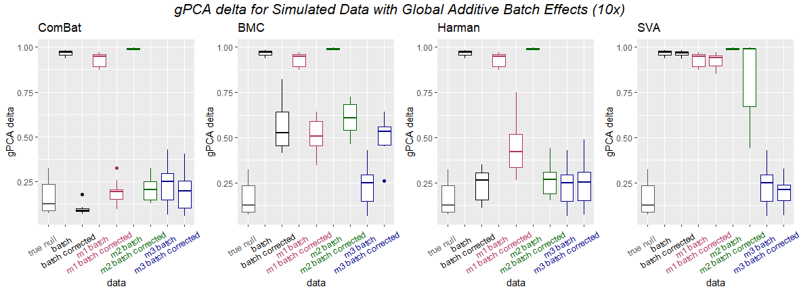
Figure S2. gPCA delta results for Initial Simulations with A. multiplicative only and B. additive only batch effects have no strong differences with results with mixed batch effects (Additive + Multiplicative).

A.
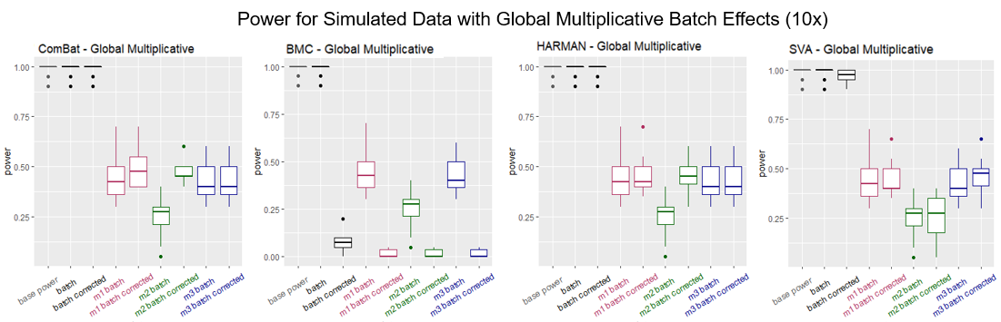
B.
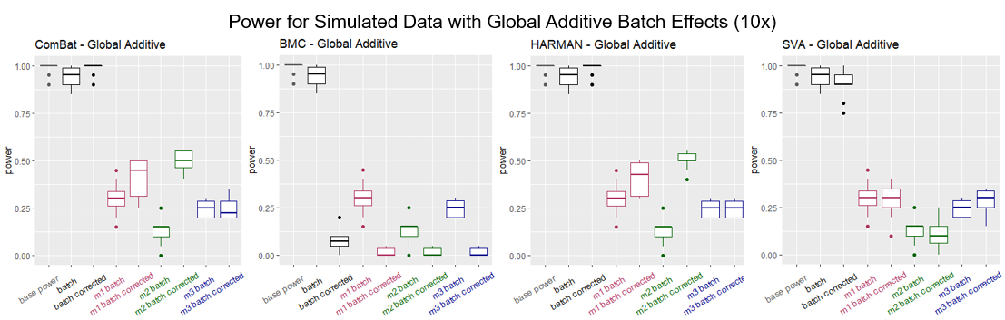
Figure S3. Power for Initial Simulations with A. multiplicative only and B. additive only batch effects show that BMC and SVA do not work well in these scenarios either.

A.
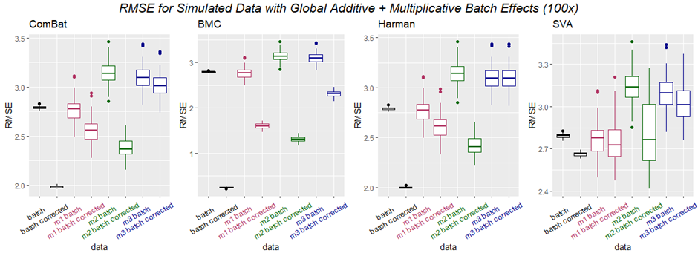
B.
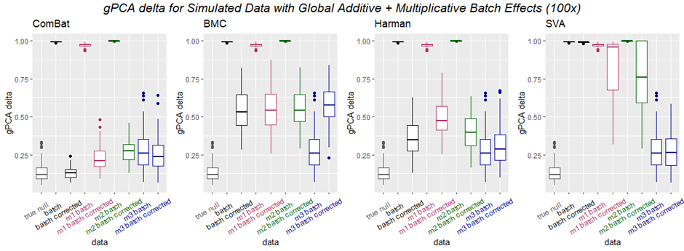
Figure S4. A. RMSE, B. gPCA results for Initial Simulation with 100x repeat have no strong differences with results for 10x repeat.

1. Proteomics Simulation
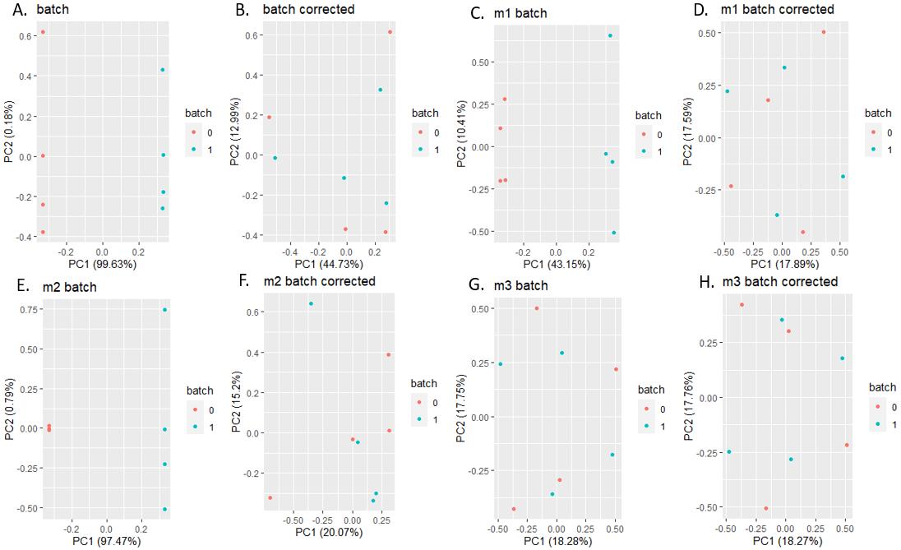
2. Genomics Simulation
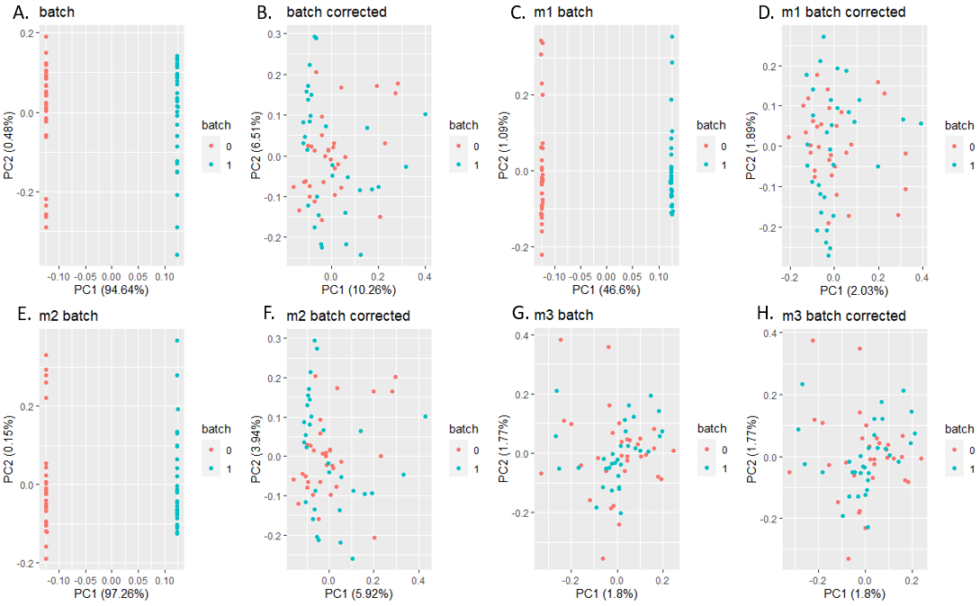

Figure S5. PCA Scatterplots (which includes both pre batch corrected and post batch corrected data) for 1. Proteomics Simulation and 2. Genomics Simulation showed that despite reporting higher gPCA levels for M2, samples appear well-mixed, with no apparent batch effects for all imputation strategies (M1 to M3), given the first two principal components (PC1 and PC2).

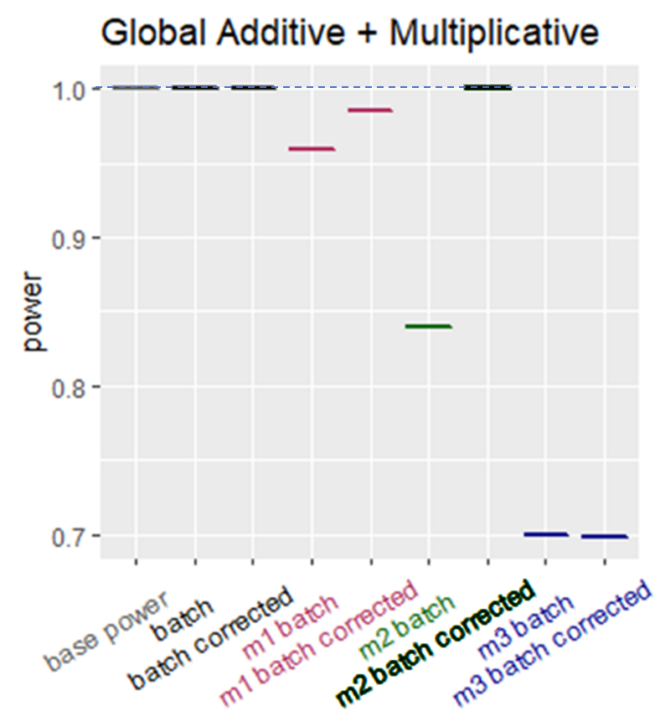
Figure S6. Only ComBat is used for evaluation of power for Genomics Simulation based on statistical feature selection. Higher values indicate better performance (higher recall of correct features).

A.
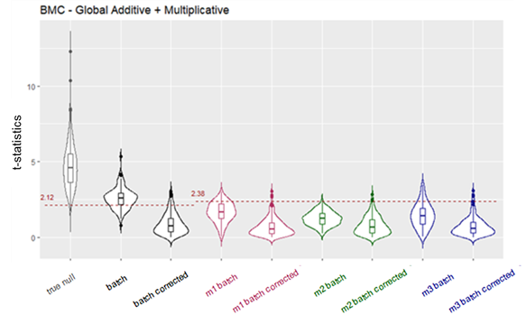
B.
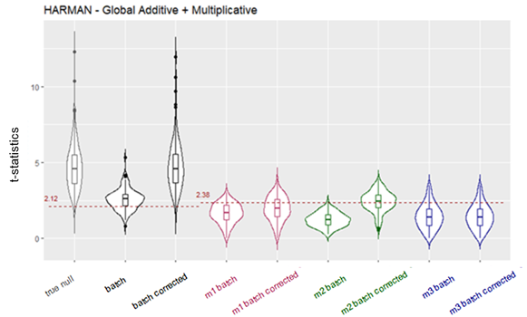
C.
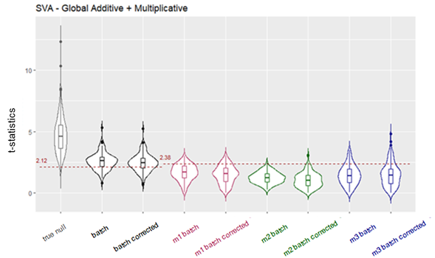

Figure S7. t-statistics distribution for Initial Simulation using BECAs such as A. BMC, B. Harman, C. SVA also show that all imputation strategies (M1 to M3) suffer from a reduction in effect size.
A. Numerator
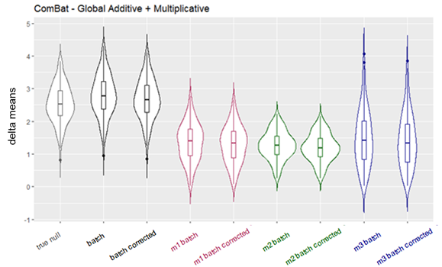
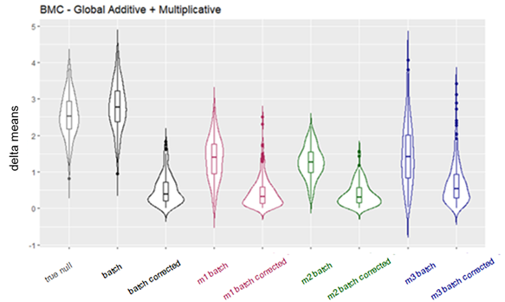
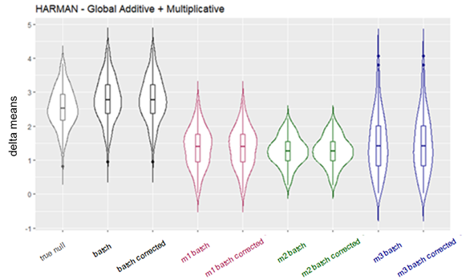
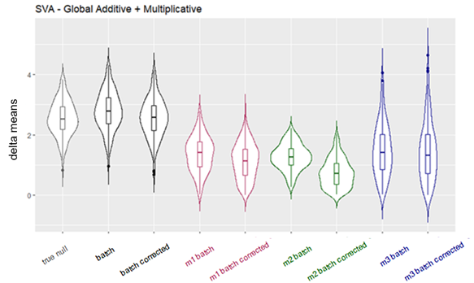
B. Denominator
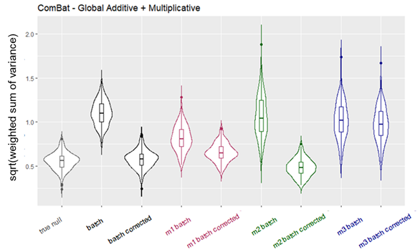
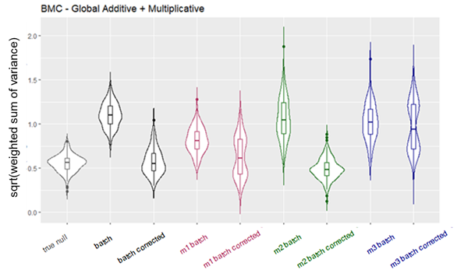
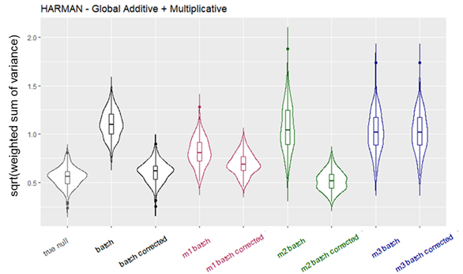
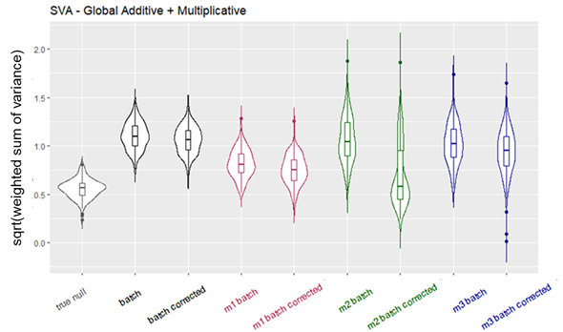
Figure S8. t-statistics split into A. numerator (delta means) and B. denominator (standard error of the mean) for Initial Simulation.

A.  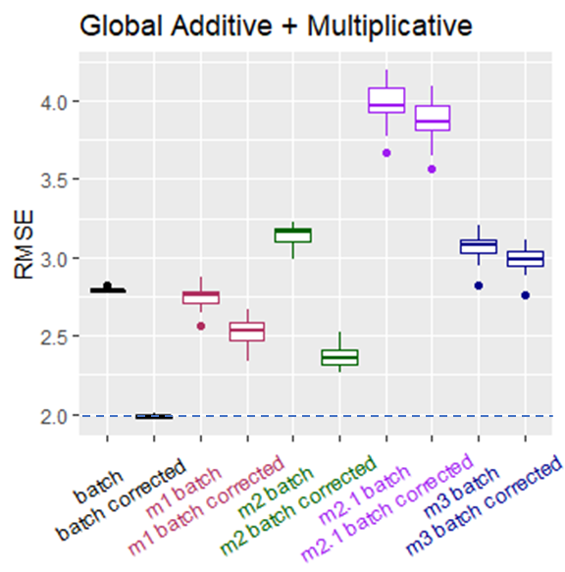 | B.  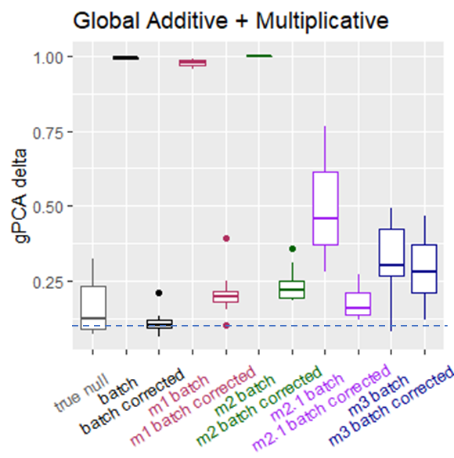 | C.  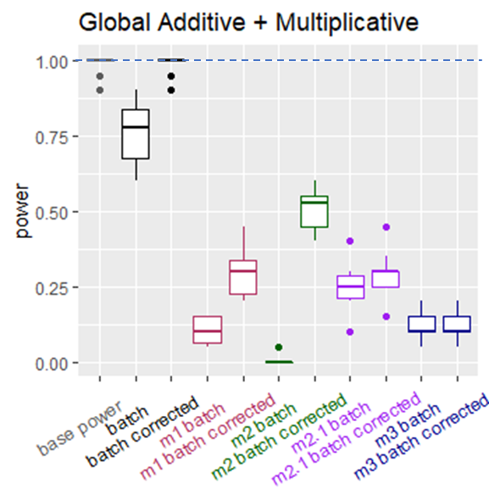
D.
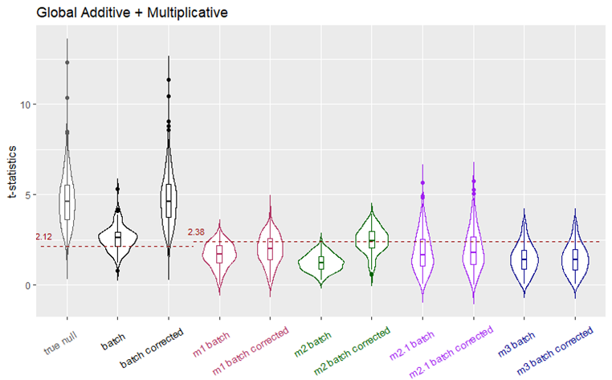

Figure S9. A. RMSE, B. gPCA delta, C. Power, D. t-statistics results for imputation strategies (M1 to M3), including M2.1 (imputation based on same class and batch), show that while M2.1 yield t-statistics more similar to original data, it did not outperform M2 in terms of RMSE, gPCA and power.

A. Proteomics Simulation
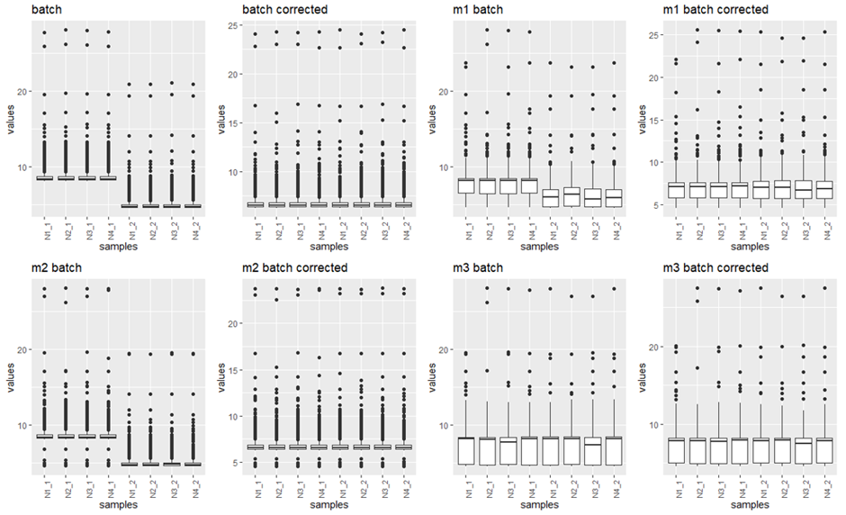
B. Genomics Simulation
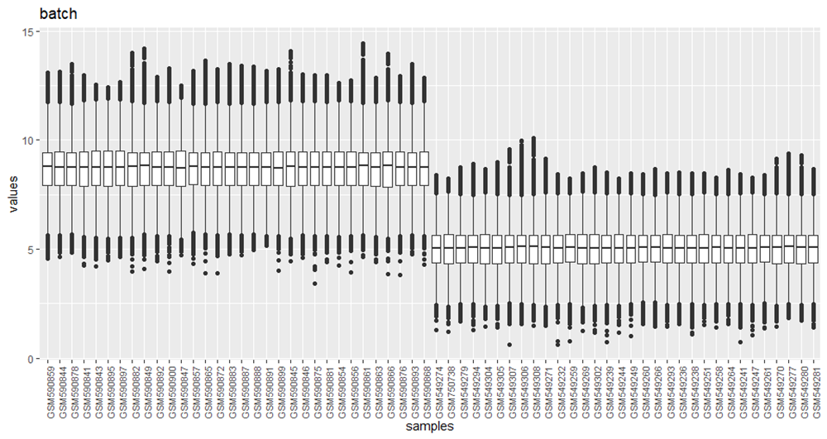
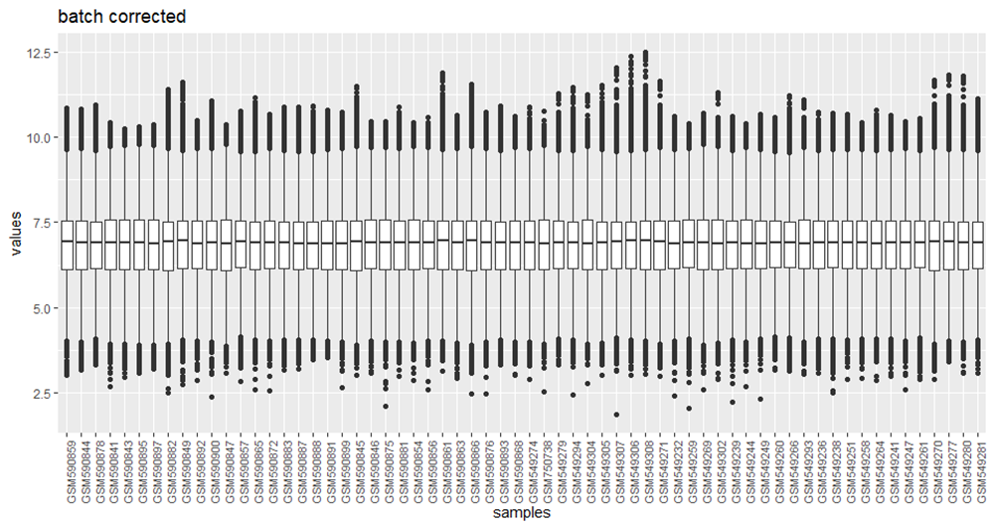
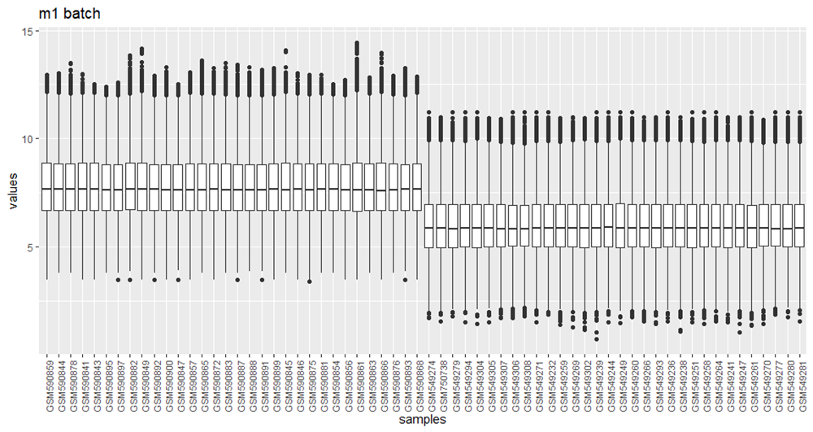
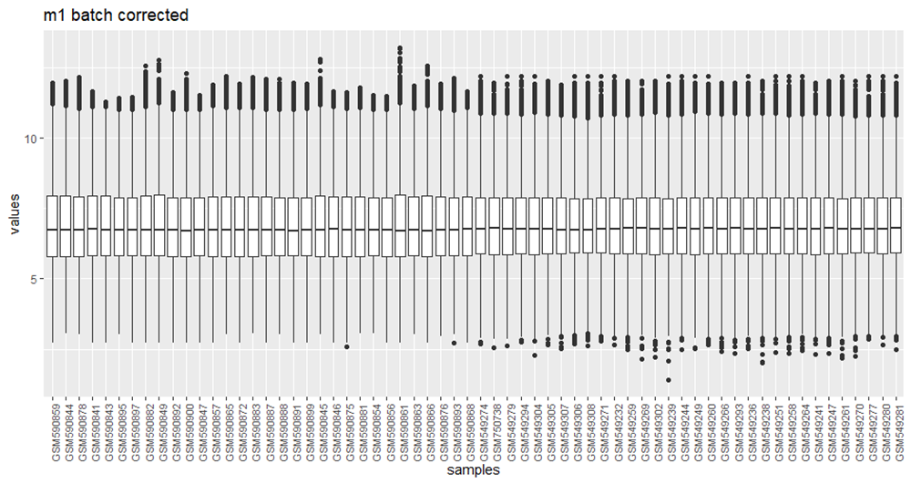
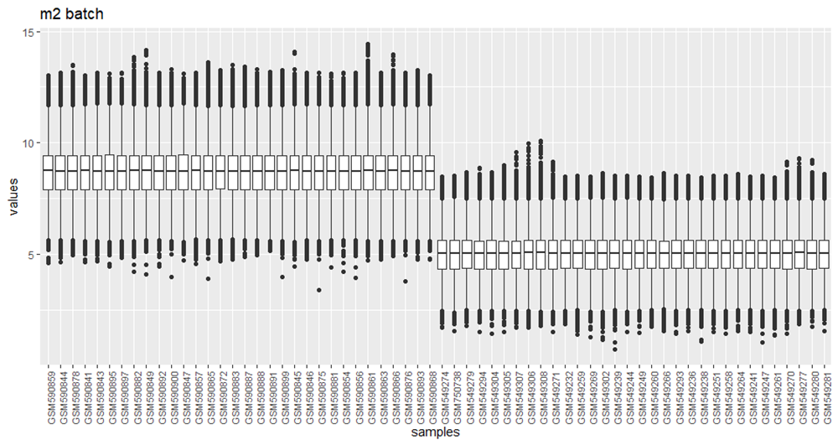
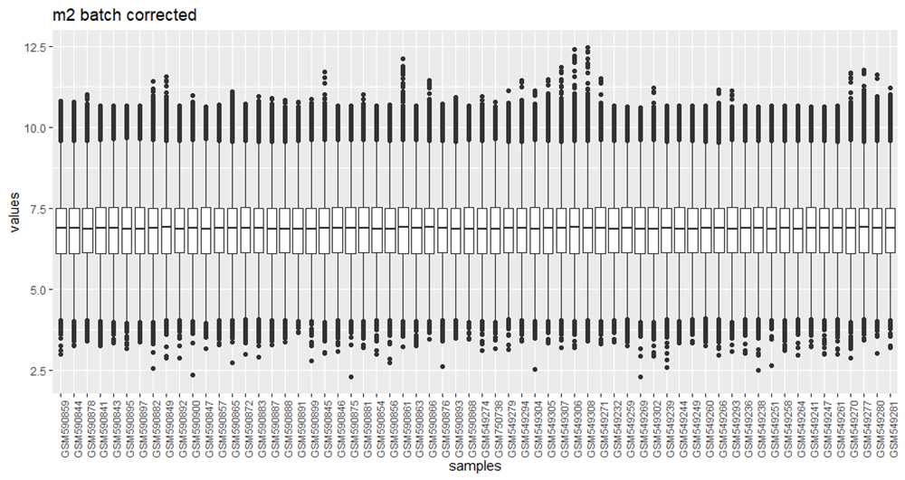
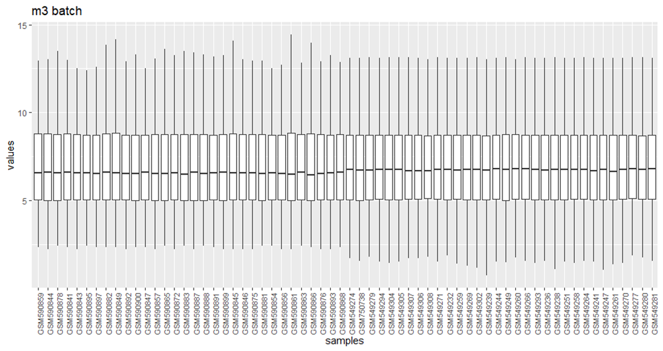
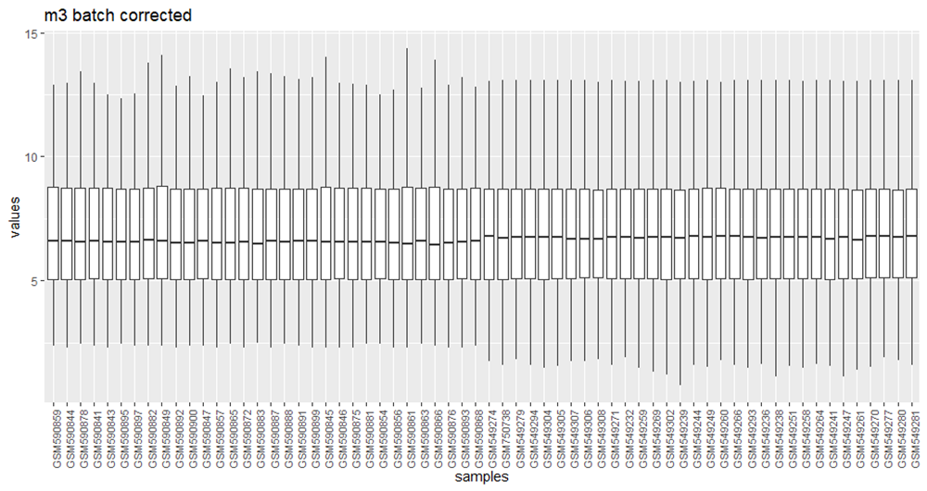

Figure S10. Sample Boxplots for A. Proteomics Simulation and B. Genomics Simulation although batch effects appear to be “mitigated” in the PCA scatterplots, M1 and M3 result in increased noise (i.e. larger interquartile range) in the data.

A.  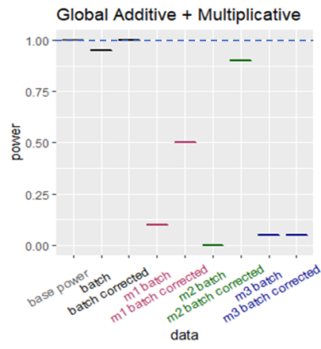 | B.  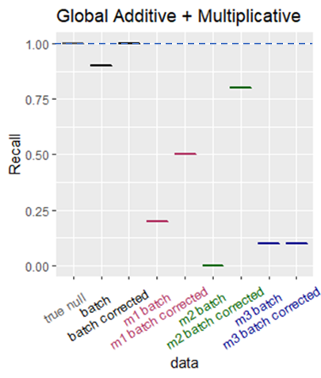
Figure S11. A. Power and B. Recall for reduced genomics data (20x20 matrix) show that after reducing sample size of genomics data, M2 batch corrected no longer performs as well as batch corrected

