Skeletal muscle area is an independent predictor for mortality in elderly patients with ANCA associated vasculitis
Xixi Zhengª M.D., Peng Xiaª M.D., Jiaying Liª M.S., Gu-Mu-Yang Zhang^{b} M.D., Yan Qinª M.D., Xuemei Liª M.D., Hao Sun^{b} M.D., Limeng Chenª M.D.
Affiliations
ª Nephrology Division, Peking Union Medical College Hospital, Chinese Academy of Medical Sciences, Beijing, China, 100730
^{b} Radiology Department, Peking Union Medical College Hospital, Chinese Academy of Medical Sciences, Beijing, China, 100730
Corresponding Authors
Limeng Chen and Hao Sun
Peking Union Medical College Hospital, Chinese Academy of Medical Sciences
No.1 Shuaifuyuan Wangfujing Dongcheng District,
Beijing, 100730, China
Tel: 69155055
E-Mail: chenlimeng@pumch.cn

Supplementary Material

Supplement Table 1 Analysis of Muscle Area and Clinical Parameters
Clinical parameters |  |  | P value
Binary Variables, muscle area in cm²
Gender | Male: 114.16 ±23.63 | Female: 92.34 ±20.40 | <0.0001***
Diabetes | Diabetes 94.33 ±19.18 | Non-diabetic: 105.39 ±25.49 | 0.142
Pulmonary comorbidities | With: 106.15 ±27.60 | Without: 101.20 ±23.14 | 0.696
Plasma exchange | Yes: 98.68 ±27.16 | No:104.10 ±23.53 | 0.465
Continuous Variables | Correlation coefficient |  | P value
Age | r = -0.40 |  | 0.002**
BMI | r = 0.39 |  | 0.003**
BVAS | r = 0.08 |  | 0.544
ANCA titer | Speraman’s Rho = -0.24 |  | 0.06
eGFR | Speraman’s Rho = -0.10 |  | 0.48
Hemoglobin | r = 0.16 |  | 0.23
Lymphocyte | Speraman’s Rho = 0.10 |  | 0.47
Albumin | r = 0.15 |  | 0.27
Immunoglobulin G | Speraman’s Rho = -0.04 |  | 0.77
hsCRP | Speraman’s Rho = -0.18 |  | 0.20
Abbreviations: BMI body mass index, BVAS Birmingham Vasculitis Activity Score (version 3), ANCA Antineutrophil Cytoplasmic Antibodies, eGFR estimated glomerular filtration rate, hsCRP high sensitivity C-Reactive Protein
* P value <0.05
** P value<0.01
***P value <0.001

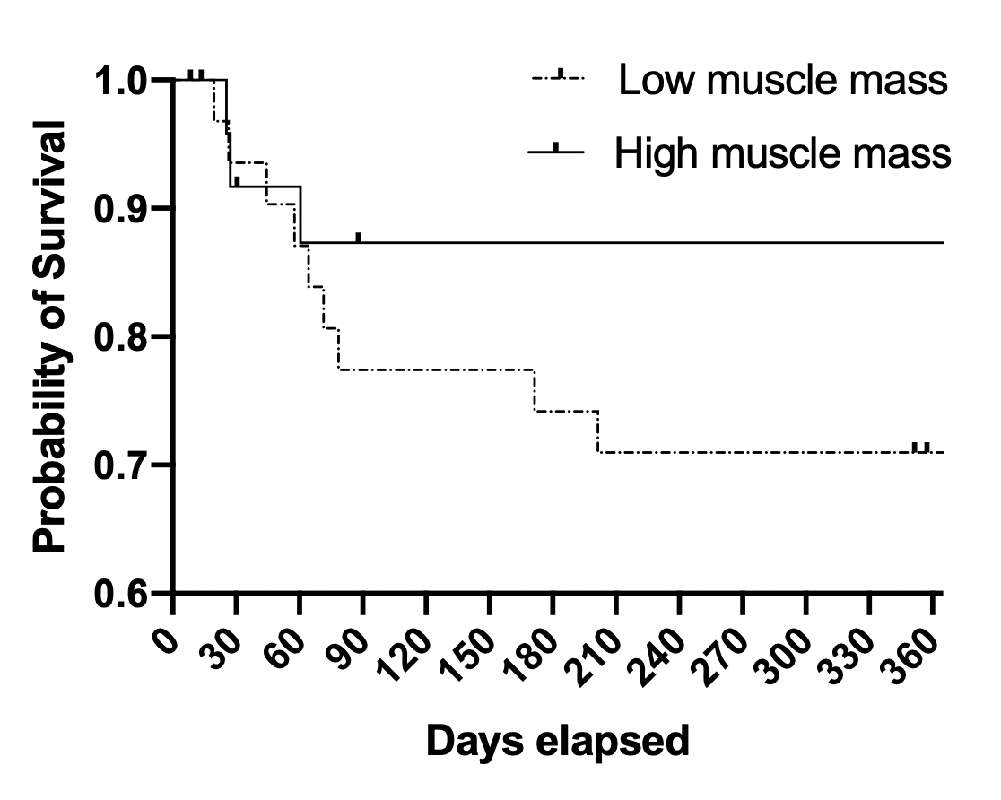
Supplement Fig. 1. Kaplan-Meier Curve of One year survival stratified by muscle mass

