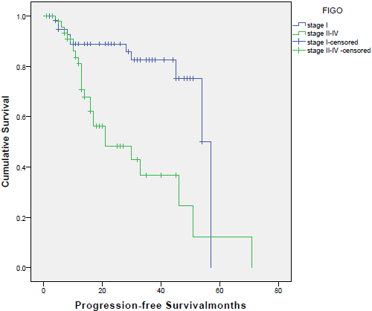
Figure 1
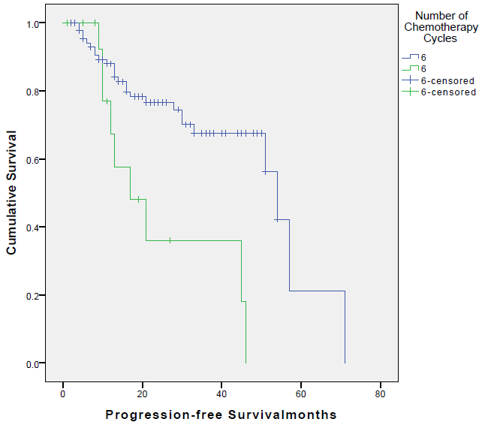
Figure 2
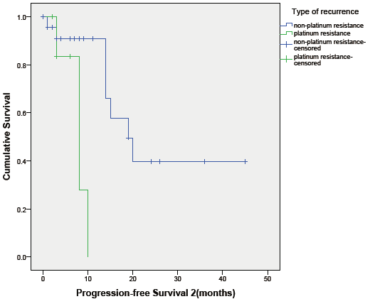
Figure 3

Table 4 Survival analyses of PFS1 for stage I and stage III disease
Parameter | Stage I |  | Stage III
 | HR | P-value | HR | P-value
chemotherapy cycles of CA-125 normalization (>1 vs ≤1) | 2.26 (0.45, 11.27) | 0.319* | 1.03 (0.27, 3.89) | 0.965*
* Multivariate Cox regression adjusted for age; HR: hazard ratio

Table 5 Survival analysis of PFS2
Parameter | HR (95% CI) | P-value
Recurrence type (platinum resistance vs platinum sensitive) | 11.562 (1.873, 71.353) | 0.0080*
* Multivariate Cox regression adjusted for FIGO stage and age; HR: hazard ratio

