Supplementary Date

Improvement of hyperlipidemia by aerobic exercise in mice through a regulatory effect of miR-21a-5p on its target genes
Jinfeng Zhao¹, Yaxin Wang², Anping Chen¹, Yu Zeng¹, Feng Yan¹, Longchang Chen¹, Baoai Wu¹
¹ Department of Exercise Physiology, Shanxi University, Taiyuan, Shanxi, China
² Department of Exercise Physiology, Beijing Sports University, Beijing, China
Short title: Exercise improves hyperlipidemia by upregulating miR-21a-5p
Address correspondence to: Baoai Wu, School of Shanxi university, Sports and educiation College, No. 92, Wucheng Road, Xiaodian District, Taiyuan City 030000, Shanxi Province, China, Tel: 86-15035168548; E-mail: 469203910@qq.com

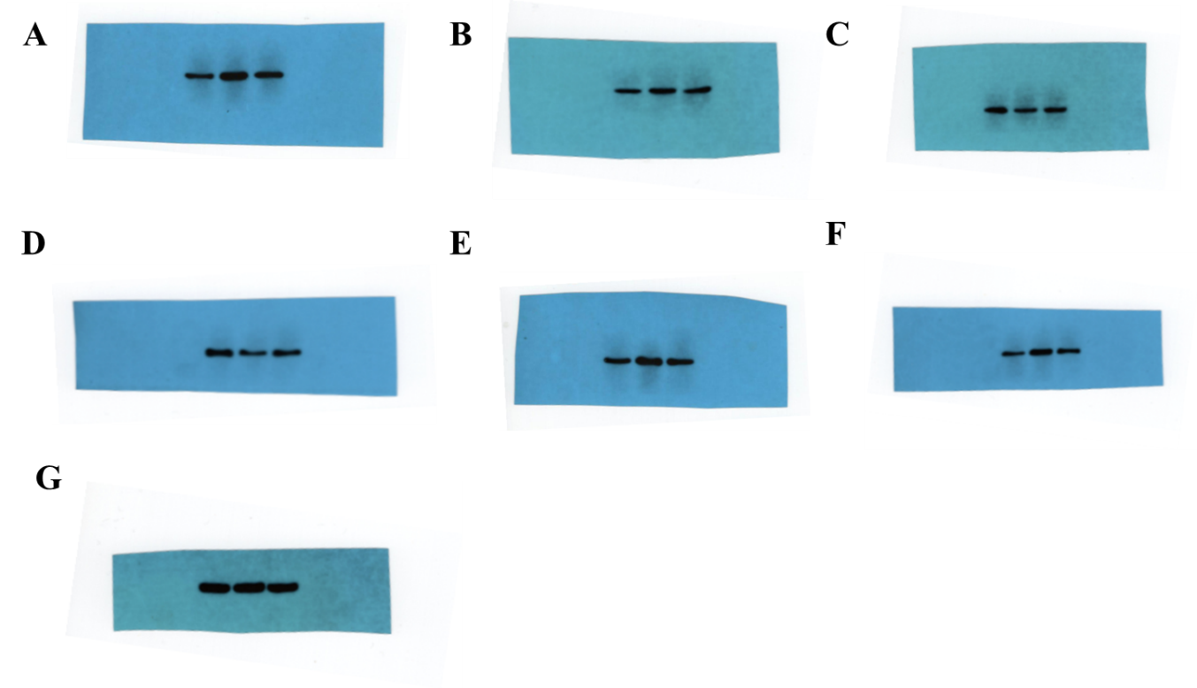
Supplementary Figure. Original western blot gel figures. (A) FABP7, (B) HMGCR, (C) PPARα, (D) PTEN, (E) ACAT1, (F) OLR1.

