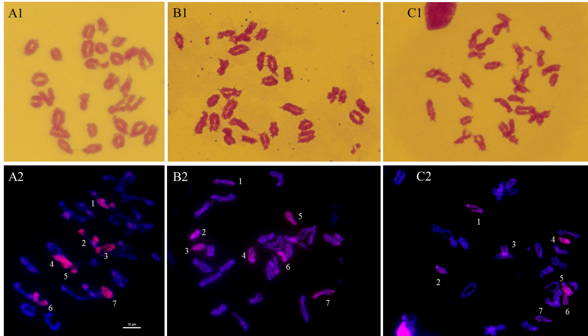
Supplemental Fig. 1. Chromosome configuration of PMC MI in TE261-1 (A1), TE266-1 (B1) and TE346-1 (C1), chromosomes were dyed red by carbol fuchsin, Based on investigating 40 cells every material, the chromosome configuration of TE261-1, TE266-1, TE346-1 is 2n=28II=56. GISH of PMC MI in TE261-1 (A2), TE266-1 (B2) and TE346-1 (C2), St (Ps. Strigosa) genome DNA labeled with Texas-Red-5-dCTP were used as probe and YN15 genome DNA were used as block, 14 alien chromosomes matched 7II.

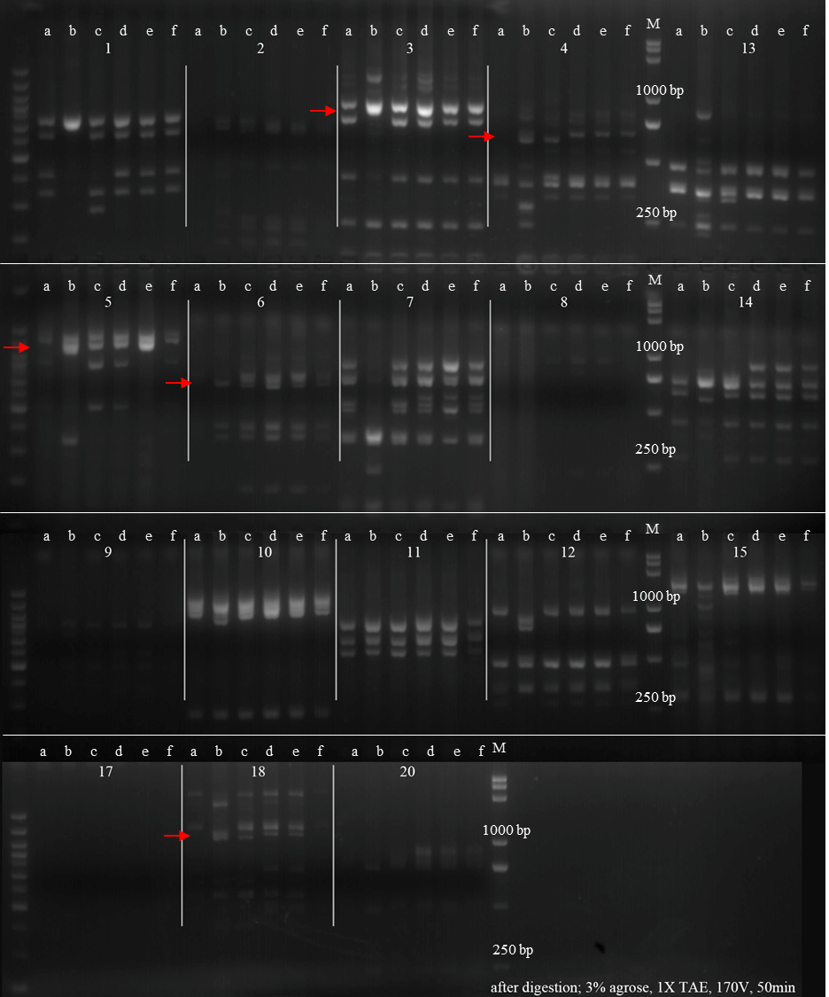
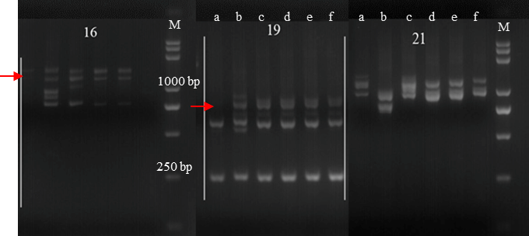
Supplemental Fig. 2. PCR patterns of amplification with the St-chromosome-specific molecular markers
a. YN15, b. Th. intermedium, c. Ps. strigosa, d. TE261-1, e. TE266-1, f. TE346-1, M. DL5000
The information of makers were shown in Supplemental Table 2.

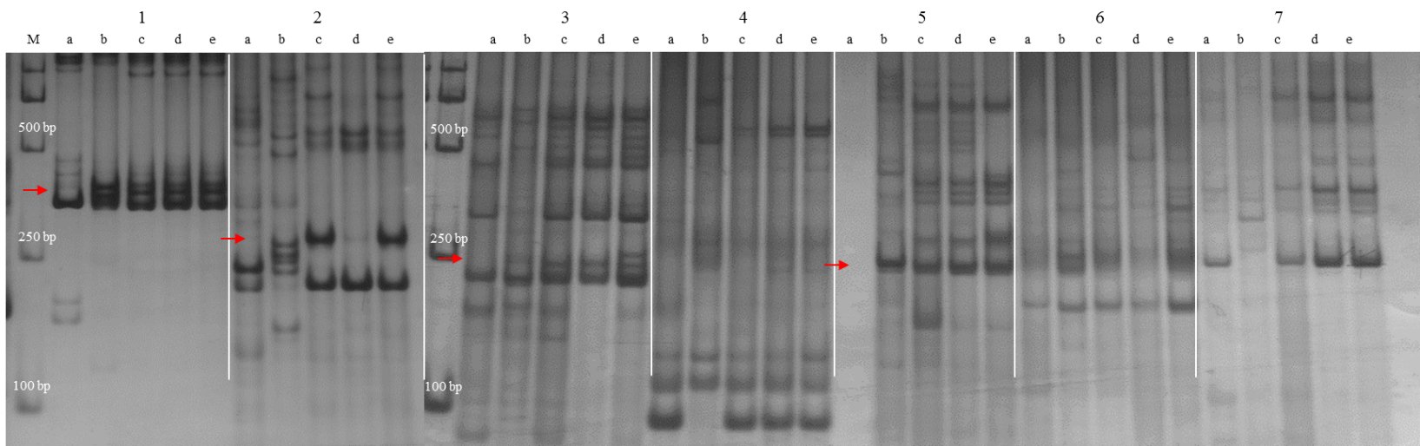
Supplemental Fig. 3. PCR patterns of amplification with the E-chromosome-specific molecular markers
a. YN15, b. Th. intermedium, c. TE261-1, d. TE266-1, e. TE346-1, M. DL2000
The information of makers were shown in Supplemental Table 3.

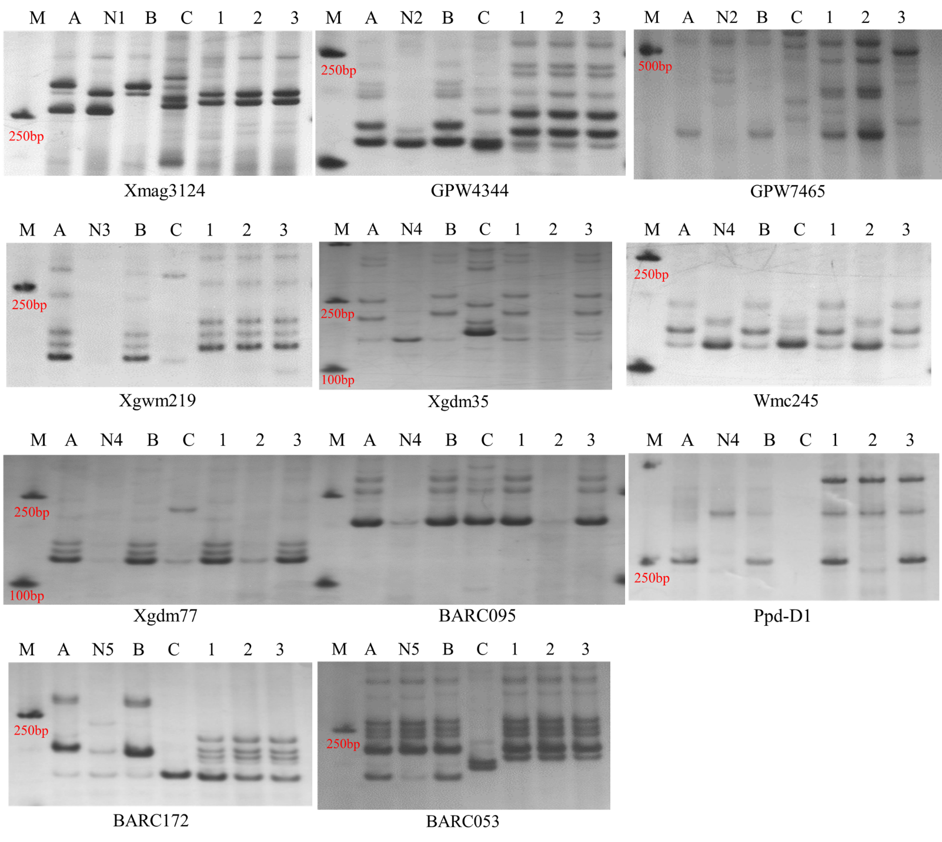
Supplemental Fig. 4. Amplified results of wheat chromosome-specific markers Xmag3124 (1A), GPW4344, GPW7465 (6A), Xgwm219 (6B), Xgdm35, Wmc245, Xgdm77, BARC095, Ppd-D1 (2D) and BARC172, BARC053 (7D).
M. Maker, A. Chinese spring, N1. N1AT1D, N2. N6AT6D, N3. N6BT6D, N4. N2DT2B,
N5. N7DT7B, B. Yannong15, C. Th. intermedium, 1. TE261-1, 2. TE266, 3. TE346

Supplemental Table 1. Chromosome configurations of TE261-1, TE266 and TE346-1 at PMC MI
Material | Plants observed | Cells scored | Average chromosome configuration |  |  |  | Relative chaotic coefficient
 |  |  | Ⅰ | Ⅱ | Ⅲ | IV
TE261-1 | 6 | 45 | 0.089 | 27.778 | 0.044 | - | 0.005
TE266-1 | 5 | 40 | 0.150 | 27.85 | 0.050 | - | 0.007
TE346-1 | 5 | 42 | 0.095 | 27.905 | - | 0.024 | 0.004
Relative chaotic coefficient (RCC) = (number of univalents + number of multivalents)/number of bivalents.

Supplemental Table 2. The St-chromosome-specific molecular markers used in the study(Hu et al., 2014)
No. | Maker | Homologous relationship | Enzyme | No. | Maker | Homologous relationship | Enzyme
1 | TNAC1001 | 1StS | TaqⅠ | 12 | TNAC1540 | 5StL | HaeⅢ
2 | TNAC1010 | 1StS | TaqⅠ | 13 | TNAC1554 | 5StL | HaeⅢ
3 | TNAC1021 | 1StL | TaqⅠ | 14 | TNAC1674 | 6StS | TaqⅠ
4 | TNAC1026 | 1StL | TaqⅠ | 15 | TNAC1685 | 6StS | TaqⅠ
5 | TNAC1102 | 2StS | TaqⅠ | 16 | TNAC1702 | 6StL | -
6 | TNAC1176 | 2StS | TaqⅠ | 17 | TNAC1752 | 6StL | TaqⅠ
7 | TNAC1204 | 2StL | HaeⅢ | 18 | TNAC1806 | 7StS | TaqⅠ
8 | TNAC1248 | 3StS | TaqⅠ | 19 | TNAC1926 | 7StS | -
9 | TNAC1263 | 3StL | TaqⅠ | 20 | TNAC1903 | 7StL | TaqⅠ
10 | TNAC1485 | 5StS | TaqⅠ | 21 | TNAC1957 | 7StL | -
11 | TNAC1497 | 5StS | TaqⅠ

Supplemental Table 3. The E-chromosome-specific molecular markers used in the study(Hu et al., 2012)
No. | Maker | Homologous relationship | No. | Maker | Homologous relationship
1 | Xmag3253 | 2E | 5 | Xmag2276 | 6E
2 | Xmag905 | 3E | 6 | Xmag2134 | 7E
3 | Xmag532 | 5E | 7 | Xmag3284 | 7E
4 | Xmag1579 | 5E
Note：Results showed that TE261-1 has 1St, 2St, 6St, 7St, 2E, 3E, 5E, 6E, 7E; TE266-1 has 1St, 2St, 6St, 7St, 2E, 5E, 6E, 7E; and TE346-1 has 1St, 2St, 7St, 2E, 3E, 5E, 6E, 7E.

