SUPPLEMENTARY DATA

SELF-ASSEMBLING HUMAN HEART ORGANOIDS FOR THE MODELING OF CARDIAC DEVELOPMENT AND CONGENITAL HEART DISEASE
Yonatan R. Lewis Israeli^{1,2}, Aaron H. Wasserman^{1,2}, Mitchell Gabalski^{1,2}, Kristen Ball^{1,2}, Brett Volmert^{1,2}, Weiyang Yang^{3,4}, Bo Li^{2,3}, Jinyun Zou⁶, Guangming Ni⁶, Natalia Pajares⁵, Xanthippi Chatzistavrou⁵, Chao Zhou^{6,}, Zhen Qiu^{2,3}, Wen Li^{3,4} and Aitor Aguirre^{1,2*}

¹Institute for Quantitative Health Science and Engineering, Division of Developmental and Stem Cell Biology, Michigan State University, MI, USA
²Department of Biomedical Engineering, College of Engineering, Michigan State University, MI, USA
³Institute for Quantitative Health Science and Engineering, Division of Biomedical Devices, Michigan State University, MI, USA
⁴Department of Electrical and Computer Engineering, College of Engineering, Michigan State University, MI, USA
⁵Department of Chemical Engineering and Material Science, College of Engineering, Michigan State University, MI, USA
⁶Department of Biomedical Engineering, Washington University at Saint Louis, MO, USA
*Corresponding author (email: aaguirre@msu.edu)

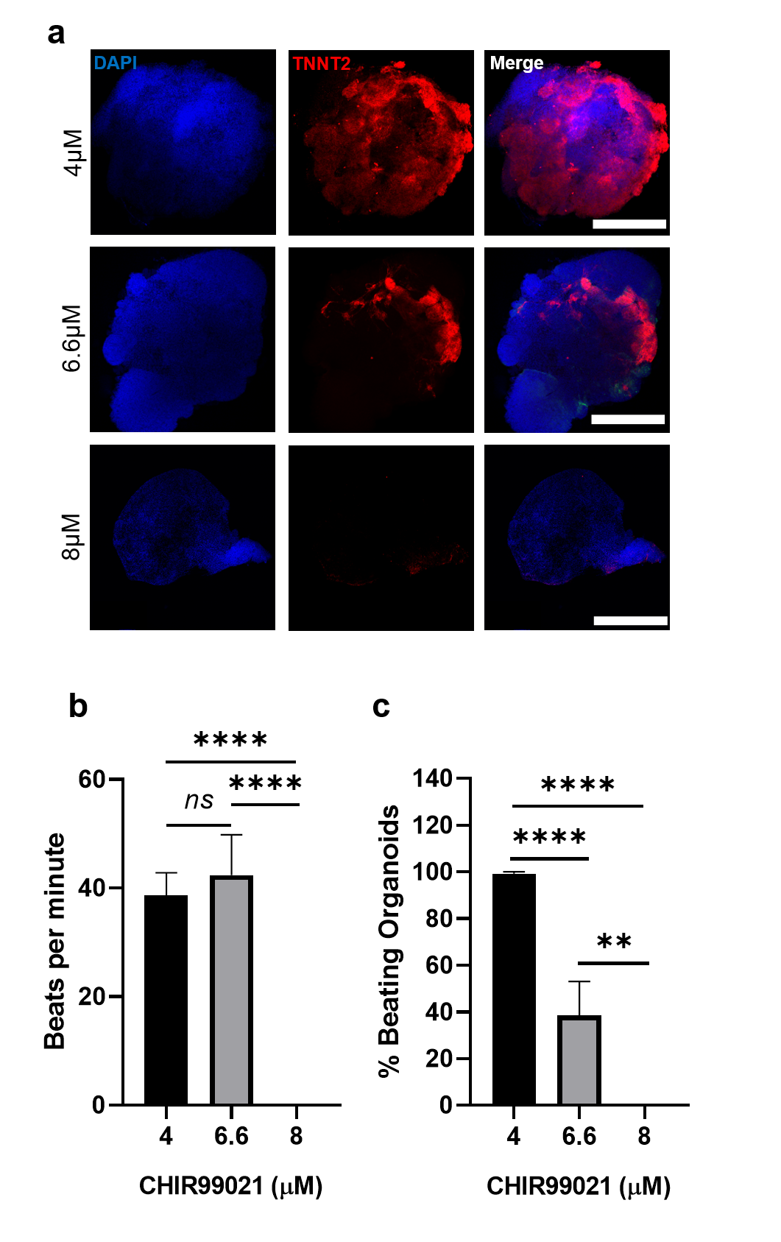

Supplementary Figure 1. a, Confocal immunofluorescent images for DAPI (blue) and TNNT2 (red), in organoids with CHIR99021 exposure concentrations of 4µM (top), 6.6µM (middle), and 8µM (bottom) at day 15. Scale bars, 500µm. b, Frequency of beats per minute of the hHOs and c, percentage of beating hHOs per treatment. (Value = mean ± s.d., 1-way ANOVA multiple comparison test; **p<0.01, ****p<0.0001).

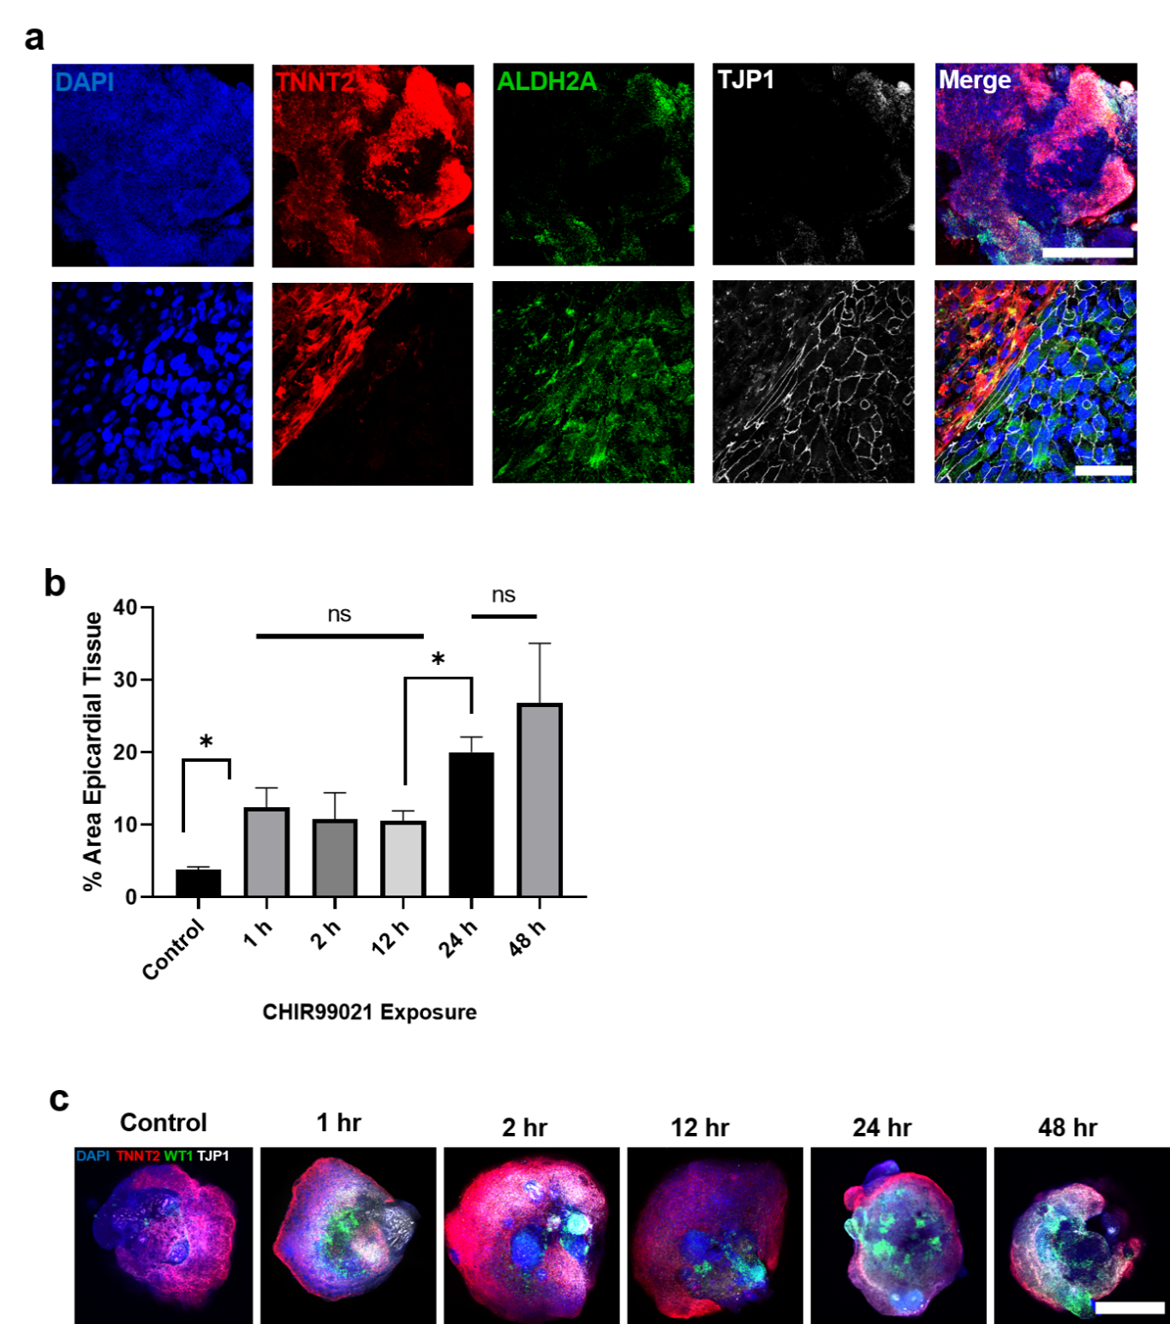
Supplementary Figure 2. a, Confocal immunofluorescent images for DAPI (blue) and TNNT2 (red), in hHOs showing epicardial markers ALDH2A (green) and TJP1 (white) near edge of the organoid. b, Area analysis of cardiomyocyte regions (TNNT2+) and epicardial regions (WT1+ and TJP1+) within organoids taken at multiple z-planes as a percentage of DAPI+ regions of each organoid treated with CHIR99021 at day 7 for different time durations, and c, representative confocal immunofluorescent images of organoids from these time durations: Scale bar: 500 µm. (Value = mean ± s.d., 1-way ANOVA multiple comparison test; *p<0.05).
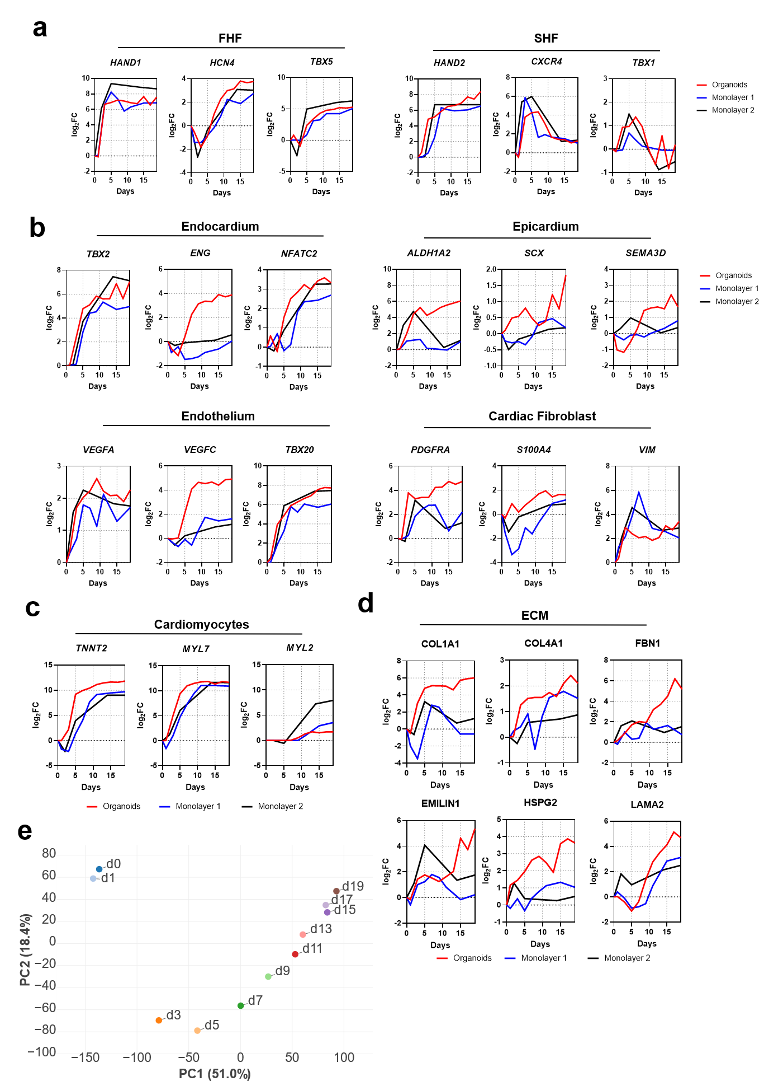
Supplementary Figure 3.a, Gene expression analysis indicating of more first and second heart field markers over heart organoid differentiation process. b, Gene expression analysis (log₂ fold-change vs. D0) for cardiac-specific cell type populations in heart organoids, including (from top left to bottom right) endocardial cells, epicardial cells, endothelium and cardiac fibroblasts. c, Gene expression analysis (log₂ fold-change vs. D0) for cardiomyocyte markers. d, Gene expression analysis (log₂ fold-change vs. D0) for ECM protein coding genes that are present in cardiac tissue. e, Principal component analysis of heart organoid differentiation over time.
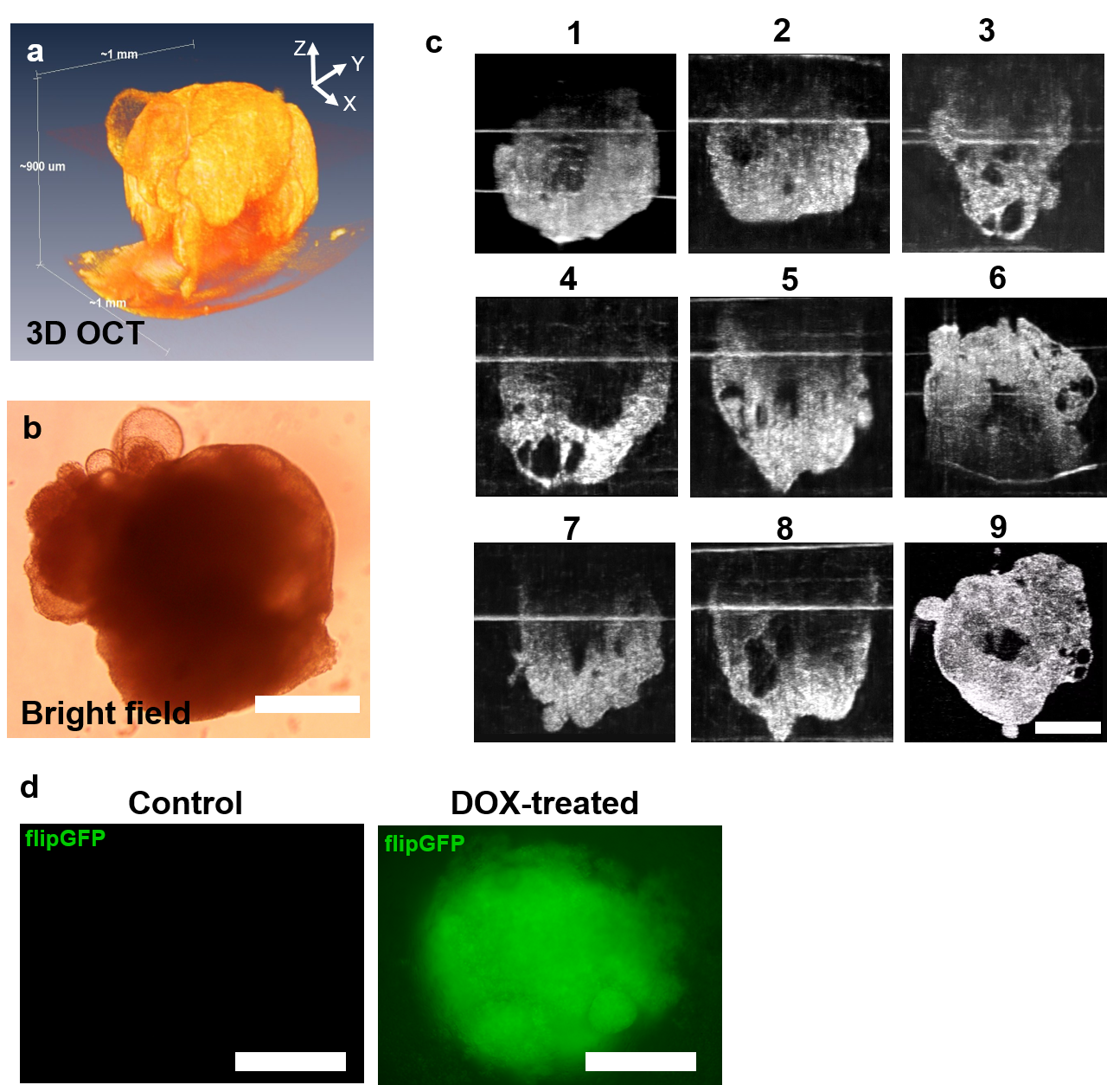
Supplementary Figure 4. a, 3D reconstruction of OCT images and b, bright field image of hHO. c, OCT images showing cross-section of center of 9 different organoids, revealing central chambers; scale bar: 500µm. d, Immunofluorescence images of organoids derived from a flipGFP transgenic iPSC line L1 showing no apoptosis in control hHOs (left) and high apoptosis in hHOs treated with 5µM Doxorubicin (DOX) (right); scale bar: 500µm.

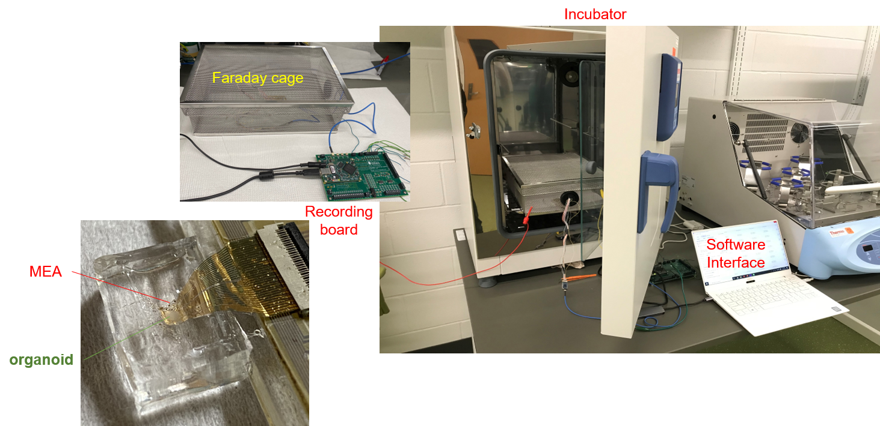
Supplementary Figure 5. Microelectrode array (MEA) recording system showing the gold electrode array in a PDMS chamber where the organoid is placed within a Faraday cage inside an incubator.

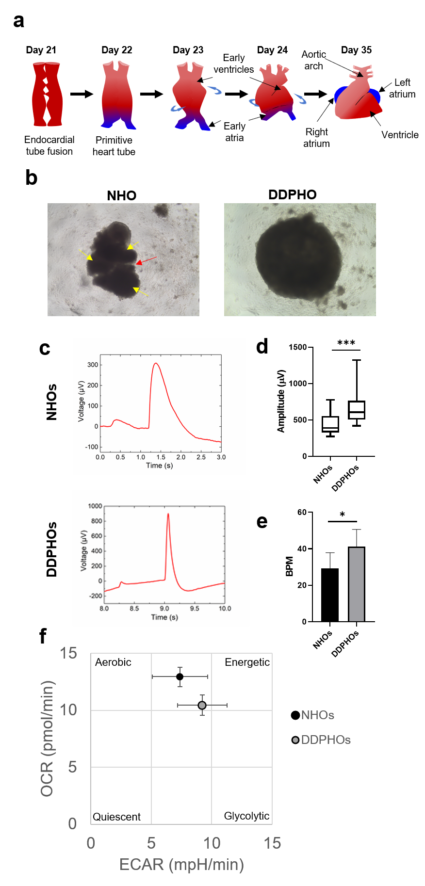
Supplementary Figure 6. Human heart organoids modeling functional features healthy vs diabetic conditions. a, Schematic of heart tube formation and looping into the four chambers of the heart. b, Brightfield image of NHO and DDPHO at day 15 showing segmentation (red arrow) and separate heart regions resembling early heart structures. c, Representative MEA electrophysiology detail of normal vs. diabetic organoids. d, Amplitude magnitude in µV of action potentials in normal and diabetic hHOs (n>12 over 3 replicates per condition; unpaired t-test, ***p<0.001). e, Beating frequency in beats per minute (BPM) in normal and diabetic organoids as recorded by MEA (mean±SD, n>5 organoids; unpaired t-test, *p<0.05,) f, Seahorse energy map of normal and diabetic-like organoids (mean±sd).
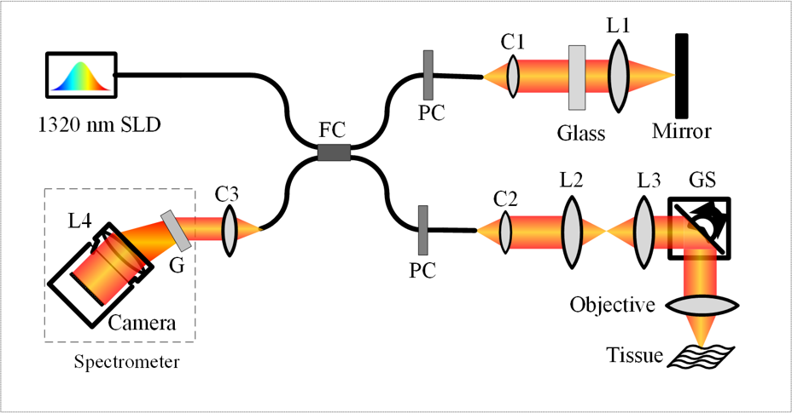
Supplementary Figure 7. Illustration of a custom SD-OCT imaging system, FC: fiber coupler, PC: polarization controller, C1-C3: collimator, L1 - L4: lens, GS: galvo scanner; G: grating.

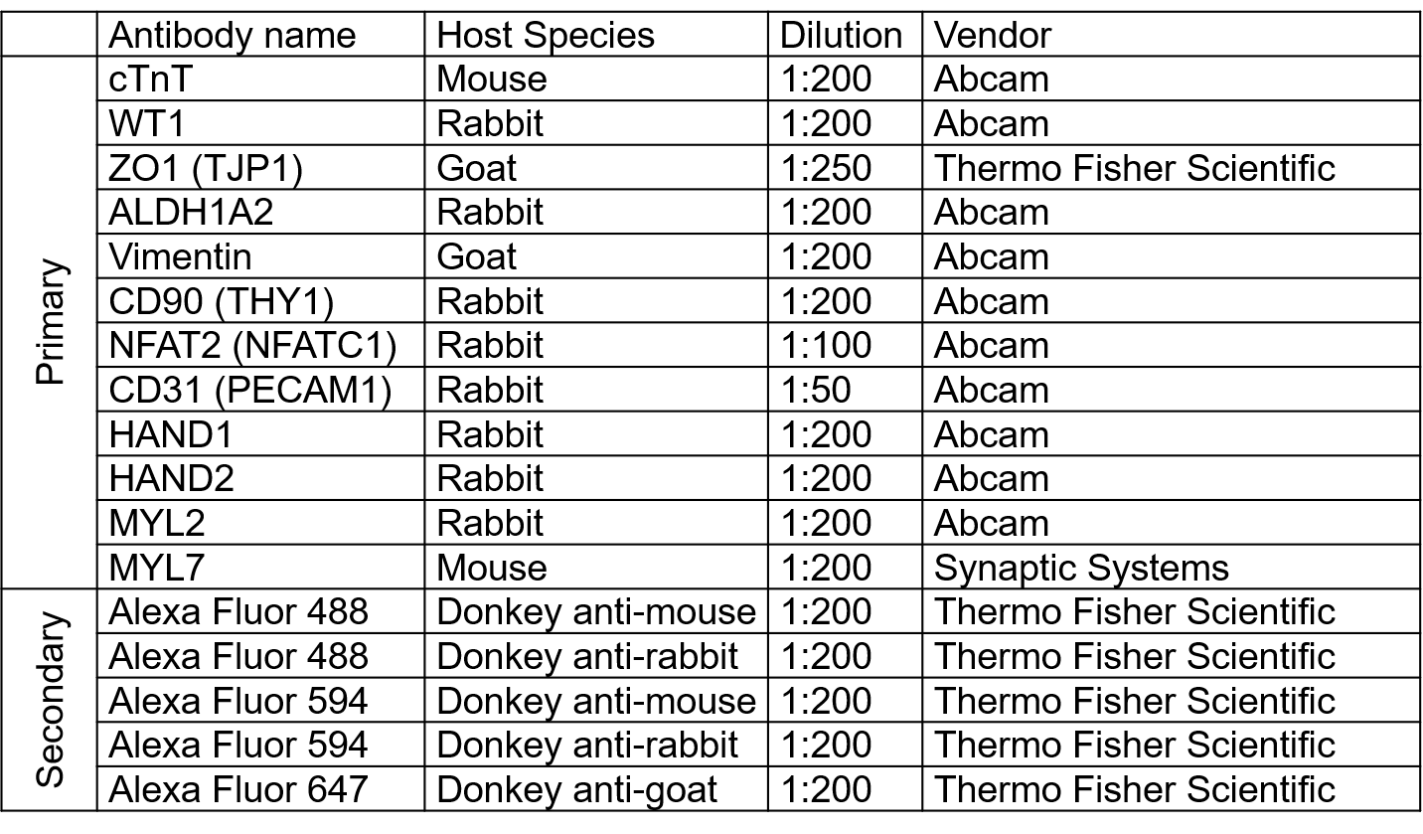
Supplementary Table 2. Antibodies used for immunofluorescence in this report.

