Appendix I
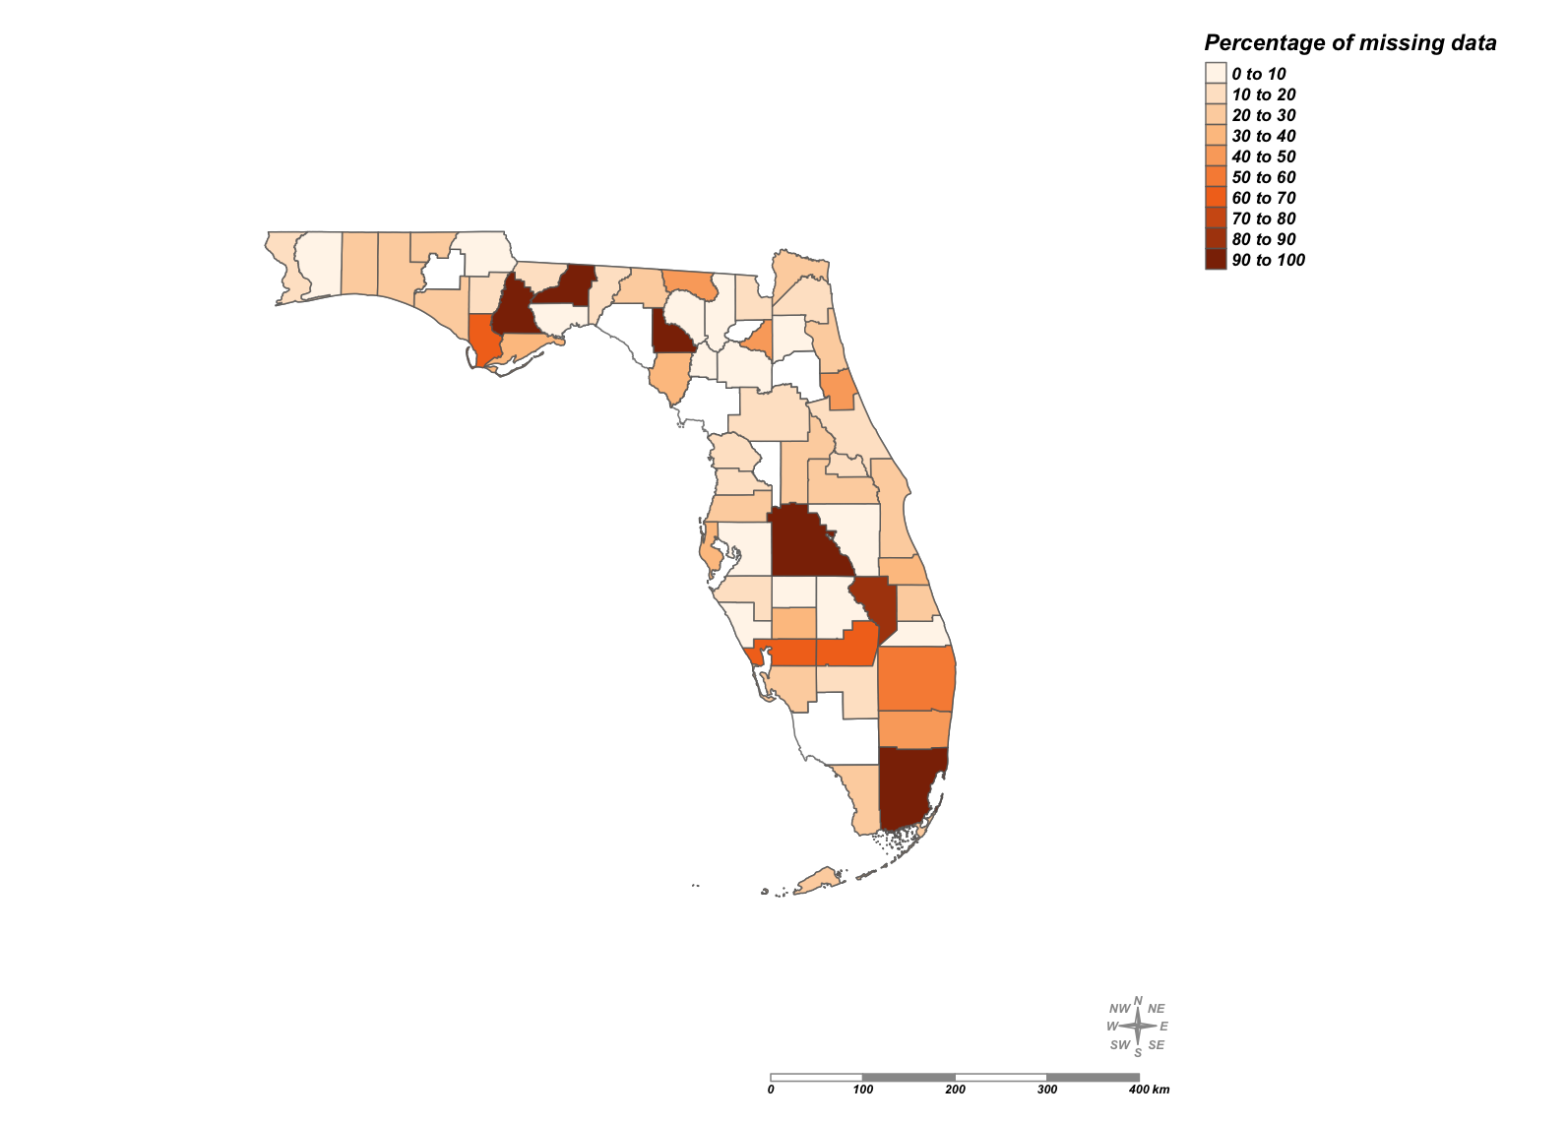

Figure 1. Percentage of missing data at county level

Table 1 Summary of data in Florida
 | Min. | Median | Mean | Max. | SD.
Built year | 1905 | 1970 | 1972 | 2020 | 17.47
Total area of property (square ft) | 240 | 1461 | 5234 | 831358 | 21518.11
Over 65 year old live alone | 0 | 189 | 240.3 | 5285 | 209.90
Black African | 0 | 364 | 806.8 | 11482 | 1137.06
Hispanic or Latino | 0 | 648 | 1285.6 | 14269 | 1650.66
Median Household Income ($) | 9463 | 54176 | 59694 | 250001 | 97609312
Value ($) | 0 | 1069 | 1218.4 | 20222 | 879.99
Total population | 249 | 4524 | 5025 | 39928 | 3033.08
Historical Black African | 0 | 86.0 | 595.5 | 14587.0 | 1303.09

