Use of rare earth elements as tracers for soil–plant transfer of trace elements
Bryan Arbalestrie¹, Julie Falys¹, Nathan Bemelmans¹, Adil Thami¹, Yannick Agnan¹*
¹Earth and Life Institute, Université catholique de Louvain, 1348 Louvain-la-Neuve, Belgium

Electronic supplementary material
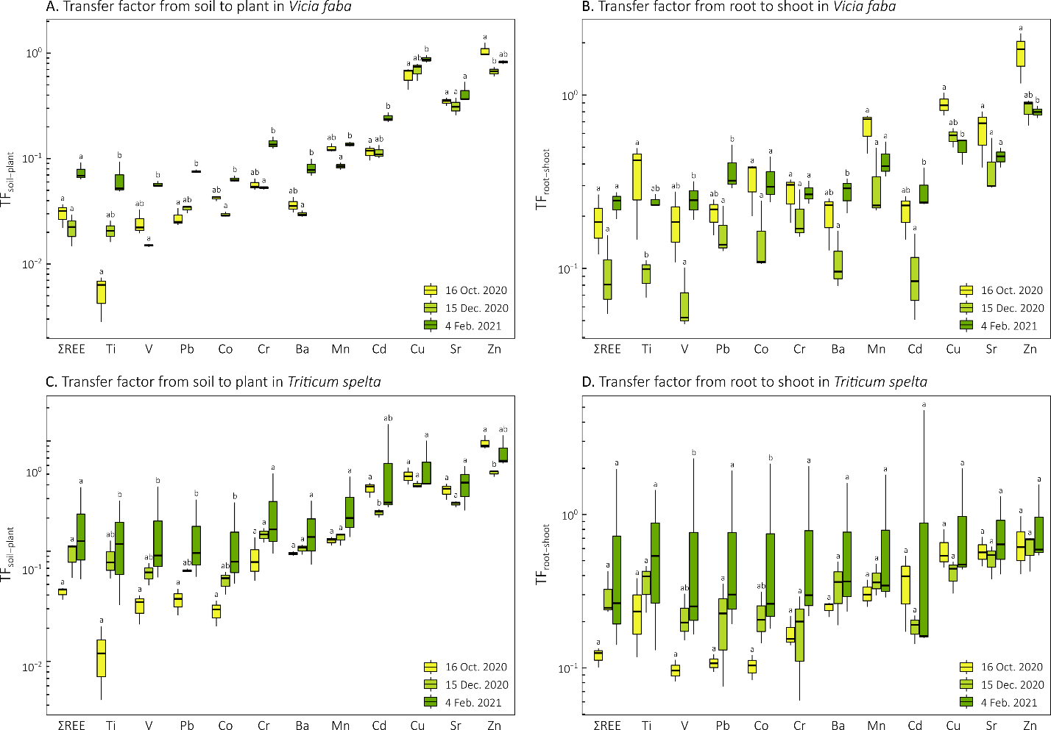
Figure S1. Transfer factors from soil to plant (TF_{soil-plant}; A and C) and from root to shoot (TF_{root-shoot}; B and D) of trace elements and sum of rare earth elements (ΣREE) in bean (Vicia faba; A-B) and spelt (Triticum spelta; C-D) collected at three sampling dates at the centre de Marbaix. Letters indicate statistically significant differences between sampling dates.

