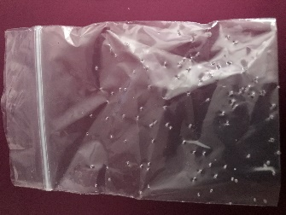  Plate 1: Image to show a plastic bag pierced with holes (Vaghela,2019). | To begin the preparation, a small resealable plastic bag was pierced multiple times with a thin sterile needle, as seen in Plate 1. This is to prepare the bags before putting the substances within and is a crucial process as it reduces direct exposure and ingestion of plant substances whilst still allowing for scent to penetrate through. Direct exposure was avoided during the study due to the lack of extensive research behind the safe dosages of Silver vine and Valerian root.
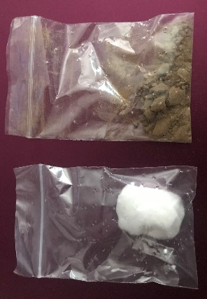  Plate 2: Image to show the plastic bags filled with plant material. (Vaghela,2019). | All dried plant matter (Catnip, Valerian root and Silver vine) was weighed at 1g and all liquid products (Beaphar Catnip Play spray, Valerian spray, Pet Remedy’s Calming spray and water) were measured at 1ml. The three dried substances were inserted into the plastic bags and the four liquids were injected onto a ball of cotton wool, using a sterile syringe, before placing the cotton into the bag, as seen in Plate 2. Each liquid product had its own syringe to reduce cross contamination and a cotton ball was used to reduce vaporisation of the liquid products.
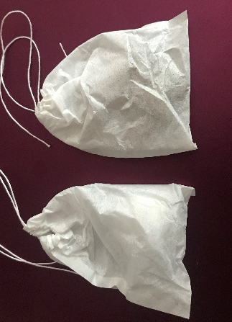  Plate 3: Image to show a plastic bag within tea bags (Vaghela,2019). | Once the plastic bag was filled with the products, it was then sealed before placing it inside a tea bag made of filter paper (see Plate 3). This process ensures than any product escaping from the small holes in the plastic bag stay encased and limits direct exposure. The filter paper was also an ideal material as it still allowed for the scent to penetrate through.
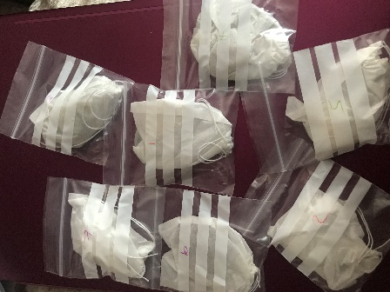  Plate 4: Image to show all tea bags filled with plant materials within another sealed plastic bag (Vaghela,2019). | The tea bag was then placed inside another plastic bag which was airtight and sealed to eliminate the chances of cross contamination. All the bags were numbered from 1 to 7 (see Plate 4) according to the material, as this reduces the chance of experimental bias. Experimental bias could occur in the study if any person conducting the experiment recognises the plant material and unwittingly encourage the cat to react (Kronsnick, 1999).  The researcher created the bags in intervals and ensured that all bags were used within a two-week time frame from creation. Although the products were airtight and sealed, this was an additional measure taken to ensure the products remained fresh, so the scent did not diminish due to time.
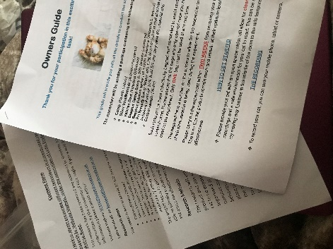  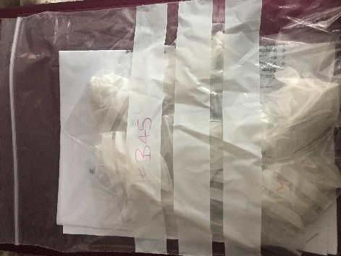  Plate 6: Image to show consent form and owners guide within each package (Vaghela,2019).  Plate 5: Image to show a package of bags and relevant paperwork ready for each cat (Vaghela,2019). | Once all bags are sealed, all seven samples are placed into one large bag (see Plate 5) equipped with a consent form and owners guide (see appendix x; Plate 6) which provides instructions for pet owners.

