Additional File, Table 1. Characteristics of Included Studies
Author, year, and (country of study) | Type of Study | Population | Demographics | % of women | Results stratified by gender | Type of Job Tasks specified | Confounders Adjusted | Description and measures Exposures | Description and Measures of outcome
Alzahrani 2019[1]  (England & Scotland) | Cross-sectional Study | Adults >/ 16 years. 32,087 women | Mean age=45.7years,  BMI, smoking status, education, ethnicity, employment status | Yes  50% | No | Tidying, cleaning, scrubbing and gardening | Age, Sex, smoking status, ethnicity, BMI, education, occupation, employment status, other physical activities (exercise) | OR, Low (<3.8) versus high (>=12.1) domestic activity (MET h/week). Low versus high/Work intensity | Chronic back pain
Ahlgren, 2012[2]  (Sweden) | Cross-sectional Study | Working women in blue-collar (253) and white-collar jobs (262) | Mean age=40.7 years (white collar), 44.3 years (blue-collar), education, family situation, employment status and working hours | Yes | Yes | Cleaning, carrying children, coking, washing clothes, regular shopping, washing dishes | Age, smoking, number of children, employment hours, blue collar work | OR, High versus low Engagement in domestic chores and caring for children/ Work frequency | Three months prevalence of Self-reported low back disorders
Fong, 2008[3] (Hong Kong) | Cross-sectional Study | 153 full time homemakers | Mean age=41.7 years, marital status, education, years in household work, number of children | Yes, 100 | NA | Carrying children, washing clothes, washing dishes, shopping | Demographics, other daily recreational activities | OR, Domestic activity (mean hours spent shopping& washing utensils)/ Time | 12-months prevalence of Self-perceived discomfort in the lower back
Geere, 2018[4]  (South Africa, Ghana and Vietnam) | Cross-sectional Survey | 789 women | Mean age= 29.7 years, type of water supply, general health functioning and disability | Yes  53.6 | No | Carrying water | Age and Sex | RR, History of water carriage (No history versus currently carries water)/Biomechanical | Upper back pain
Habib, 2012[5] (Lebanon) | Cross-sectional Study | 331 full time homemakers | Age, education, household income, size, number of children, smoking status | Yes, 100 | NA | Cleaning, carrying children, cooking, shopping | Age, education, paid work, income, household size | OR, working occasionally in Non-neutral versus Working all the time in Non-neutral postures (bending, kneeling and squatting) /Biomechanical | 12-months prevalence of low back pain
Habib, 2015[6] (Bangladesh) | Cross-sectional Study | 73 housewives | Age=20-45 years, education, | Yes, 100 | NA | Cooking, washing dishes, sweeping, collecting /carrying water. | None | OR, Trunk Flexion >45 degrees for more than 2 hours total per day/Biomechanical | 12-months prevalence of low back pain
Hubscher, 2014[7] (Australia) | Cross-sectional Study | 486 twins (277 females), ages 18-65 years. | Age, sex, smoking history | Yes, 57 | No | Vigorous gardening or heavy work around the yard | Age, Sex and smoking history | OR, Total time spent in domestic PA dichotomized as (more than 2 hours, less than 2 hours) | 1-month prevalence of self-reported Low Back pain
Josephson  2003[8] (Sweden) | Case-Control Study | 320 cases with low back pain  873 controls | Age, number of children, income, type of occupation, number of children | Yes, 100 | NA | Cleaning, carrying children, maintenance work, care of elderly parents | Psychosocial and physical factors of paid work, socio-demographic factors, and previous symptoms of LBP in the past three months | RR, Far too much and too little time on domestic work per day/Time | Clinically diagnosed low back pain
Rosano, 2004[9] (Italy) | Cross-sectional | 317 people, mean age=48.7 years, education, occupation | Sex, age, education | Yes, 96 | No | Making beds sewing cooking, cleaning, washing clothes/utensils, care giving, pet care | Age, education and occupation | OR, Self-reported frequency of domestic task per week/ Frequency | Self-reported low back pain
Malta  (2017)[10]  Brazil | Cross-sectional | 64,348 households | Age, education, race, residence, smoking, alcohol, BMI | No (can’t tell) | Yes | Heavy physical work at home, time spent on heavy physical activity at home | Age and education | OR, heavy physical domestic activity (Yes or No), /work intensity | Self-reported chronic back pain
Ranasinghe (2016)[11]  Sri Lanka | Cross-sectional | 1102 housewives | Age, marital status, number of children under-5, house ownership status, | Yes, 100 | NA | Cooking, handwash clothes, ironing, sweeping, shopping, childcare, cleaning | Child <5, married more than 10years, family income, self-rated health, psychosocial factors, long term illness | OR, working occasionally awkward versus working all the time in awkward postures/ Biomechanical | Self-reported low back pain

Additional File, Table 2. Risk of Bias and Overall Quality Rating using the New Castle Ottawa Scale

Study | Study design | Selection | Comparability | Exposure/outcome |  | Overall score | Quality
Alzaharani 2019 | Cross-sectional | **** | ** | ** | 8 |  | High
Geere 2018 | Cross-sectional | *** | ** | ** | 7 |  | Moderate
Ahlgren 2012 | Cross-sectional | **** | ** | ** | 8 |  | High
Hubscher 2014 | Cross-sectional | **** | ** | ** | 8 |  | High
Habib 2015 | Cross-sectional | *** | None | ** | 5 |  | Low
Habib 2012 | Cross sectional | **** | ** | ** | 8 |  | High
Josephson 2003 | Case-Control | *** | ** | ** | 7 |  | Moderate
Fong 2008 | Cross-sectional | ** | ** | ** | 6 |  | Moderate
Rosano 2004 | Cross-sectional | **** | * | ** | 7 |  | Moderate
Malta 2017 | Cross-sectional | **** | ** | ** | 8 |  | High
Ranasinghe 2016 | Cross-sectional | **** | ** | ** | 8 |  | High

Additional File, Table 3. Quantifying Heterogeneity Between Study Sub-Groups

Sub-Groups | Q-Statistic | p-value
Country Status | 11.16 | 0.0008
Exposure Definition | 7.48 | 0.02
Women-Specific Population | 0.54 | 0.46

Additional File, Table 4. Excluded Studies
Excluded Studies | Reason for Exclusion
Apostoli et al. 2012[12]; Sanders and Morse, 2005[13]; Vincent and Hocking 2013[14] | Did not present means to calculate effect estimates
Backhausen et al. 2019[15]; Biglarian et al. 2012[16] | Only pregnant women
Mundt et al. 1993[17] | Included a sample of women comprising <50% of the total sample
Altinel et al. 2008[18]; Fazli et al. 2016[19]; Gupta and Nandini 2015[20]; Kalra and Bhatnagar 2017[21] | Defined exposures based on a women’s role but not the PDDW
Croft et al. 1999[22]; Takahashi et al. 2018[23]; Yip et al. 2004[24] | Focused on or included elderly women
Cavallari et al. 2016[25]; Cheung et al. 2006[26]; Krause et al. 2005[27] | Focused on paid housekeeping
Kopec et al. 2004[28]; Picavet and Schouten 2000[29] | Did not describe the types of domestic tasks
Cezar-Vaz et al. 2015[30]; Fernández et al. 2000[31] | Focused on other health outcomes
S. Mattioli et al. 2009[32]; Tang et al. 1999[33] | Focused on MSDs besides BP

Additional File, Figure 1. Baujat Plot showing significant contribution to heterogeneity by Alzaharani 2019 (top-right corner)

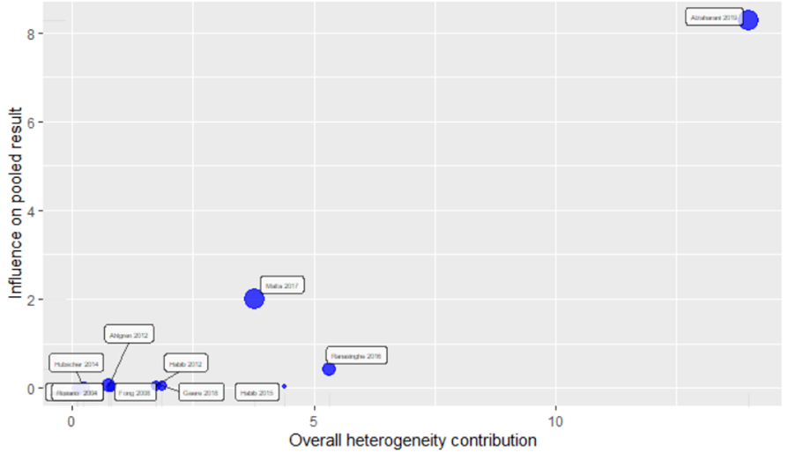

Additional File, Figure 2. Forest Plot with each study’s contribution to heterogeneity, omitted one at a time.

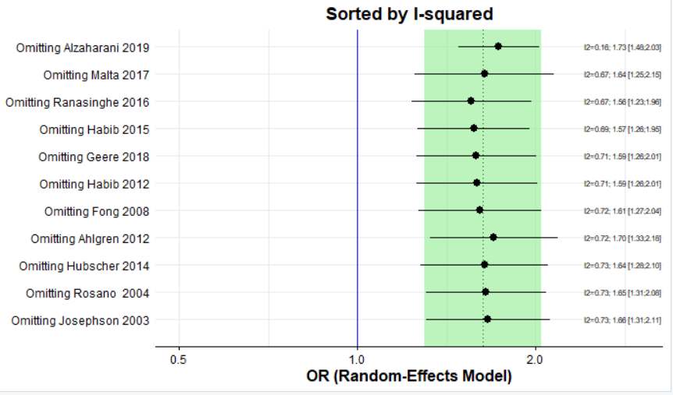

Additional File, Figure 3. Forest plot showing sensitivity analysis of high-quality studies, investigating the association between physically demanding domestic work and back pain in women

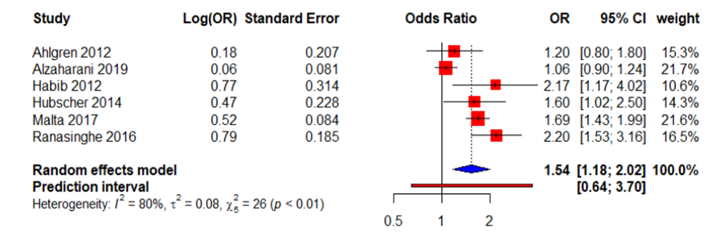

Additional File, Figure 4. Funnel plot

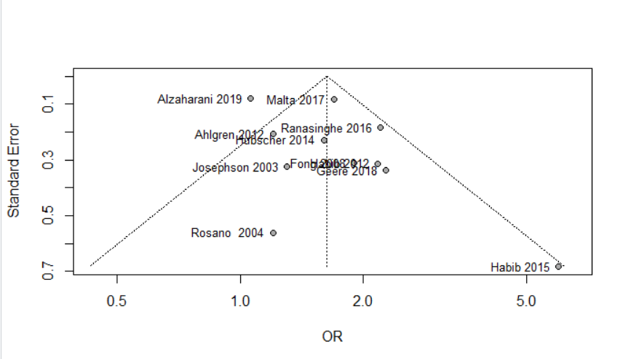

Additional File, Appendix
PubMed
Population: Housekeepers [All Fields] OR ("housekeeping"[MeSH Terms] OR "housekeeping"[All Fields] OR "housework"[All Fields]) OR homecare [All Fields] OR "domestic"[All Fields]) OR housewives [All Fields]
Outcome:(Musculoskeletal[All Fields] AND ("injuries"[Subheading] OR "injuries"[All Fields] OR "wounds and injuries"[MeSH Terms] OR ("wounds"[All Fields] AND "injuries"[All Fields]) OR "wounds and injuries"[All Fields])) OR ("musculoskeletal diseases"[MeSH Terms] OR ("musculoskeletal"[All Fields] AND "diseases"[All Fields]) OR "musculoskeletal diseases"[All Fields] OR ("musculoskeletal"[All Fields] AND "disorders"[All Fields]) OR "musculoskeletal disorders"[All Fields]) OR ("occupational injuries"[MeSH Terms] OR ("occupational"[All Fields] AND "injuries"[All Fields]) OR "occupational injuries"[All Fields]) OR (("upper extremity"[MeSH Terms] OR ("upper"[All Fields] AND "extremity"[All Fields]) OR "upper extremity"[All Fields]) AND ("injuries"[Subheading] OR "injuries"[All Fields] OR (("lower extremity"[MeSH Terms] OR ("lower"[All Fields] AND "extremity"[All Fields]) OR "lower extremity"[All Fields]) AND ("injuries"[Subheading] OR "injuries"[All Fields] OR "pain"[All Fields]) OR ("back pain"[MeSH Terms] OR ("low"[All Fields] AND "back"[All Fields] AND "pain"[All Fields]) OR "low back pain"[All Fields])
Exposure:(("ergonomics"[MeSH Terms] OR "ergonomics"[All Fields] OR "ergonomic"[All Fields]) AND ("risk"[MeSH Terms] OR "risk"[All Fields])) OR (("physical examination"[MeSH Terms] OR ("physical"[All Fields] AND "examination"[All Fields]) OR "physical examination"[All Fields] OR "physical"[All Fields]) AND load[All Fields]) OR ("lifting"[MeSH Terms] OR "lifting"[All Fields]) OR ("lifting"[MeSH Terms] OR "lifting"[All Fields] OR "carrying"[All Fields]) OR (("manuals as topic"[MeSH Terms] OR ("manuals"[All Fields] AND "topic"[All Fields]) OR "manuals as topic"[All Fields] OR "manual"[All Fields]) AND task[All Fields]) OR (("physical examination"[MeSH Terms] OR ("physical"[All Fields] AND "examination"[All Fields]) OR "physical examination"[All Fields] OR "physical"[All Fields]) AND ("risk"[MeSH Terms] OR "risk"[All Fields])) OR ("posture"[MeSH Terms] OR "posture"[All Fields])

Embase:
('housewife'/exp OR housewife OR 'housekeeping'/exp OR housekeeping OR 'cleaning'/exp OR cleaning OR 'household'/exp OR household OR 'home care'/exp OR 'home care' OR 'caregiver burden'/exp OR 'caregiver burden') AND ('musculoskeletal disease'/exp OR 'musculoskeletal disease' OR 'musculoskeletal pain'/exp OR 'musculoskeletal pain' OR 'injury'/exp OR injury OR 'occupational disease'/exp OR 'occupational disease' OR 'ergonomics'/exp OR ergonomics OR 'physical load'/exp OR 'physical load' OR (physical AND ('load'/exp OR load)) OR 'weight bearing'/exp OR 'weight bearing' OR 'manual labor'/exp OR 'manual labor' OR 'biomechanics'/exp OR biomechanics OR 'load carrying capacity'/exp OR 'load carrying capacity') AND 'human'/de AND ('cohort analysis'/de OR 'cross-sectional study'/de OR 'longitudinal study'/de OR 'prospective study'/de OR 'questionnaire

REFERENCES

1. Alzahrani H, Shirley D, Cheng SWM, Mackey M, Stamatakis E: Physical activity and chronic back conditions: A population-based pooled study of 60,134 adults. Journal of Sport and Health Science 2019.
2. Ahlgren C, Malmgren Olsson EB, Brulin C: Gender analysis of musculoskeletal disorders and emotional exhaustion: interactive effects from physical and psychosocial work exposures and engagement in domestic work. Ergonomics 2012, 55(2):212-228.
3. Fong KN, Law CY: Self-perceived musculoskeletal complaints: relationship to time use in women homemakers in Hong Kong. J Occup Rehabil 2008, 18(3):273-281.
4. Geere JA, Bartram J, Bates L, Danquah L, Evans B, Fisher MB, Groce N, Majuru B, Mokoena MM, Mukhola MS et al: Carrying water may be a major contributor to disability from musculoskeletal disorders in low income countries: a cross-sectional survey in South Africa, Ghana and Vietnam. Journal of global health 2018, 8(1):010406.
5. Habib RR, El Zein K, Hojeij S: Hard work at home: musculoskeletal pain among female homemakers. Ergonomics 2012, 55(2):201-211.
6. Habib MM, Rahman SU: Musculoskeletal symptoms (MSS) and their associations with ergonomic physical risk factors of the women engaging in regular rural household activities: A picture from a rural village in Bangladesh. Work (Reading, Mass) 2015, 50(3):347-356.
7. Hubscher M, Ferreira ML, Junqueira DR, Refshauge KM, Maher CG, Hopper JL, Ferreira PH: Heavy domestic, but not recreational, physical activity is associated with low back pain: Australian Twin low BACK pain (AUTBACK) study. Eur Spine J 2014, 23(10):2083-2089.
8. Josephson M, Ahlberg G, Harenstam A, Svensson H, Theorell T, Wiktorin C, Vingard E: Paid and unpaid work, and its relation to low back and neck/shoulder disorders among women. Women & health 2003, 37(2):17-30.
9. Rosano A, Moccaldi R, Cioppa M, Lanzieri G, Persechino B, Spagnolo A: [Musculoskeletal disorders and housework in Italy]. Annali di igiene : medicina preventiva e di comunita 2004, 16(3):497-507.
10. Malta DC, Oliveira MM, Andrade S, Caiaffa WT, Souza MFM, Bernal RTI: Factors associated with chronic back pain in adults in Brazil. Rev Saude Publica 2017, 51(suppl 1):9s.
11. Ranasinghe PD, Atukorala I, Samaranayake A, Gunawardana NS: SAT0504 Prevalence and Correlates of Household Work Related Musculoskeletal Disorders in Low Back Region among Sri Lankan Housewives. Annals of the Rheumatic Diseases 2016, 75(Suppl 2):852-852.
12. Apostoli P, Sala E, Curti S, Cooke RM, Violante FS, Mattioli S: Loads of housework? Biomechanical assessments of the upper limbs in women performing common household tasks. Int Arch Occup Environ Health 2012, 85(4):421-425.
13. Sanders MJ, Morse T: The Ergonomics of Caring for Children: An Exploratory Study. American Journal of Occupational Therapy 2005, 59(3):285-295.
14. Vincent R, Hocking C: Factors that might give rise to musculoskeletal disorders when mothers lift children in the home. Physiother Res Int 2013, 18(2):81-90.
15. Backhausen MG, Bendix JM, Damm P, Tabor A, Hegaard HK: Low back pain intensity among childbearing women and associated predictors. A cohort study. Women Birth 2019, 32(4):e467-e476.
16. Biglarian A, Seifi B, Bakhshi E, Mohammad K, Rahgozar M, Karimlou M, Serahati S: Low back pain prevalence and associated factors in Iranian population: findings from the national health survey. Pain Res Treat 2012, 2012:653060.
17. Mundt DJ, Kelsey JL, Golden AL, Pastides H, Berg AT, Sklar J, Hosea T, Panjabi MM: An epidemiologic study of non-occupational lifting as a risk factor for herniated lumbar intervertebral disc. The Northeast Collaborative Group on Low Back Pain. Spine 1993, 18(5):595-602.
18. Altinel L, Kose KC, Ergan V, Isik C, Aksoy Y, Ozdemir A, Toprak D, Dogan N: [The prevalence of low back pain and risk factors among adult population in Afyon region, Turkey]. Acta orthopaedica et traumatologica turcica 2008, 42(5):328-333.
19. Fazli B, Ansari H, Noorani M, Jafari SM, Sharifpoor Z, Ansari S: The Prevalence of Musculoskeletal Disorders and its Predictors among Iranians’ Housewives. International Journal of Epidemiologic Research 2016, 3(1):53-62.
20. Gupta G, Nandini N: Prevalence of low back pain in non working rural housewives of Kanpur, India. International journal of occupational medicine and environmental health 2015, 28(2):313-320.
21. Kalra S, Bhatnagar B: Prevalence of Musculoskeletal Disorder among Housewives. In: 2017; 2017.
22. Croft PR, Papageorgiou AC, Thomas E, Macfarlane GJ, Silman AJ: Short-term physical risk factors for new episodes of low back pain. Prospective evidence from the South Manchester Back Pain Study. Spine 1999, 24(15):1556-1561.
23. Takahashi A, Kitamura K, Watanabe Y, Kobayashi R, Saito T, Takachi R, Kabasawa K, Oshiki R, Tsugane S, Iki M et al: Epidemiological profiles of chronic low back and knee pain in middle-aged and elderly japanese from the Murakami cohort. Journal of Pain Research 2018, 11:3161-3169.
24. Yip YB, Ho SC, Chan SG: Identifying risk factors for low back pain (LBP) in Chinese middle-aged women: a case-control study. Health care for women international 2004, 25(4):358-369.
25. Cavallari JM, Ahuja M, Dugan AG, Meyer JD, Simcox N, Wakai S, Garza JL: Differences in the prevalence of musculoskeletal symptoms among female and male custodians. American journal of industrial medicine 2016, 59(10):841-852.
26. Cheung K, Gillen M, Faucett J, Krause N: The prevalence of and risk factors for back pain among home care nursing personnel in Hong Kong. American Journal of Industrial Medicine 2006, 49(1):14-22.
27. Krause N, Scherzer T, Rugulies R: Physical workload, work intensification, and prevalence of pain in low wage workers: Results from a participatory research project with hotel room cleaners in Las Vegas. American Journal of Industrial Medicine 2005, 48(5):326-337.
28. Kopec JA, Sayre EC, Esdaile JM: Predictors of Back Pain in a General Population Cohort. Spine 2004, 29(1):70-77.
29. Picavet HS, Schouten JS: Physical load in daily life and low back problems in the general population-The MORGEN study. Preventive medicine 2000, 31(5):506-512.
30. Cezar-Vaz MR, Bonow CA, da Silva MR: Mental and Physical Symptoms of Female Rural Workers: Relation between Household and Rural Work. International journal of environmental research and public health 2015, 12(9):11037-11049.
31. Fernández E, Schiaffino A, Martí M: Influencia del trabajo doméstico sobre la salud y la utilización de servicios sanitarios en mujeres con trabajo remunerado y amas de casa. Gaceta Sanitaria 2000, 14(4):287-290.
32. Mattioli S, Baldasseroni A, Bovenzi M, Curti S, Cooke RMT, Campo G, Barbieri PG, Ghersi R, Broccoli M, Cancellieri MP et al: Risk factors for operated carpal tunnel syndrome: a multicenter population-based case-control study. BMC public health 2009, 9:343-343.
33. Tang X, Zhuang L, Lu Z: Carpal tunnel syndrome: a retrospective analysis of 262 cases and a one to one matched case-control study of 61 women pairs in relationship between manual housework and carpal tunnel syndrome. Chinese medical journal 1999, 112(1):44-48.

