Supplementary information

De novo identification of complex multimorbid conditions by integration of gene regulation and protein interaction networks with genome-wide association studies
Roan E. Zaied¹, Tayaza Fadason^{1,2}, Justin M. O’Sullivan^{1,2,3,4 *}
¹ The Liggins Institute, The University of Auckland, Auckland, Private Bag 92019, New Zealand
² The Maurice Wilkins Centre, The University of Auckland, Auckland, Private Bag 92019, New Zealand
³ Australian Parkinsons Mission, Garvan Institute of Medical Research, Sydney, New South Wales, 384 Victoria Street, Darlinghurst NSW 2010, Australia
⁴ MRC Lifecourse Epidemiology Unit, University of Southampton, Southampton, SO16 6YD, United
Kingdom
* To whom correspondence should be addressed: justin.osullivan@auckland.ac.nz
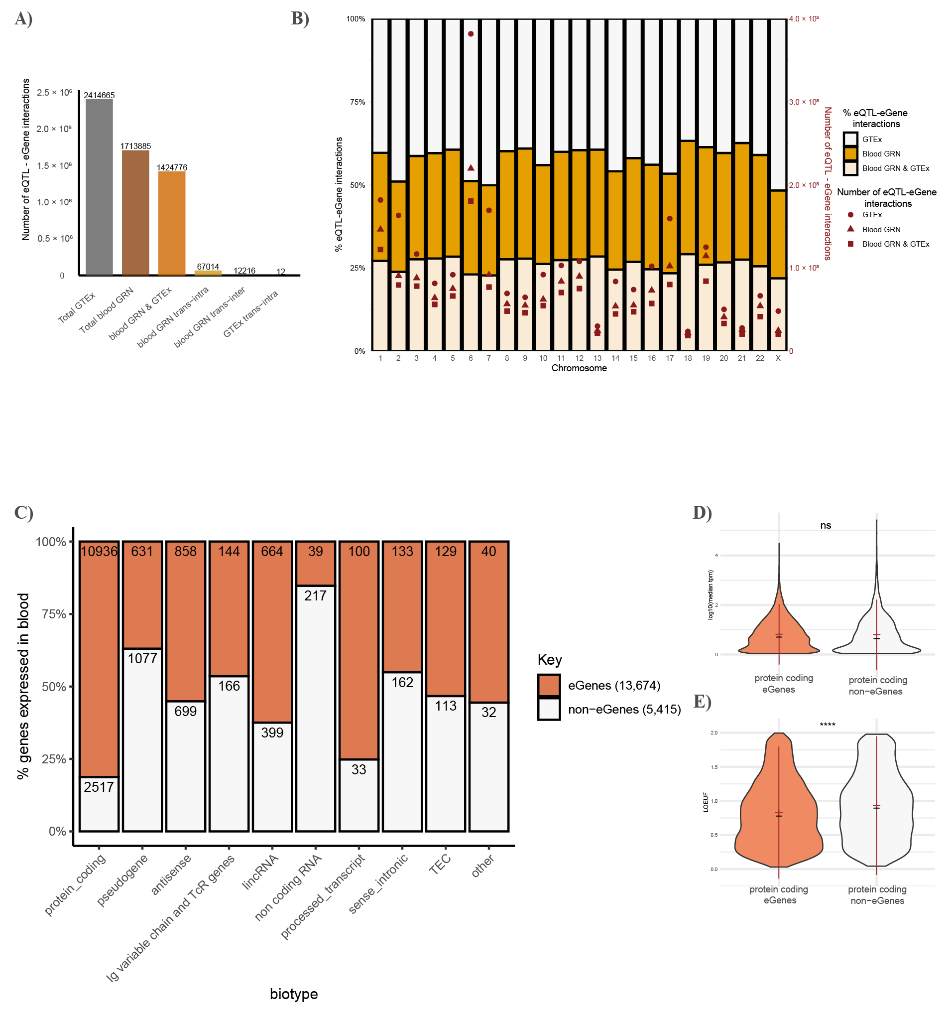
Supplementary Figure 1. Protein coding eGenes are significantly more intolerant to loss of function compared to protein coding non-eGenes. A) Number of eQTL-eGene interactions in GTEx v8 compared to spatial eQTL-eGene interactions seen in whole blood, classified by interaction type. B) Proportion of eQTL-eGene interactions across chromosomes. C) Proportion of non-eGenes and statistically significant eGenes expressed in whole blood (median TPM >0.1) classified by biotype. D) expression level and E) tolerance to loss of function of protein coding eGenes and non-eGenes expressed in whole blood. In both D and E, the mean is shown in red while the median is shown in black. NS, not significant, t test (****P <1 × 10−4).
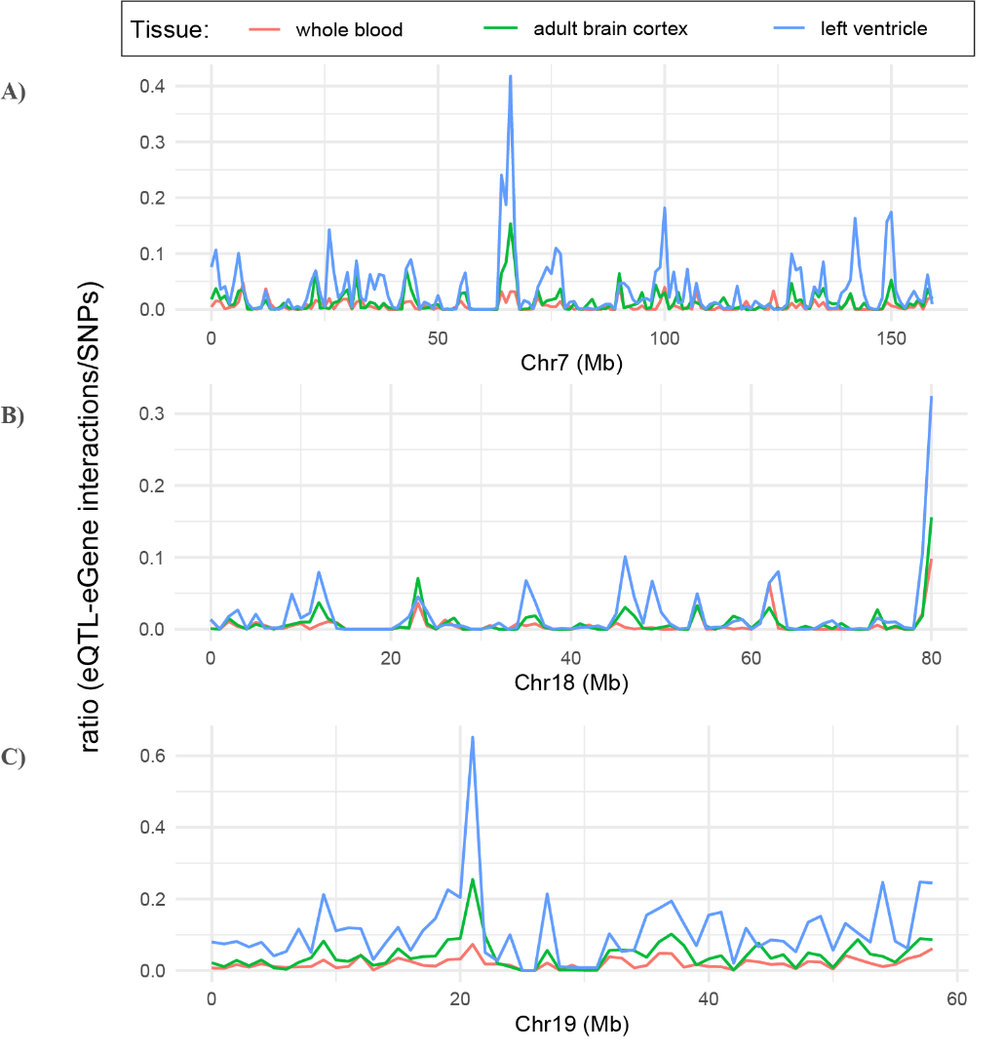
Supplementary Figure 2. Tissue-specific spikes in the ratio of eQTL-eGene interactions to SNPs seen in chromosomes 7, 18 and 19. Ratio of whole blood, adult brain, and left ventricle spatial eQTL-eGene interactions to SNPs across A) chromosome 7, B) chromosome 18 and C) chromosome 19.
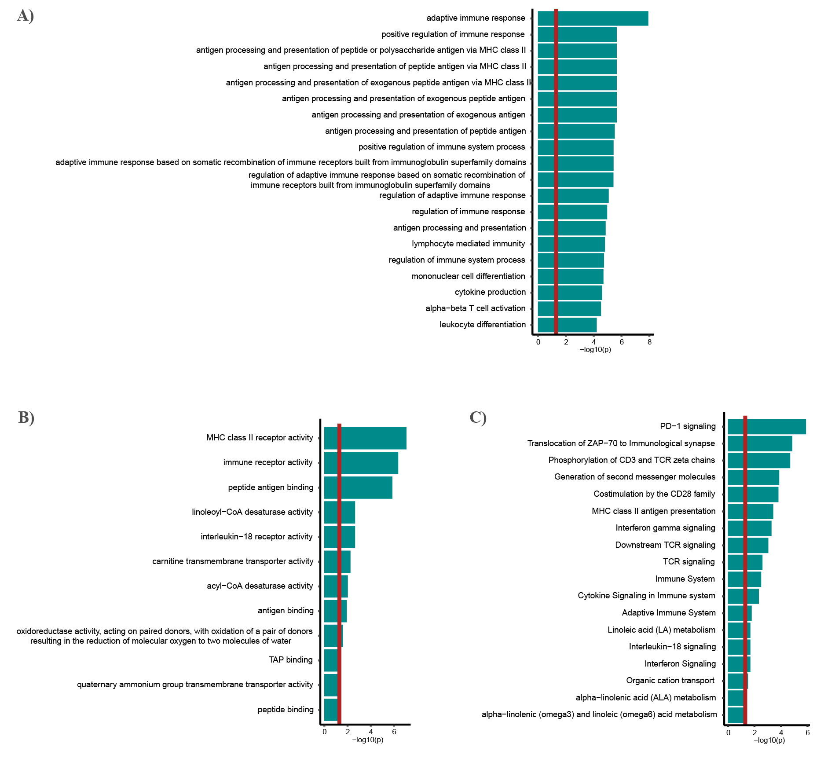
Supplementary Figure 3. Asthma eGenes are enriched for immune-related processes and lipid metabolism. GO enrichment analysis of asthma eGenes having significant enrichment of A) biological processes B) molecular functions and C) reactome pathways.
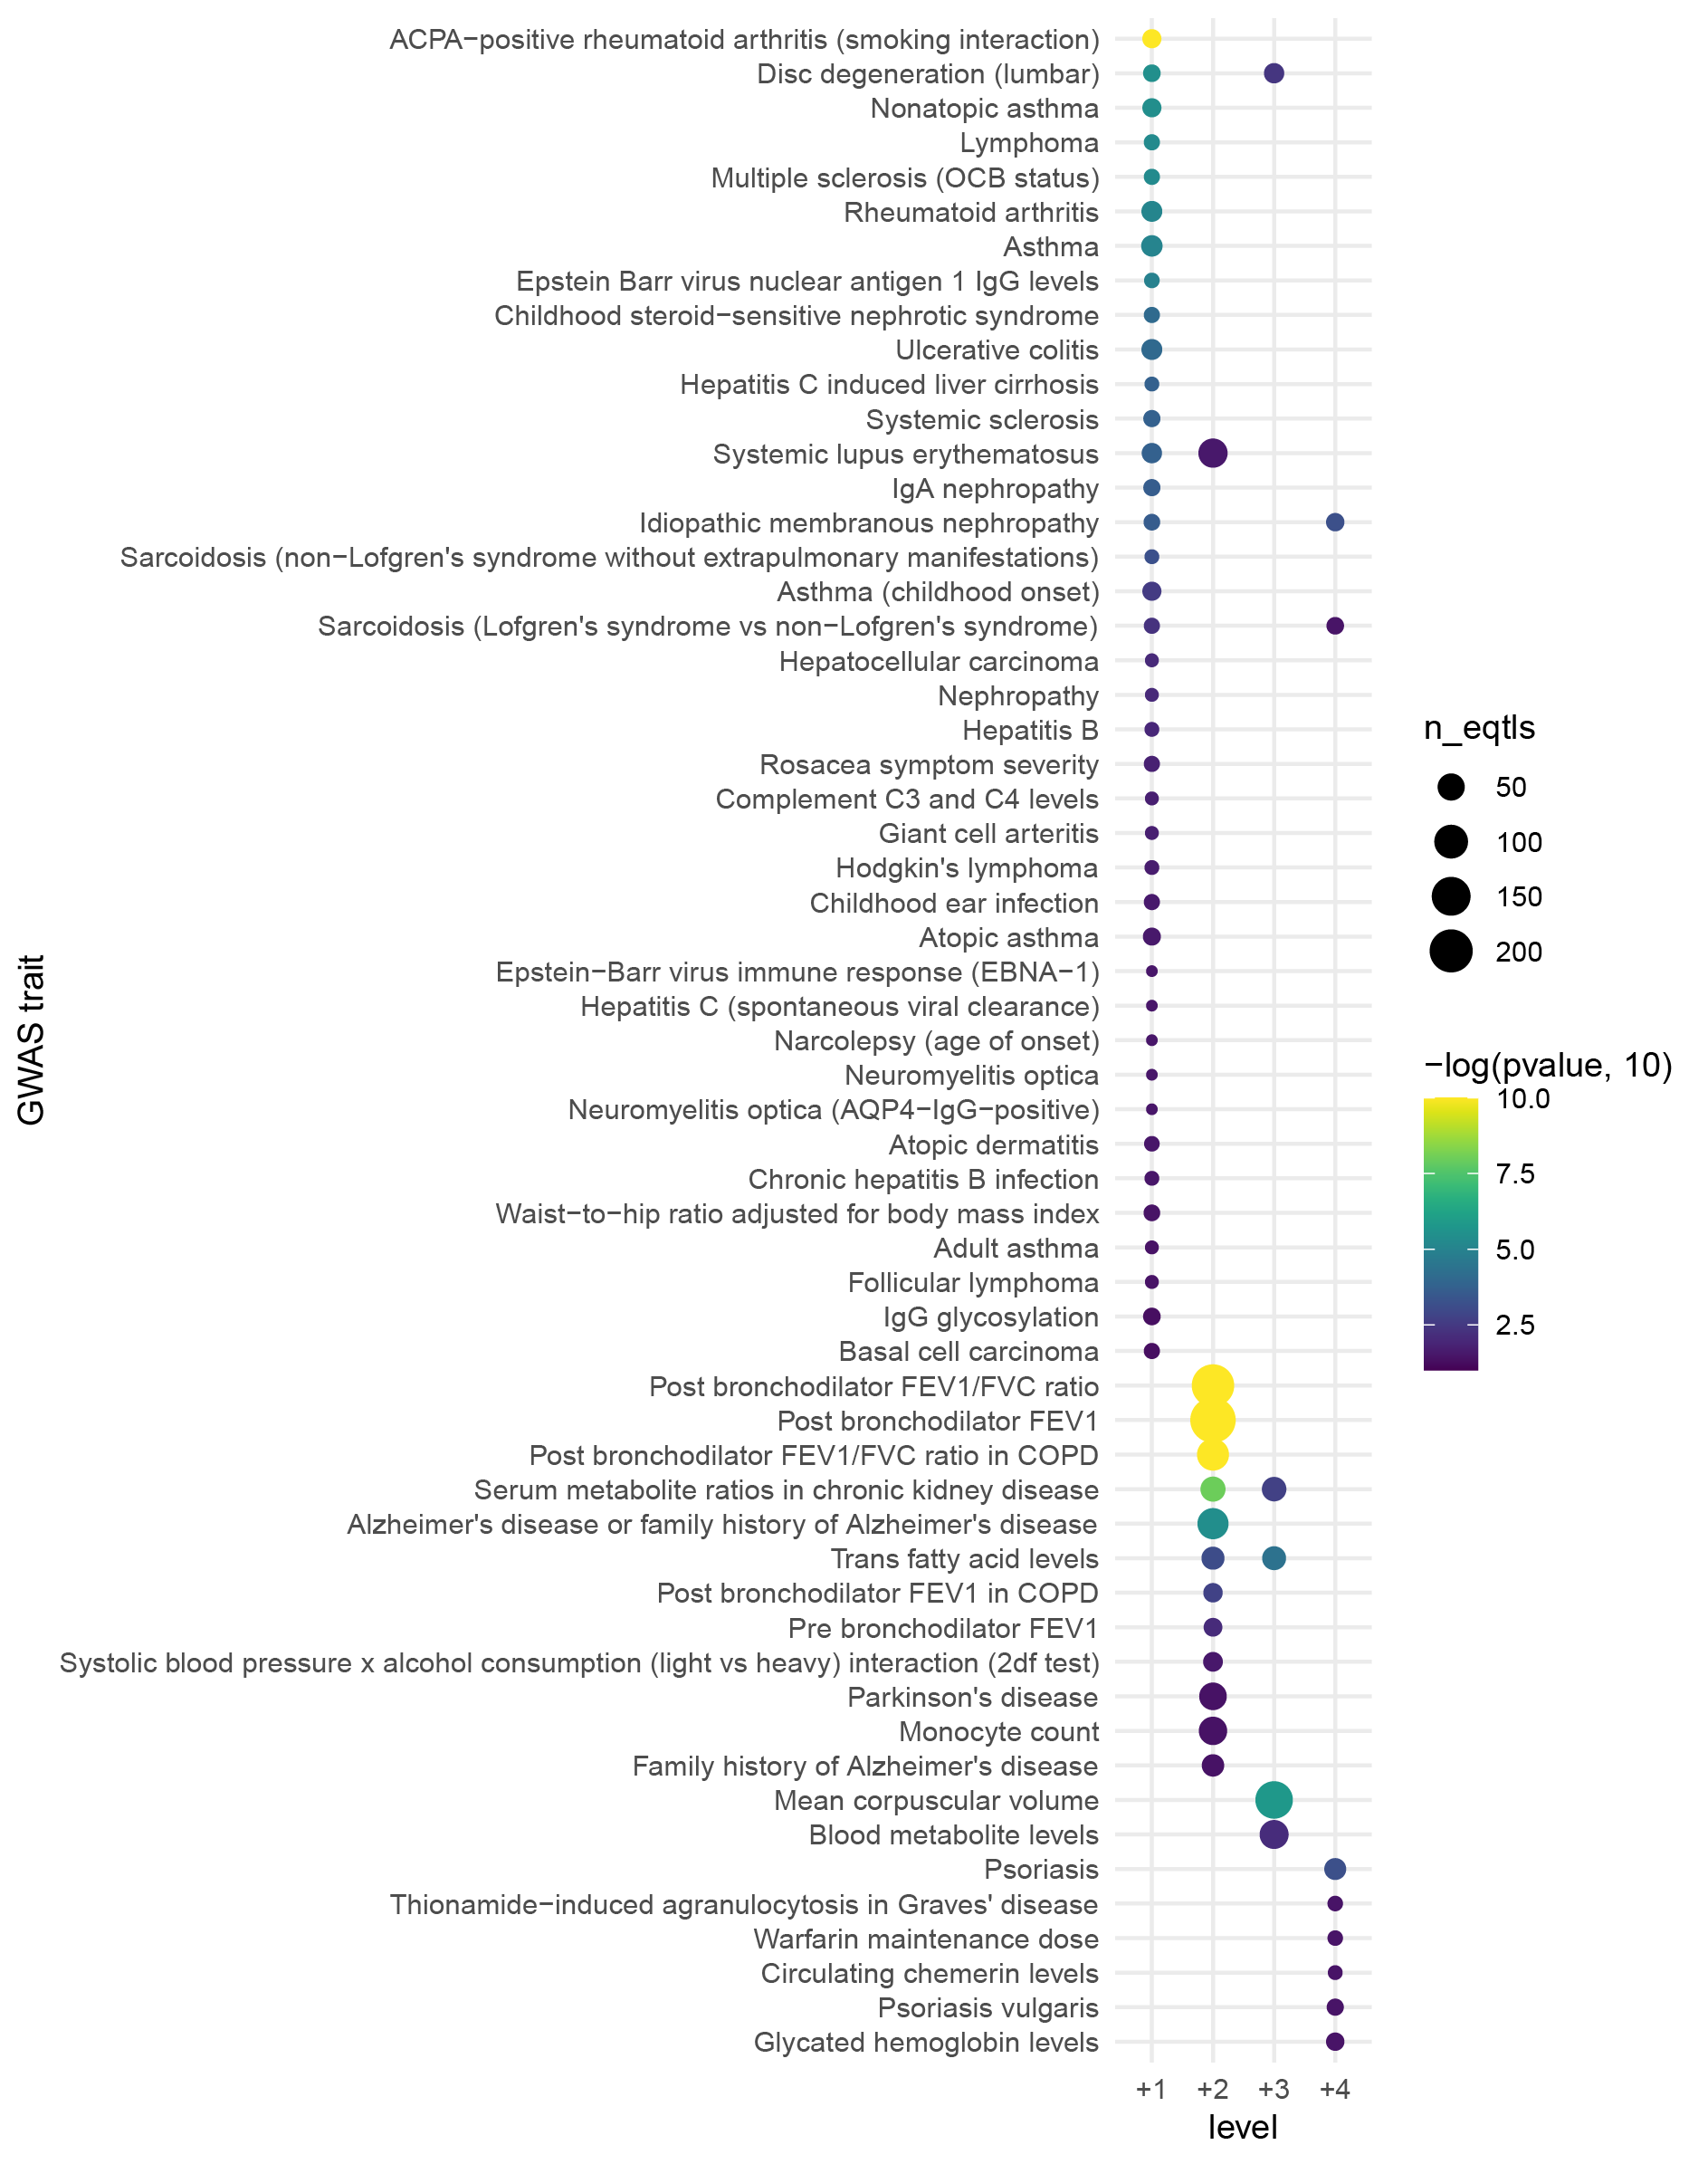
Supplementary Figure 4. Blood GRN de novo identifies conditions that are multimorbid with ALL. GWAS traits enriched in each of the four expanded PPIN neighbors of the ALL disease module. Circle size indicates the number of eQTLs, and circle color indicates statistical significance. ACPA; anti-citrullinated protein antibodies, OCB; oligoclonal band, EBNA-1; Antibodies against Epstein-Barr nuclear antigen 1, AQP4; Aquaporin 4, FEV1; forced expiratory volume in the first second, FVC; Forced vital capacity, COPD; chronic obstructive pulmonary disease.

