Supplementary data
Table S1 Information of sweetpotato materials
Taxon | Variety | Herbarium | Voucher | Geographic origin | identifier
Ipomoea batata L. | Xinxiang | Zhejiang Academy of Agricultural Sciences | 2007001 | Hangzhou, Zhejiang, China | Liehong Wu

Table S2 Information of differentially expressed proteins
 | Up-regulation (>1.5) | Down-regulation (<1.5)
4℃-VS-13℃ | 266 | 158

Table S3 Number of differentially expressed metabolisms
 | All sig diff | Down-regulation | Up-regulated
4℃-VS-13℃ | 76 | 45 | 31

Fig. S1. SDS-PAGE of total proteins extracted from root tuber of Ipomoea batatas L.. (30 μg total proteins each lane)

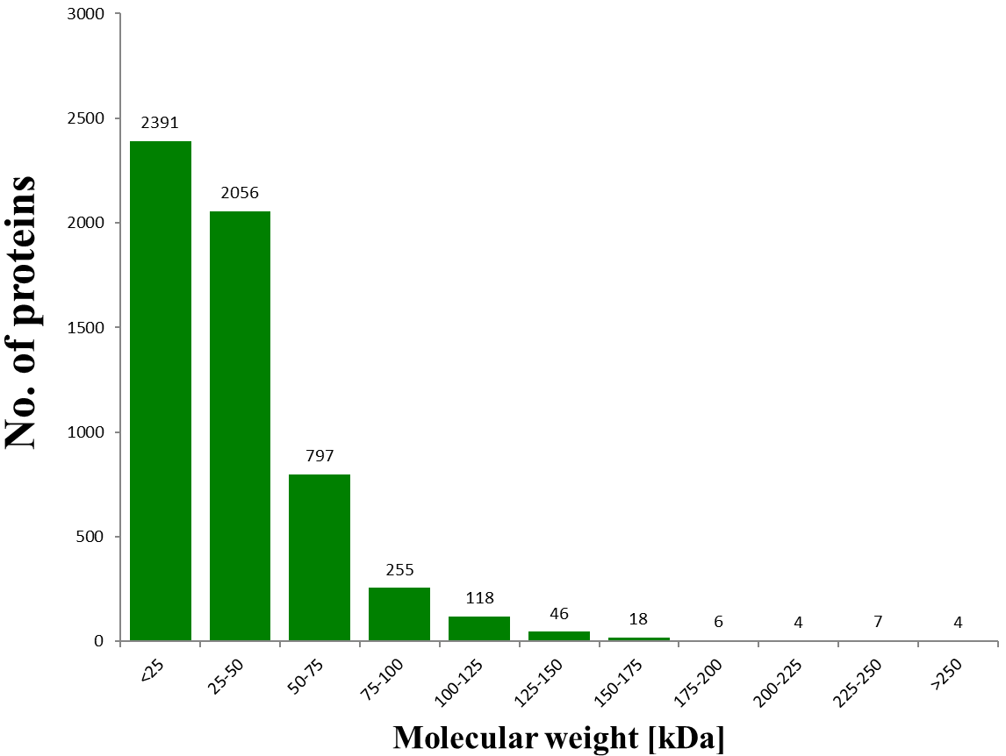
Fig. S2. Distribution of proteins according to molecular weights

