Actin Related Protein 2/3 Complex Subunit 2-enriched extracellular vesicles drive liver cancer metastasis

Piaorong Mei¹, Sze Keong Tey^{2,3}, Samuel Wan Ki Wong², Tung Him Ng², Xiaowen Mao², Cherlie Lot Sum Yeung², Qianhua Huang¹, Peihua Cao^{1,4}, Judy Wai Ping Yam^{1,2,*}, Yi Gao^{1,5,6,*}

¹Department of Hepatobiliary Surgery II, Zhujiang Hospital, Southern Medical University, Guangzhou, Guangdong, China
²Department of Pathology, School for Clinical Medicine, Li Ka Shing Faculty of Medicine, The University of Hong Kong, Hong Kong
³School of Biological Sciences, College of Science, Nanyang Technological University, Singapore 637551, Singapore
⁴Clinical Research Center, Zhujiang Hospital, Southern Medical University, Guangzhou, Guangdong, P. R. China
⁵Guangdong Provincial Research Center for Artificial Organ and Tissue Engineering, Guangzhou Clinical Research and Transformation Center for Artificial Liver, Institute of Regenerative Medicine, Zhujiang Hospital, Southern Medical University, Guangzhou, China
⁶State Key Laboratory of Organ Failure Research, Southern Medical University, Guangzhou, China

Corresponding author
Yi Gao
Department of Hepatobiliary Surgery II, Zhujiang Hospital, Southern Medical University, Guangzhou, Guangdong, China. E-mail: gaoyi6146@163.com; Phone number: 086-18922345399
Judy Wai Ping Yam
Department of Pathology, 7/F Block T, Queen Mary Hospital, Pokfulam, Hong Kong. E-mail: judyyam@pathology.hku.hk; Phone number: 852-22552681

Content:
Supplementary Materials and Methods
Supplementary Figures
References

Supplementary Materials and Methods

Human immortalized normal liver cell line MIHA was obtained from Jayanta Roy-Chowdhury, Albert Einstein College of Medicine, New York [1]. Human HCC cell lines Huh7 and PLC/PRF/5, and embryonic kidney cell line HEK293FT were all purchased from American Type Culture Collection (ATCC). Human metastatic HCC cell lines MHCC97L and MHCCLM3 were obtained from Cancer Institute, Fudan University, China. Murine p53-/-;Myc-transduced hepatoblasts were provided by Scott Lowe, Memorial Sloan Kettering Cancer Center, New York [2-4]. All cell lines used were cultured in Dulbecco’s modified Eagle’s medium (DMEM, Gibco) supplemented with 10% fetal bovine serum (FBS, Gibco) and 100 U/ml penicillin-streptomycin (Gibco) in a 5% CO2 humidified incubator at 37°C. All cell lines were tested routinely to avoid mycoplasma contamination.

Construction of expression vectors
ARPC2 knockout vectors were constructed by subcloning annealed oligos of sgRNA1 and sgRNA2 into pLentiCRISPR_V2 vector (#52961, Addgene) via BsmBI site. The oligos of sgRNA1 and sgRNA2 are as follows, ARPC2-KO1: sgRNA1-forward: 5′-CACCGTATTTCTTTGAAATTCTACA-3′ and sgRNA1-reverse: 5′-AAACTGTAGAATTTCAAAGAAATAC-3′; ARPC2-KO2: sgRNA2-forward: 5′-CACCGGATTCCATTGTGCATCAAGC-3′ and sgRNA2-reverse: 5′-AAACGCTTGATGCACAATGGAATCC-3′. The success of inserting sgRNA1 and sgRNA2 into ARPC2-KO1 and APRC2-KO2 constructs, respectively, was confirmed by DNA sequencing.

Establishment of ARPC2 knockout stable clones
To establish ARPC2 knockout stable clones (ARPC2-KO1 and ARPC2-KO2) in MHCC97L cells, Lenti-Pac HIV Expression Packaging Kit (#LT001, GeneCopoeia Inc.) was used to transfect ARPC2-knockout vector into HEK293FT cells. The viral supernatant was collected, filtered by 0.45 µm filter (Millipore) and transduced to MHCC97L cells with 8 μg/ml polybrene (Sigma-Aldrich) added to enhance the transduction efficiency. 24 hr after transduction, MHCC97L cells was selected by 1:1,000 puromycin (1 mg/ml, Thermo Fisher Scientific). The knockout efficiency of ARPC2 was examined by western blotting using anti-ARPC2 antibody (#NBP1-32297, Novus Biological).

Isolation and validation of EVs
EV-depleted FBS was obtained from normal FBS with 16 hr centrifugation at 100,000 × g at 4°C (Beckman Coulter, Optima XPN-100). Conditioned medium (CM) supplemented with 10% EV-depleted FBS was collected after 72 hr incubation. EVs were isolated by differential centrifugation. In brief, CM was centrifuged at 3,000 × g for 15 min and the supernatant was then centrifuged at 20,000 × g for 30 min at 4°C. The supernatant was collected and passed through 0.22 μm filter (Millipore), followed by subsequent centrifugation at 100,000 × g for 70 min at 4°C to pellet EVs. The EVs were then washed with PBS, centrifuged at 100,000 × g for 70 min at 4°C, resuspend in PBS and stored at -20°C.
Size range of EVs was measured by nanoparticle tracking analysis by ZetaView TWIN-NTA PMX-220 (Particles Metrix GmbH). Data analysis was performed using software ZetaView (version 8.05.11). Proteins of EVs were examined for small EV markers by western blot analysis. The integrity of EVs was analyzed by immunogold labeling.

Immunogold labeling of EVs
The labeling was performed as described by Thery et al [5] with optimizations. Briefly, 10 µl of EVs was resuspended in PBS and deposited on an activated electron-microscopy grid coated with Formvar-Carbon. The grid was transferred to PBS, washed, and blocked with 1% BSA. The grid was then incubated with anti-ARPC2 (#ab11798, Abcam) and anti-CD63 (#ab134045, Abcam) antibodies, washed with 1% BSA, and incubated with goat anti-rabbit conjugates (#ab41498, 6 nm gold, Abcam) and rabbit anti-goat (ab27247, 15 nm gold, Abcam). After washing with PBS and drying, the grid was contrasted, embedded, and visualized using Philips CM100 transmission electron microscope connected with a camera (Olympus SIS Tengra CCD).

Treatment before cell functional assays
To demonstrate the inhibiting effect of Pimozide (#P1793-500MG, Sigma Aldrich), cells were pre-treated either with PBS, or 10 μg MHCCLM3-EV or 10 μg MHCC97L-EV for 48 hr, followed by 24 hr co-incubation with the addition of DMSO or 10 µM Pimozide. For the investigation on the role of ARPC2 in HCC, cells were incubated with 10 μg EVs obtained from MHCC97L non-target knockout control cells (Control-ARPC2) and MHCC97L ARPC2 knockout cell lines (ARPC2-KO1 and ARPC2-KO2). All the treatments were performed in the 6-well plates before subjected to subsequent functional assays.

Colony formation assay
Cells were seeded in triplicates in 6-well plate at a density of 1,000 cells per well. After culturing for 12 days, colonies were fixed, stained with 0.08% crystal violet and counted.

Migration and invasion assay
Cell lines were seeded at a density of 5 × 10⁴ and 7 × 10⁴ cells per well for migration and invasion assays, respectively. For invasion assay, Matrigel basement membrane matrix (Corning) was coated in the upper chamber of the Transwell insert (Corning). Cells were resuspended in 100 μl of serum-free medium and seeded to the upper chamber of the insert and 500 μl medium with 10% FBS and 1:1,000 HGF (20 μg /mL, #100-39, PeproTech) was added to the lower chamber. After incubation for 18 hr, cells on the lower surface were fixed, stained with 0.08% crystal violet and counted.

Western blot analysis
Total cell lysates of 30 μg or 10 μg EV were resolved by 10% SDS-PAGE and then transferred onto PVDF membranes (Amersham). Primary antibody was added to the membrane and incubated overnight at 4°C. After washing, the membrane was incubated with secondary antibody. In this study, the following antibodies were used: anti-ARPC2 (#NBP1-32297, Novus Biological); anti-CD9 (#ab92726, Abcam), anti-Alix (#2171, Cell Signaling Technology), anti-TSG101 (#612696, BD Biosciences), anti-GM130 (#ab52649, Abcam) and anti-p62 (#ab140651, Abcam) antibodies. The proteins were detected by ECL™ Western Blotting Detection Reagents (GE Healthcare) according to the manufacturer’s instructions.

Statistical analysis
All in vitro assays were performed in triplicates and three independent experiments were done. The data of all assays were presented as mean ± standard error of mean (SEM). Student t-test and one-way ANOVA was performed using GraphPad Prism 8 for statistical analysis. Kaplan-Meier analysis was used to estimate the survival function. p < 0.05 was considered statistically significant.

References

[1] Brown JJ, Parashar B, Moshage H, Tanaka KE, Engelhardt D, Rabbani E, Roy-Chowdhury N, Roy-Chowdhury J. A long-term hepatitis B viremia model generated by transplanting nontumorigenic immortalized human hepatocytes in Rag-2-deficient mice. Hepatology 2000;31(1):173-181.
[2] Xue W, Kitzing T, Roessler S, Zuber J, Krasnitz A, Schultz N, Revill K, Weissmueller S, Rappaport AR, Simon J, Zhang J, Luo W, Hicks J, Zender L, Wang XW, Powers S, Wigler M, Lowe SW. A cluster of cooperating tumor-suppressor gene candidates in chromosomal deletions. Proc Natl Acad Sci U S A 2012;109(21):8212-8217.
[3] Zender L, Xue W, Cordón-Cardo C, Hannon GJ, Lucito R, Powers S, Flemming P, Spector MS, Lowe SW. Generation and analysis of genetically defined liver carcinomas derived from bipotential liver progenitors. Cold Spring Harb Symp Quant Biol 2005;70:251-261.
[4] Zender L, Spector MS, Xue W, Flemming P, Cordon-Cardo C, Silke J, Fan ST, Luk JM, Wigler M, Hannon GJ, Mu D, Lucito R, Powers S, Lowe SW. Identification and validation of oncogenes in liver cancer using an integrative oncogenomic approach. Cell 2006;125(7):1253-1267.
[5] Thery C, Amigorena S, Raposo G, Clayton A. Isolation and characterization of exosomes from cell culture supernatants and biological fluids. Curr Protoc Cell Biol 2006;Chapter 3:Unit 3 22.

Supplementary figure legends

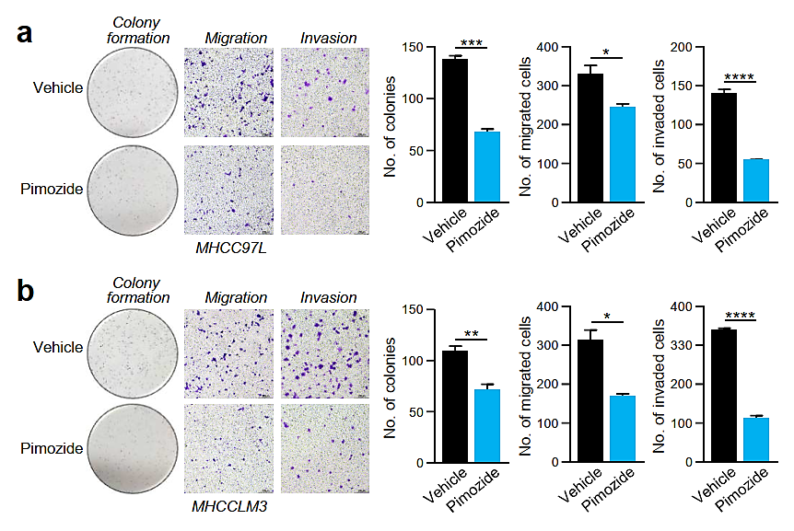
Fig. S1 Pimozide inhibits cell growth and motility of metastatic HCC cells lines. MHCC97L (a) and MHCCLM3 (b) cells pre-treated either with vehicle or 10 µM Pimozide were seeded in triplicates for colony formation, migration and invasion assays. At the end of experiment, cells were fixed, stained with crystal violet and counted. Representative images of colonies and cells and are shown. The numbers of colonies and cells are plotted. Data are represented as the mean ± SEM, *p < 0.05, **p < 0.01, ***p < 0.001, ****p <0.0001, p < 0.05 is considered as statistically significant.

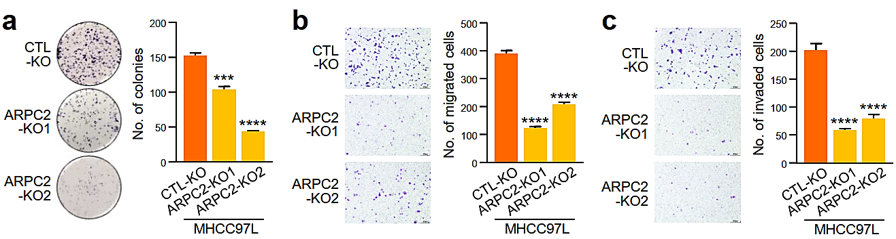

Fig. S2 Knockout ARPC2 diminishes the ability of metastatic HCC cells to form colony, migrate and invade. MHCC97L control (CTL-KO) and ARPC2 knockout (ARPC2-KO1 and ARPC2-KO2) stable clones were seeded in triplicates for colony formation (a), migration (b) and invasion (c) assays. At the end of experiment, cells were fixed, stained with crystal violet and counted. Representative images of colonies and cells and are shown. The numbers of colonies and cells are plotted. Data are represented as the mean ± SEM, ***p < 0.001, ****p <0.0001, p < 0.05 is considered as statistically significant.

