Supplementary Table 1: International Classification of Diseases 9 (ICD-9) codes used for classifying outcomes and comorbidities

Medical condition | ICD-9 codes
Outcome
VA/SCD | 427.01,427.40-427.59
Comorbidities
Peripheral vascular disease | 250.7
Ischemic stroke | 433.01,433.11,433.21,433.31, 433.81, 433.91, 434.01, 434.11, 435, 436
Atrial fibrillation | 427.31, 429.4
Heart failure | 428.00-428.99
Prior VA/SCD | 427.01,427.40-427.59
Intracranial hemorrhage | 430,431,432.0,432.1,432.9,852.0-852.1,852.2-852.3,852.4-852.5,853.0
Coronary heart disease | 410.0-411.9,413.0-414.9
Hypertension | 401.9
Chronic Obstructive Pulmonary Disease | 491.00-492.99
Cardiomyopathy | 425.0-425.9
Valvular disease | 424.0-424.4
VA/SCD: Ventricular arrhythmia or sudden cardiac death

Supplementary Figure 1: Covariate balance before and after propensity score matching
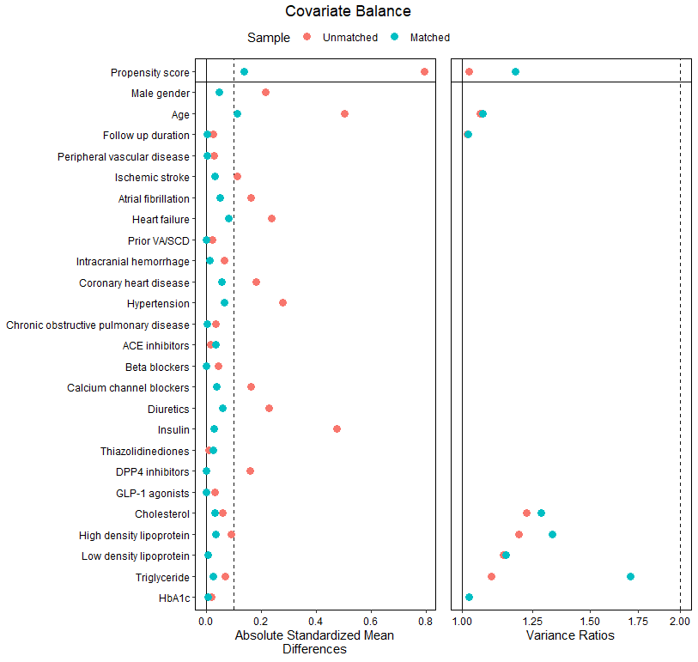
VA/SCD: Ventricular arrhythmia or sudden cardiac death; DPP4: dipeptidyl-peptidase 4; GLP-1: glucagon-like peptide 1.

Supplementary Table 2: Baseline characteristics of metformin and sulfonylurea users stratified by insulin versus insulin nonusers after 1:1 propensity score matching.

Characteristics | Insulin users |  | Insulin nonusers
 | Metformin (N=863) | Sulfonylurea (N=919) | Metformin (N=4,893) | Sulfonylurea (N=4,837)
Demographics
Male , N (%) | 472 (54.7%) | 522 (56.8%) | 2290 (46.8%) | 2371 (49.0%)
Baseline age, years | 70.28±10.01 | 70.63±10.37 | 67.92±10.55 | 69.26±10.92
Follow up duration since type 2 diabetes diagnosis, years | 5.14±2.53 | 5.12±2.54 | 5.02±2.57 | 5.02±2.54
Comorbidities
Peripheral vascular disease, N (%) | 10 (1.2%) | 9 (1.0%) | 0 (0.0%) | 0 (0.0%)
Ischemic stroke, N (%) | 58 (6.7%) | 89 (9.7%) | 253 (5.2%) | 268 (5.5%)
Atrial fibrillation, N (%) | 60 (7.0%) | 92 (10.0%) | 201 (4.1%) | 245 (5.1%)
Heart failure, N (%) | 99 (11.5%) | 170 (18.5%) | 192 (3.9%) | 267 (5.5%)
Prior VA/SCD, N (%) | 0 (0.0%) | 0 (0.0%) | 0 (0.0%) | 0 (0.0%)
Intracranial hemorrhage, N (%) | 14 (1.6%) | 22 (2.4%) | 82 (1.7%) | 83 (1.7%)
Coronary heart disease, N (%) | 169 (19.6%) | 222 (24.2%) | 669 (13.7%) | 745 (15.4%)
Hypertension, N (%) | 447 (51.8%) | 555 (60.4%) | 1812 (37.0%) | 1893 (39.1%)
Chronic obstructive pulmonary disease, N (%) | 4 (0.5%) | 7 (0.8%) | 18 (0.4%) | 14 (0.3%)
Medications
ACE inhibitors, N (%) | 638 (73.9%) | 589 (64.1%) | 2449 (50.1%) | 2592 (53.6%)
Beta blockers, N (%) | 365 (42.3%) | 469 (51.0%) | 2115 (43.2%) | 2009 (41.5%)
Calcium channel blockers, N (%) | 477 (55.3%) | 573 (62.4%) | 2219 (45.4%) | 2234 (46.2%)
Diuretics, N (%) | 326 (37.8%) | 443 (48.2%) | 1045 (21.4%) | 1088 (22.5%)
Thiazolidinediones, N (%) | 47 (5.4%) | 21 (2.3%) | 27 (0.6%) | 71 (1.5%)
DPP4 inhibitors, N (%) | 1 (0.1%) | 0 (0.0%) | 0 (0.0%) | 1 (0.0%)
GLP-1 agonists, N (%) | 0 (0.0%) | 0 (0.0%) | 0 (0.0%) | 0 (0.0%)
Laboratory tests
Cholesterol, mmol/L | 4.64±1.02 | 4.75±1.25 | 4.84±0.95 | 4.78±1.06
High density lipoprotein, mmol/L | 1.18±0.34 | 1.12±0.36 | 1.21±0.31 | 1.21±0.36
Low density lipoprotein, mmol/L | 2.76±0.86 | 2.82±0.98 | 2.94±0.87 | 2.92±0.92
Triglyceride, mmol/L | 1.69±1.24 | 1.86±2.03 | 1.71±1.09 | 1.63±1.31
HbA1c, % | 7.42±1.43 | 7.45±1.39 | 7.46±1.44 | 7.44±1.43
Continuous variables were expressed as mean ± standard deviation. SMD <0.1 / VR >0.5 & <2.0 indicated good balance in matching. SMD: Standardized mean difference; VR: Variance Ratio; VA/SCD: Ventricular arrhythmia or sudden cardiac death DPP4: dipeptidyl-peptidase 4; GLP-1: glucagon-like peptide 1.

Supplementary Table 3: Baseline characteristics of metformin and sulfonylurea users stratified by history of coronary heart disease (CHD) after 1:1 propensity score matching.

Characteristics | With CHD |  | Without CHD
 | Metformin (N=838) | Sulfonylurea (N=967) | Metformin (N=4,918) | Sulfonylurea (N=4,789)
Demographics
Male , N (%) | 446 (53.2%) | 515 (53.3%) | 2316 (47.1%) | 2378 (49.7%)
Baseline age, years | 71.35±9.72 | 72.72±9.35 | 67.75±10.54 | 68.82±11.01
Follow up duration since type 2 diabetes diagnosis, years | 5.15±2.56 | 5.18±2.57 | 5.02±2.57 | 5.01±2.54
Comorbidities
Peripheral vascular disease, N (%) | 1 (0.1%) | 4 (0.4%) | 9 (0.2%) | 5 (0.1%)
Ischemic stroke, N (%) | 64 (7.6%) | 66 (6.8%) | 247 (5.0%) | 291 (6.1%)
Atrial fibrillation, N (%) | 88 (10.5%) | 105 (10.9%) | 173 (3.5%) | 232 (4.8%)
Heart failure, N (%) | 117 (14.0%) | 224 (23.2%) | 174 (3.5%) | 213 (4.4%)
Prior VA/SCD, N (%) | 0 (0.0%) | 0 (0.0%) | 0 (0.0%) | 0 (0.0%)
Intracranial hemorrhage, N (%) | 22 (2.6%) | 22 (2.3%) | 74 (1.5%) | 83 (1.7%)
Hypertension, N (%) | 554 (66.1%) | 631 (65.3%) | 1705 (34.7%) | 1817 (37.9%)
Chronic obstructive pulmonary disease, N (%) | 1 (0.1%) | 8 (0.8%) | 21 (0.4%) | 13 (0.3%)
Medications
ACE inhibitors, N (%) | 547 (65.3%) | 631 (65.3%) | 2540 (51.6%) | 2550 (53.2%)
Beta blockers, N (%) | 608 (72.6%) | 665 (68.8%) | 1872 (38.1%) | 1813 (37.9%)
Calcium channel blockers, N (%) | 424 (50.6%) | 524 (54.2%) | 2272 (46.2%) | 2283 (47.7%)
Diuretics, N (%) | 249 (29.7%) | 378 (39.1%) | 1122 (22.8%) | 1153 (24.1%)
Insulin, N (%) | 169 (20.2%) | 222 (23.0%) | 694 (14.1%) | 697 (14.6%)
Thiazolidinediones, N (%) | 3 (0.4%) | 15 (1.6%) | 71 (1.4%) | 77 (1.6%)
DPP4 inhibitors, N (%) | 0 (0.0%) | 1 (0.1%) | 1 (0.0%) | 0 (0.0%)
GLP-1 agonists, N (%) | 0 (0.0%) | 0 (0.0%) | 0 (0.0%) | 0 (0.0%)
Laboratory tests
Cholesterol, mmol/L | 4.35±0.88 | 4.46±1.14 | 4.89±0.95 | 4.84±1.07
High density lipoprotein, mmol/L | 1.17±0.31 | 1.13±0.32 | 1.21±0.31 | 1.21±0.37
Low density lipoprotein, mmol/L | 2.59±0.82 | 2.72±0.98 | 2.97±0.87 | 2.95±0.92
Triglyceride, mmol/L | 1.64±0.92 | 1.70±1.30 | 1.72±1.14 | 1.66±1.48
HbA1c, % | 7.41±1.42 | 7.49±1.50 | 7.46±1.45 | 7.43±1.41
Continuous variables were expressed as mean ± standard deviation. SMD <0.1 / VR >0.5 & <2.0 indicated good balance in matching. SMD: Standardized mean difference; VR: Variance Ratio; VA/SCD: Ventricular arrhythmia or sudden cardiac death; DPP4: dipeptidyl-peptidase 4; GLP-1: glucagon-like peptide 1.

Supplementary Table 4: Baseline characteristics of individual sulfonylurea users after 1:1 propensity score matching.

Characteristics | Glicazide  (N=3411) | Glipizide  (N=138) | Tolbutamide  (N=115) | Glibenclamide  (N=467) | Glimepiride  (N=39)
Demographics
Male , N (%) | 1680 (49.3%) | 67 (48.6%) | 70 (60.9%) | 234 (50.1%) | 18 (46.2%)
Baseline age, years | 69.87±11.00 | 70.51±11.09 | 72.44±11.27 | 67.87±9.51 | 68.03±10.37
Follow up duration since type 2 diabetes diagnosis, years | 5.03±2.53 | 5.17±2.49 | 5.02±2.60 | 5.12±2.68 | 4.93±2.41
Comorbidities
Peripheral vascular disease, N (%) | 0 (0.0%) | 0 (0.0%) | 0 (0.0%) | 0 (0.0%) | 0 (0.0%)
Ischemic stroke, N (%) | 220 (6.4%) | 10 (7.2%) | 8 (7.0%) | 15 (3.2%) | 3 (7.7%)
Atrial fibrillation, N (%) | 206 (6.0%) | 6 (4.3%) | 9 (7.8%) | 11 (2.4%) | 1 (2.6%)
Heart failure, N (%) | 228 (6.7%) | 7 (5.1%) | 13 (11.3%) | 13 (2.8%) | 4 (10.3%)
Prior VA/SCD, N (%) | 0 (0.0%) | 0 (0.0%) | 0 (0.0%) | 0 (0.0%) | 0 (0.0%)
Intracranial hemorrhage, N (%) | 64 (1.9%) | 3 (2.2%) | 5 (4.3%) | 5 (1.1%) | 1 (2.6%)
Coronary heart disease, N (%) | 539 (15.8%) | 28 (20.3%) | 25 (21.7%) | 58 (12.4%) | 4 (10.3%)
Hypertension, N (%) | 1393 (40.8%) | 67 (48.6%) | 73 (63.5%) | 129 (27.6%) | 17 (43.6%)
Chronic obstructive pulmonary disease, N (%) | 11 (0.3) | 1 (0.7%) | 0 (0.0%) | 2 (0.4%) | 0 (0.0%)
Medications
ACE inhibitors, N (%) | 1838 (53.9%) | 85 (61.6%) | 69 (60.0%) | 230 (49.3%) | 24 (61.5%)
Beta blockers, N (%) | 1416 (41.5%) | 68 (49.3%) | 68 (59.1%) | 162 (34.7%) | 19 (48.7%)
Calcium channel blockers, N (%) | 1629 (47.8%) | 73 (52.9%) | 85 (73.9%) | 185 (39.6%) | 23 (59.0%)
Diuretics, N (%) | 834 (24.5%) | 39 (28.3%) | 51 (44.3%) | 68 (14.6%) | 10 (25.6%)
Insulin, N (%) | 169 (5.0%) | 10 (7.2%) | 12 (10.4%) | 7 (1.5%) | 6 (15.4%)
Thiazolidinediones, N (%) | 47 (1.4%) | 7 (5.1%) | 1 (0.9%) | 3 (0.6%) | 5 (12.8%)
DPP4 inhibitors, N (%) | 0 (0.0%) | 0 (0.0%) | 0 (0.0%) | 0 (0.0%) | 0 (0.0%)
GLP-1 agonists, N (%) | 0 (0.0%) | 0 (0.0%) | 0 (0.0%) | 0 (0.0%) | 0 (0.0%)
Laboratory tests
Cholesterol, mmol/L | 4.73±1.05 | 4.80±1.13 | 4.83±1.20 | 4.99±1.06 | 4.75±1.07
High density lipoprotein, mmol/L | 1.21±0.36 | 1.23±0.39 | 1.09±0.28 | 1.24±0.37 | 1.22±0.39
Low density lipoprotein, mmol/L | 2.89±0.91 | 2.73±0.97 | 2.97±1.27 | 3.10±0.89 | 2.98±0.85
Triglyceride, mmol/L | 1.62±1.36 | 1.85±1.45 | 1.85±1.51 | 1.61±1.08 | 1.78±1.13
HbA1c, % | 7.43±1.44 | 7.37±1.36 | 7.67±1.56 | 7.37±1.34 | 7.33±1.33
VA/SCD: Ventricular arrhythmia or sudden cardiac death; DPP4: dipeptidyl-peptidase 4; GLP-1: glucagon-like peptide 1.

