Supplementary Material Figures
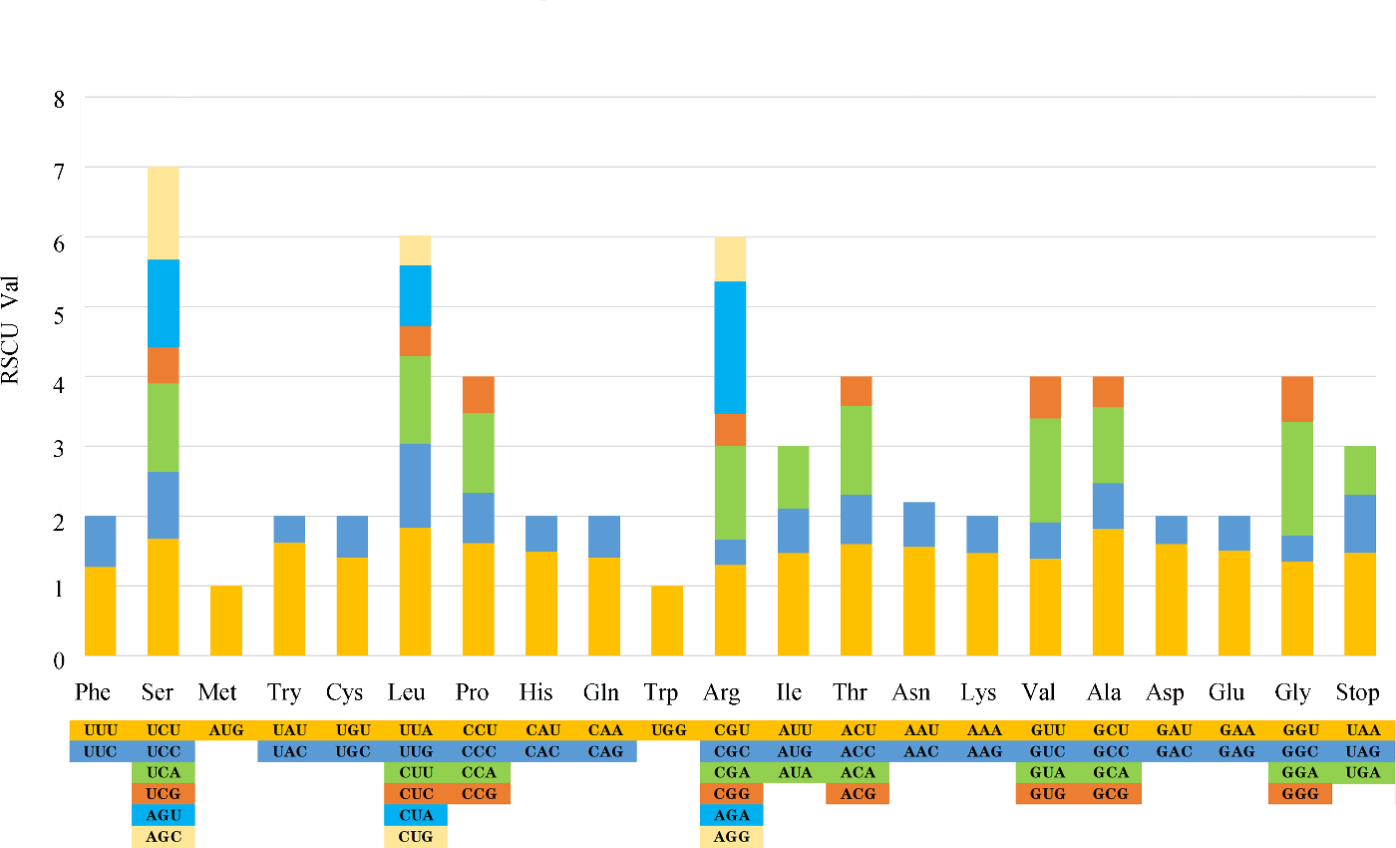

Supplementary Figure 1. The RSCU value of the 20 amino acids and stop codons in all the protein- coding genes of the chloroplast genome of Tetrastigma hemsleyanum sample from Jiangxi Province.

Supplementary Material

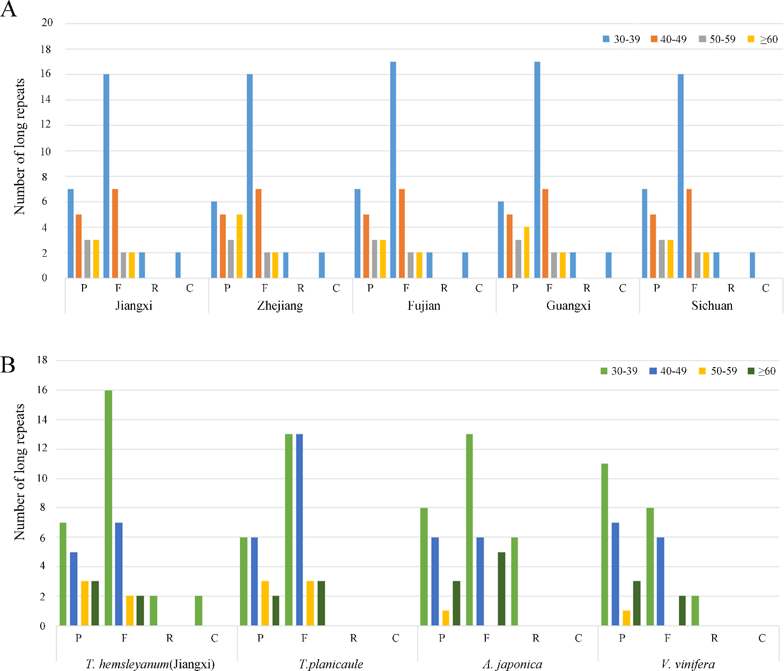

Supplementary Figure 2. Analysis of the long repeats in cp genomes of Vitaceae plants and Tetrastigma hemsleyanum species with different geographical origins. (A) The number, length and type of the long repeats identified in five samples of Tetrastigma hemsleyanum. (B) The number, length and type of the long repeats detected in Tetrastigma hemsleyanum (Jiangxi Province), Tetrastigma planicaule, Ampelopsis japonica and Vitis vinifera cp genomes.

