**Supplementary Figure 1:** Distribution of percentage of missing data (a) per SNP and (b) per individual for Deli and La Mé oil palm breeding populations.

**(a)**

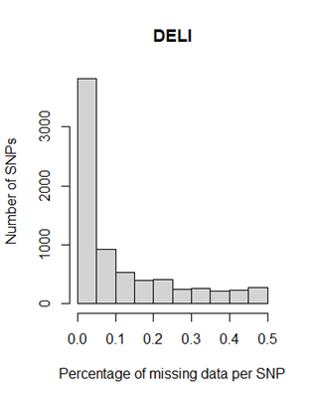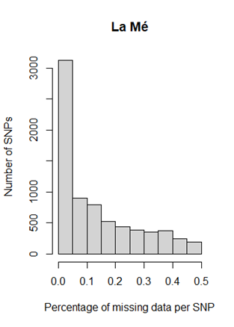

**(b)**

**(a)**

