Surface bio-interactions stand at the base of the short-term nano CuO-induced cell oxidative stress: insights for a safe(r)-by-design approach

ADDITIONAL FILE 3
Elisa Moschini^{1,4}, Graziano Colombo², Giuseppe Chirico³, Giancarlo Capitani¹, Isabella Dalle-Donne², Paride Mantecca^{1*}

¹ Department of Earth and Environmental Sciences, Research Center POLARIS, University of Milano Bicocca, 1 Piazza della Scienza - 20126 Milan, Italy
² Department of Biosciences, Università degli Studi di Milano, 26 via Celoria - 20133 Milan, Italy
³ Department of Physic, University of Milano Bicocca, 2 Piazza della Scienza - 20126 Milano, Italy
⁴ Luxembourg Institute of Science and Technology (LIST), Environmental Research and Innovation (ERIN) Department, 41, rue du Brill, L-4422 Belvaux, Grand-Duchy of Luxembourg

1. Copper cytochemistry
Intracellular copper ion dissolution was determined by a cytochemical method using rhodanine. After exposure to 10 μg/ml and 25 μg/ml CuO NPs for 6h. Cells were rinsed, formalin fixed, and incubated with 0.12 g/l rhodanine (p-Dimethylaminobenzylinene-rhodanine) alcoholic solution. Abundantly rinsing was done and nuclei were counterstained with haematoxylin. Slides were mounted in a glycerol-based medium and immediately observed under the light microscope (Axioplan - Zeiss).
Results from this test are summarised in Additional Figure 4.
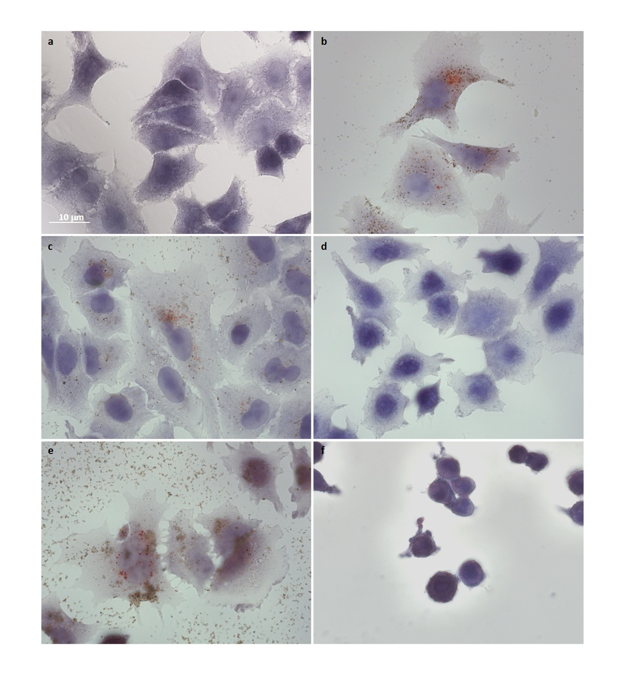
Additional Figure 4. Cytochemistry of Cu²⁺ by Rhodanine staining in A549 exposed to nCuO for 6h. a) negative control (unexposed cells); b) positive control (10 μg/ml cCuO-BSA -exposed cells, 24h); c, e) 10 μg/ml and 25 μg/ml cCuO-exposed cells; d, f) 10 μg/ml and 25 μg/ml sCuO-exposed cells. Red/orange spots testify for the intracellular release of Cu⁺⁺ (b, c, e).

