Genome-wide analysis of PR-1 genes from Piper nigrum reveals critical role in defense response during Phytophthora capsici infection
Kattupalli Divya#, Srinivasan Asha#, Eppurathu Vasudevan Soniya*

Supplementary Figures

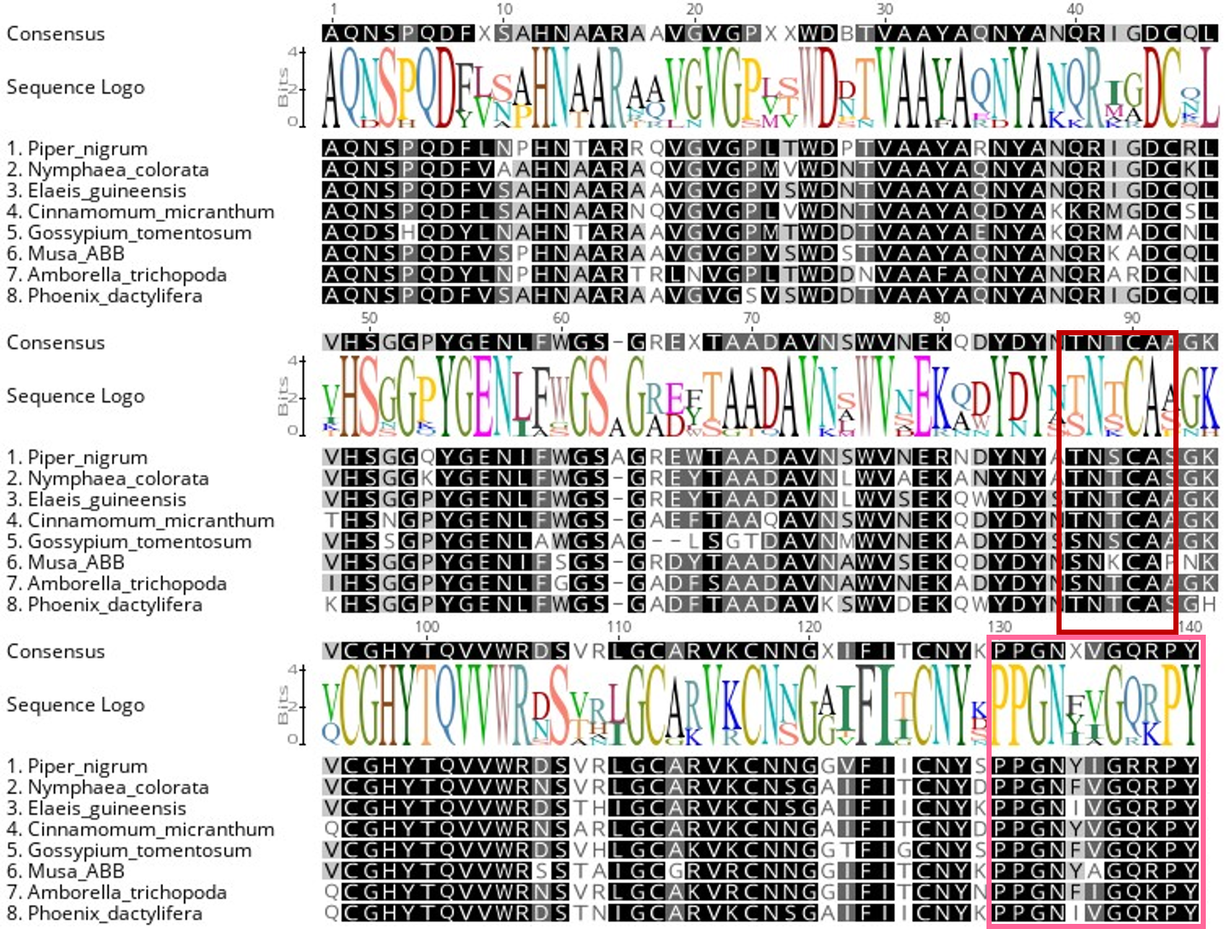
Fig. S1: The amino acid sequences from Piper nigrum, Nymphaea colorata, Elaeis guineensis, Cinnamomum micranthum, Gossypium tomentosum, Musa ABB, Amborella trichopoda and Phoenix dactylifera were aligned using Geneious bioinformatic software (https://www.geneious.com/) with default settings. The conserved domains are highlighted in different colours. CAP domain structure with caveolin-binding motif (CBM) and CAP-derived peptide (CAPE) are shown in red and pink boxes.

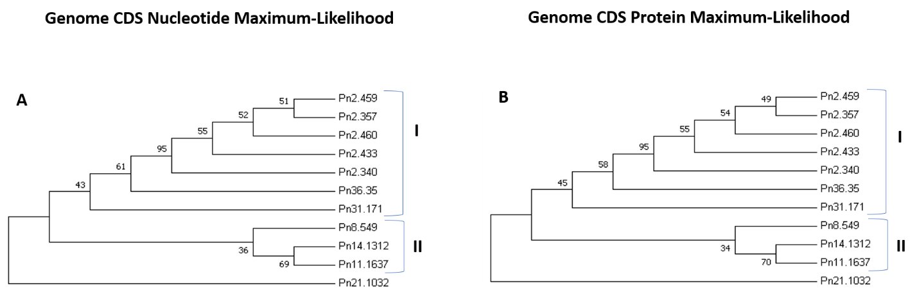
Fig. S2: (A&B) Phylogenetic analyses of Piper nigrum PR-1 nucleotide and protein sequences. The phylogenetic tree was constructed using MEGA 7.0. by the maximum-likelihood (ML) method with 1000 bootstrap replicates and default parameters. The PnPR-1 family genes were divided into two major groups, groups I and II.

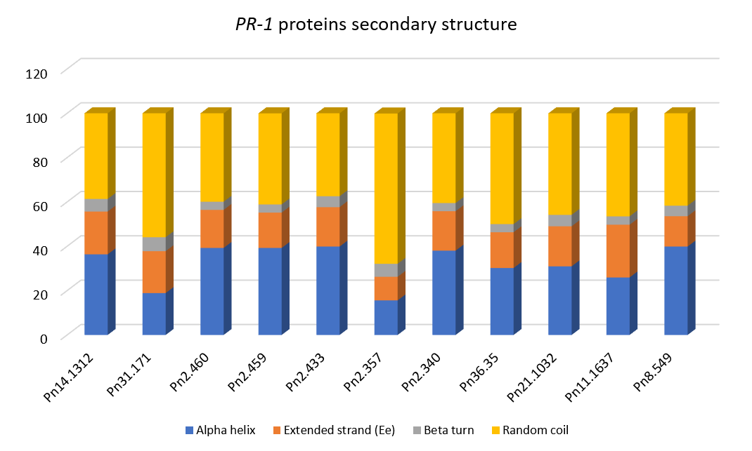
Fig. S3: Details of predicted secondary structure of PnPR-1 proteins.
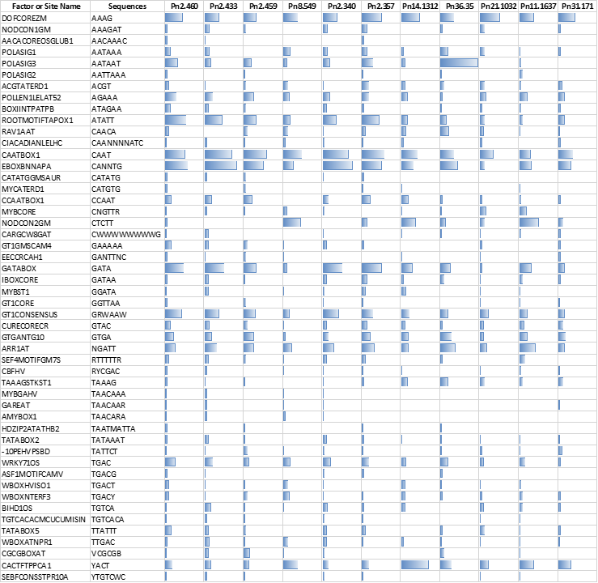
Fig. S4: Analysis of cis-acting elements in PnPR-1 promoters using the NewPlace online server. The number of elements in each gene were represented in data bars.

