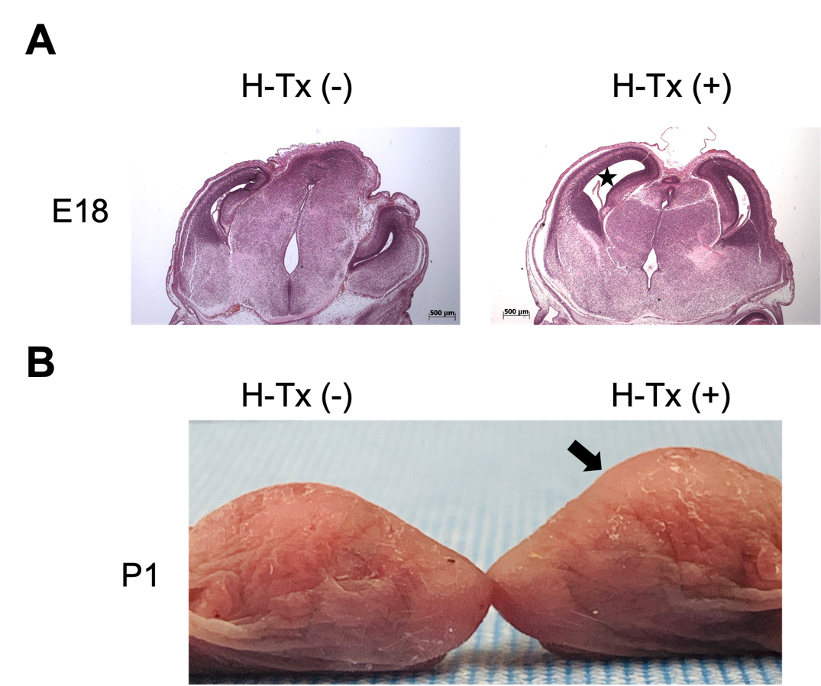
Figure S1. H-Tx rats for genetic risk identification.
A. HE-stained coronal sections of H-Tx (-) and H-Tx (+) rats at E18, asterisk shows the dilated lateral ventricle. Scale bar = 500 µm.
B. Images of P1 H-Tx (-) and H-Tx (+) rats, arrow points to the domed head.

