Fluorescence umpolung enables light-up sensing of N-acetyltransferases and nerve agents
Chenxu Yan¹, Zhiqian Guo¹, Weijie Chi², Wei Fu¹, Xiaogang Liu², He Tian¹ and Wei-Hong Zhu¹*
¹Key Laboratory for Advanced Materials and Joint International Research Laboratory of Precision Chemistry and Molecular Engineering, Shanghai Key Laboratory of Functional Materials Chemistry, Frontiers Science Center for Materiobiology and Dynamic Chemistry, Institute of Fine Chemicals, School of Chemistry and Molecular Engineering, East China University of Science & Technology, Shanghai 200237 (China).
²Fluorescence Research Group, Singapore University of Technology and Design, Singapore 487372, Singapore.
*e-mail: whzhu@ecust.edu.cn

Table of Contents
1. Experimental section S3
1.1 Materials and general methods S3
1.2 Theoretical calculation details S3
1.3 Cell lines S3
1.4 Cellular imaging S3
1.5 Animals S4
1.6 Synthesis of indazole-based fluorophores S5
1.7 References S15
2. Fluorescence spectra of indazole-based fluorophores S16
3. Crystal information of IN-NH₂, IN-Boc, IN1-NH₂, DC-IN-NH₂, DC-IN-Boc, and DCM-IN-NH₂ S17
4. Quantum chemical calculations for elucidating the unusual fluorescence umpolung mechanism S24
5. ESI-MS spectra characterization of Lighter EW Tracker reaction with NAT2 mimic S25
6. Quantitative and light-up detection of DCP S26
7. ESI-MS spectra characterization of Lighter EW Tracker reaction with DCP S27
8. Intracellular localization of Lighter EW Tracker S28
9. Characterization of indazole-based fluorophores S29

1. Experimental section

1.1 Materials and general methods
Unless specially stated, all solvents and chemicals were purchased from commercial suppliers in analytical grade and used without further purification. The ¹H and ¹³C NMR spectra were recorded on a Bruker AM 400 spectrometer using TMS as an internal standard. The high-resolution mass spectrometry data were obtained with a Waters LCT Premier XE spectrometer. The single-crystal data were obtained with a Bruker D8 Venture X-Ray Diffractometer. UV-vis absorption spectra were collected on a Varian Cary 500 spectrophotometer, and fluorescence spectrum measurements were performed on a Varian Cary Eclipse fluorescence spectrophotometer. Confocal fluorescence images were taken on a Leica TCS SP8 (63 × oil lens).

1.2 Theoretical calculation details
All calculations were carried out using Gaussian 16 A.¹ Density functional theory (DFT) and time-dependent DFT (TD-DFT) were employed to investigate the fluorescence (quenching) mechanism of all compounds. All structural optimizations in the ground and excited states were performed using M06-2X functional² and Def2-SVP basis set.³ Solvation effects in dimethyl sulfoxide (DMSO) were taken into account using the SMD model.⁴ Frequency calculations were performed to confirm that we obtained stable structures without imaginary vibrational frequencies.
The potential energy surface (PES) in the first excited state (S₁) was calculated at the same level (M06-2X/Def2-SVP) using relaxed scans with the corrected Linear Response (cLR) solvent formalism around the bond connecting the indazole to the furan moieties.

1.3 Cell lines
The cell lines were purchased from the Institute of Cell Biology (Shanghai, China). All cells were propagated in T-75 flasks cultured at 37 ºC under a humidified 5% CO₂ atmosphere in RPMI-1640 medium or DMEM medium (GIBCO/Invitrogen, Camarillo, CA, USA) which were supplemented with 10 % fetal bovine serum (FBS, Biological Industry, Kibbutz Beit Haemek, Israel) and 1% penicillin-streptomycin (10,000U mL⁻¹ penicillin and 10 mg mL⁻¹ streptomycin, Solarbio life science, Beijing, China).

1.4 Cellular imaging
The cells at 1 × 10⁵ cells/well were seeded onto glass-bottom petri dishes with complete medium (1.5 mL) for 12 h. Then the cells were exposed to desired concentrations of fluorophores for 2 h. PBS was used to wash cells for three times to clean the background. The cells were rinsed with PBS twice. The images were then photographed by using a confocal laser scanning microscope Leica TCS SP8 (63 × oil lens).

1.5 Animals
All animal studies were approved by the Animal Care and Use Committee in accordance with the guidelines for the care and use of laboratory animals. The 3-4-week-old female BALB/cA nude mice were purchased from Shanghai Genechem Co. Ltd. and maintained under standard conditions. The animals were housed in sterile cages within laminar airflow hoods in a specific pathogen-free room with a 12-h light/12-h dark schedule and fed autoclaved chow and water ad libitum. Production Permit No.: SCXK (Shanghai) 2013-0017. SYXK No. of Shanghai Institute of Materia Medica: SYXK (Shanghai) 2013-0049.

1.6 Synthesis of indazole-based fluorophores
The compounds DCM, DCM-Ac, and DCM-NH₂ were synthesized by the established procedures from our reported works.⁵

Supplementary Fig. 1. Synthetic route of IN-Ac, DCM-SIN-NH₂, DC-IN-Ac, and DCM-IN-NH₂

Supplementary Fig. 2. Synthetic route of DCM-IN1-NH₂ and DCM-NH₂

Synthesis of IN-NO₂
I-NO₂ (1.00 g, 6.13 mmol) and KOH (3.36 g, 60.10 mmol) were dissolved in water (10 mL) under an argon atmosphere at room temperature. Then Me₂SO₄ (3.50 g, 27.80 mmol) was added dropwise. The mixture was refluxed for 1 h under an argon atmosphere. The solution was filtered and the residue was purified by silica gel chromatography (CH₂Cl₂:PE = 1:1) to get the desired product IN-NO₂ (300 mg). Yield was 28%. ¹H NMR (400 MHz, DMSO-d₆, ppm): δ 4.25 (s, 3H, NCH₃-H), 7.77 (d, J = 8.0 Hz, 1H, phenyl-H), 8.00 (dd, J = 8.0 Hz, 1H, phenyl-H), 8.77 (s, 1H, imidazole-H), 8.88 (d, J = 4.0 Hz, 1H, phenyl-H). ¹³C NMR (100 MHz, CDCl₃, ppm): δ 150.02, 143.08, 127.77, 120.40, 120.25, 119.22, 118.19, 40.96. Mass spectrometry (ESI-MS, m/z): [M + H]⁺ calcd. for [C₈H₇N₃O₂ + H]⁺ 178.0629; found 178.0629.

Synthesis of IN-NH₂
IN-NO₂ (100 mg, 0.56 mmol), iron powder (110 mg, 2.00 mmol), and NH₄Cl (75 mg, 1.41 mmol) were dissolved in mixture of methanol and water (16 mL, v:v = 3:1) under an argon atmosphere at room temperature. Then the mixture was refluxed for 4 h under an argon atmosphere. The solution was added to ethyl acetate (20 mL) and washed with deionized H₂O (5 mL × 5). The organic layer was dried over anhydrous Na₂SO₄, filtered and concentrated by evaporation. The residue was purified by silica gel chromatography (CH₂Cl₂) to get the product IN-NH₂ (70 mg). Yield was 84%.¹H NMR (400 MHz, CDCl₃, ppm): δ 4.14 (s, 3H, NCH₃-H), 6.75 (m, 1H, phenyl-H), 6.81 (dd, J = 8.0 Hz, 4.0 Hz, 1H, phenyl-H), 7.53(d, J = 8.8 Hz, 1H, phenyl-H), 7.62 (s, 1H, imidazole-H). ¹³C NMR (100 MHz, CDCl₃, ppm): δ 145.50, 140.55, 122.82, 121.33, 120.42, 118.29, 99.70, 40.09. Mass spectrometry (ESI-MS, m/z): [M + H]⁺ calcd. for [C₈H₉N₃ + H]⁺ 148.0875; found 148.0871.

Synthesis of IN-Boc
IN-NH₂ (200 mg, 1.36 mmol) was dissolved in THF (5 mL) under an argon atmosphere at room temperature. Then (Boc)₂O (296 mg, 1.36 mmol, mixed with 10 mL of THF) was added dropwise. Then the mixture was stirred overnight at room temperature. The solution was added to CH₂Cl₂ (20 mL) and washed with deionized H₂O (20 mL × 5). The organic layer was dried over anhydrous Na₂SO₄, filtered and concentrated by evaporation. The residue was purified by silica gel chromatography (CH₂Cl₂:PE = 1:1) to get desired product IN-Boc (235 mg). Yield was 70%. ¹H NMR (400 MHz, CDCl₃, ppm): δ 1.53 (s, 9H, -(CH₃)₃), 4.19 (s, 3H, NCH₃-H), 6.45 (s, 1H, imidazole-H), 7.00 (dd, J = 8.0 Hz, 1H, phenyl-H), 7.61 (d, J = 8.0 Hz, 1H, phenyl-H), 7.79 (s, 1H, phenyl-H), 7.89 (s, 1H, amide-H). ¹³C NMR (100 MHz, CDCl₃, ppm): δ 153.22, 146.46, 132.04, 123.32, 122.14, 121.13, 111.87, 107.32, 80.30, 40.26, 28.39. Mass spectrometry (ESI-MS, m/z): [M + Na]⁺ calcd. for [C₁₃H₁₇N₃O₂ + Na]⁺ 270.1218; found 270.1222.

Synthesis of IN-Ac
IN-NH₂ (200 mg, 1.36 mmol) was dissolved in CH₂Cl₂ (5 mL) under an argon atmosphere at room temperature. Then (CH₃CO)₂O (0.5 mL) was added dropwise. Then the mixture was stirred overnight at room temperature. The solution was added to CH₂Cl₂ (20 mL) and washed with deionized H₂O (20 mL × 5). The organic layer was dried over anhydrous Na₂SO₄, filtered and concentrated by evaporation. The residue was purified by silica gel chromatography (CH₂Cl₂:MeOH = 100:1) to get desired product IN-Ac (192 mg). Yield was 75%. ¹H NMR (400 MHz, CDCl₃, ppm): δ 2.20 (s, 3H, -CH₃), 4.19 (s, 3H, NCH₃-H), 7.04 (dd, J = 9.2 Hz, 1H, phenyl-H), 7.34 (s, 1H, amide-H), 7.62 (d, J = 9.2 Hz, 1H, phenyl-H), 7.83 (s, 1H, imidazole-H), 8.14 (s, 1H, phenyl-H). ¹³C NMR (100 MHz, CDCl₃, ppm): δ 168.43, 146.75, 131.53, 123.83, 121.96, 121.41, 117.94, 109.67, 10.33, 24.59. Mass spectrometry (ESI-MS, m/z): [M + H]⁺ calcd. for [C₁₃H₁₇N₃O₂ + H]⁺ 190.0980; found 190.0978.

Synthesis of AL-SIN-Boc
IN-Boc (400 mg, 1.62 mmol), Cu(OAc)₂ H₂O (486 mg, 2.43 mmol), thiophene-2-carbaldehyde (544 mg, 4.86 mmol), pyridine (0.2 mL), and Pd(PPh₃)₄ (94 mg, 0.08 mmol) were dissolved in 1,4-dioxane (4 mL) under an argon atmosphere at room temperature. Then the mixture was refluxed for 24 h under an argon atmosphere. The solution was filtered and concentrated by evaporation. The residue was purified by silica gel chromatography (CH₂Cl₂) to get the product AL-SIN-Boc (252 mg). Yield was 44%. ¹H NMR (400 MHz, CDCl₃, ppm): δ 1.53 (s, 9H, -(CH₃)₃), 4.32 (s, 3H, NCH₃-H), 6.63 (s, 1H, phenyl-H), 7.11 (dd, 1H, phenyl-H), 7.44 (d, J = 4.0 Hz, 1H, furan-H), 7.65 (d, J = 8.0 Hz, 1H, phenyl-H), 7.88 (d, J = 4.0 Hz, 1H, furan-H), 8.01 (s, 1H, amide-H), 9.98 (s, 1H, CHO-H). Mass spectrometry (ESI-MS, m/z): [M + H]⁺ calcd. for [C₁₈H₁₉N₃O₃S + H]⁺ 358.1225; found 358.1233.

Synthesis of DCM-SIN-Boc
AL-SIN-Boc (89 mg, 0.25 mmol), DCM (52 mg, 0.25 mmol), piperidine (0.2 mL), and acetic acid (0.1 mL) were dissolved in toluene (10 mL) under an argon atmosphere at room temperature. Then the mixture was refluxed for 6 h under an argon atmosphere. The solution was concentrated by evaporation. The residue was purified by silica gel chromatography (CH₂Cl₂) to get the product DCM-SIN-Boc (28 mg). Yield was 20%. ¹H NMR (400 MHz, DMSO-d₆, ppm): δ 1.49 (s, 9H, -(CH₃)₃), δ= 4.26 (s, 3H, NCH₃-H), 7.15 (s, 1H, phenyl-H), 7.30 (dd, J = 8.0 Hz, 1H, phenyl-H), 7.37 (d, J = 16.0 Hz, 1H, alkene-H), 7.58 (d, J = 4.0 Hz, 1H, thiophene-H), 7.59 (d, J = 8.0 Hz, 1H, phenyl-H), δ= 7.64 (t, J = 4.0 Hz, 1H, phenyl-H), 7.77 (d, J = 4.0 Hz, 1H, thiophene-H), 7.81 (d, J = 8.0 Hz, 1H, phenyl-H), 7.94 (t, J = 8.0 Hz, 1H, phenyl-H), 8.02 (d, J = 16.0 Hz, 1H, alkene-H), 8.14 (s, 1H, phenyl-H), 8.74 (dd, J = 8.0 Hz, 1H, phenyl-H), 9.42 (s, 1H, amide-H). Mass spectrometry (ESI-MS, m/z): [M + Na]⁺ calcd. for [C₃₁H₂₅N₅O₃S + Na]⁺ 548.1756; found 548.1754.

Synthesis of DCM-SIN-NH₂
DCM-SIN-Boc (20 mg, 0.04 mmol) was dissolved in CH₂Cl₂ (5 mL) under an argon atmosphere at room temperature. Then trifluoroacetic acid (TFA, 1 mL) was added dropwise. The mixture was stirred overnight at room temperature. The solution was concentrated by evaporation. The residue was purified by silica gel chromatography (CH₂Cl₂:EtOAc = 6:1) to get desired product DCM-SIN-NH₂ (10 mg). Yield was 56%. ¹H NMR (400 MHz, DMSO-d₆, ppm): δ 4.23 (s, 3H, NCH₃-H), 5.21 (s, 2H, NH₂-H), 6.85 (m, 2H, phenyl-H), 7.12 (s, 1H, phenyl-H), 7.28 (d, J = 16.0 Hz, 1H, alkene-H), 7.42 (d, J = 8.0 Hz, 1H, phenyl-H), 7.51 (d, J = 4.0 Hz, 1H, thiophene-H), 7.62 (t, J = 8.0 Hz, 1H, phenyl-H), 7.70 (d, J = 4.0 Hz, 1H, thiophene-H), 7.79 (d, J = 8.0 Hz, 1H, phenyl-H), 7.94 (t, J = 8.0 Hz, 1H, phenyl-H), 8.00 (d, J = 16.0 Hz, 1H, phenyl-H), 8.74 (d, J = 8.0 Hz, 1H, phenyl-H). Mass spectrometry (ESI-MS, m/z): [M + H]⁺ calcd. for [C₂₆H₁₇N₅OS + H]⁺ 448.1232; found 448.1230.

Synthesis of AL-IN-Boc
IN-Boc (200 mg, 0.81 mmol), Cu(OAc)₂ H₂O (242 mg, 1.20 mmol), furan-2-carbaldehyde (233 mg, 2.43 mmol), pyridine (0.2 mL), and Pd(PPh₃)₄ (47 mg, 0.04 mmol) were dissolved in 1,4-dioxane (4 mL) under an argon atmosphere at room temperature. Then the mixture was refluxed for 24 h under an argon atmosphere. The solution was filtered and concentrated by evaporation. The residue was purified by silica gel chromatography (CH₂Cl₂:PE = 1:1) to get the product AL-IN-Boc (65 mg). Yield was 41%. ¹H NMR (400 MHz, CDCl₃, ppm): δ 1.55 (s, 9H, -(CH₃)₃), 4.46 (s, 3H, NCH₃-H), 6.63 (s, 1H, furan-H), 7.01 (d, J = 4.0 Hz, 1H, furan-H), 7.15 (dd, J = 8.0 Hz, 4.0 Hz, 1H, phenyl-H), 7.43 (d, J = 4.0 Hz, 1H, phenyl-H), 7.66 (s, 1H, phenyl-H), 8.11 (s, 1H, amide-H), 9.72 (s, 1H, CHO-H). ¹³C NMR (100 MHz, CDCl₃, ppm): δ 176.90, 153.00, 151.88, 149.83, 145.19, 134.42, 132.85, 132.05, 128.47, 124.22, 121.84, 118.63, 110.49, 80.67, 40.91, 28.38. Mass spectrometry (ESI-MS, m/z): [M + H]⁺ calcd. for [C₁₈H₁₉N₃O₄ + H]⁺ 342.1454; found 342.1458.

Synthesis of DC-IN-Boc
AL-IN-Boc (100 mg, 0.3 mmol) and malononitrile (28 mg, 0.4 mmol) were dissolved in CHCl₃ (5 mL) under an argon atmosphere at room temperature. Then triethylamine (TEA, 0.2 mL) was added dropwise. The mixture was stirred overnight at room temperature. The solution was added to CH₂Cl₂ (20 mL) and washed with deionized H₂O (20 mL × 5). The organic layer was dried over anhydrous Na₂SO₄, filtered and concentrated by evaporation. The residue was purified by silica gel chromatography (CH₂Cl₂:EtOAc = 80:1) to get the desired product DC-IN-Boc (100 mg). Yield was 85%. ¹H NMR (400 MHz, DMSO-d₆, ppm): δ 1.50 (s, 9H, -(CH₃)₃), 4.42 (s, 3H, NCH₃-H), 7.30 (d, J = 4.0 Hz, 1H, Ph-H), 7.37 (d, J = 12.0 Hz, 1H, Ph-H), 7.66 (d, J = 12.0 Hz, 1H, Ph-H), 7.72 (d, J = 4.0 Hz, 1H, Ph-H), 8.14 (s, 1H, Ph-H), 8.32(s, 1H, Ph-H), 9.44 (s, 1H, amide-H). Mass spectrometry (ESI-MS, m/z): [M + H]⁺ calcd. for [C₂₆H₁₇N₅O₂ + H]⁺ 390.1566; found 390.1566.

Synthesis of DC-IN-NH₂
DC-IN-Boc (161 mg, 0.41 mmol) was dissolved in CH₂Cl₂ (10 mL) under an argon atmosphere at room temperature. Then trifluoroacetic acid (TFA, 8 mL) was added dropwise. The mixture was stirred overnight at room temperature. The solution was concentrated by evaporation. The residue was purified by silica gel chromatography (CH₂Cl₂) to get the desired product DC-IN-NH₂ (70 mg). Yield was 59%. ¹H NMR (400 MHz, DMSO-d₆, ppm): δ 4.35 (s, 3H, NCH₃-H), 5.24 (s, 2H, NH₂-H), 6.88 (d, J = 8.0 Hz, 1H, Ph-H), 7.00 (s, 1H, Ph-H), 7.24 (d, J = 4.0 Hz, 1H, Ph-H), 7.49 (d, J = 8.0 Hz, 1H, Ph-H), 7.68 (d, J = 4.0 Hz, 1H, Ph-H), 8.20 (s, 1H, Ph-H). Mass spectrometry (ESI-MS, m/z): [M + H]⁺ calcd. for [C₁₆H₁₂N₅O + H]⁺ 290.1042; found 290.1042.

Synthesis of DC-IN-Ac
DC-IN-NH₂ (40 mg, 0.14 mmol) was dissolved in CH₂Cl₂ (5 mL) under an argon atmosphere at room temperature. Then (CH₃CO)₂O (0.5 mL) was added dropwise. Then the mixture was stirred overnight at room temperature. The solution was added to CH₂Cl₂ (20 mL) and washed with deionized H₂O (20 mL × 5). The organic layer was dried over anhydrous Na₂SO₄, filtered and concentrated by evaporation. The residue was purified by silica gel chromatography (CH₂Cl₂) to get the desired product DC-IN-Ac (18 mg). Yield was 39%. ¹H NMR (400 MHz, DMSO-d₆, ppm): δ 2.08 (s, 3H, CH₃-H), 4.42 (s, 3H, NCH₃-H), 7.31 (d, J = 4.0 Hz, 1H, furan-H), 7.40 (d, J = 8.0 Hz, 1H, phenyl-H), 7.69 (s, 1H, phenyl-H), 7.72 (d, J = 4.0 Hz, 1H, furan-H), 8.32 (s, 1H, alkene-H), 8.36 (s, 1H, phenyl-H), 10.1(s, 1H, amide-H). Mass spectrometry (ESI-MS, m/z): [M + H]⁺ calcd. for [C₁₈H₁₃N₅O₂ + H]⁺ 332.1147; found 332.1147.

Synthesis of DCM-IN-Boc
AL-IN-Boc (57 mg, 0.17 mmol), DCM (52 mg, 0.25 mmol), piperidine (0.2 mL), and acetic acid (0.1 mL) were dissolved in Toluene (10 mL) under an argon atmosphere at room temperature. Then the mixture was refluxed for 6 h under an argon atmosphere. The solution was concentrated by evaporation. The residue was purified by silica gel chromatography (CH₂Cl₂) to get the product DCM-IN-Boc (28 mg). Yield was 31%. ¹H NMR (400 MHz, DMSO-d₆, ppm): δ 1.51 (s, 9H, -(CH₃)₃), 4.38 (s, 3H, NCH₃-H), 7.09 (s, 1H, phenyl-H), 7.15 (d, J = 4.0 Hz, 1H, furan-H), 7.22 (d, J = 16.0 Hz, 1H, alkene-H), 7.28 (d, J = 4.0 Hz, 1H, furan-H), 7.44 (d, J = 8.0 Hz, 1H, phenyl-H), 7.62 (t, J = 8.0 Hz, 2H, phenyl-H), 7.74 (d, J = 16 Hz, 1H, alkene-H), 7.79 (d, J = 8.0 Hz, 1H, phenyl-H), 7.94 (t, J = 8.0 Hz, 1H, phenyl-H), 8.23 (s, 1H, phenyl-H), 8.74 (d, J = 8.0 Hz, 1H, phenyl-H), 9.47 (s, 1H, amide-H). Mass spectrometry (ESI-MS, m/z): [M + Na]⁺ calcd. for [C₃₁H₂₅N₅O₄ + Na]⁺ 554.1804; found 554.1804.

Synthesis of DCM-IN-NH₂
DC-IN-Boc (20 mg, 0.04 mmol) was dissolved in CH₂Cl₂ (10 mL) under an argon atmosphere at room temperature. Then trifluoroacetic acid (TFA, 1 mL) was added dropwise. The mixture was stirred overnight at room temperature. The solution was concentrated by evaporation. The residue was purified by silica gel chromatography (CH₂Cl₂) to get desired product DCM-IN-NH₂ (10 mg). Yield was 59%. ¹H NMR (400 MHz, DMSO-d₆, ppm): δ 4.31 (s, 3H, NCH₃-H), 5.32 (s, 2H, NH₂-H), 6.86 (d, J = 8.0 Hz, 1H, phenyl-H), 7.07 (m, 2H, phenyl-H, furan-H), 7.21 (d, J = 16.0 Hz, 1H, alkene-H), 7.23 (s, 1H, phenyl-H), 7.25 (d, J = 4.0 Hz, 1H, furan-H)), 7.44 (d, J = 8.0 Hz, 1H, phenyl-H), 7.62 (t, J = 8.0 Hz, 1H, phenyl-H), 7.71 (d, J = 16.0 Hz, 1H, alkene-H), 7.89 (d, J = 8.0 Hz, 1H, phenyl-H), 7.93 (t, J = 8.0 Hz, 1H, phenyl-H), 8.74 (d, 1H, J = 8.0 Hz, phenyl-H). ¹³C NMR (100 MHz, DMSO-d₆, ppm): δ 158.06, 152.54, 151.95, 150.30, 148.29, 144.63, 142.52, 135.30, 126.05, 124.65, 124.58, 122.10, 121.71, 120.50, 119.13, 118.89, 118.01, 117.47, 117.06, 116.05, 115.46, 110.35, 106.63, 97.53, 59.43. Mass spectrometry (ESI-MS, m/z): [M + H]⁺ calcd. for [C₂₆H₁₇N₅O₂ + H]⁺ 432.1461; found 432.1461.

Synthesis of IN1-NO₂
I1-NO₂ (1.00 g, 6.13 mmol) and KOH (3.36 g, 60.1 mmol) were dissolved in water (10 mL) under an argon atmosphere at room temperature. Then Me₂SO₄ (3.50 g, 27.8 mmol) was added dropwise. The mixture was refluxed for 1 h under an argon atmosphere. The solution was filtered and the residue was purified by silica gel chromatography (CH₂Cl₂:PE = 1:1) to get the desired product IN1-NO₂ (320 mg). Yield was 29%. ¹H NMR (400 MHz, d₆-DMSO, ppm): δ 4.13 (s, 3H, CH₃-H), 7.86 (d, 1H, J = 8.0 Hz, phenyl-H), 8.24 (dd, 1H, J = 8.0 Hz, 4.0 Hz, phenyl-H), 8.39 (s, 1H, imidazole-H), 8.84 (d, 1H, J = 4.0 Hz, phenyl-H). Mass spectrometry (ESI-MS, m/z): [M + H]⁺ calcd. for [C₈H₇N₃O₂ + H]⁺ 178.0617; found 178.0631.

Synthesis of IN1-NH₂
IN1-NO₂ (200 mg, 1.12 mmol), iron powder (220 mg, 4.00 mmol), and NH₄Cl (150.6 mg, 2.82 mmol) were dissolved in mixture of methanol and water (16 mL, v:v = 3:1) under an argon atmosphere at room temperature. Then the mixture was refluxed for 4 h under an argon atmosphere. The solution was added to ethyl acetate (20 mL) and washed with deionized H₂O (5 mL × 5). The organic layer was dried over anhydrous Na₂SO₄, filtered and concentrated by evaporation. The residue was purified by silica gel chromatography (CH₂Cl₂) to get the product IN1-NH₂ (130 mg). Yield was 79%. ¹H NMR (400 MHz, CDCl₃, ppm): δ 3.99 (s, 3H, CH₃-H), 6.85 (dd, 1H, J = 8.0, 4.0 Hz, phenyl-H), 6.90 (s, 1H, phenyl-H), 7.19 (d, J = 8.0 Hz, 1H, phenyl-H), 7.76 (s, 1H, imidazole-H). ¹³C NMR (100 MHz, CDCl₃, ppm): δ 140.08, 135.67, 131.05, 124.89, 118.45, 109.66, 103.48, 35.58. Mass spectrometry (ESI-MS, m/z): [M + H]⁺ calcd. for [C₈H₉N₃ + H]⁺ 148.0875; found 148.0915.

Synthesis of IN1-Boc
IN1-NH₂ (400 mg, 2.72 mmol) was dissolved in THF (5 mL) under an argon atmosphere at room temperature. Then (Boc)₂O (594 mg, 2.72 mmol, mixed with 10 mL of THF) was added dropwise. Then the mixture was stirred overnight at room temperature. The solution was added to CH₂Cl₂ (20 mL) and washed with deionized H₂O (20 mL × 5). The organic layer was dried over anhydrous Na₂SO₄, filtered and concentrated by evaporation. The residue was purified by silica gel chromatography (CH₂Cl₂:PE = 1:1) to get the desired product IN1-Boc (500 mg). Yield was 74%. ¹H NMR (400 MHz, CDCl₃, ppm) δ= 1.53 (s, 9H, -(CH₃)₃), δ= 4.04 (s, 3H, CH₃-H), δ= 6.60 (s, 1H, phenyl-H), 7.29 (s, 2H, phenyl-H, imidazole-H), 7.81 (s, 1H, phenyl-H), δ= 7.88 (s, 1H, amide-H). ¹³C NMR (100 MHz, CDCl₃, ppm): δ 153.39, 137.09, 132.41, 131.59, 124.16, 120.48, 110.19, 109.16, 80.39, 35.60, 28.40. Mass spectrometry (ESI-MS, m/z): [M + Na]⁺ calcd. for [C₁₃H₁₇N₃O₂ + Na]⁺ 270.1218; found 270.1211.

Synthesis of AL-IN1-Boc
IN1-Boc (400 mg, 1.62 mmol), Cu(OAc)₂ H₂O (486 mg, 2.40 mmol), furan-2-carbaldehyde (466 mg, 4.86 mmol), pyridine (0.2 mL), and Pd(PPh₃)₄ (94 mg, 0.08 mmol) were dissolved in 1,4-dioxane (4 mL) under an argon atmosphere at room temperature. Then the mixture was refluxed for 24 h under an argon atmosphere. The solution was filtered and concentrated by evaporation. The residue was purified by silica gel chromatography (CH₂Cl₂:PE = 1:1) to get the product AL-IN1-Boc (80 mg). Yield was 14%. ¹H NMR (400 MHz, CDCl₃, ppm): δ 1.55 (s, 9H, -(CH₃)₃), 4.11 (s, 3H, NCH₃-H), 6.90 (s, 1H, furan-H), 7.04 (d, J = 4.0 Hz, 1H, furan-H), 7.35 (d, J = 8.0 Hz, 1H, phenyl-H), 7.38 (d, J = 4.0 Hz, 1H, phenyl-H), 7.66 (s, 1H, phenyl-H), 8.05 (s, 1H, amide-H), 9.71 (s, 1H, CHO-H). ¹³C NMR (100 MHz, CDCl₃, ppm): δ 177.20, 154.87, 153.34, 151.81, 138.00, 133.80, 133.66, 123.11, 121.46, 121.20, 110.11, 109.69, 108.43, 80.58, 36.12, 28.38. Mass spectrometry (ESI-MS, m/z): [M + Na]⁺ calcd. for [C₁₈H₁₉N₃O₄ + Na]⁺ 364.1273; found 364.1273.

Synthesis of DCM-IN1-Boc
AL-IN1-Boc (114 mg, 0.34 mmol), DCM (104 mg, 0.50 mmol), piperidine (0.2 mL), and acetic acid (0.1 mL) were dissolved in Toluene (10 mL) under an argon atmosphere at room temperature. Then the mixture was refluxed for 6 h under an argon atmosphere. The solution was concentrated by evaporation. The residue was purified by silica gel chromatography (CH₂Cl₂) to get the product DCM-IN1-Boc (48 mg). Yield was 27%. ¹H NMR (400 MHz, DMSO-d₆, ppm) δ 1.52 (s, 9H, Boc-H), 4.09 (s, 3H, NCH₃-H), 7.04 (d, J = 4.0 Hz, 1H, furan-H), 7.08 (s, 1H, pyran-H), 7.13 (d, J = 16.0 Hz, 1H, alkene-H), 7.20 (d, J = 4.0 Hz, 1H, furan-H), 7.61 (t, J = 8.0 Hz, 2H, phenyl-H), 7.65 (s, 1H, phenyl-H), 7.70 (d, J = 16.0 Hz, 1H, alkene-H), 7.76 (d, J = 8.0 Hz, 1H, phenyl-H), 7.92 (t, J = 8.0 Hz, 1H, phenyl-H), 8.30 (s, 1H, phenyl-H), 8.72 (d, J = 8.0 Hz, 1H, phenyl-H), 9.49 (s, 1H, amide-H). Mass spectrometry (ESI-MS, m/z): [M + Na]⁺ calcd. for [C₃₁H₂₅N₅O₄ + Na]⁺ 554.1804; found 554.1797.

Synthesis of DCM-IN1-NH₂
DC-IN1-Boc (40 mg, 0.08 mmol) was dissolved in CH₂Cl₂ (10 mL) under an argon atmosphere at room temperature. Then trifluoroacetic acid (TFA, 1 mL) was added dropwise. The mixture was stirred overnight at room temperature. The solution was concentrated by evaporation. The residue was purified by silica gel chromatography (CH₂Cl₂) to get the desired product DCM-IN1-NH₂ (20 mg). Yield was 59%. ¹H NMR (400 MHz, CDCl₃, ppm): δ 4.10 (s, 3H, NCH₃-H), 6.81 (d, J = 16.0 Hz,1H, alkene-H), 6.87 (d, J = 4.0 Hz, 1H, furan-H), 6.90 (s, 1H, phenyl-H), 6.96 (m, 2H, phenyl-H, furan-H), 7.35 (s, 1H, pyran-H), 7.45 (t, J = 8.0 Hz, 2H, phenyl-H), 7.52 (m, 2H, phenyl-H, alkene-H), 7.73 (t, J = 8.0 Hz, 1H, phenyl-H), 8.93 (d, 1H, J = 8.0 Hz, phenyl-H). Mass spectrometry (ESI-MS, m/z): [M + H]⁺ calcd. for [C₂₆H₁₇N₅O₂ + H]⁺ 432.1461; found 432.1461.

1.7 References
- Frisch, M. et al. Gaussian 16 Rev. A.03 (Wallingford, CT, 2016).
- Zhao, Y. & Truhlar, D. G. The M06 suite of density functionals for main group thermochemistry, thermochemical kinetics, noncovalent interactions, excited states, and transition elements: two new functionals and systematic testing of four M06-class functionals and 12 other functionals. Theor. Chem. Acc. 120, 215-241 (2008).
- Weigend, F. & Ahlrichs, R. Balanced basis sets of split valence, triple zeta valence and quadruple zeta valence quality for H to Rn: Design and assessment of accuracy. Phys. Chem. Chem. Phys. 7, 3297-3305 (2005).
- Marenich, A. V., Cramer, C. J. & Truhlar, D. G. Universal solvation model based on solute electron density and on a continuum model of the solvent defined by the bulk dielectric constant and atomic surface tensions. J. Phys. Chem. B 113, 6378-6396 (2009).
- Wu, X. et al. In vivo and in situ tracking cancer chemotherapy by highly photostable NIR fluorescent theranostic prodrug. J. Am. Chem. Soc. 136, 3579-3588 (2014).

2. Fluorescence spectra of indazole-based fluorophores
Supplementary Fig. 3. (a) Fluorescence spectra of DCM-NH₂ (traditional ICT fluorophore) and its electron-withdrawing acetyl substituted product DCM-Ac in DMSO. (b-f) Design of indazole-based fluorophores: (i) start with D-π-A fluorophore as a basis (π-bridge: thiophene or furan; acceptor: DCM, malononitrile, or aldehyde group); (ii) insert an indazole building block (2-methyl-indazole or 1-methyl-indazole) between the π-bridge and the donor. Fluorescence spectra of these indazole-based fluorophores indicated their fluorescence umpolung properties: the D-indazole-π-A type dyes displayed extremely weak emission intensity, whereas their electron-withdrawing Boc substituted products (EWT-indazole-π-A type dyes) exhibited strong fluorescence.

3. Crystal information of IN-NH₂, IN-Boc, IN1-NH₂, DC-IN-NH₂, DC-IN-Boc, and DCM-IN-NH₂
Supplementary Fig. 4. Single-crystal X-ray structures of IN-NH₂, IN-Boc, IN1-NH₂, DC-IN-NH₂, DC-IN-Boc, and DCM-IN-NH₂

Supplementary Table 1. Crystal data and structure refinement for IN-NH₂. The X-ray crystallographic coordinates for IN-NH₂ have been deposited at the Cambridge Crystallographic Data Centre (CCDC), under deposition number: 2041870.

Identification code IN-NH₂
Empirical formula C₈ H₉ N₃
Formula weight 147.18
Temperature 293(2) K
Wavelength 0.71073 Å
Crystal system Orthorhombic
Space group P c a 21
Unit cell dimensions a = 13.9585(8) Å α = 90°.
b = 7.6178(3) Å β = 90°.
c = 7.1646(3) Å γ = 90°.
Volume 761.83(6) Å3
Z 4
Density (calculated) 1.283 Mg/m3
Absorption coefficient 0.082 mm-1
F(000) 312
Crystal size 0.200 x 0.150 x 0.120 mm3
Theta range for data collection 2.919 to 25.984°.
Index ranges -17<=h<=10, -9<=k<=9, -8<=l<=8
Reflections collected 3578
Independent reflections 1424 [R(int) = 0.0197]
Completeness to theta = 25.242° 98.4 %
Absorption correction Semi-empirical from equivalents
Max. and min. transmission 0.7456 and 0.6596
Refinement method Full-matrix least-squares on F2
Data / restraints / parameters 1424 / 1 / 110
Goodness-of-fit on F2 1.106
Final R indices [I>2sigma(I)] R1 = 0.0315, wR2 = 0.0766
R indices (all data) R1 = 0.0370, wR2 = 0.0815
Absolute structure parameter 0.6(10)
Extinction coefficient 0.11(4)
Largest diff. peak and hole 0.101 and -0.077 e.Å-3
Supplementary Table 2. Crystal data and structure refinement for IN-Boc. The X-ray crystallographic coordinates for IN-Boc have been deposited at the Cambridge Crystallographic Data Centre (CCDC), under deposition number: 2041873.

Identification code IN-Boc
Empirical formula C₁₃ H₁₇ N₃ O₂
Formula weight 247.29
Temperature 160.01 K
Wavelength 0.71073 Å
Crystal system Orthorhombic
Space group Pbca
Unit cell dimensions a = 13.8377(6) Å α = 90°.
b = 14.0408(5) Å β = 90°.
c = 14.1533(5) Å γ = 90°.
Volume 2749.88(18) Å3
Z 8
Density (calculated) 1.195 Mg/m3
Absorption coefficient 0.083 mm-1
F(000) 1056
Crystal size 0.33 x 0.25 x 0.2 mm3
Theta range for data collection 2.878 to 26.991°.
Index ranges -13<=h<=17, -16<=k<=17, -17<=l<=18
Reflections collected 12335
Independent reflections 2979 [R(int) = 0.0885]
Completeness to theta = 25.242° 99.4 %
Absorption correction Semi-empirical from equivalents
Max. and min. transmission 0.7461 and 0.3021
Refinement method Full-matrix least-squares on F2
Data / restraints / parameters 2979 / 0 / 167
Goodness-of-fit on F2 0.967
Final R indices [I>2sigma(I)] R1 = 0.0701, wR2 = 0.1814
R indices (all data) R1 = 0.0873, wR2 = 0.1984
Extinction coefficient n/a
Largest diff. peak and hole 0.399 and -0.336 e.Å-3

Supplementary Table 3. Crystal data and structure refinement for IN1-Boc. The X-ray crystallographic coordinates for IN1-Boc have been deposited at the Cambridge Crystallographic Data Centre (CCDC), under deposition number: 2041871.

Identification code IN1-Boc
Empirical formula C₁₃ H₁₇ N₃ O₂
Formula weight 247.29
Temperature 160.02 K
Wavelength 0.71073 Å
Crystal system Orthorhombic
Space group Pbca
Unit cell dimensions a = 12.8091(5) Å α = 90°.
b = 12.5740(4) Å β = 90°.
c = 16.5762(5) Å γ = 90°.
Volume 2669.79(16) Å3
Z 8
Density (calculated) 1.230 Mg/m3
Absorption coefficient 0.085 mm-1
F(000) 1056
Crystal size 0.25 x 0.1 x 0.05 mm3
Theta range for data collection 2.457 to 30.503°.
Index ranges -18<=h<=15, -15<=k<=17, -23<=l<=23
Reflections collected 29525
Independent reflections 4065 [R(int) = 0.1142]
Completeness to theta = 25.242° 99.8 %
Absorption correction Semi-empirical from equivalents
Max. and min. transmission 0.7461 and 0.4179
Refinement method Full-matrix least-squares on F2
Data / restraints / parameters 4065 / 0 / 167
Goodness-of-fit on F2 1.063
Final R indices [I>2sigma(I)] R1 = 0.0702, wR2 = 0.1511
R indices (all data) R1 = 0.0995, wR2 = 0.1684
Extinction coefficient n/a
Largest diff. peak and hole 0.315 and -0.331 e.Å-3

Supplementary Table 4. Crystal data and structure refinement for DM-IN-NH₂. The X-ray crystallographic coordinates for DM-IN-NH₂ have been deposited at the Cambridge Crystallographic Data Centre (CCDC), under deposition number: 2041872.

Identification code DM-IN-NH₂
Empirical formula C₁₆ H₁₁ N₅ O
Formula weight 289.30
Temperature 293(2) K
Wavelength 0.71073 Å
Crystal system Orthorhombic
Space group P 21 21 21
Unit cell dimensions a = 6.807(2) Å α = 90°.
b = 13.763(5) Å β = 90°.
c = 15.414(5) Å γ = 90°.
Volume 1443.9(8) Å3
Z 4
Density (calculated) 1.331 Mg/m3
Absorption coefficient 0.089 mm-1
F(000) 600
Crystal size 0.120 x 0.080 x 0.040 mm3
Theta range for data collection 2.643 to 25.500°.
Index ranges -8<=h<=8, -16<=k<=16, -18<=l<=18
Reflections collected 20143
Independent reflections 2685 [R(int) = 0.0937]
Completeness to theta = 25.242° 99.7 %
Absorption correction Semi-empirical from equivalents
Max. and min. transmission 0.7456 and 0.6536
Refinement method Full-matrix least-squares on F2
Data / restraints / parameters 2685 / 0 / 209
Goodness-of-fit on F2 1.062
Final R indices [I>2sigma(I)] R1 = 0.0561, wR2 = 0.1269
R indices (all data) R1 = 0.1107, wR2 = 0.1579
Absolute structure parameter 0.4(10)
Extinction coefficient 0.017(6)
Largest diff. peak and hole 0.154 and -0.138 e.Å-3
Supplementary Table 5. Crystal data and structure refinement for DM-IN-Boc. The X-ray crystallographic coordinates for DM-IN-Boc have been deposited at the Cambridge Crystallographic Data Centre (CCDC), under deposition number: 2041875.

Identification code DM-IN-Boc
Empirical formula C₂₁ H₁₉ N₅ O₃
Formula weight 389.41
Temperature 293(2) K
Wavelength 0.71073 Å
Crystal system Monoclinic
Space group P 21/m
Unit cell dimensions a = 11.211(3) Å α = 90°.
b = 6.7154(16) Å β = 95.461(6)°.
c = 12.960(3) Å γ = 90°.
Volume 971.4(4) Å3
Z 2
Density (calculated) 1.331 Mg/m3
Absorption coefficient 0.092 mm-1
F(000) 408
Crystal size 0.190 x 0.050 x 0.040 mm3
Theta range for data collection 2.296 to 26.000°.
Index ranges -13<=h<=13, -8<=k<=8, -15<=l<=15
Reflections collected 9048
Independent reflections 2068 [R(int) = 0.0673]
Completeness to theta = 25.242° 99.8 %
Absorption correction Semi-empirical from equivalents
Max. and min. transmission 0.7456 and 0.6683
Refinement method Full-matrix least-squares on F2
Data / restraints / parameters 2068 / 0 / 199
Goodness-of-fit on F2 1.068
Final R indices [I>2sigma(I)] R1 = 0.0524, wR2 = 0.1006
R indices (all data) R1 = 0.0988, wR2 = 0.1245
Extinction coefficient 0.044(6)
Largest diff. peak and hole 0.179 and -0.146 e.Å-3

Supplementary Table 6. Crystal data and structure refinement for DCM-IN-NH₂. The X-ray crystallographic coordinates for DCM-IN-NH₂ have been deposited at the Cambridge Crystallographic Data Centre (CCDC), under deposition number: 2041874.

Identification code DCM-IN-NH₂
Empirical formula C₂₆ H₁₇ N₅ O₂
Formula weight 431.45
Temperature 293(2) K
Wavelength 0.71073 Å
Crystal system Orthorhombic
Space group P b c a
Unit cell dimensions a = 14.015(5) Å α = 90°.
b = 16.741(6) Å β = 90°.
c = 18.395(7) Å γ = 90°.
Volume 4316(3) Å3
Z 8
Density (calculated) 1.328 Mg/m3
Absorption coefficient 0.088 mm-1
F(000) 1792
Crystal size 0.120 x 0.080 x 0.050 mm3
Theta range for data collection 2.214 to 24.995°.
Index ranges -16<=h<=16, -19<=k<=19, -16<=l<=21
Reflections collected 18341
Independent reflections 3793 [R(int) = 0.1928]
Completeness to theta = 25.242° 97.3 %
Absorption correction Semi-empirical from equivalents
Max. and min. transmission 0.7456 and 0.5728
Refinement method Full-matrix least-squares on F2
Data / restraints / parameters 3793 / 0 / 300
Goodness-of-fit on F2 0.997
Final R indices [I>2sigma(I)] R1 = 0.1036, wR2 = 0.2273
R indices (all data) R1 = 0.2900, wR2 = 0.3405
Extinction coefficient n/a
Largest diff. peak and hole 0.253 and -0.199 e.Å-3

4. Quantum chemical calculations for elucidating the unusual fluorescence umpolung mechanism
Supplementary Fig. 5. (a) Calculated S₁ potential energy surfaces, (b) corresponding oscillator strength as a function of θ, and (c) representative molecular structures I and II and associated frontier molecular orbitals both in the planar and the perpendicular conformations for DM-IN-NH₂ in DMSO. (d) Calculated S₁ potential energy surfaces, (e) corresponding oscillator strength as a function of θ, and (f) representative molecular structures I and II and associated frontier molecular orbitals both in the planar and the perpendicular conformations for DM-IN-NH₂ in DMSO.

5. ESI-MS spectra characterization of Lighter EW Tracker reaction with NAT2 mimic
Supplementary Fig. 6. ESI-MS and high-resolution mass spectra (HRMS) of the products from the reaction of Lighter EW Tracker (DCM-IN-NH₂) with NAT2 mimic.

6. Quantitative and light-up detection of DCP
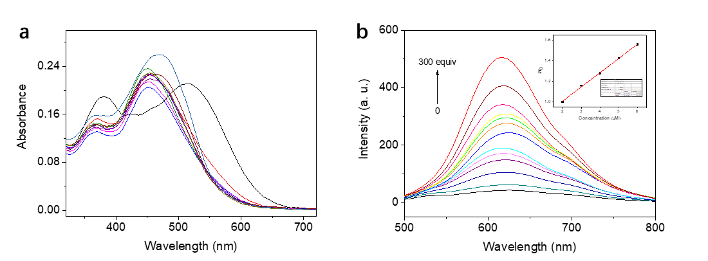
Supplementary Fig. 7. Absorption (a) and emission (b) spectra spectra of Lighter EW Tracker (DCM-IN-NH₂,10 μM) with increasing concentration of DCP (0-300 equiv) in CH₃CN solution, λ_{ex}=470 nm. Inset: Variations in I/I₀ of Lighter EW Tracker with different concentration of DCP, I₀ and I are the emission intensities of DCM-IN-NH₂ at a specific concentration of DCP, respectively.

7. ESI-MS spectra characterization of Lighter EW Tracker reaction with DCP
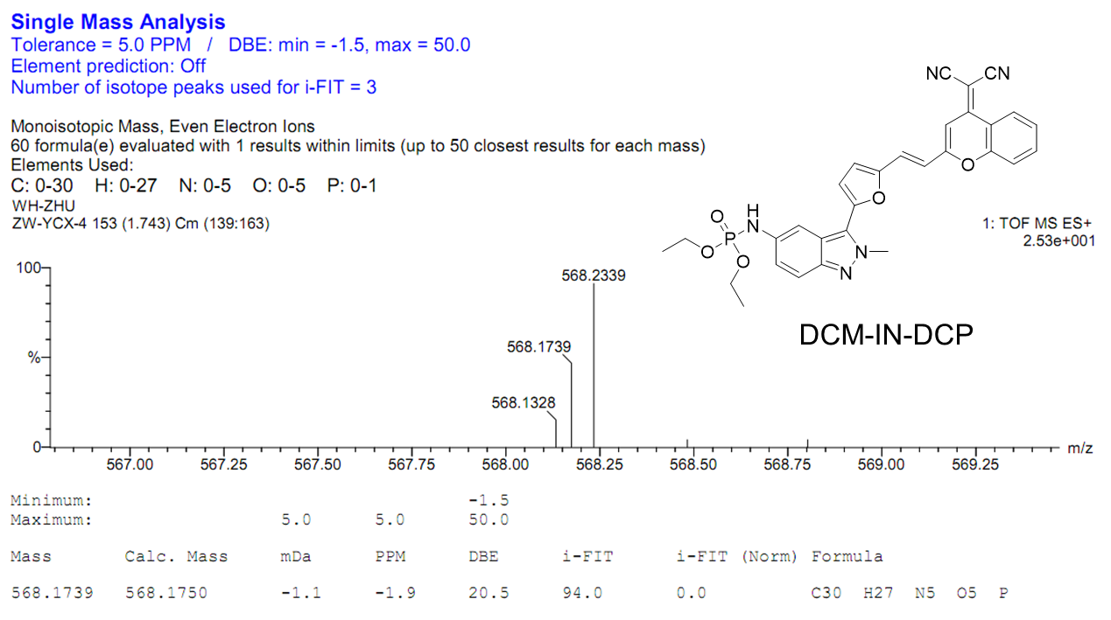
Supplementary Fig. 8. HRMS spectrum of DCM-IN-DCP from the reaction of Lighter EW Tracker (DCM-IN-NH₂) with DCP.

8. Intracellular localization of Lighter EW Tracker
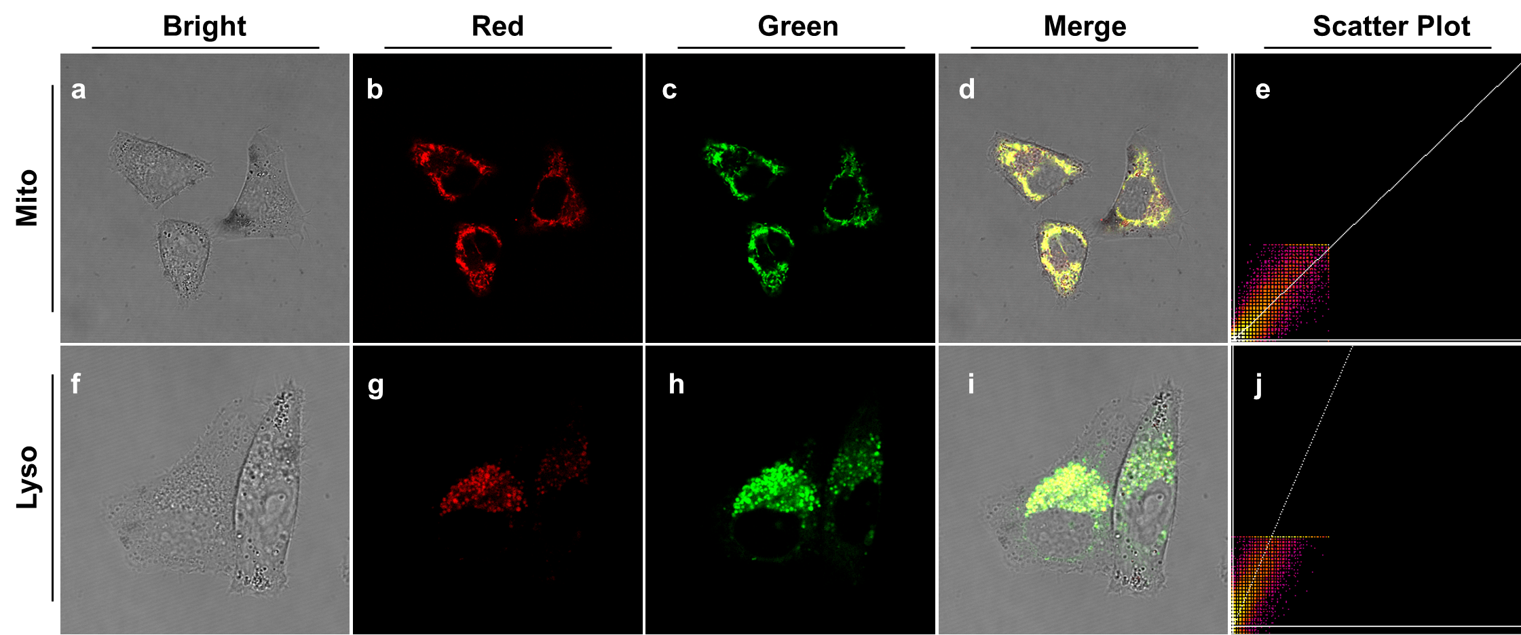
Supplementary Fig. 9. CLSM images for intracellular localization of Lighter EW Tracker (DCM-IN-NH₂) in HepG2 cells. Cells were incubated with Lighter EW Tracker (10 μM) for 3 h and then co-stained with 100 nM Lyso-Tracker Red DND-99 (a-e) and 200 nM Mito-Tracker Red (f-j) for 30 min, respectively. The green channel at 590-610 nm for Lyso-Tracker Red DND-99 and Mito-Tracker Red, λ_{ex} = 568 nm. The Red channel at 650-800 nm, λ_{ex} = 520 nm. Note: Pearson’s correlation coefficient of Lighter EW Tracker is 0.8988 and 0.7822 with Mito-Tracker Red and Lyso-Tracker Red DND-99, respectively.

9. Characterization of indazole-based fluorophores
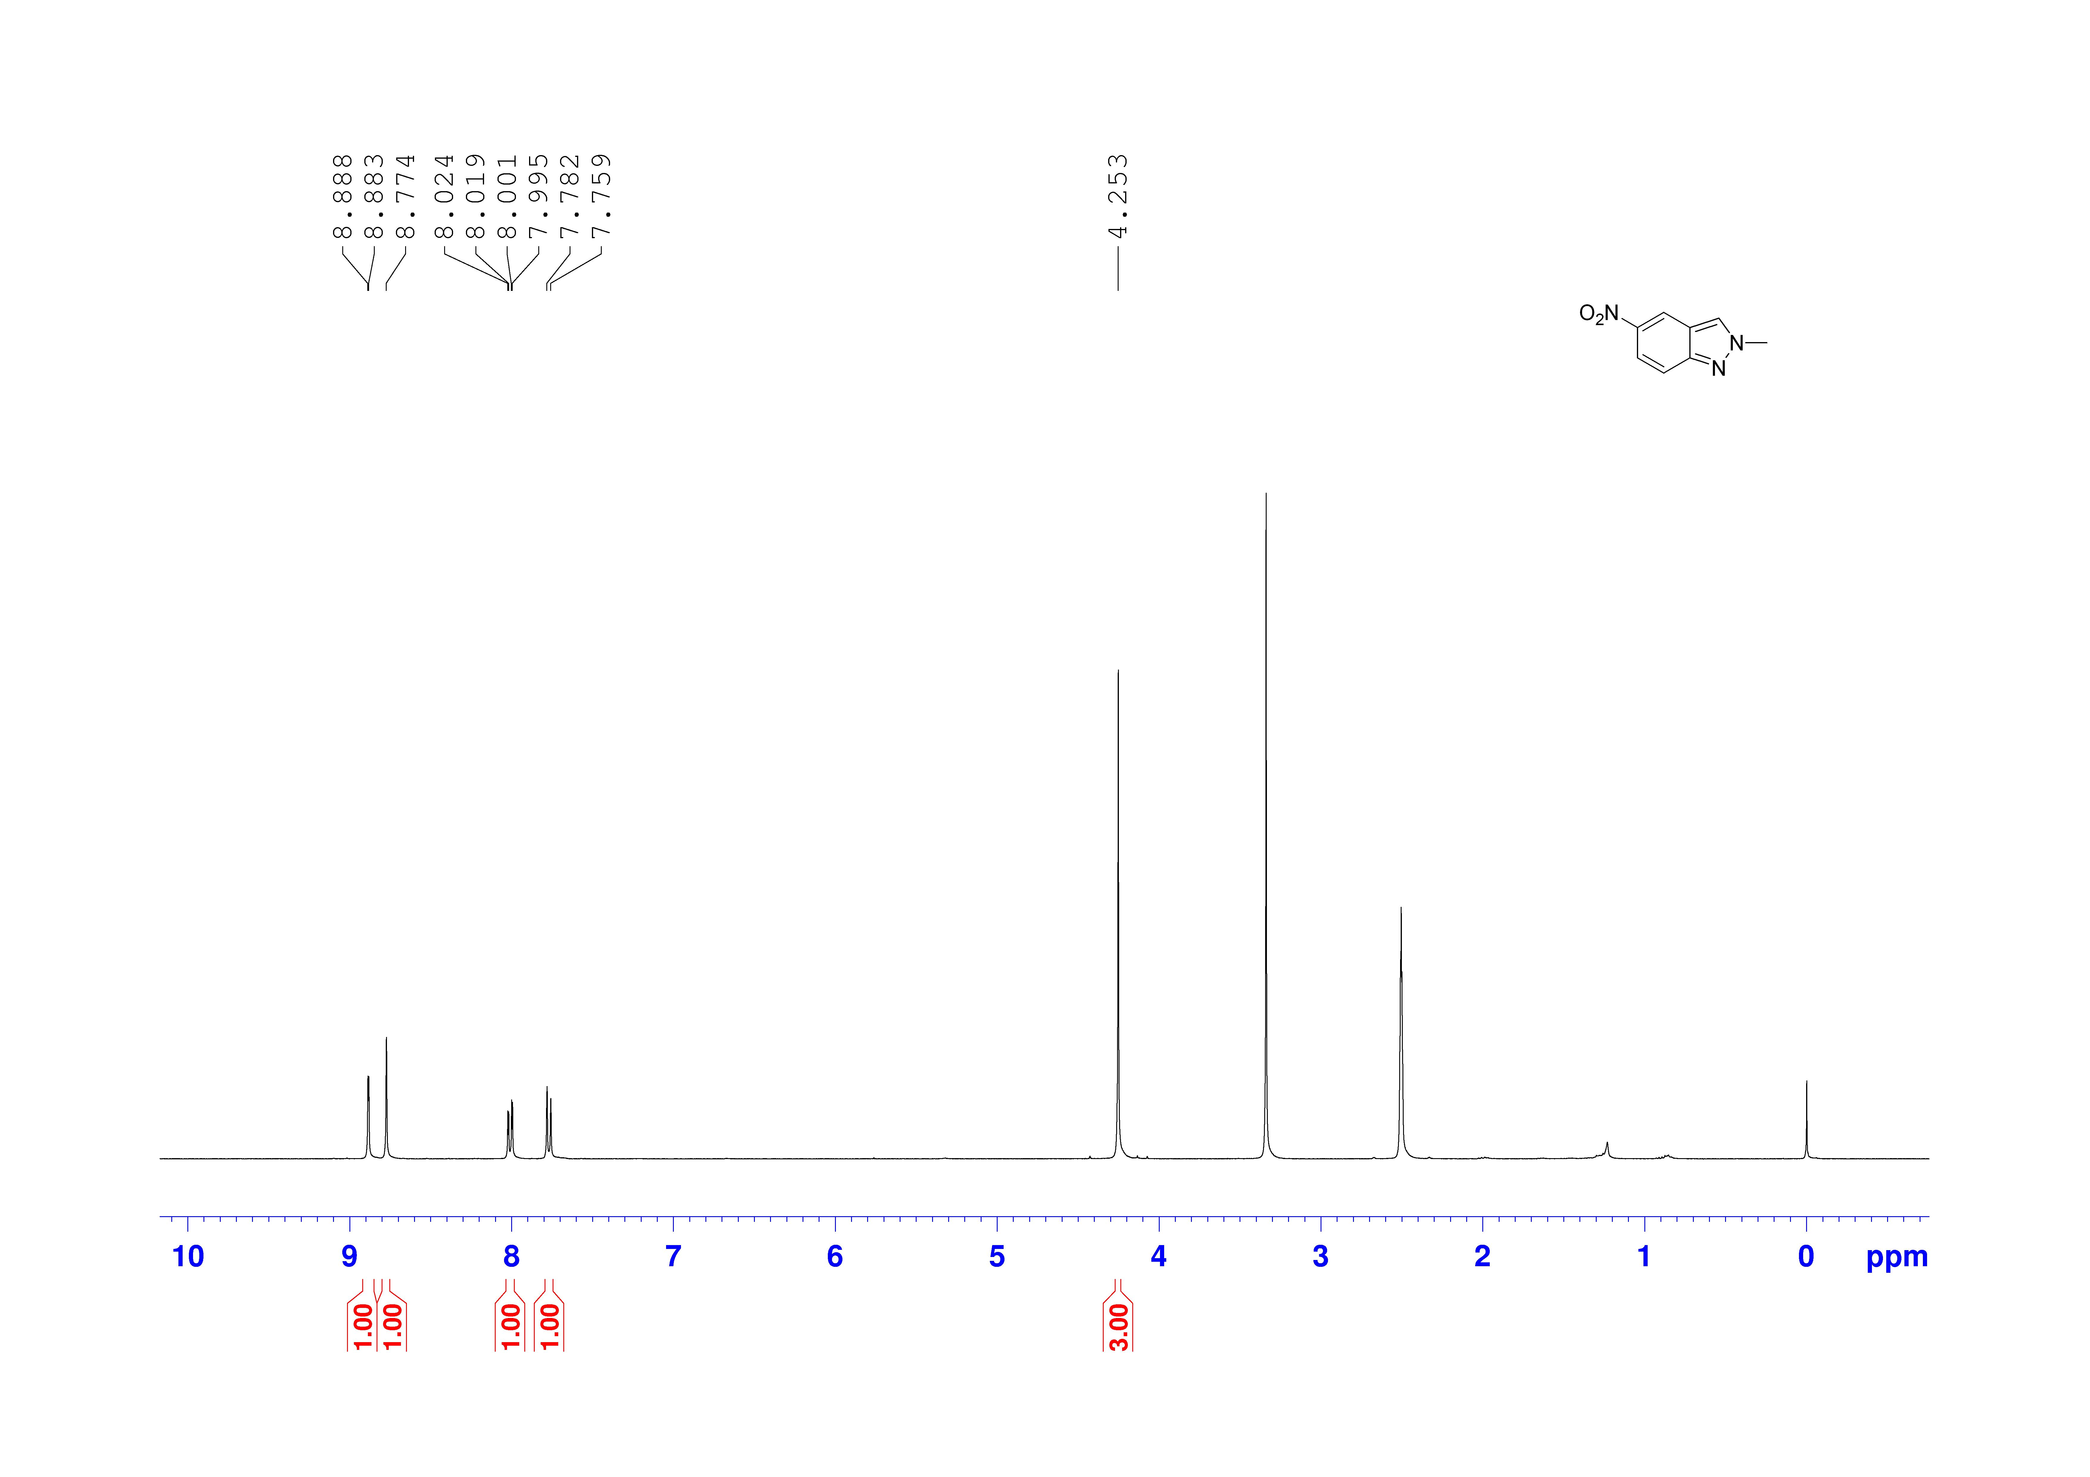
Supplementary Fig. 10. ¹H NMR spectrum of IN-NO₂ in DMSO-d₆

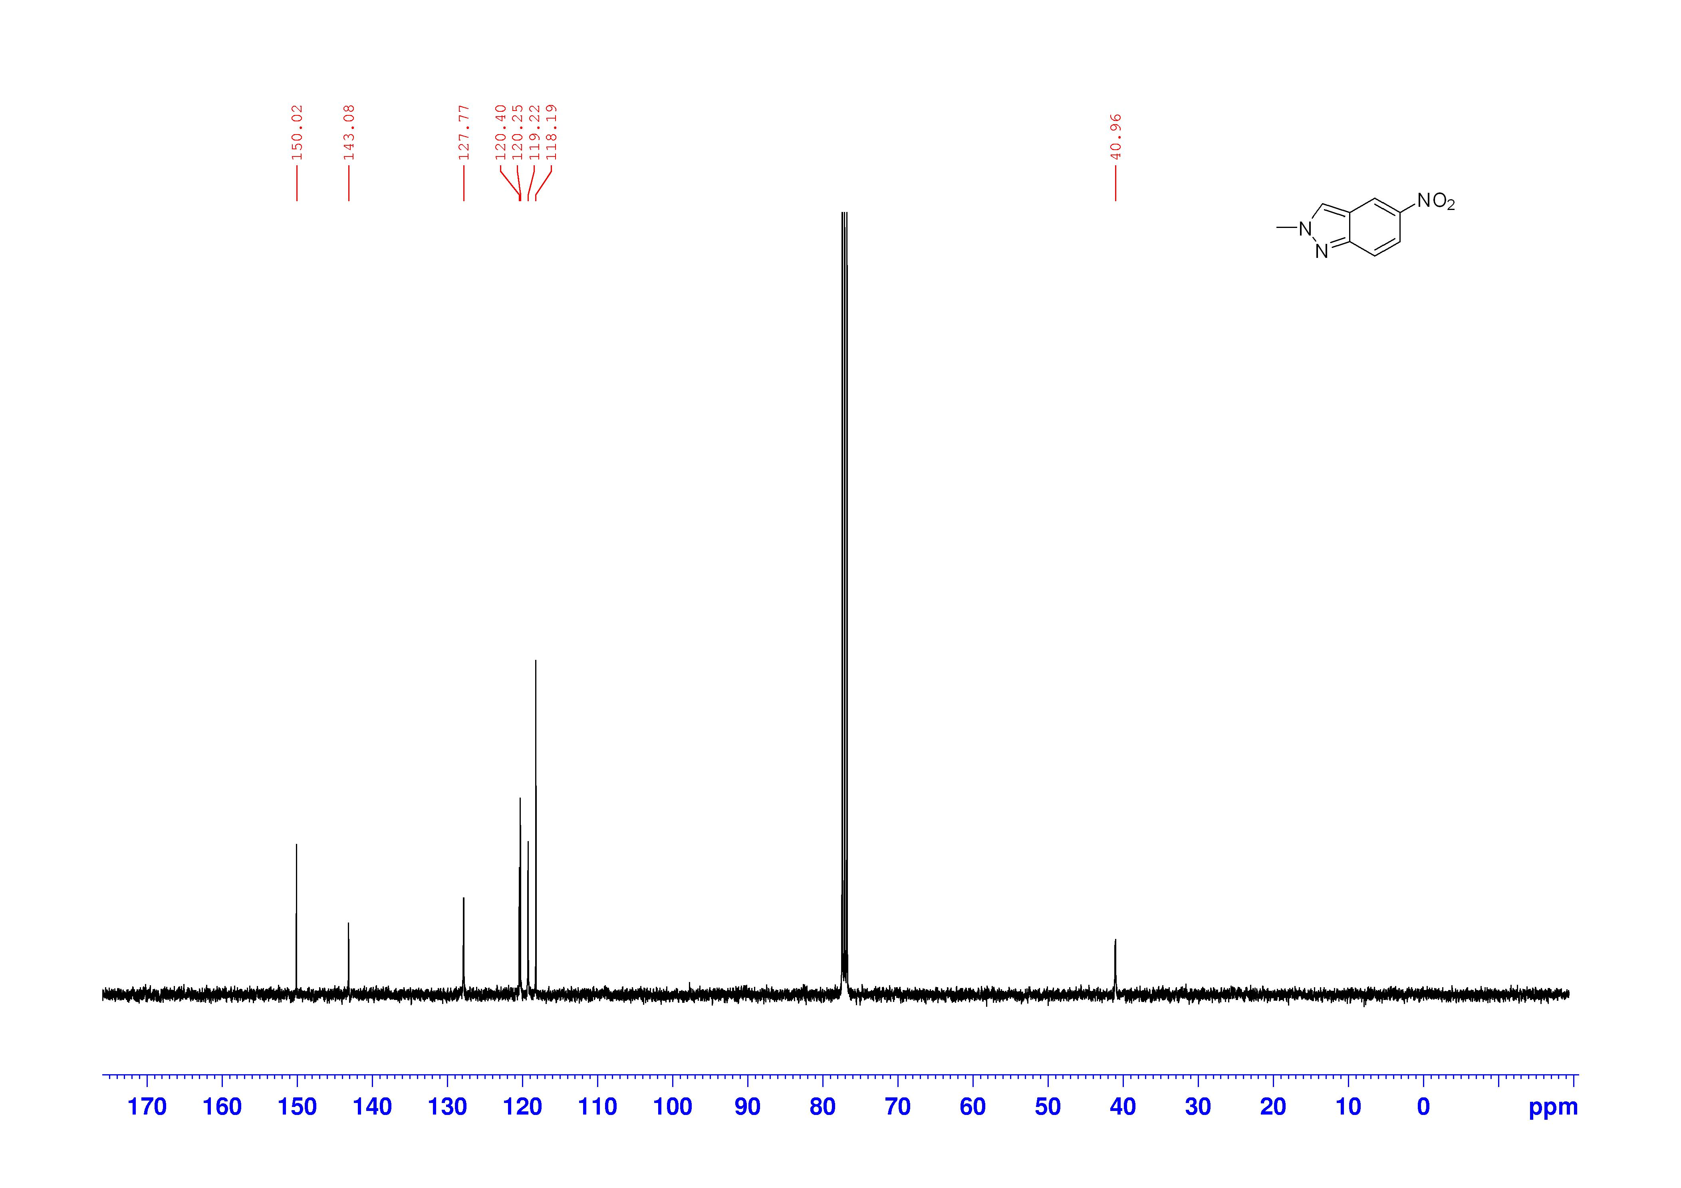
Supplementary Fig. 11. ¹³C NMR spectrum of IN-NO₂ in CDCl₃
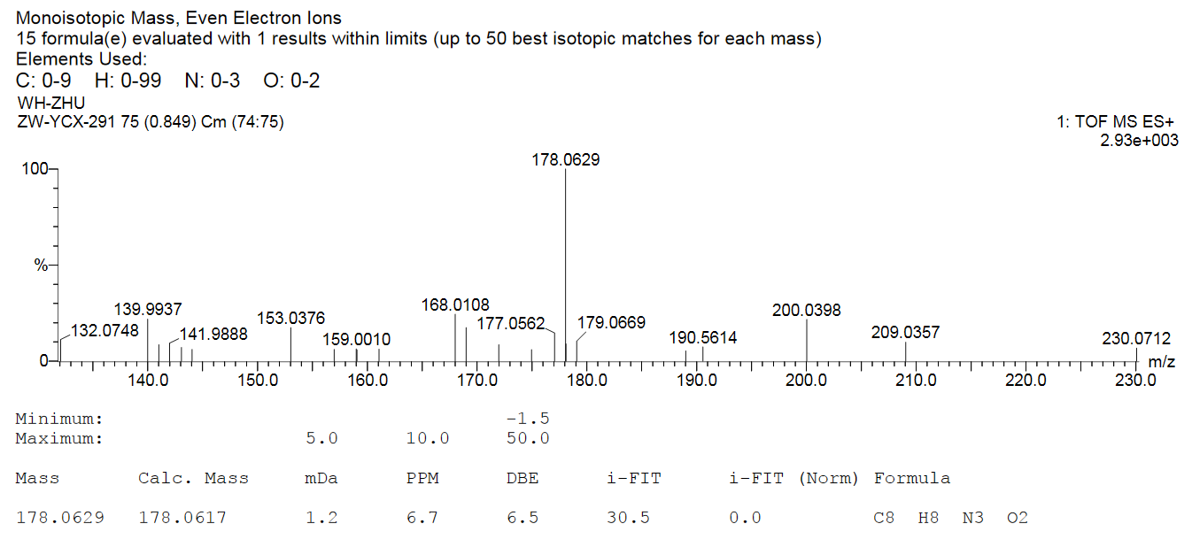
Supplementary Fig. 12. HRMS spectrum of IN-NO₂

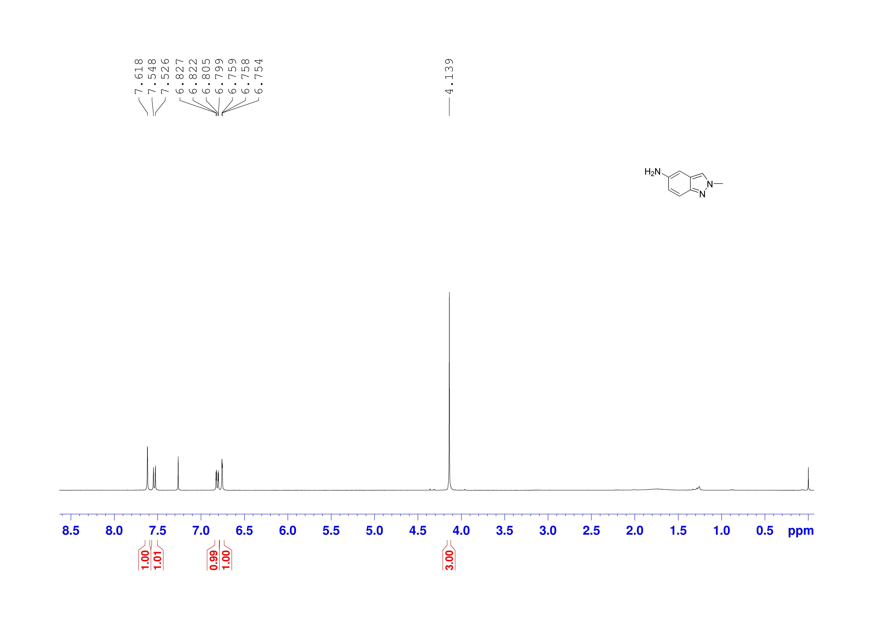
Supplementary Fig. 13. ¹H NMR spectrum of IN-NH₂ in CDCl₃

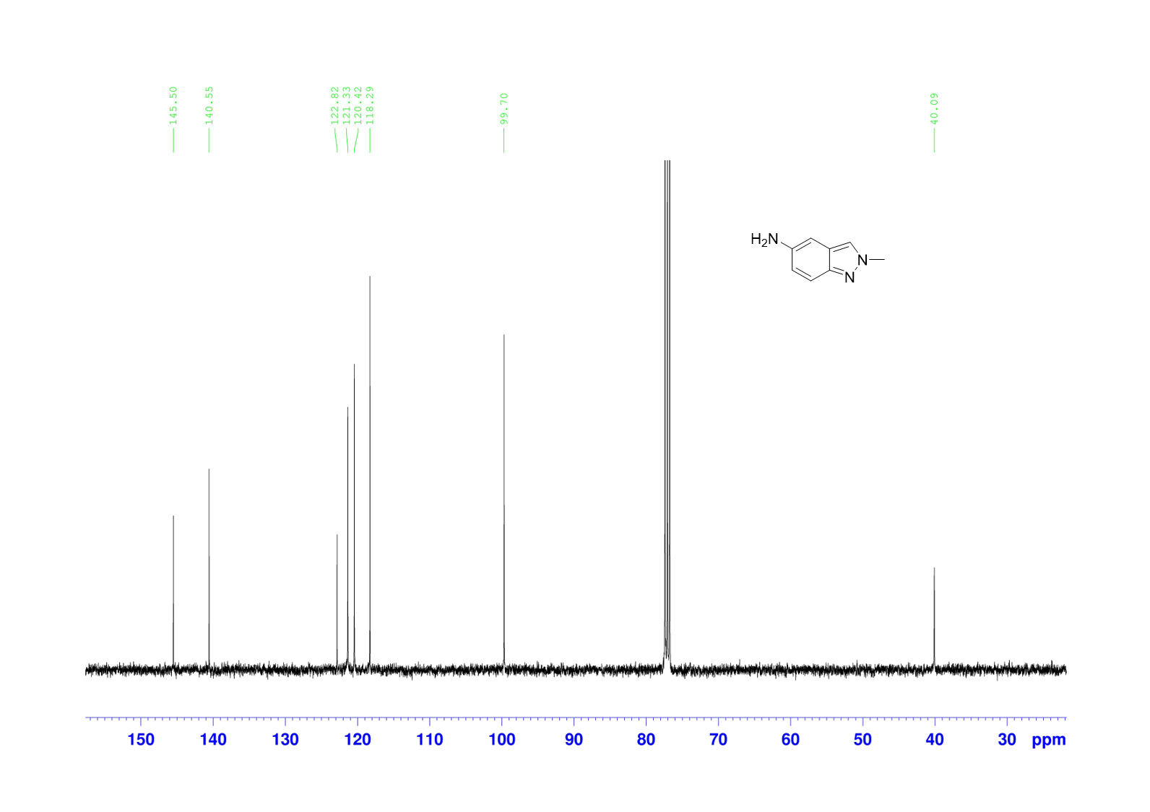
Supplementary Fig. 14. ¹³C NMR spectrum of IN-NH₂ in CDCl₃

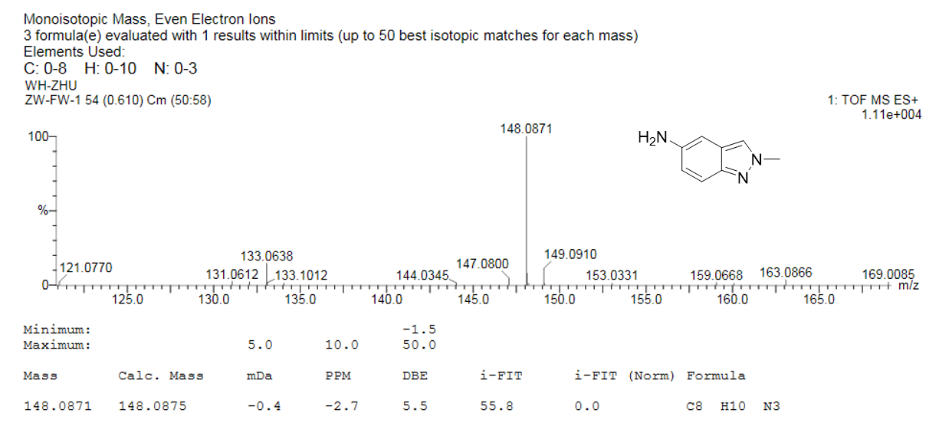
Supplementary Fig. 15. HRMS spectrum of IN-NH₂

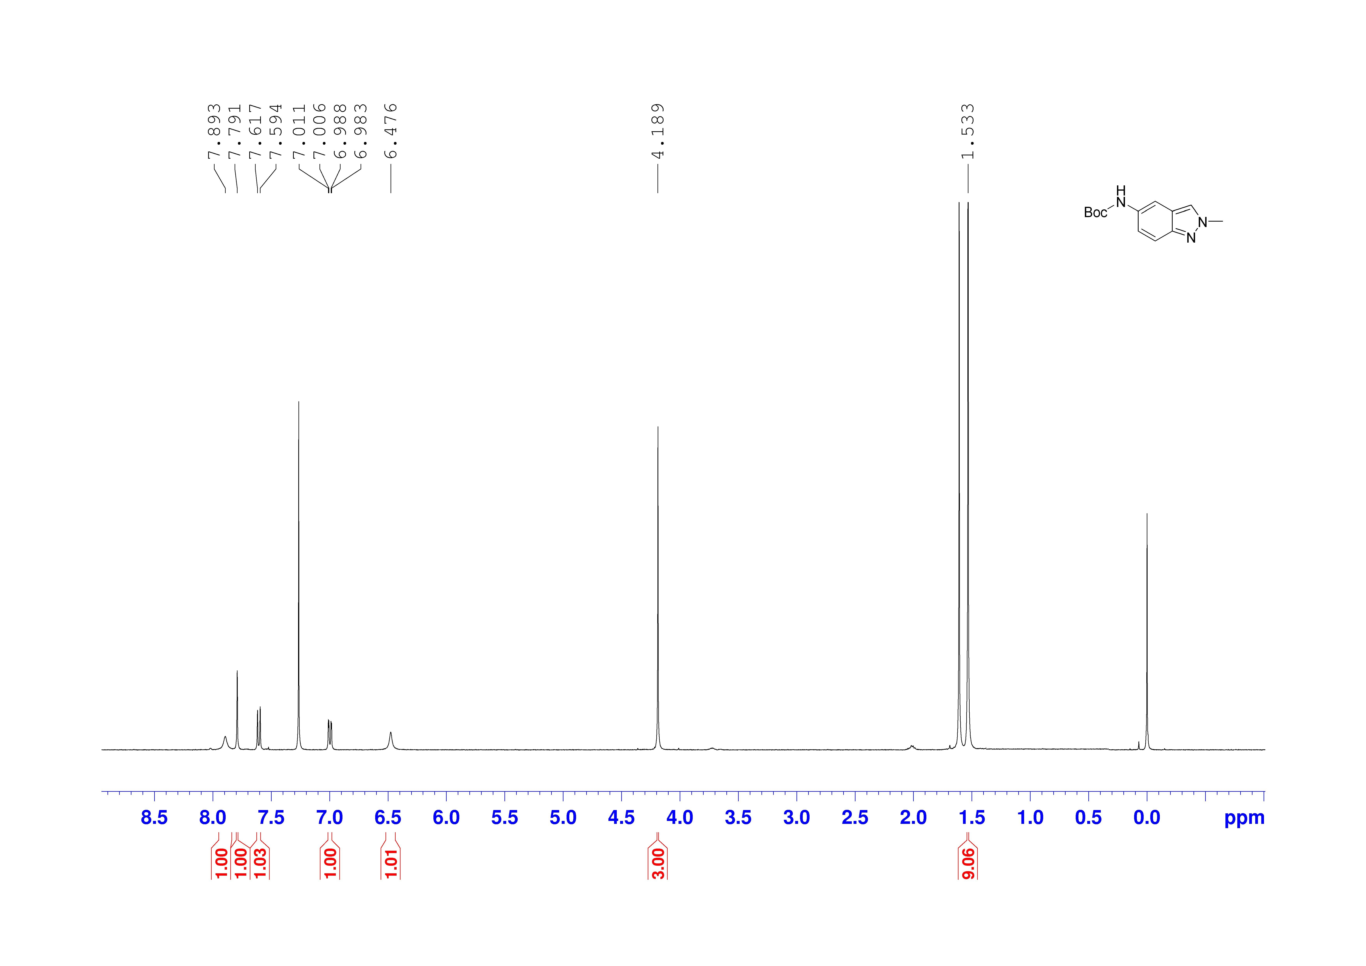
Supplementary Fig. 16. ¹H NMR spectrum of IN-Boc in CDCl₃

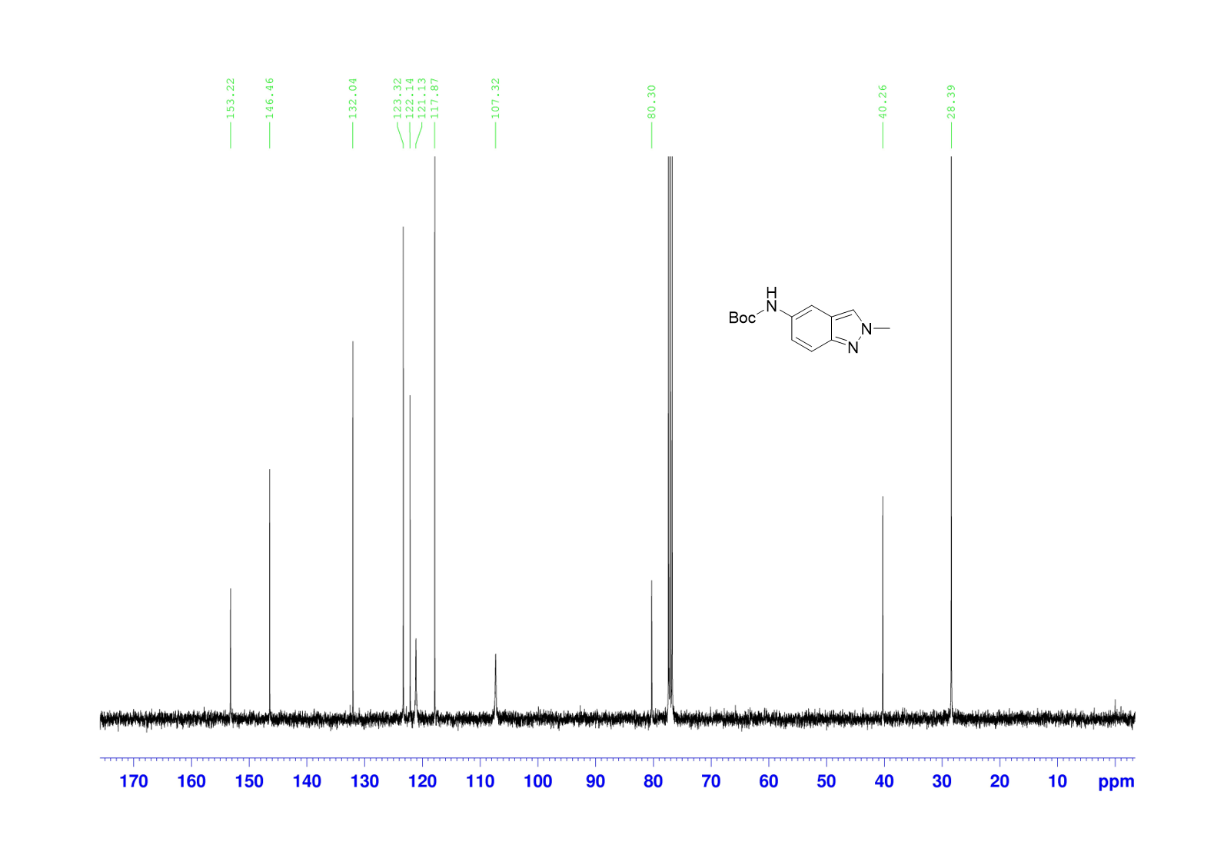
Supplementary Fig. 17. ¹³C NMR spectrum of IN-Boc in CDCl₃

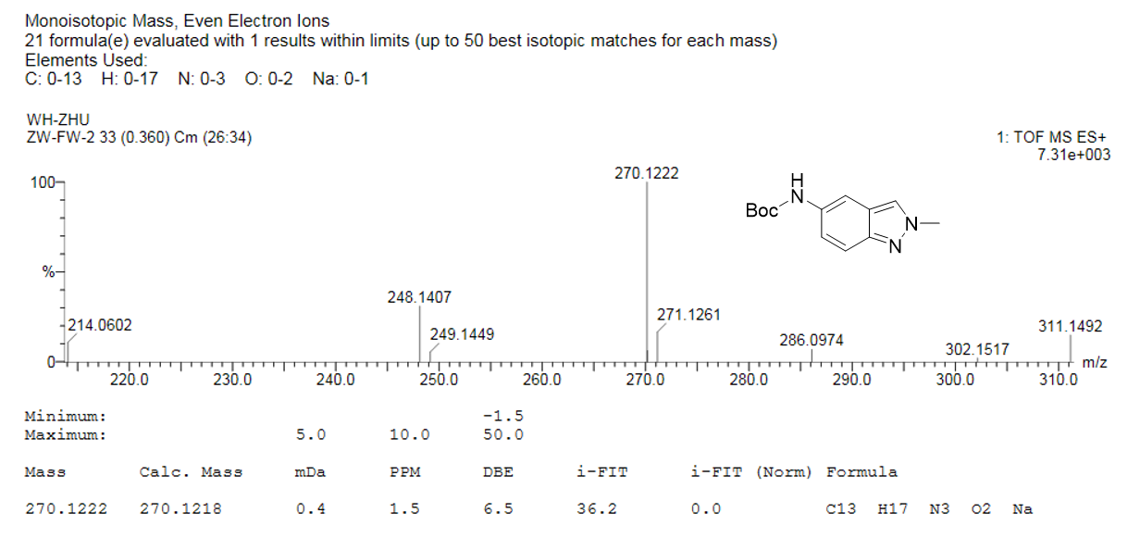
Supplementary Fig. 18. HRMS spectrum of IN-Boc

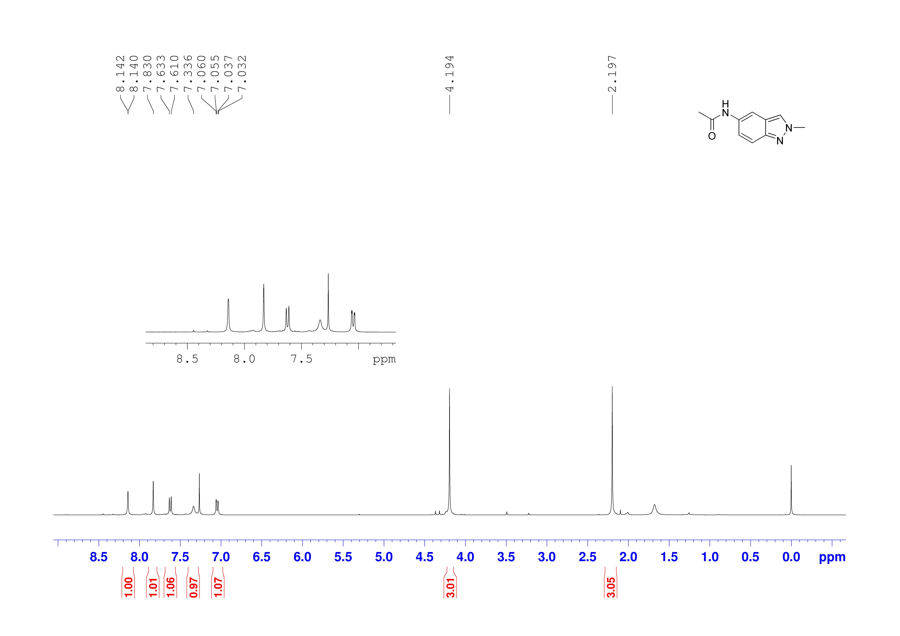
Supplementary Fig. 19. ¹H NMR spectrum of IN-Ac in CDCl₃

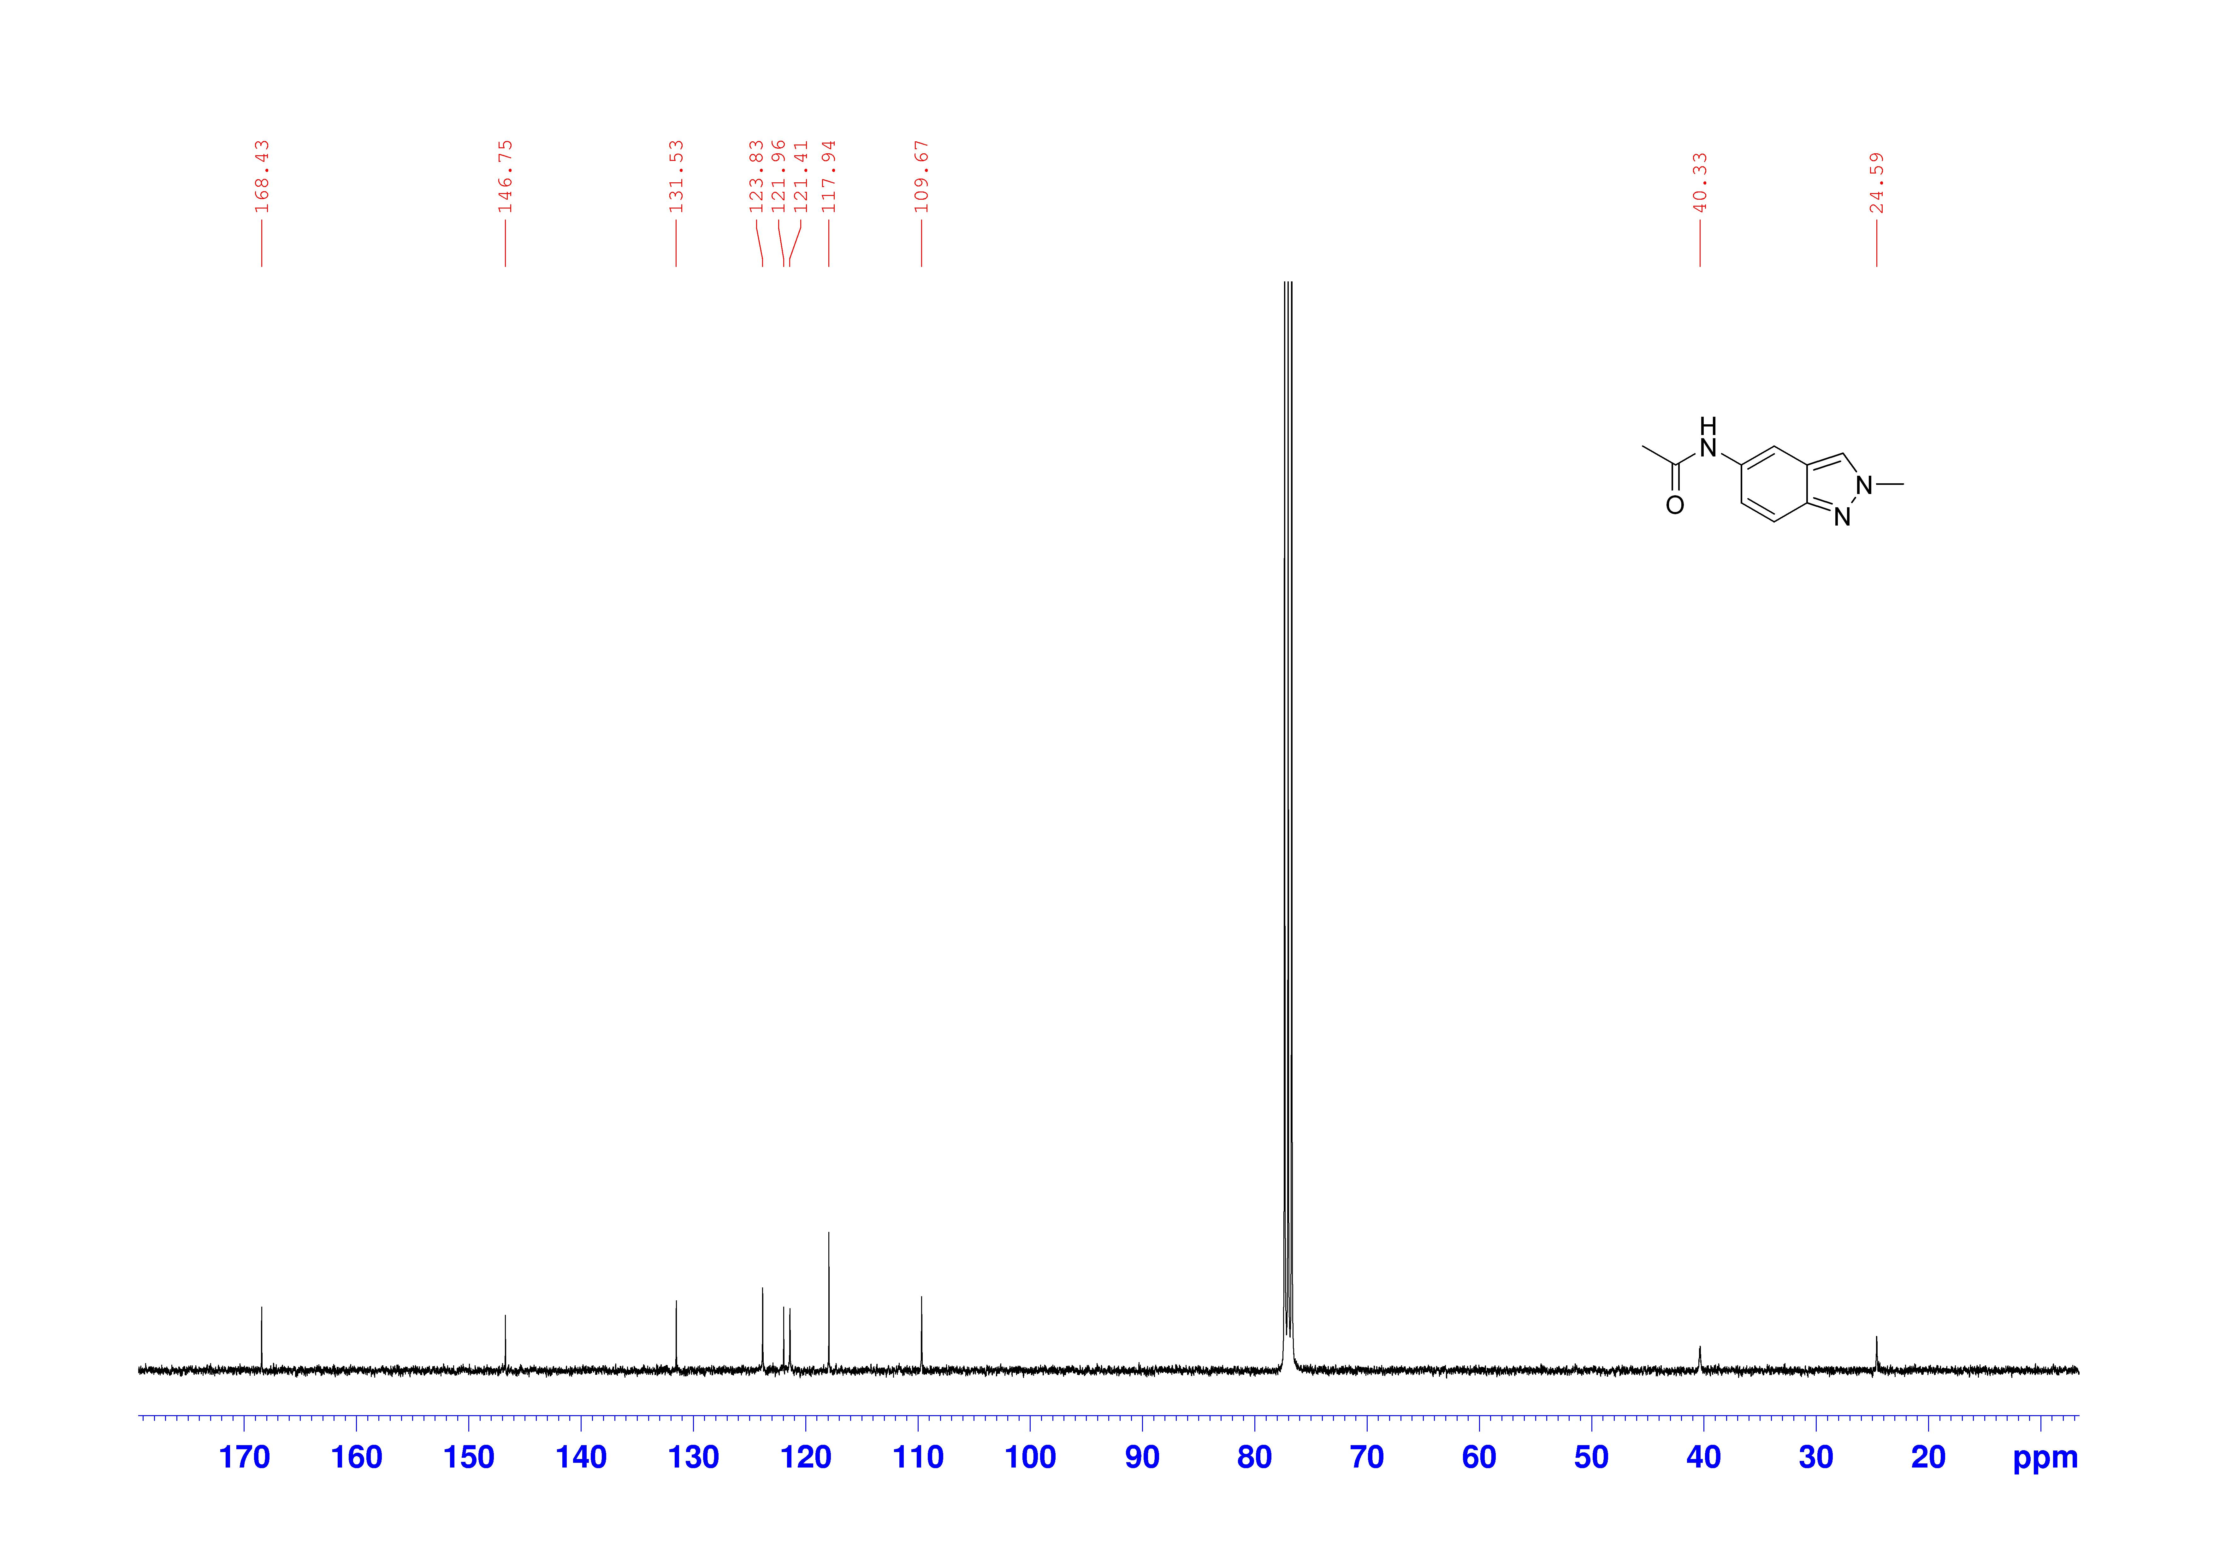
Supplementary Fig. 20. ¹³C NMR spectrum of IN-Ac in CDCl₃

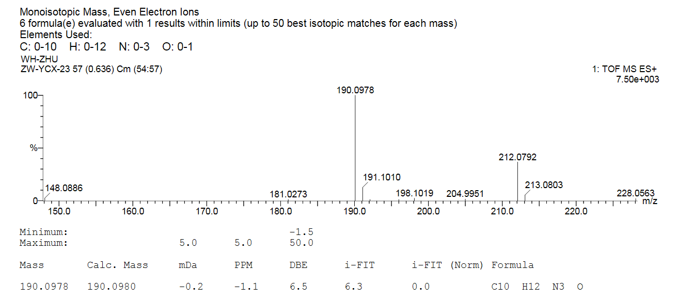
Supplementary Fig. 21. HRMS spectrum of IN-Ac

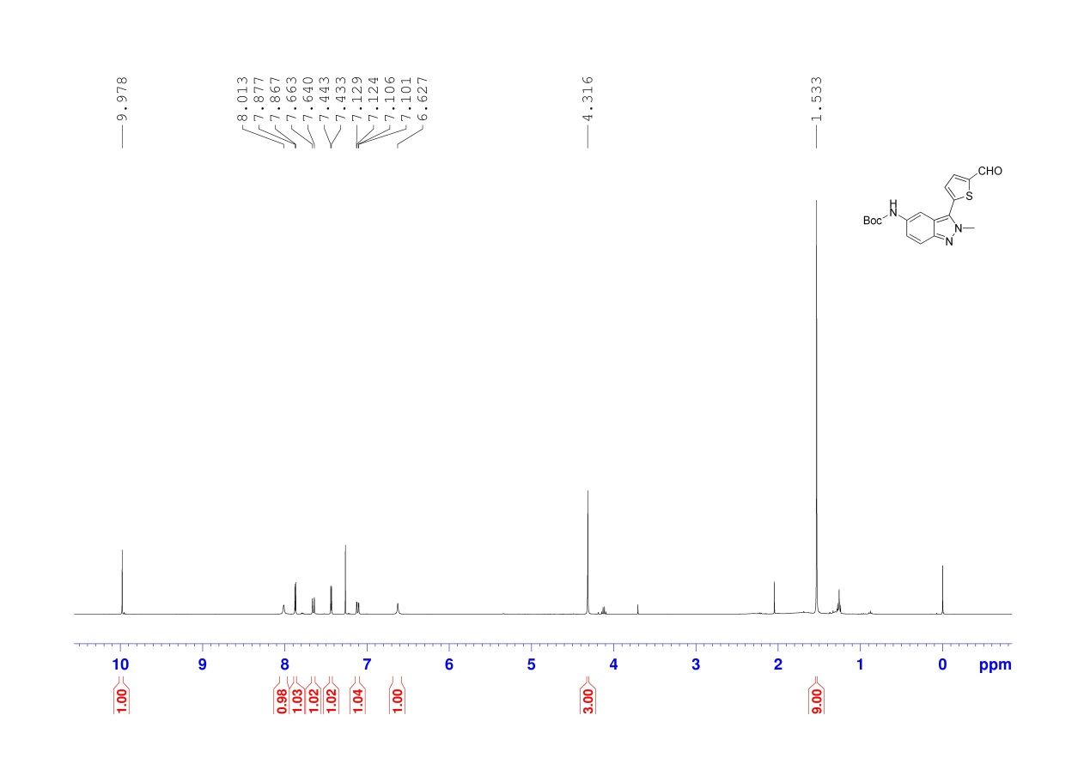
Supplementary Fig. 22. ¹H NMR spectrum of AL-SIN-Boc in CDCl₃

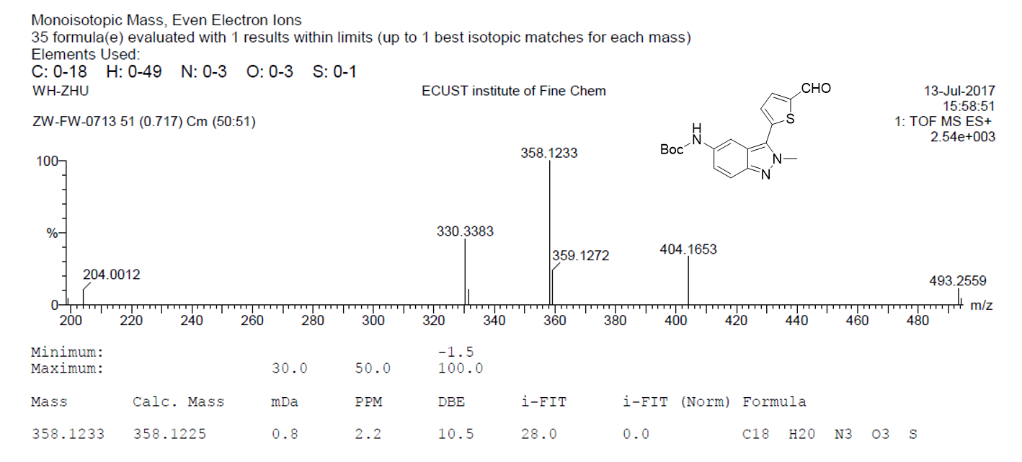
Supplementary Fig. 23. HRMS spectrum of AL-SIN-Boc

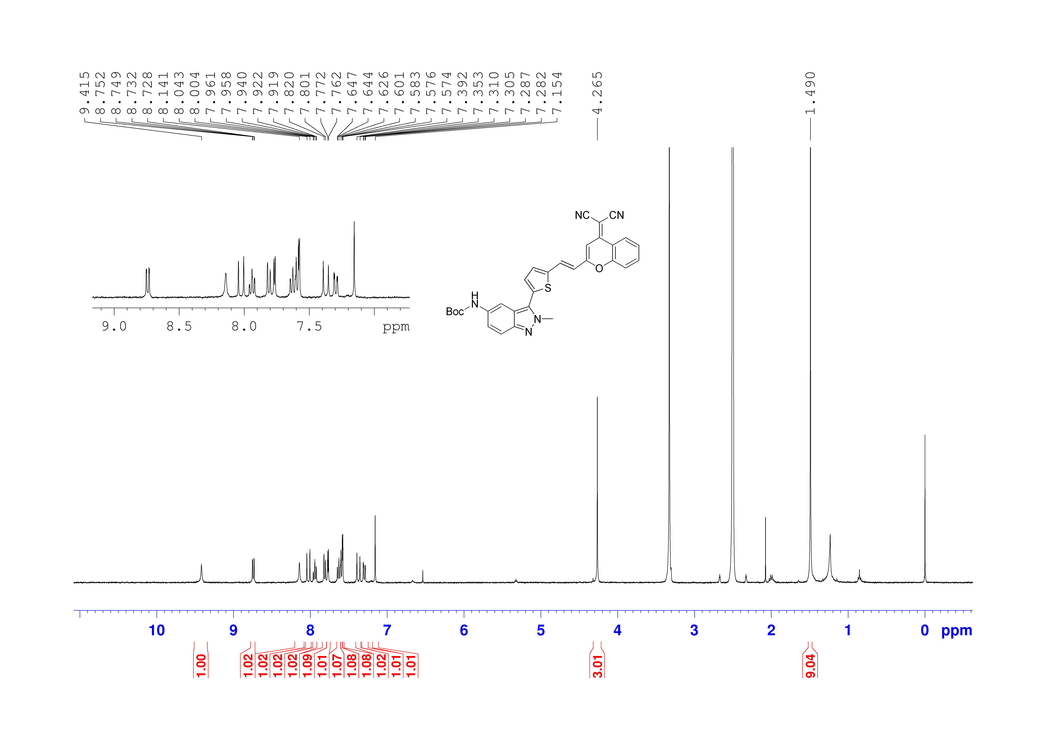
Supplementary Fig. 24. ¹H NMR spectrum of DCM-SIN-Boc in DMSO-d₆

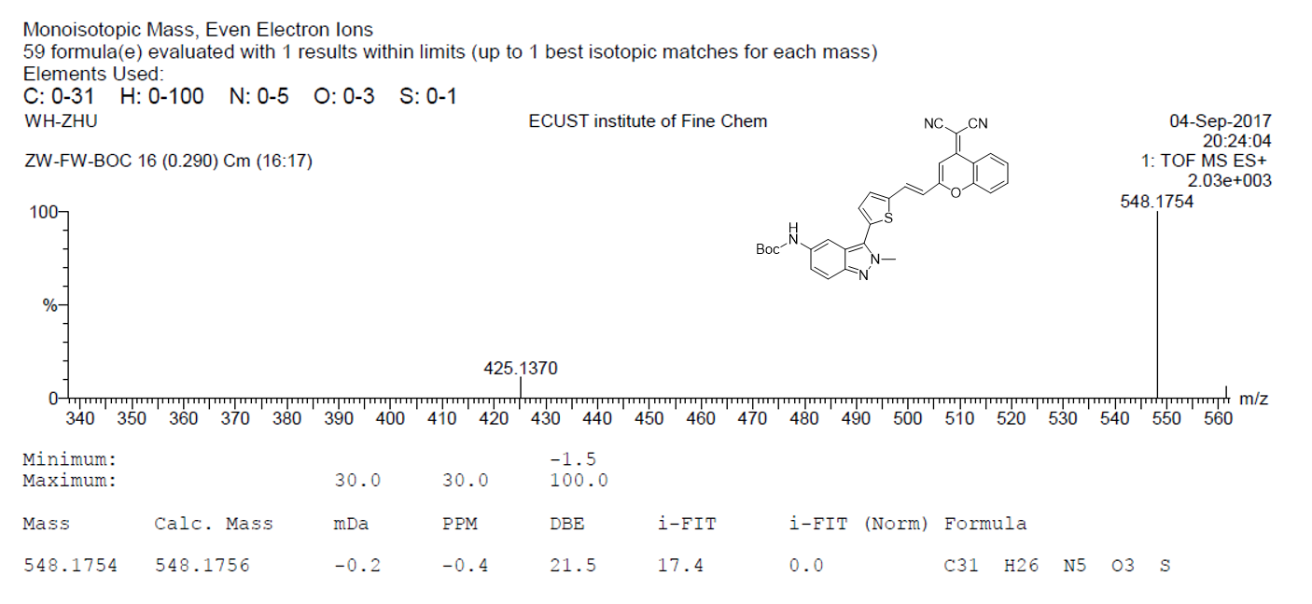
Supplementary Fig. 25. HRMS spectrum of DCM-SIN-Boc

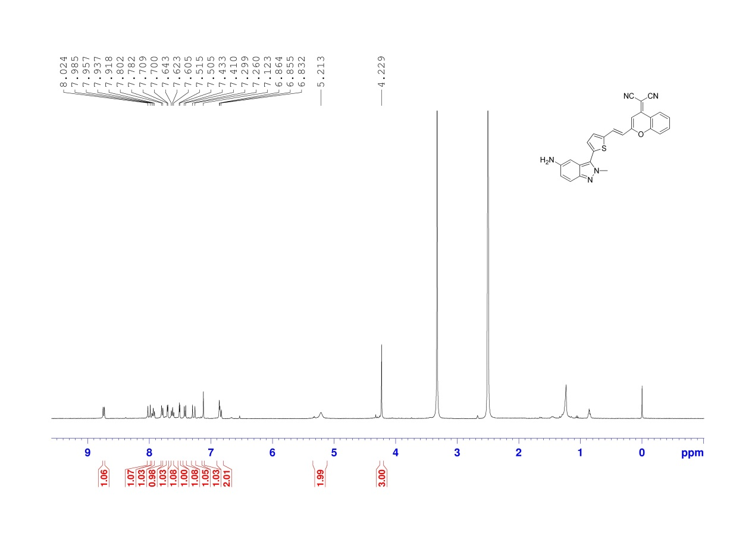
Supplementary Fig. 26. ¹H NMR spectrum of DCM-SIN-NH₂ in DMSO-d₆

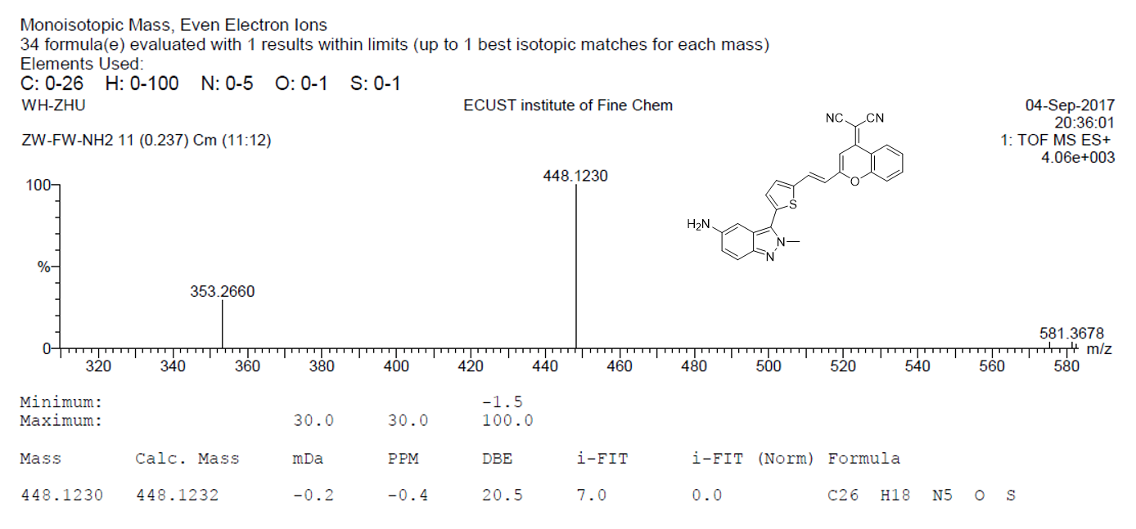
Supplementary Fig. 27. HRMS spectrum of DCM-SIN-NH₂
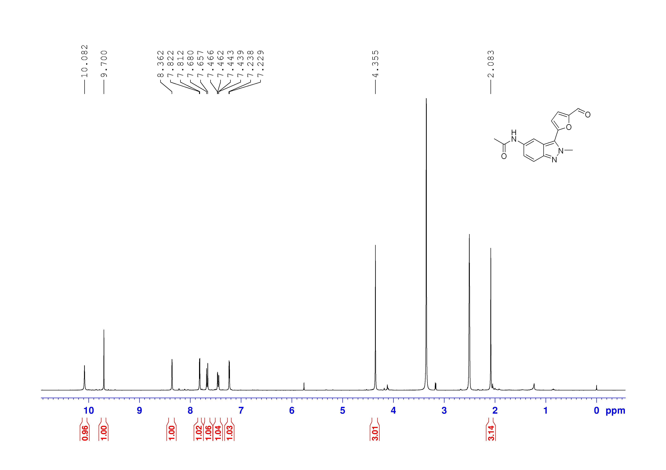
Supplementary Fig. 28. ¹H NMR spectrum of AL-IN-Ac in DMSO-d₆

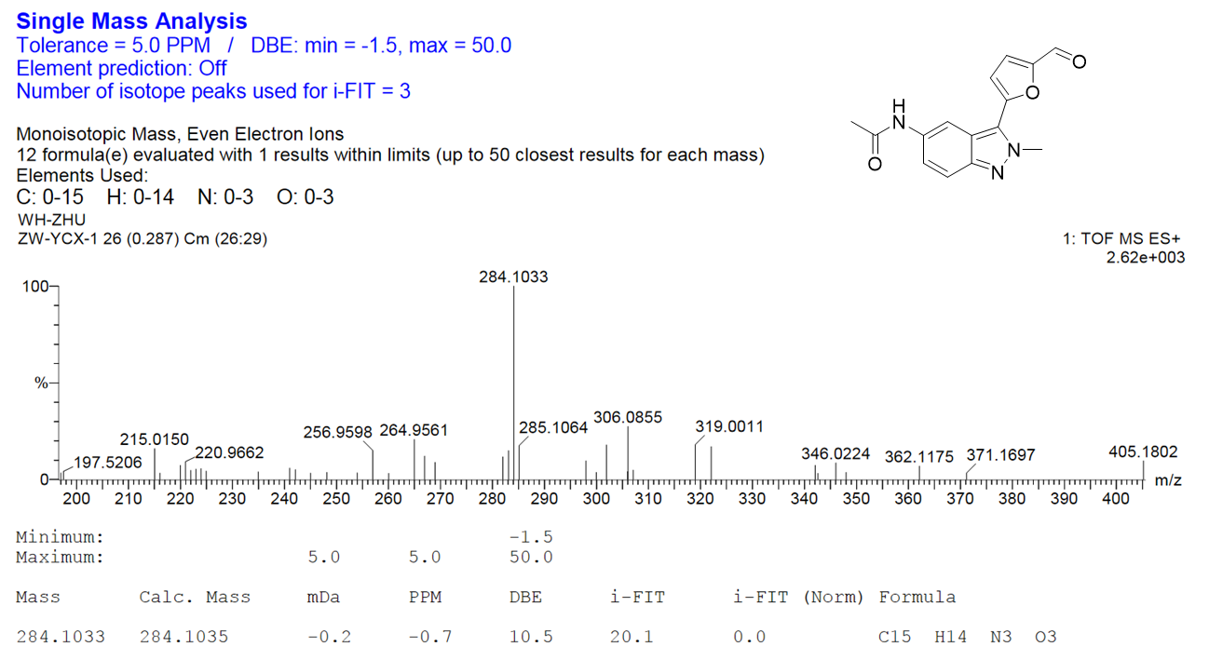
Supplementary Fig. 29. HRMS spectrum of AL-IN-Ac

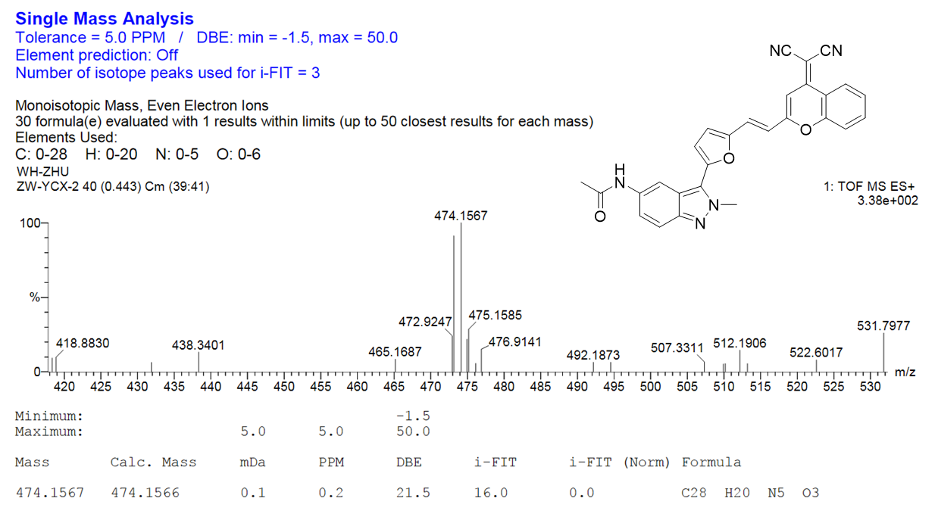
Supplementary Fig. 30. HRMS spectrum of DCM-IN-Ac

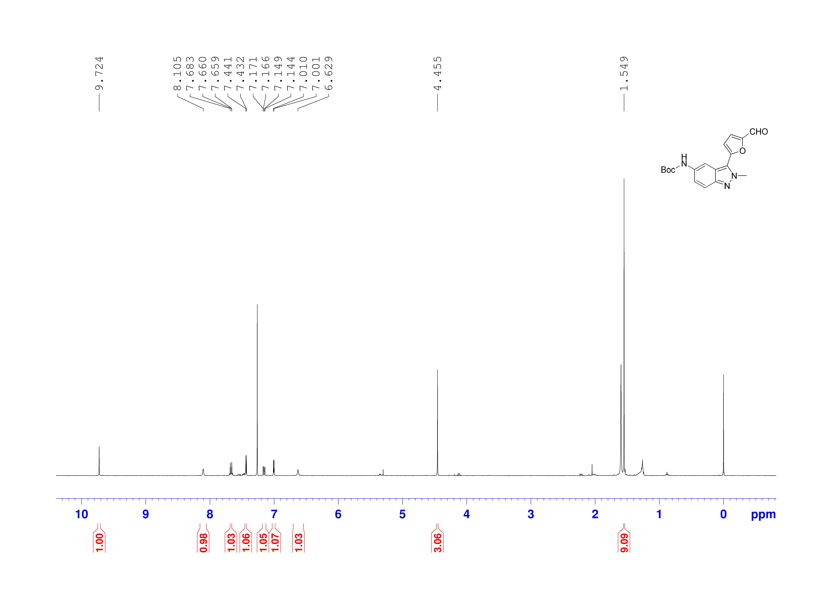
Supplementary Fig. 31. ¹H NMR spectrum of AL-IN-Boc in CDCl₃

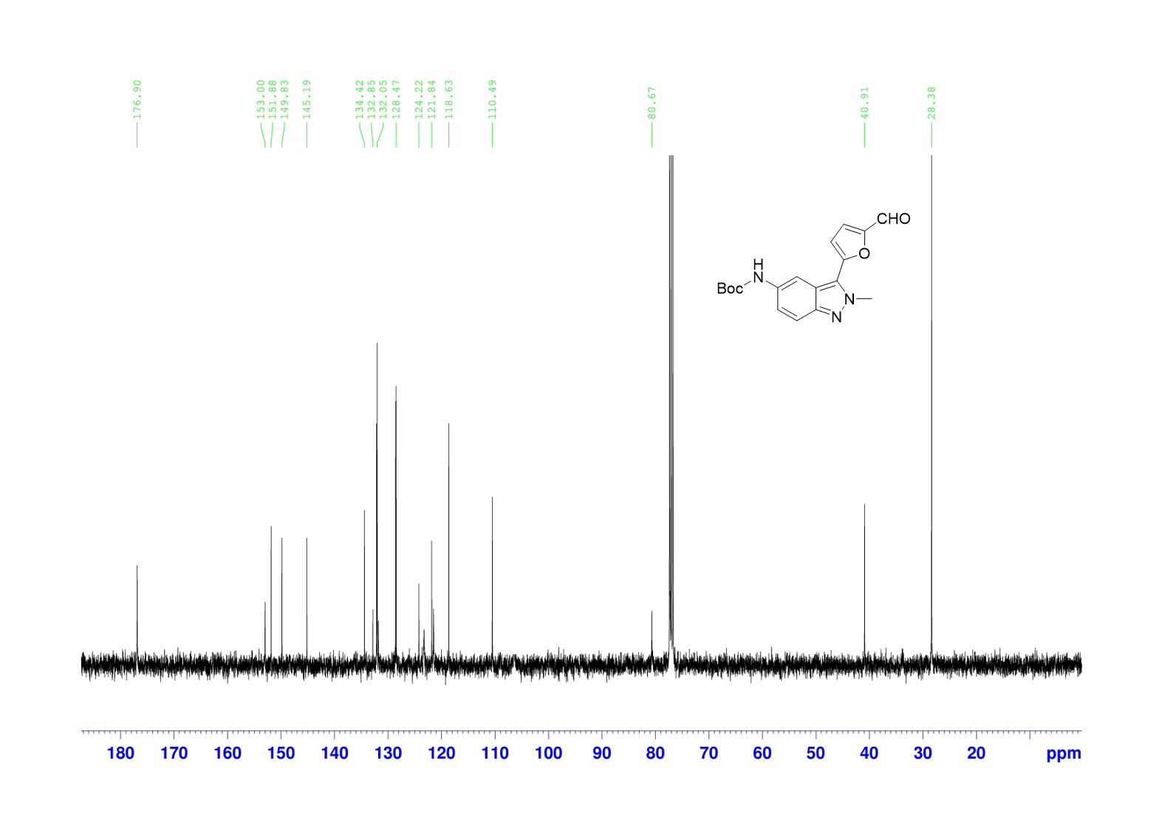
Supplementary Fig. 32. ¹³C NMR spectrum of AL-IN-Boc in CDCl₃

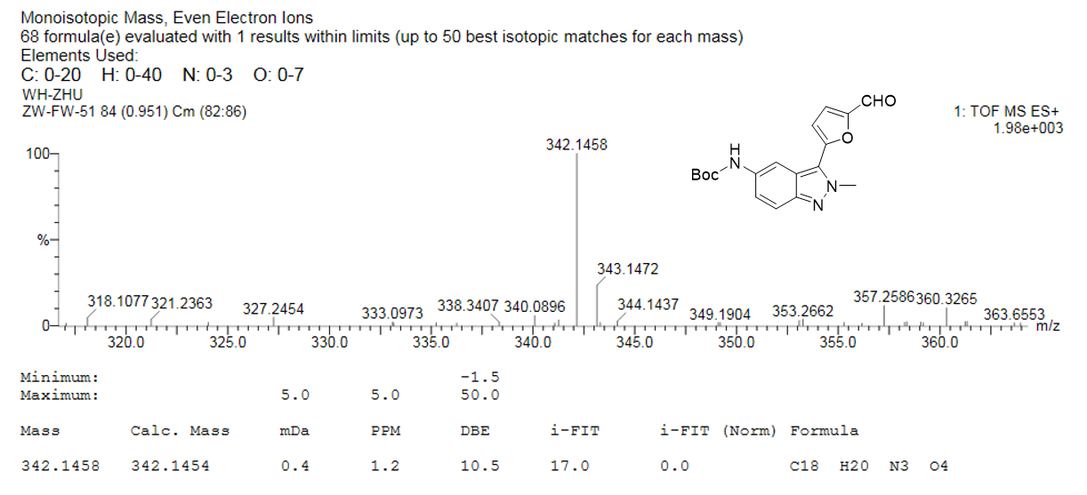
Supplementary Fig. 33. HRMS spectrum of AL-IN-Boc

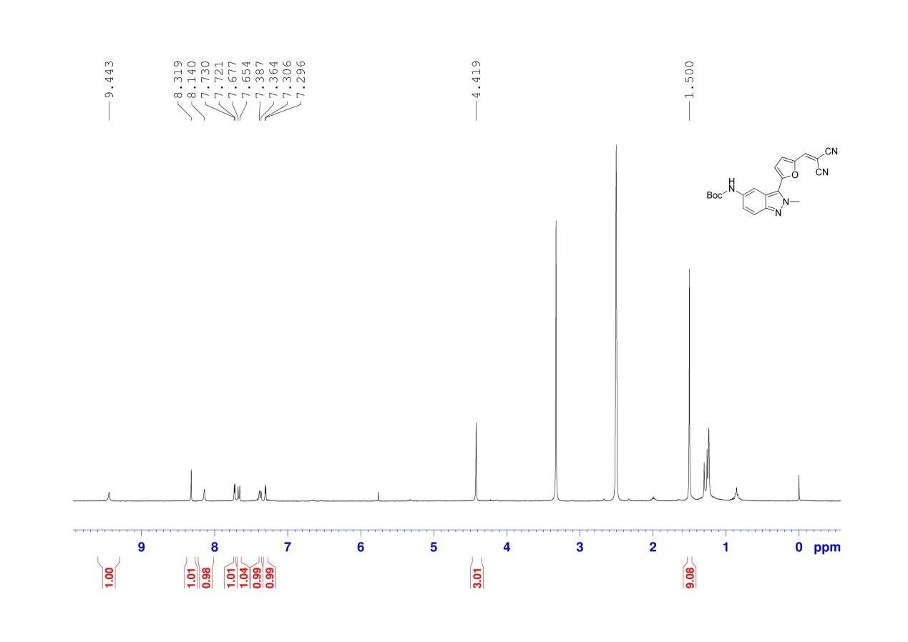
Supplementary Fig. 34. ¹H NMR spectrum of compound DC-IN-Boc in DMSO-d₆

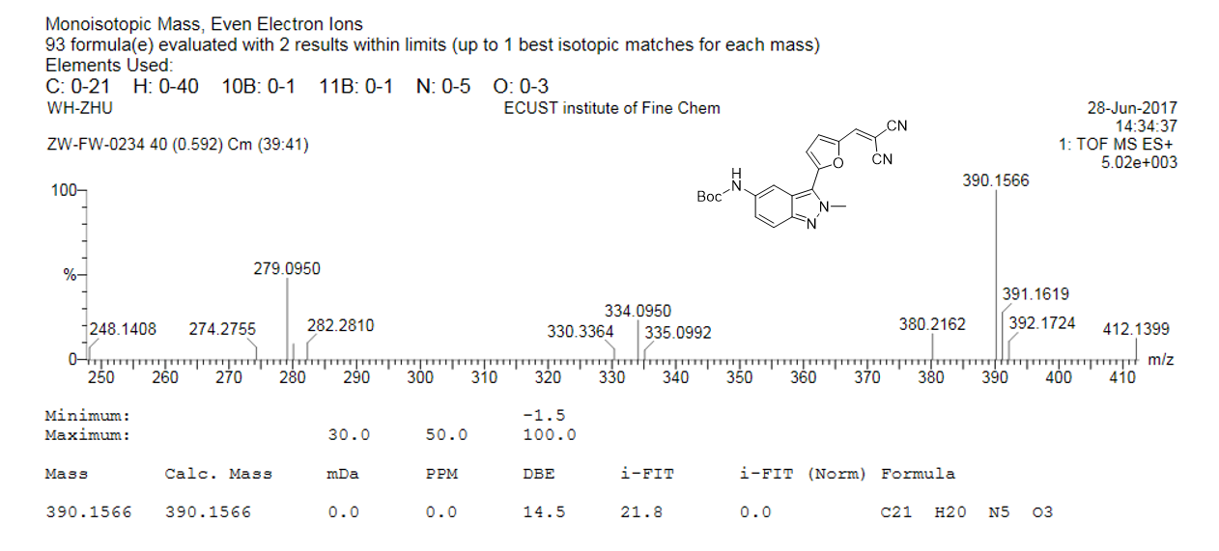
Supplementary Fig. 35. ¹³C NMR spectrum of compound DC-IN-Boc in CDCl₃

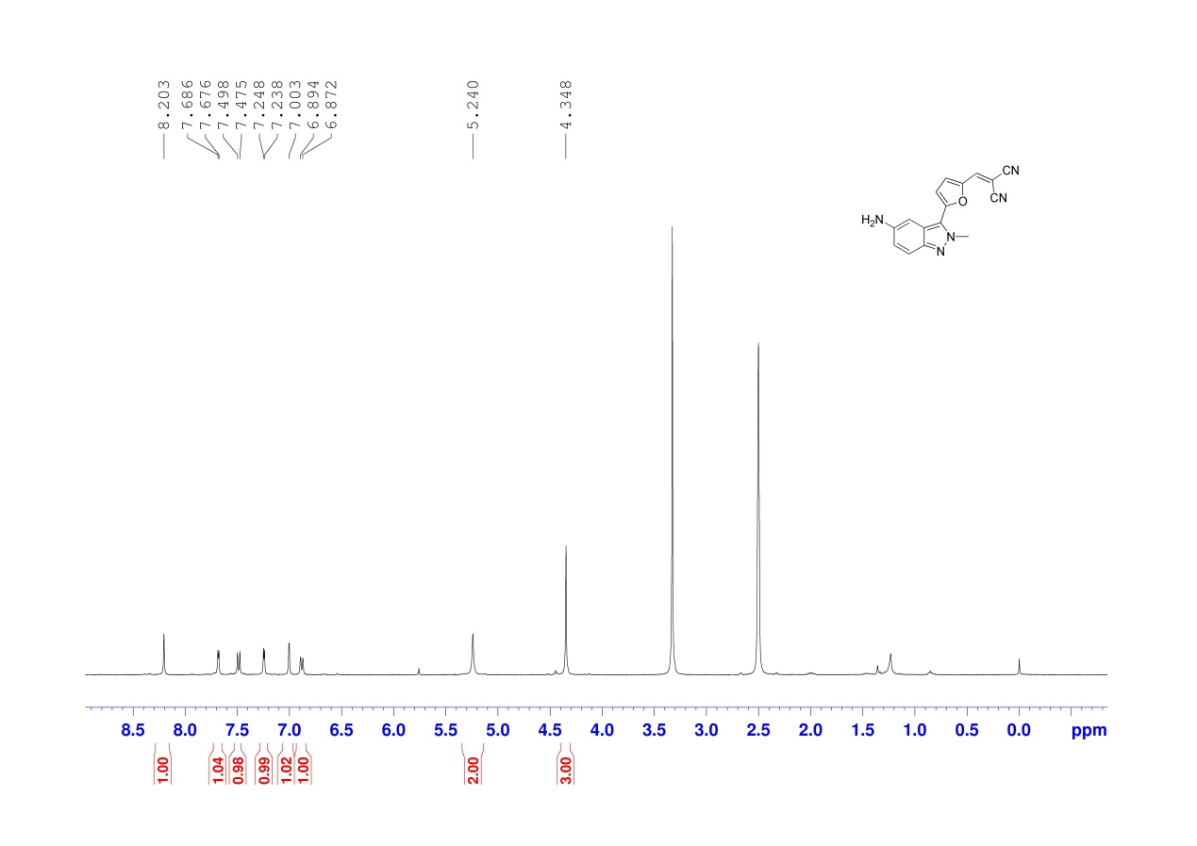
Supplementary Fig. 36. ¹H NMR spectrum of DC-IN-NH₂ in DMSO-d₆

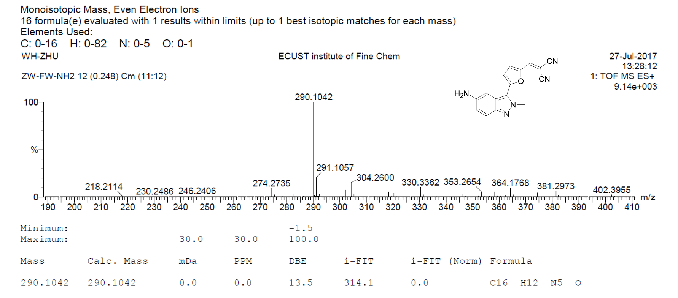
Supplementary Fig. 37. HRMS spectrum of DC-IN-NH₂

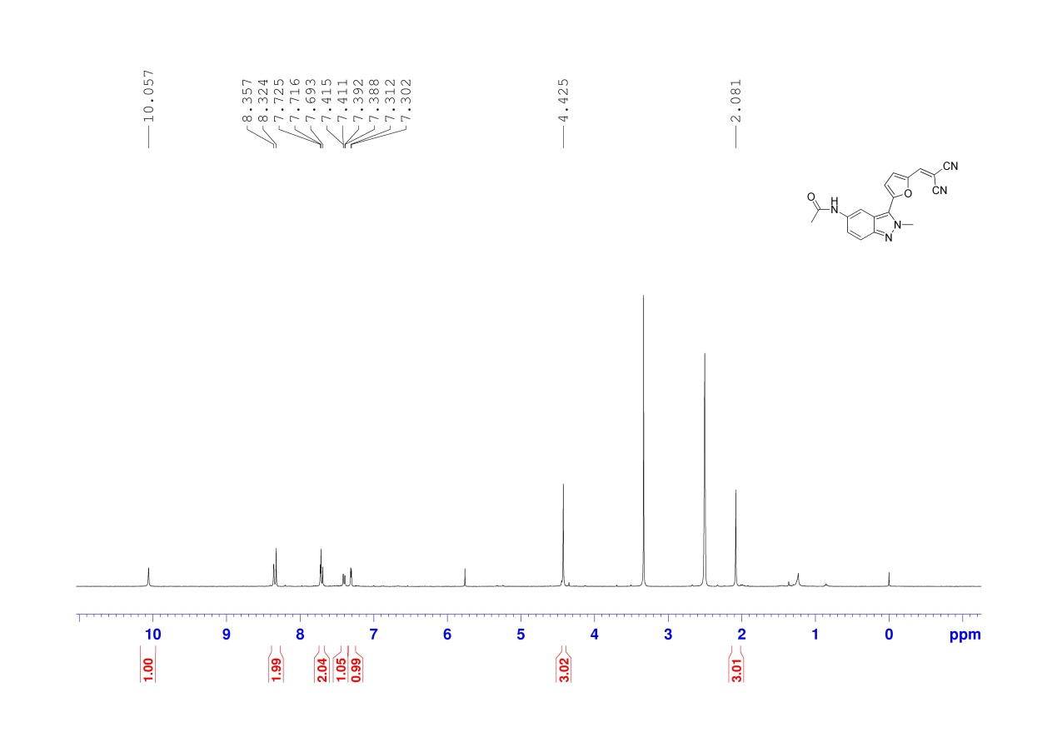
Supplementary Fig. 38. ¹H NMR spectrum of DC-IN-Ac in DMSO-d₆

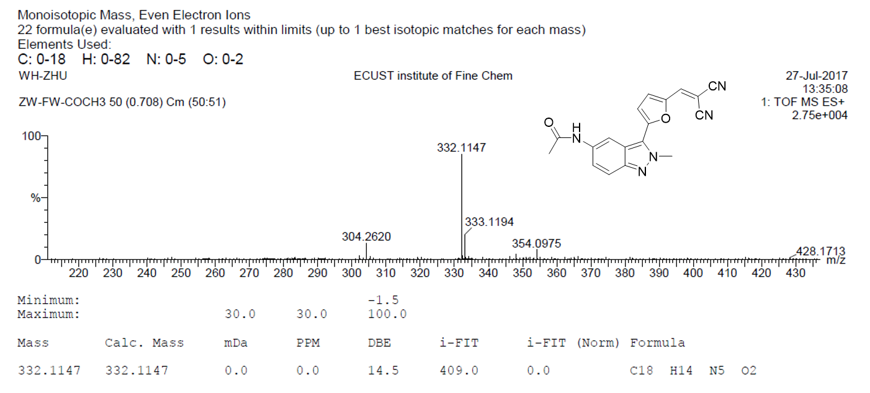
Supplementary Fig. 39. HRMS spectrum of DC-IN-Ac

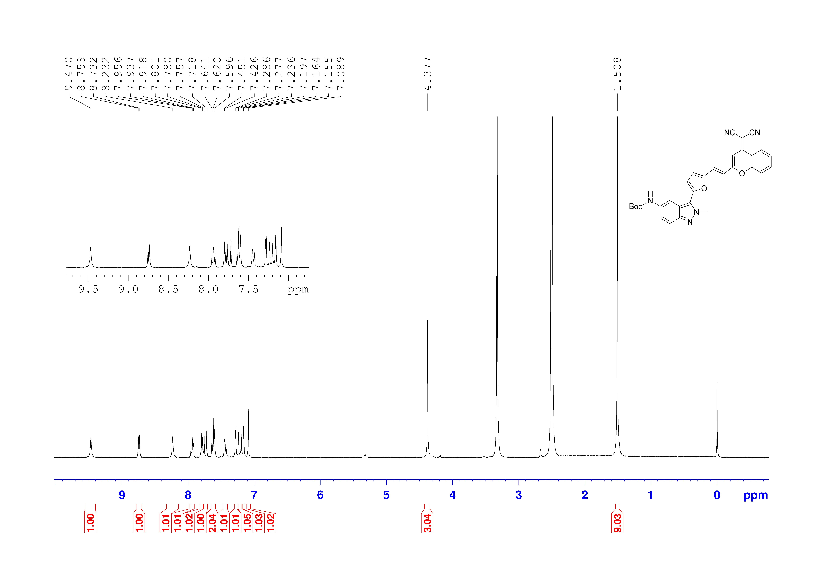
Supplementary Fig. 40. ¹H NMR spectrum of DCM-IN-Boc in DMSO-d₆

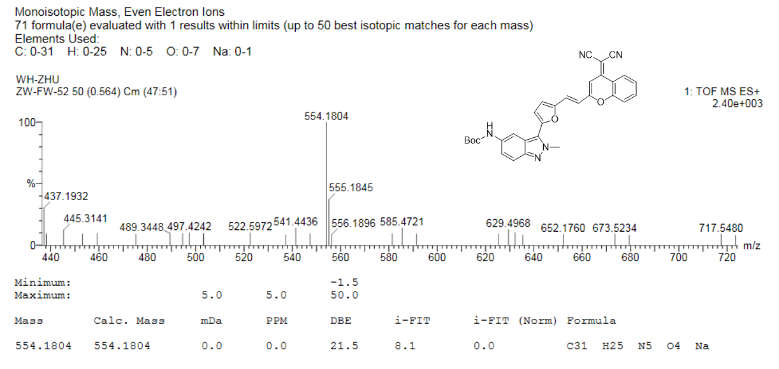
Supplementary Fig. 41. HRMS spectrum of DCM-IN-Boc

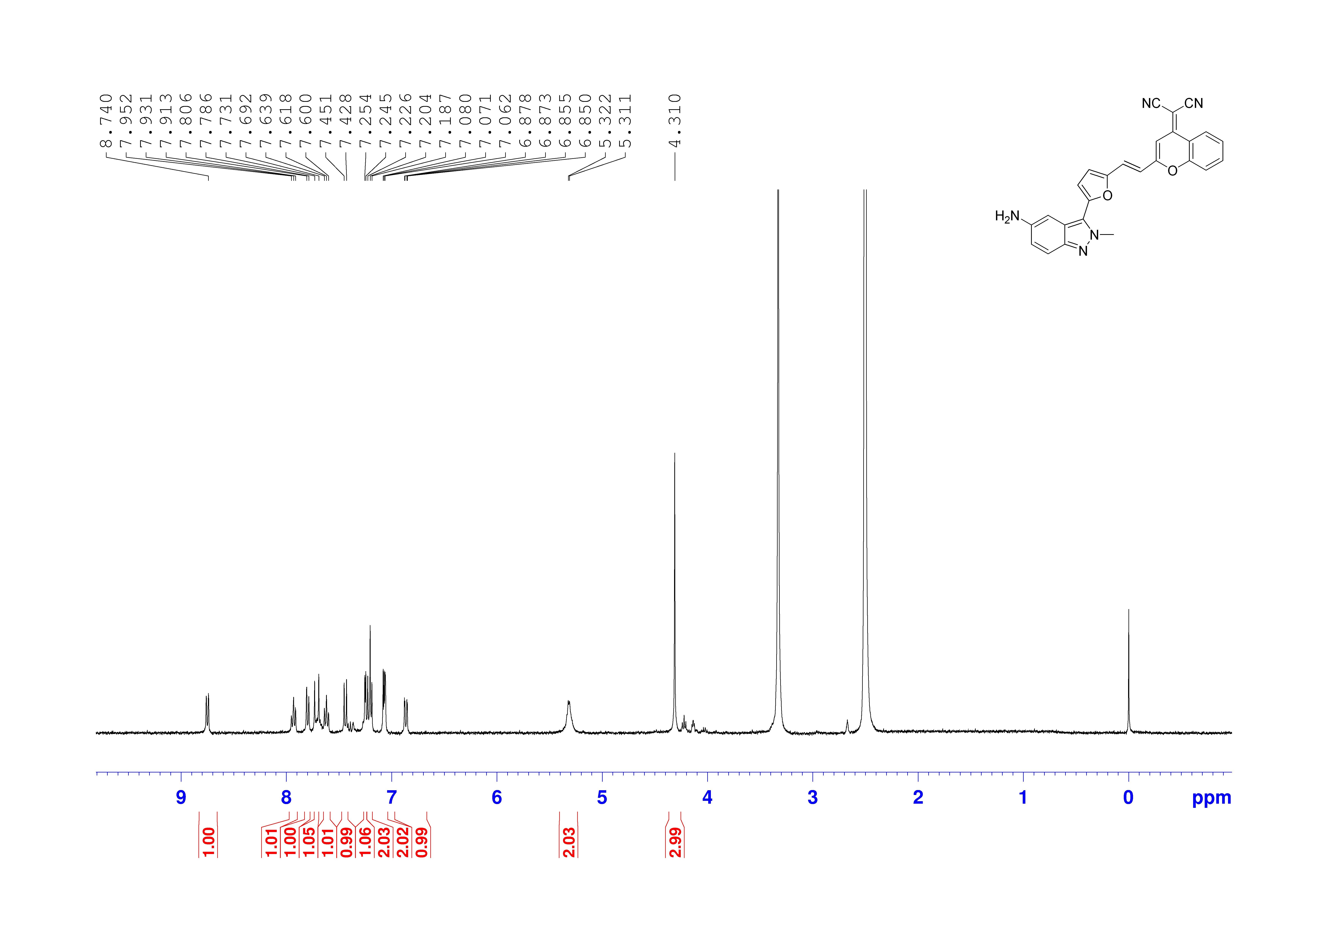
Supplementary Fig. 42. ¹H NMR spectrum of DCM-IN-NH₂ in DMSO-d₆

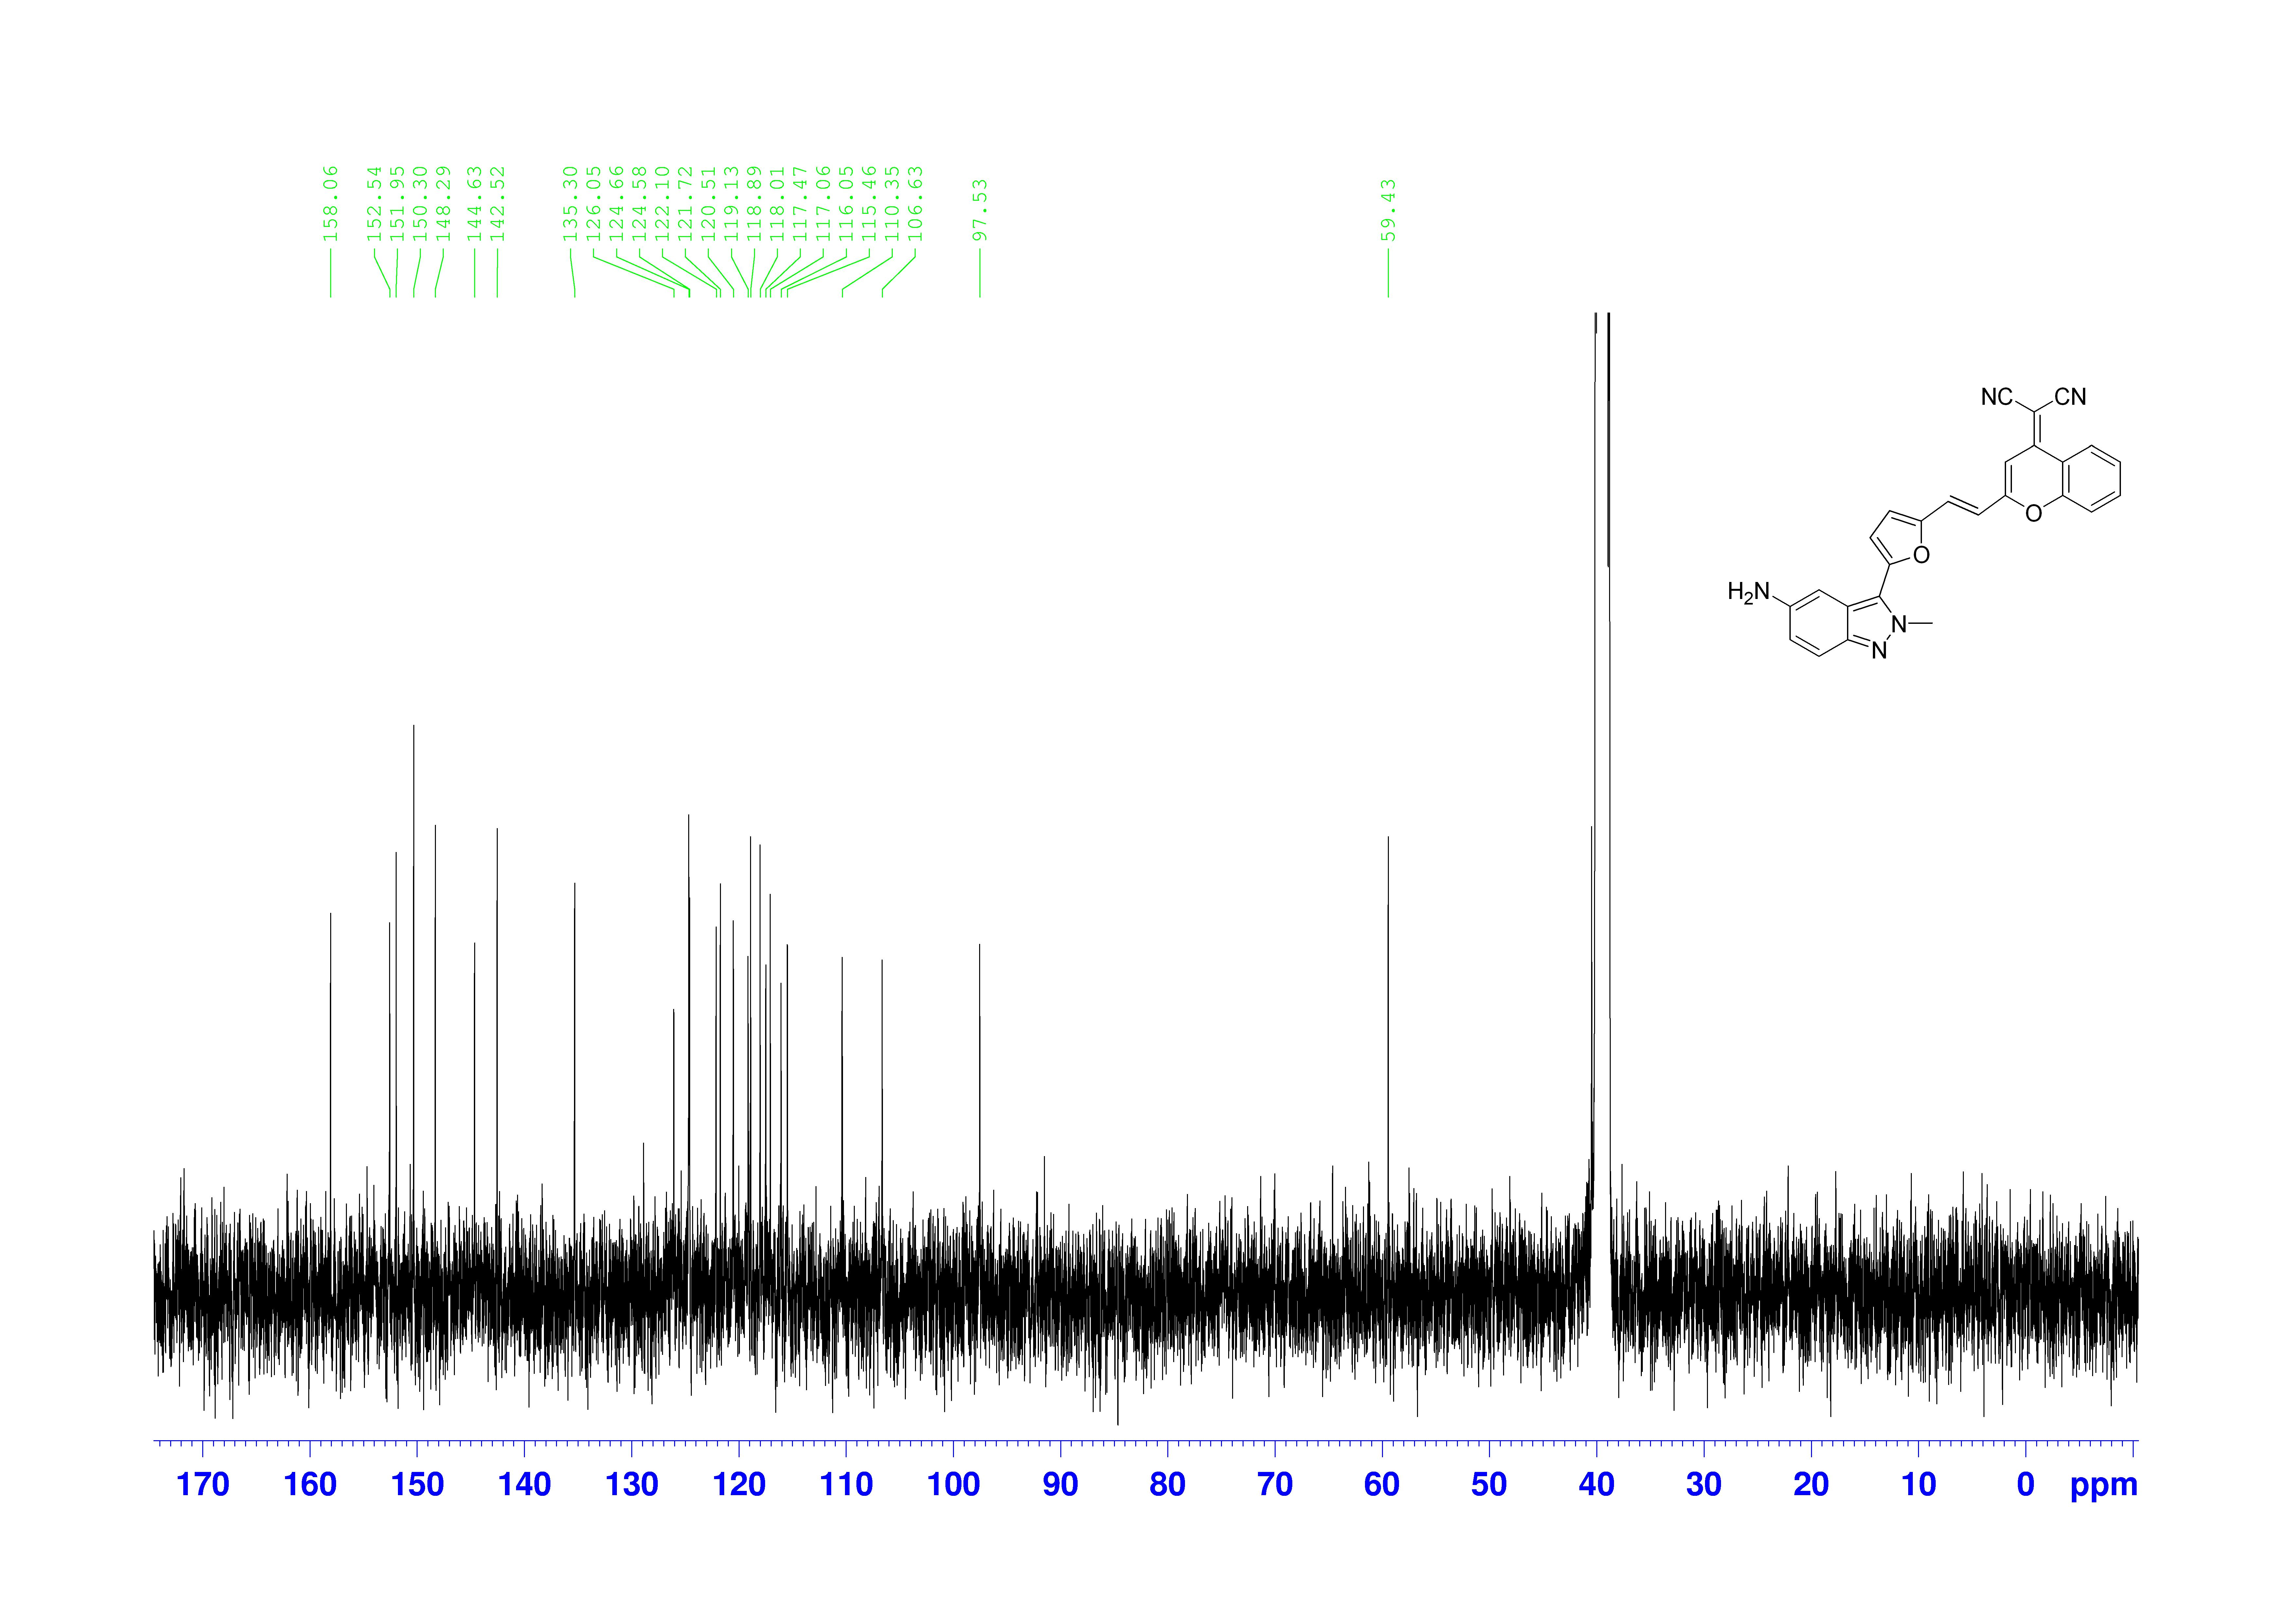
Supplementary Fig. 43. ¹³C NMR spectrum of DCM-IN-NH₂ in DMSO-d₆

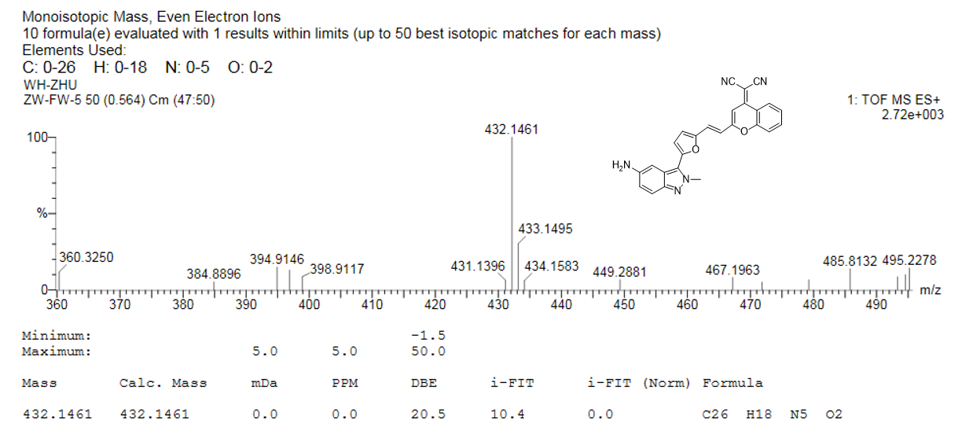
Supplementary Fig. 44. HRMS spectrum of DCM-IN-NH₂

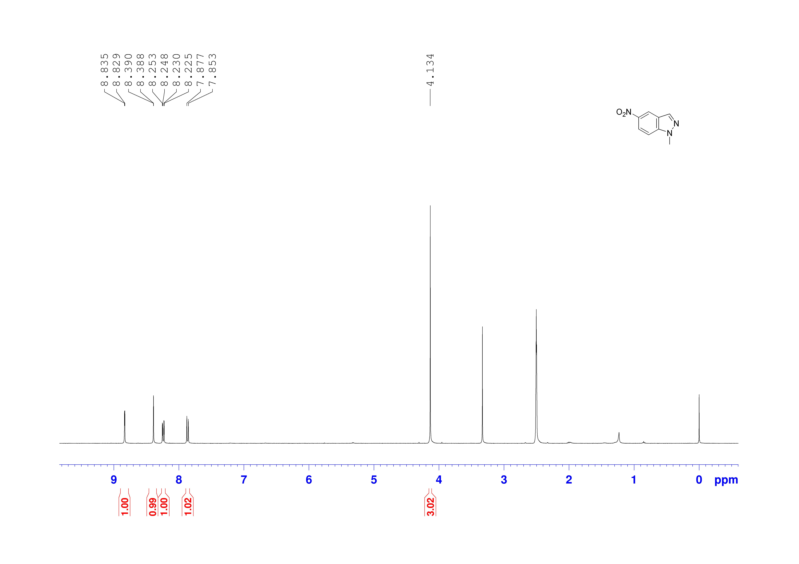
Supplementary Fig. 45. ¹H NMR spectrum of IN1-NO₂ in DMSO-d₆

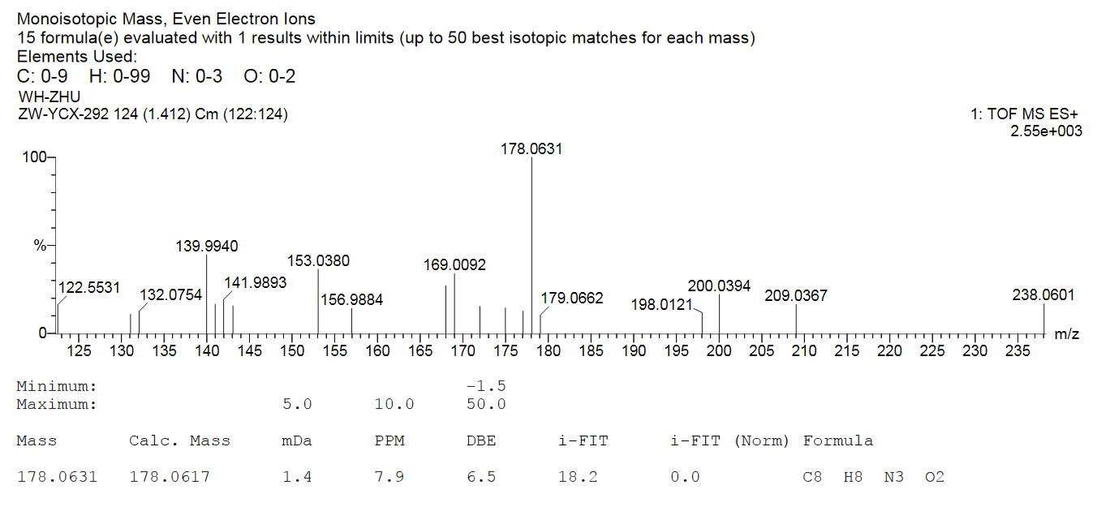
Supplementary Fig. 46. HRMS spectrum of IN1-NO₂

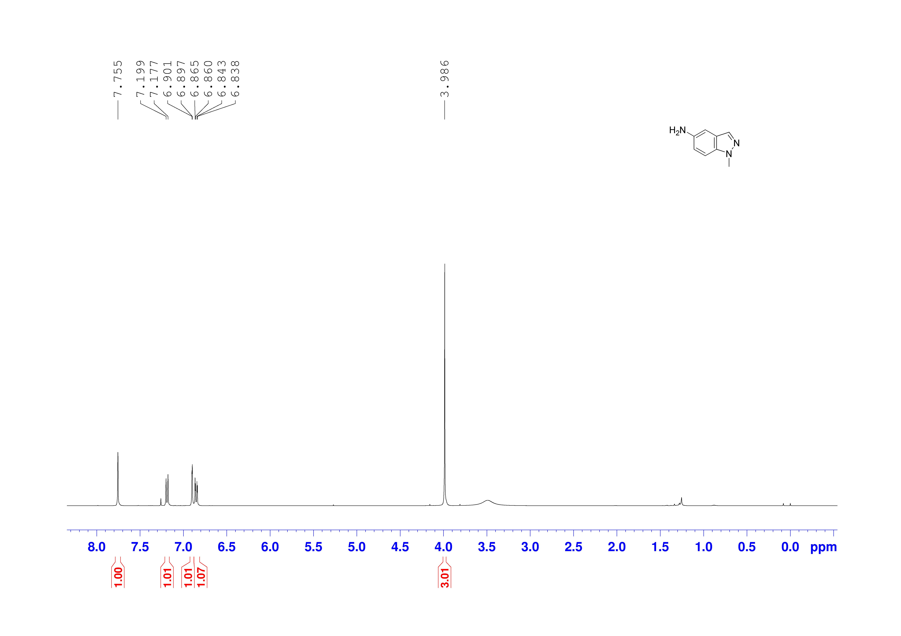
Supplementary Fig. 47. ¹H NMR spectrum of IN1-NH₂ in CDCl₃

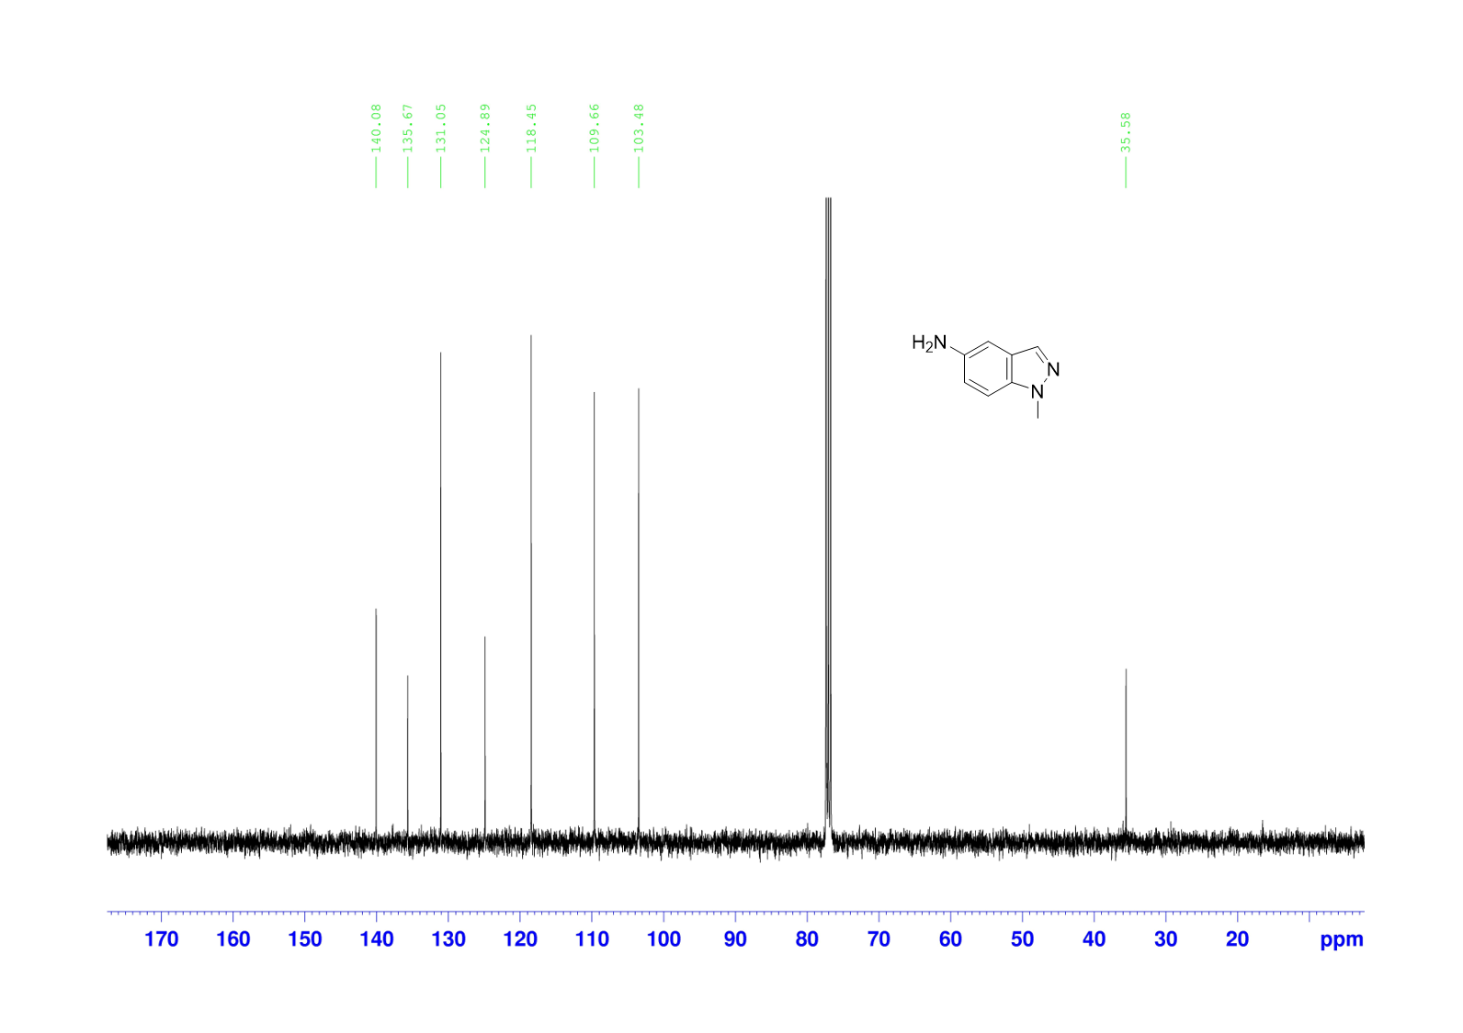
Supplementary Fig. 48. ¹³C NMR spectrum of IN1-NH₂ in CDCl₃

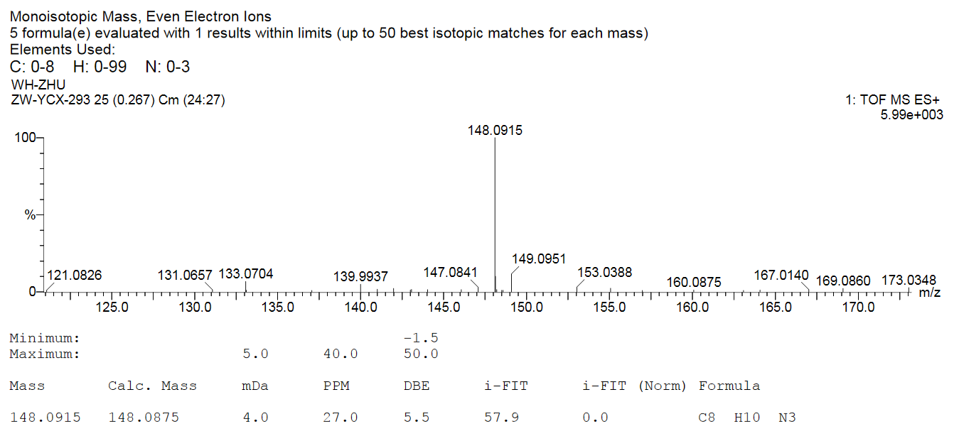
Supplementary Fig. 49. HRMS spectrum of IN1-NH₂
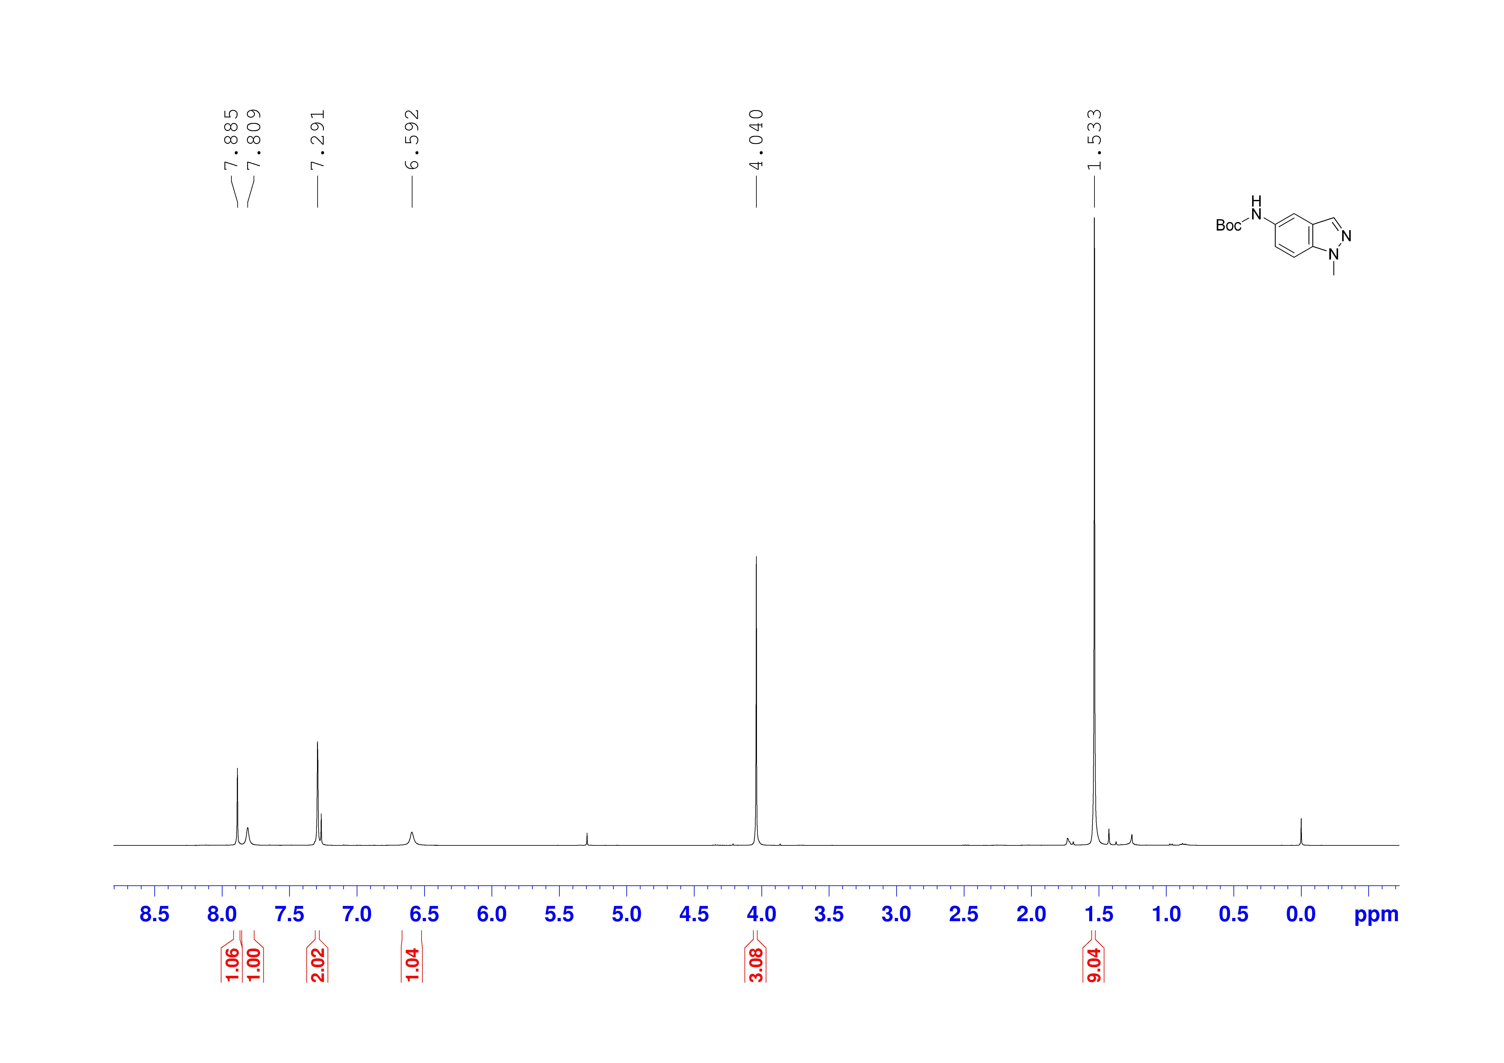
Supplementary Fig. 50. ¹H NMR spectrum of IN1-Boc in CDCl₃

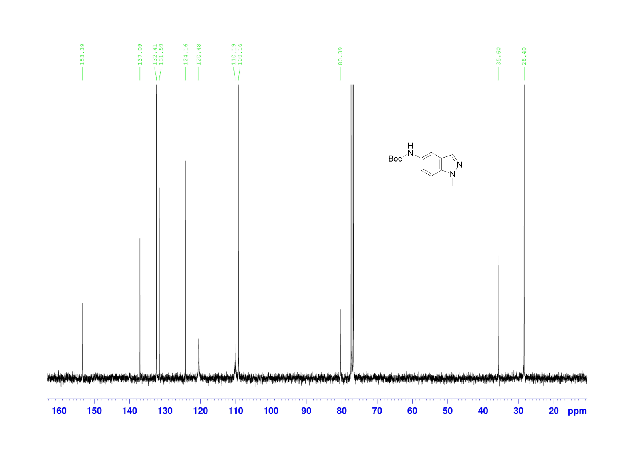
Supplementary Fig. 51. ¹³C NMR spectrum of IN1-Boc in CDCl₃

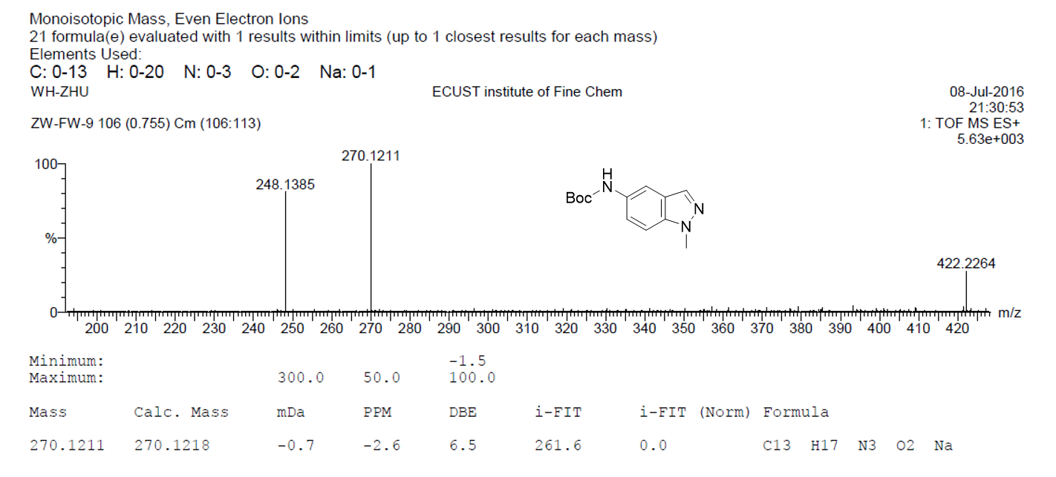
Supplementary Fig. 52. HRMS spectrum of IN1-Boc

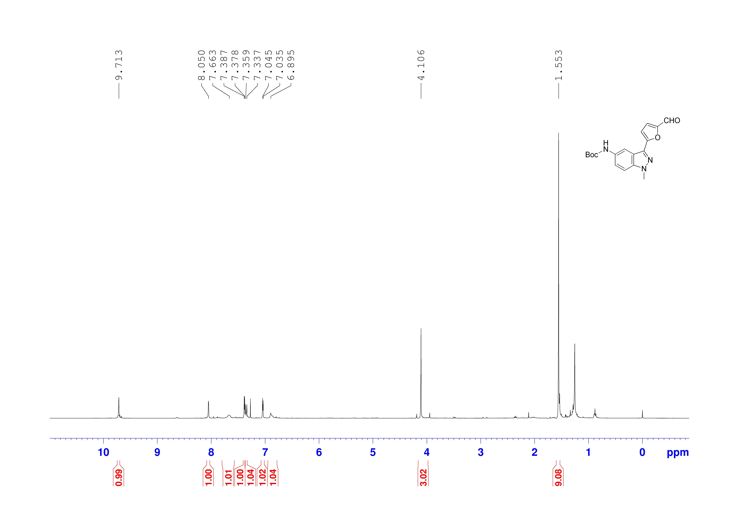
Supplementary Fig. 53. ¹H NMR spectrum of AL-IN1-Boc in CDCl₃

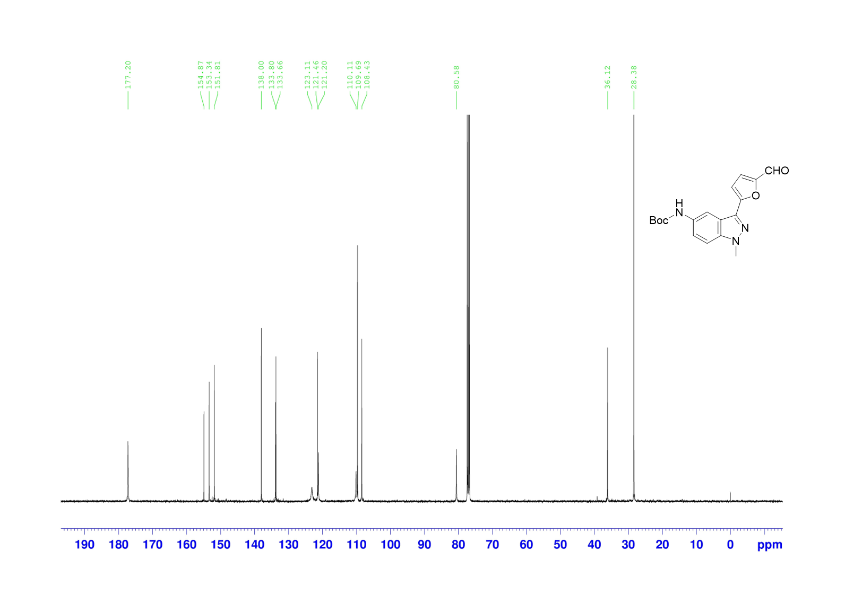
Supplementary Fig. 54. ¹³C NMR spectrum of AL-IN1-Boc in CDCl₃

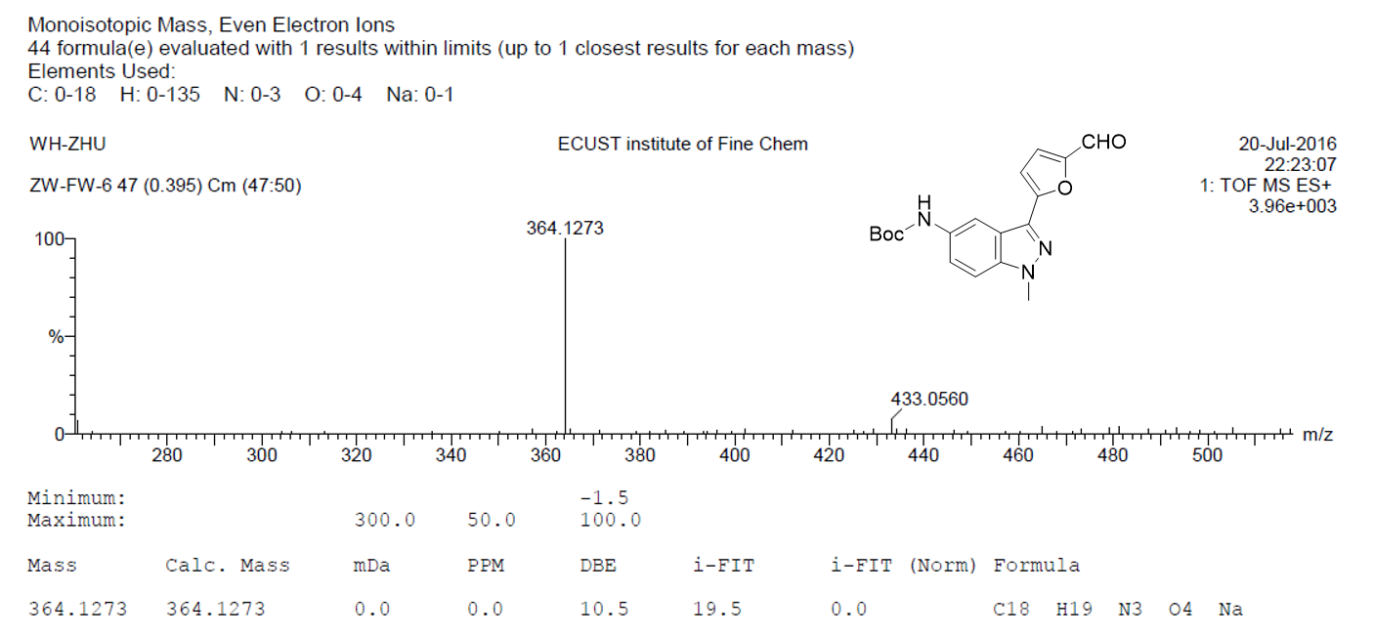
Supplementary Fig. 55. HRMS spectrum of AL-IN1-Boc

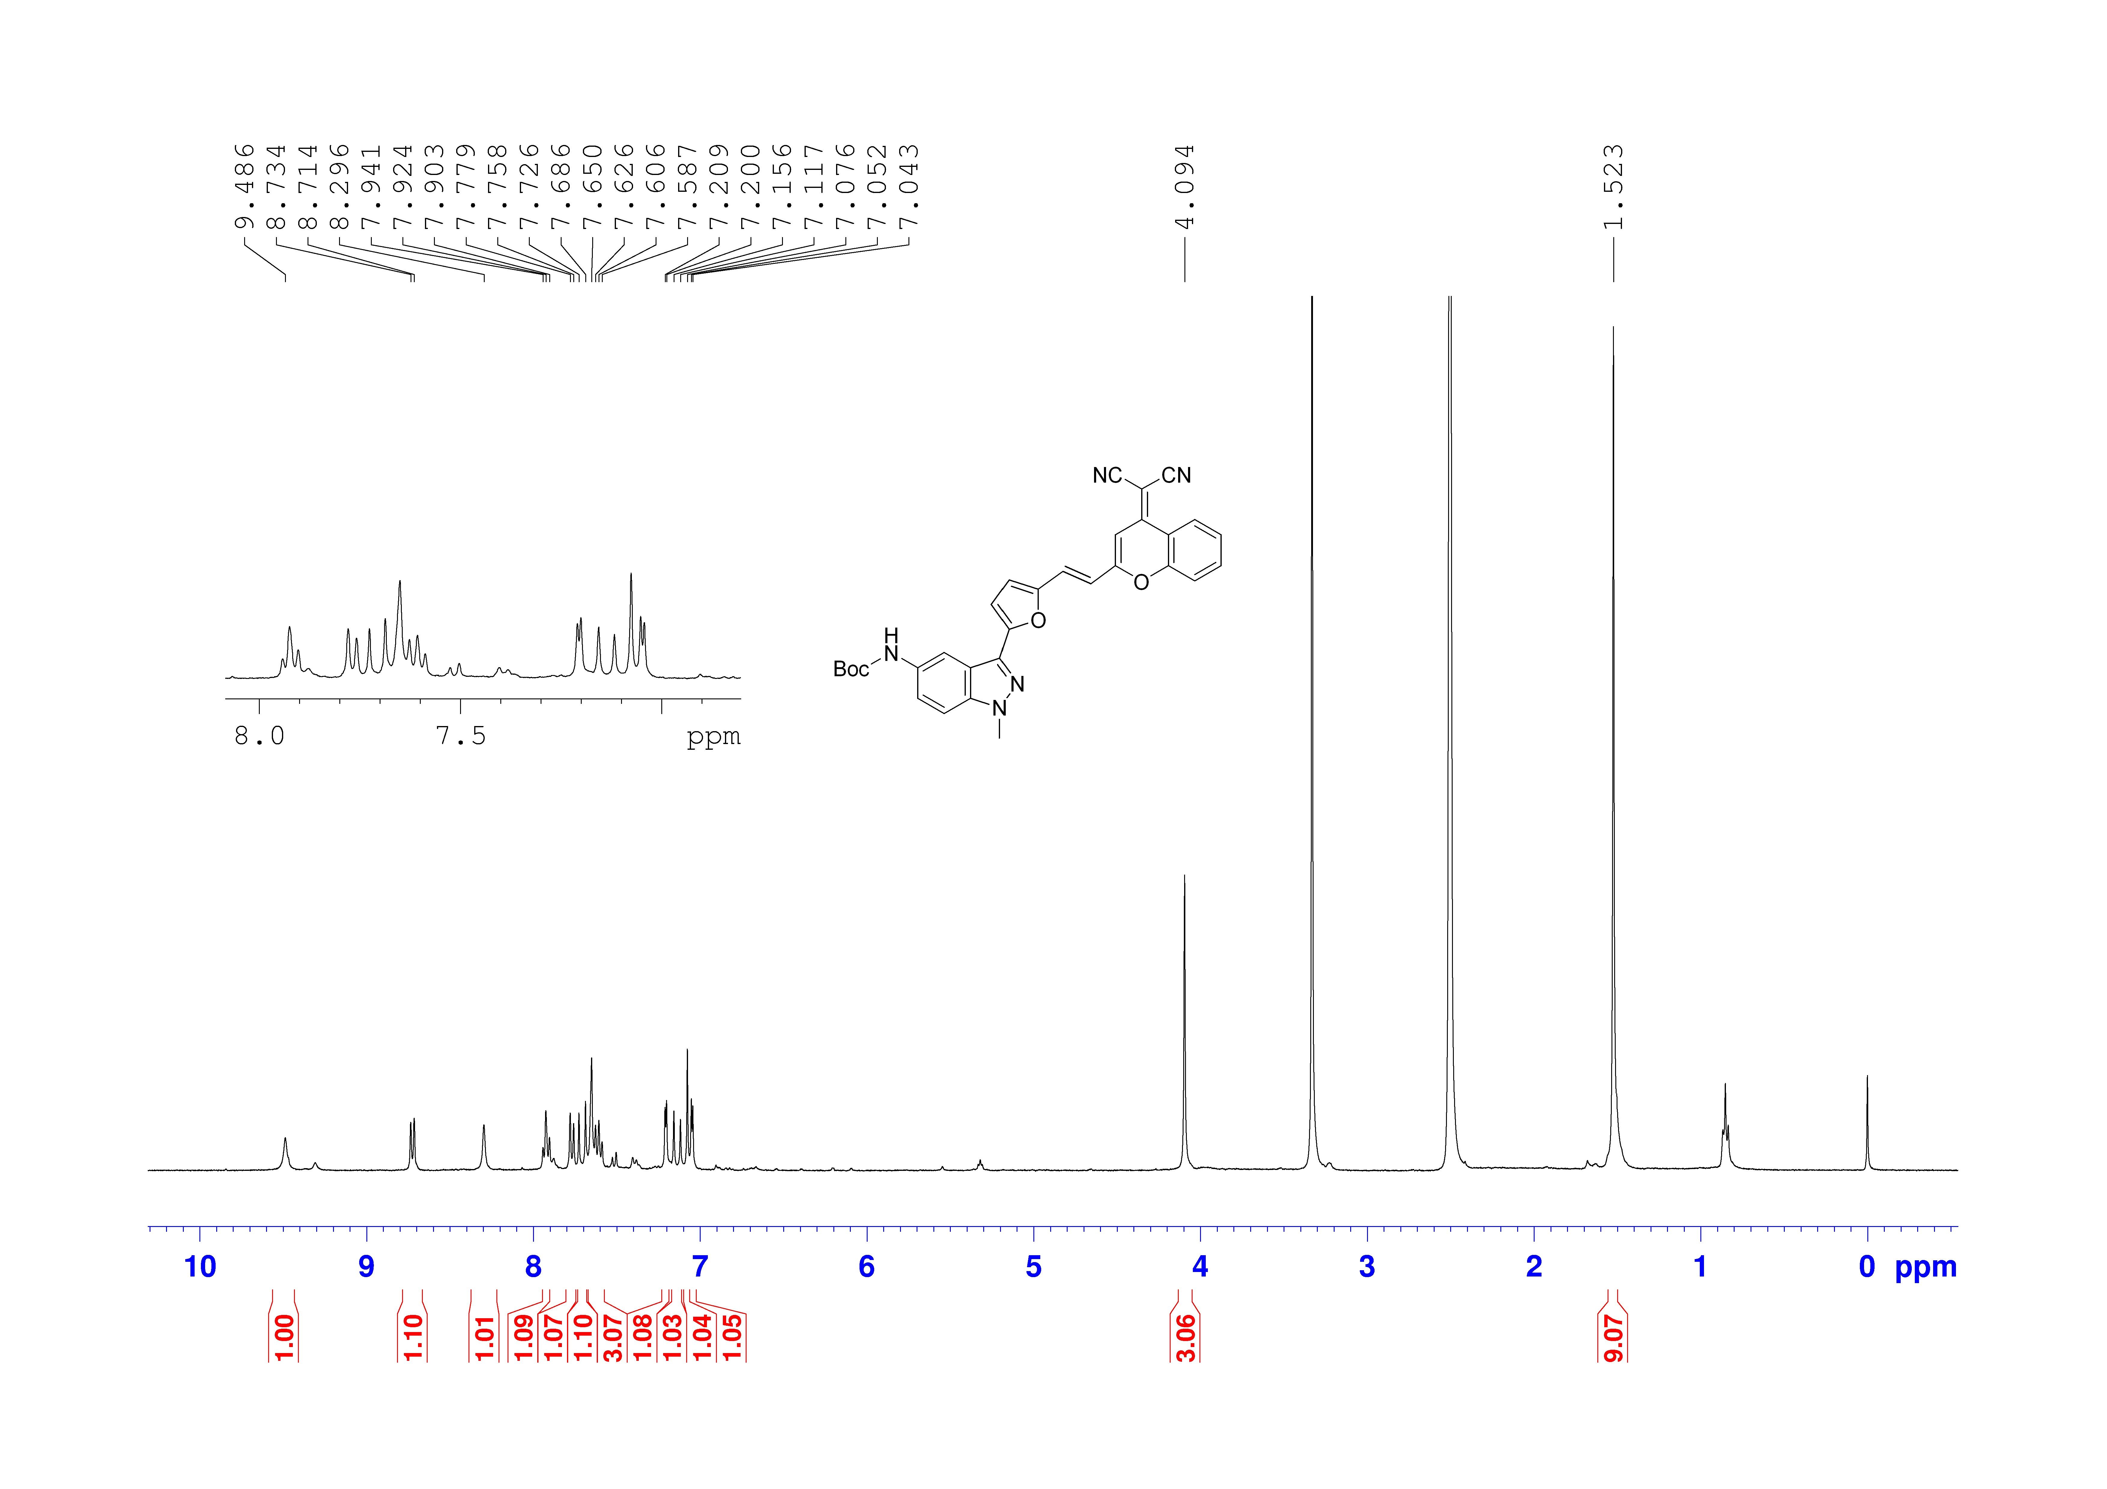
Supplementary Fig. 56. ¹H NMR spectrum of DCM-IN1-Boc in DMSO-d₆

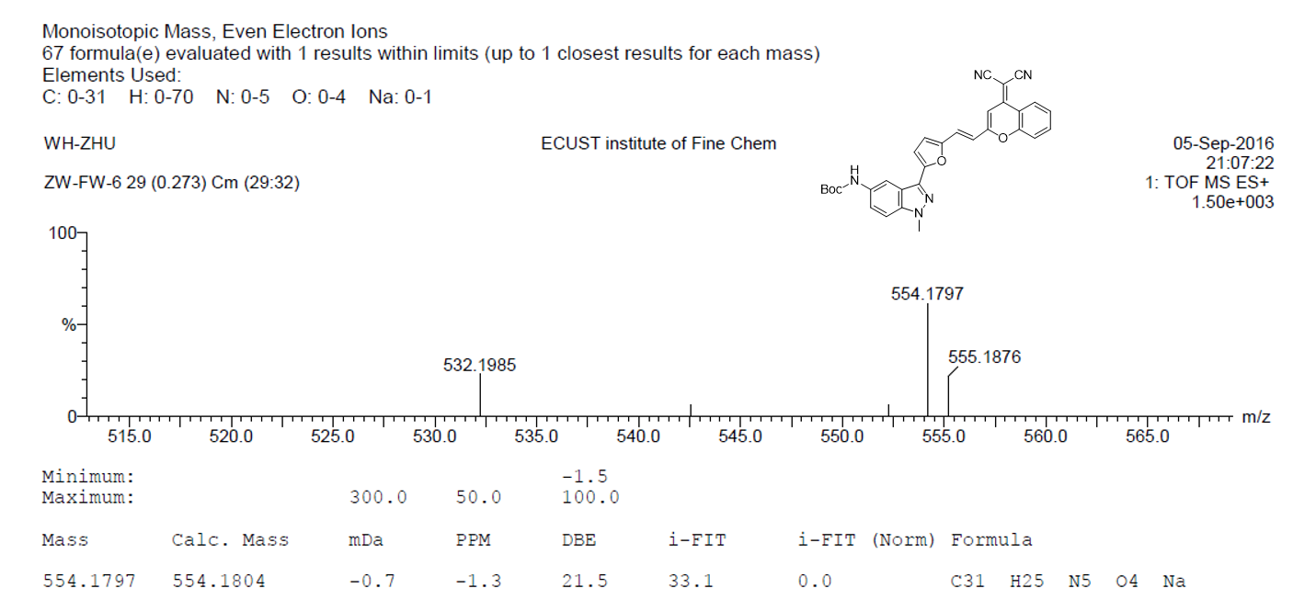
Supplementary Fig. 57. HRMS spectrum of DCM-IN1-Boc

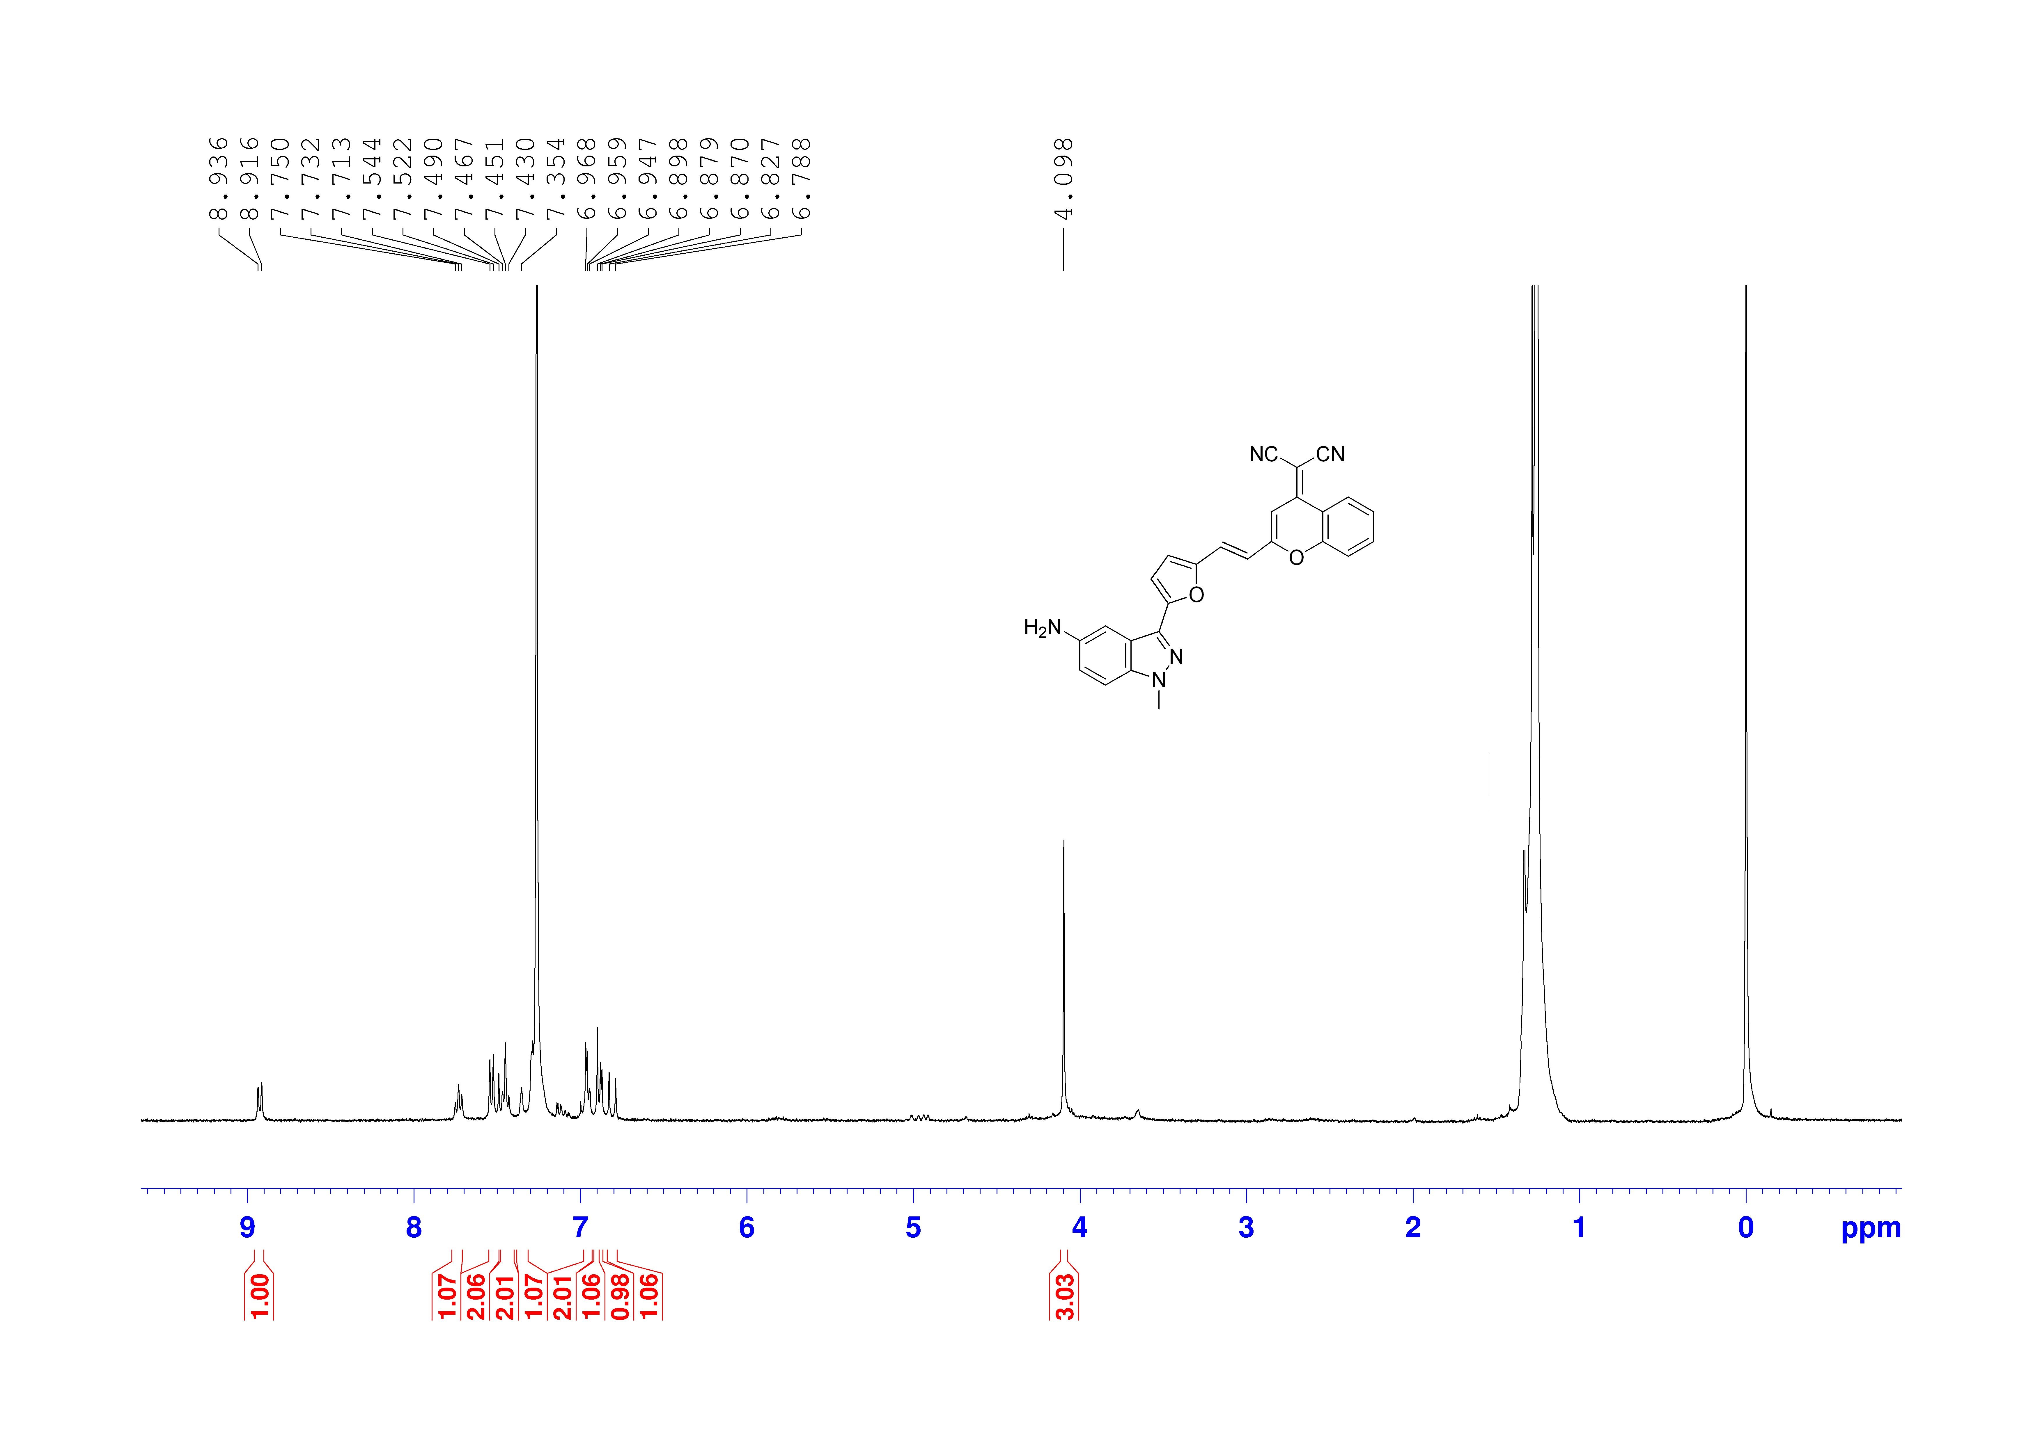
Supplementary Fig. 58. ¹H NMR spectrum of DCM-IN1-NH₂ in CDCl₃

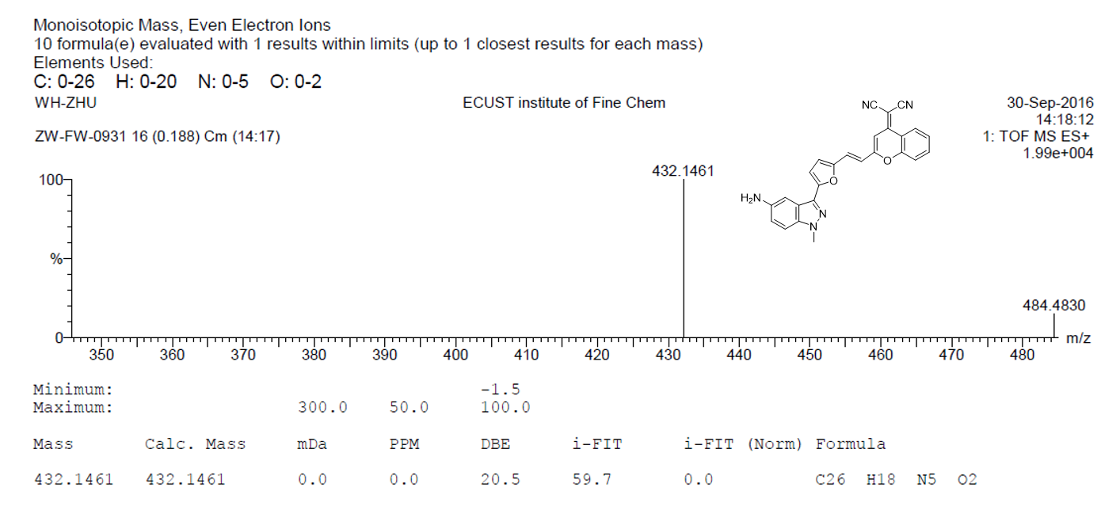
Supplementary Fig. 59. HRMS spectrum of DCM-IN1-NH₂

