**Figure 1. (Control 1) He was 3 years old boy, ECHO showed LM aneurysmal dilation and with thrombus in it at 6 months later of misdiagnosis in case 1 (a-orange arrow). He was treated withe Warfarin, Aspirin, and Dipyridamole, LM was still aneurysmal dilation and with no thrombus in it at 10 months later of misdiagnosis (b), but LVED increased to 64mm (c). At 1 year later of misdiagnosis, LVEF decreased to 24%(d). CTCA showed LM dilatation and there was the filling defect near the LAD (e-****orange arrow)，the blood flow was almost interrupted in the LAD (f-black arrow). About 3 years later of misdiagnosis, he was sudden death.**

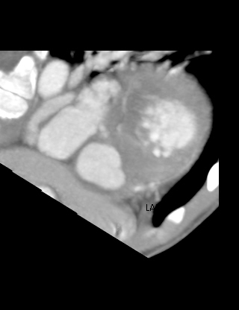

LAD

occlusion?

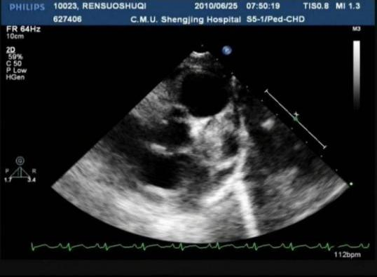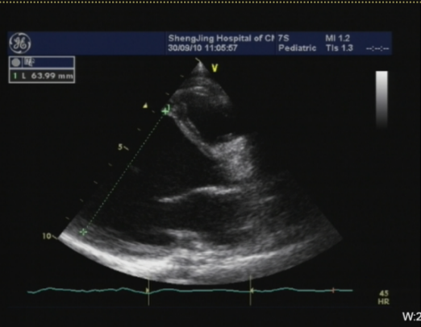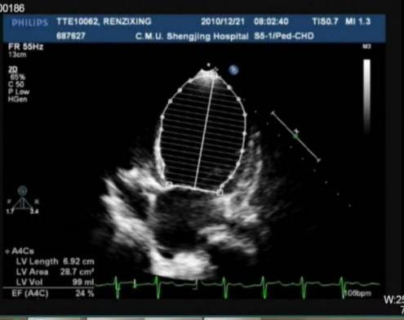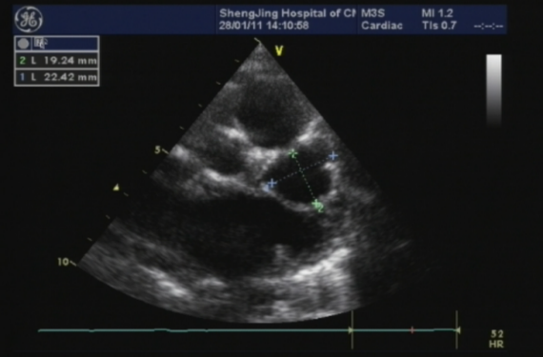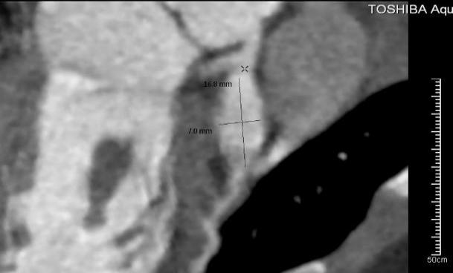

a

f

e

d

c

b

**Figure 2. (Control 2) He was 3 years old boy, ECHO showed LM aneurysmal dilation and with thrombus in it at 6 months later of misdiagnosis in case 2 (a-orange arrow)，the blood flow almost cut off (b), LVEF 0.39 (c). He was treated withe Warfarin, Aspirin, and Dipyridamole. At 5.5 years of illness, the thrombus almost absorbed (d). LVED enlarged to 72mm (e).** **CMR showed transmural myocardial necrosis of the left ventricular free wall (f).**

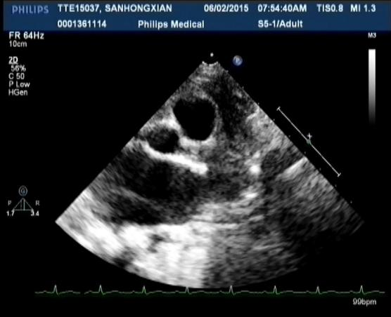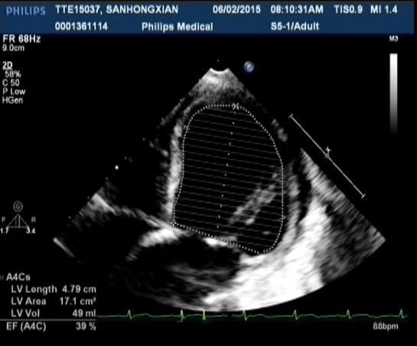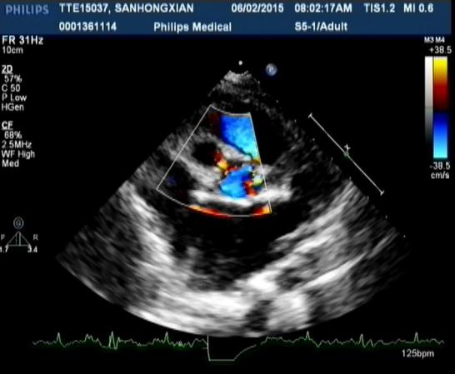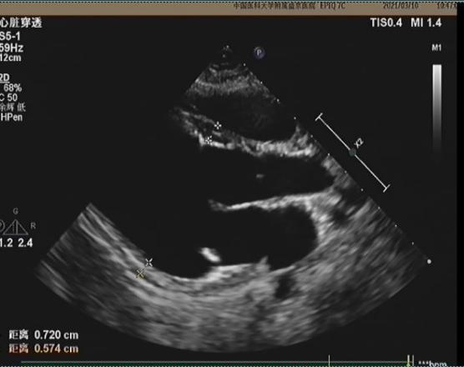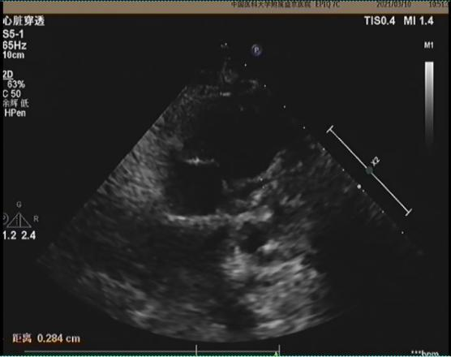

**a**

**d**

**e**

**c**

**b**

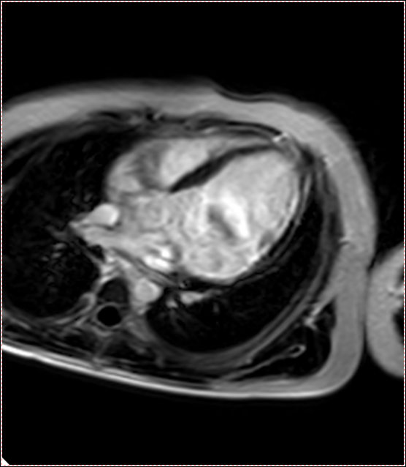

**d**