Supplementary Table 1. Details of drugs among the medication groups
Medication group | Details
SSZ and/or BUC (n=20) | SSZ (n=16), BUC (n=2), and SSZ with BUC (n=2)
MTX (n=42) | -
IGUR (n=11) | -
TNFi with MTX (n=42) | Infliximab (n=11), adalimumab (n=11), golimumab (n=6), certolizumab-pegol (n=6), etanercept (n=5), and other (n=3)
TNFi without MTX (n=24) | Infliximab (n=5), adalimumab (n=5), golimumab (n=6), certolizumab-pegol (n=4), and etanercept (n=4)
IL6i without MTX (n=43) | Tocilizumab (n=39) and sarilumab (n=4)
ABT without MTX (n=21) | -
JAKi without MTX (n=14) | Tofacitinib (n=2), baricitinib (n=7), and upadacitinib (n=5)
CNI (n=38) | Tacrolimus (n=33) and cyclosporine (n=5)
MMF (n=14) | -
MMF or MZR with CNI (n=19) | MMF with CNI (n=15) and MZR with CNI (n=4)
RTX or CPA (n=9) | RTX (n=5) and CPA (n=4)
SSZ, sulfasalazine; BUC, bucillamin; IGUR, iguratimod; MTX, methotrexate; TNFi, tumor necrosis factor inhibitor; IL6i, interleukin-6 inhibitor; ABT, abatacept; JAKi, Janus kinase inhibitor; CNI, calcineurin inhibitor; MMF, mycophenolate mofetil; MZR, mizoribine; RTX, rituximab; CPA, cyclophosphamide

Supplementary Table 2. Demographic characteristics of medication groups
 | SSZ and/or BUC  n=20 | MTX  n=40 | IGUR  n=11 | TNFi with MTX  n=42 | TNFi without MTX  n=24 | IL6i without MTX  n=43 | ABT without MTX  n=21 | JAKi without MTX  n=14 | CNI  n=38 | MMF  n=14 | MMF or MZR with CNI n=19 | RTX or CPA  n=9
Gender: male, n (%) | 5  (25.0) | 12  (30.0) | 5  (45.5) | 12  (28.6) | 7  (29.2) | 13  (30.2) | 5  (23.8) | 2  (14.3) | 7  (18.2) | 4  (28.6) | 4  (21.1) | 2  (22.2)
Age, n (%)
20-39 | 0  (0) | 2  (5.0) | 1  (9.1) | 5  (11.9) | 7  (29.2) | 5  (11.6) | 0  (0) | 0  (0) | 11  (29.0) | 1  (7.1) | 3  (15.8) | 1  (11.1)
40-64 | 14  (70.0) | 23  (57.5) | 5  (45.5) | 23  (54.8) | 13  (54.2) | 27  (62.8) | 7  (33.3) | 6  (42.9) | 21  (55.3) | 10  (71.4) | 16  (84.2) | 4  (44.4)
≥ 65 | 6  (30.0) | 15  (37.5) | 5  (45.5) | 14  (33.3) | 4  (16.7) | 11  (25.6) | 14  (66.7) | 8  (57.1) | 6  (15.8) | 3  (21.4) | 0  (0) | 4  (44.4)
Immunologic diagnosis, n (%)
Rheumatoid arthritis | 11  (55.0) | 31  (77.5) | 11  (100) | 38  (90.5) | 14  (58.3) | 31  (72.1) | 20  (95.2) | 11  (78.6) | 6  (15.8) | 2  (14.3) | 1  (5.3) | 0  (0)
Systemic lupus erythematosus | 0  (0) | 0  (0) | 0  (0) | 0  (0) | 0  (0) | 0  (0) | 0  (0) | 1  (7.1) | 22  (57.9) | 7  (50.0) | 12  (63.2) | 1  (11.1)
Spondyloarthritis | 5  (25.0) | 2  (5.0) | 0  (0) | 4  (9.5) | 4  (16.7) | 0  (0) | 0  (0) | 0  (0) | 0  (0) | 0  (0) | 0  (0) | 0  (0)
Polymyositis and dermatomyositis | 0  (0) | 1  (2.5) | 0  (0) | 0  (0) | 0  (0) | 0  (0) | 0  (0) | 0  (0) | 6  (15.8) | 2  (14.3) | 3  (15.8) | 2  (22.2)
Scleroderma | 0  (0) | 0  (0) | 0  (0) | 0  (0) | 0  (0) | 1  (2.3) | 0  (0) | 1  (7.1) | 0  (0) | 2  (14.3) | 2  (10.5) | 1  (11.1)
Vasculitis | 0  (0) | 1  (2.5) | 0  (0) | 0  (0) | 0  (0) | 1  (2.3) | 0  (0) | 0  (0) | 0  (0) | 1  (7.1) | 0  (0) | 4  (44.4)
Behçet's disease | 1  (5.0) | 1  (2.5) | 0  (0) | 0  (0) | 5  (20.9) | 0  (0) | 0  (0) | 0  (0) | 0  (0) | 0  (0) | 0  (0) | 0  (0)
Mixed connective tissue disease | 1  (5.0) | 1  (2.5) | 0  (0) | 0  (0) | 0  (0) | 0  (0) | 0  (0) | 1  (7.1) | 2  (5.3) | 0  (0) | 1  (5.3) | 0  (0)
Castleman disease | 0  (0) | 0  (0) | 0  (0) | 0  (0) | 0  (0) | 5  (11.6) | 0  (0) | 0  (0) | 0  (0) | 0  (0) | 0  (0) | 0  (0)
Other | 2  (10.0) | 3  (7.5) | 0  (0) | 0  (0) | 1  (4.2) | 5  (11.6) | 1  (4.8) | 0  (0) | 2  (5.3) | 0  (0) | 0  (0) | 1  (11.1)
Glucocorticoid dose (prednisone equivalent), n (%)
0 mg/day | 15  (75.0) | 21  (52.5) | 7  (63.6) | 30  (71.4) | 17  (70.8) | 27  (62.8) | 13  (61.9) | 7  (50.0) | 7  (18.4) | 2  (14.3) | 1  (5.3) | 0  (0)
>0 ≤ 5 mg/day | 3  (15.0) | 17  (42.5) | 2  (18.2) | 12  (28.6) | 5  (20.8) | 16  (37.2) | 7  (33.3) | 3  (21.4) | 26  (68.4) | 6  (42.9) | 9  (47.4) | 5  (55.6)
>5 ≤ 10 mg/day | 2  (10.0) | 2  (5.0) | 2  (18.2) | 0  (0) | 2  (8.3) | 0  (0) | 1  (4.8) | 4  (28.6) | 5  (13.2) | 6  (42.9) | 9  (47.4) | 4  (44.4)
Diagnoses were strongly associated with the treatment group, as can be easily seen by the rate of diagnosis of rheumatoid arthritis and systemic lupus erythematosus.

Supplementary Table 3. Summary of the Bonferroni-Dunn test comparing antibody titers by medication group
 | SSZ and/or BUC | MTX | IGUR | TNFi with MTX | TNFi without MTX | IL6i without MTX | ABT without MTX | JAKis without MTX | CNI | MMF | MMF or MZR with CNI
MTX | NS
IGUR | NS | NS
TNFi with MTX | <0.01 | NS | NS
TNFi without MTX | NS | NS | NS | NS
IL6i without MTX | NS | NS | NS | NS | NS
ABT without MTX | <0.01 | NS | NS | NS | NS | <0.05
JAKi without MTX | NS | NS | NS | NS | NS | NS | NS
CNI | NS | NS | NS | <0.01 | NS | NS | <0.01 | NS
MMF | <0.01 | <0.01 | <0.01 | NS | 0.01 | <0.01 | NS | NS | <0.01
MMF or MZR with CNI | <0.01 | <0.01 | <0.01 | NS | <0.01 | <0.01 | NS | <0.05 | <0.01 | NS
RTX or CPA | <0.01 | NS | <0.05 | NS | NS | 0.01 | NS | NS | <0.01 | NS | NS
The numbers in the table are Bonferroni-adjusted p values. NS: not significance

Supplementary Figure 1. The QQ plot of residuals
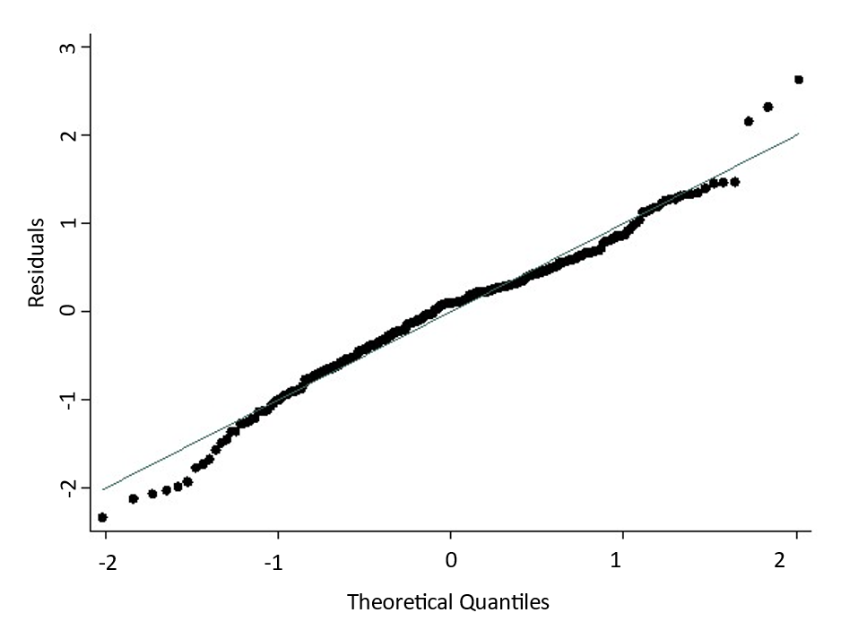
The QQ plot of residuals is almost linear.

