Supplementary Figure 1.

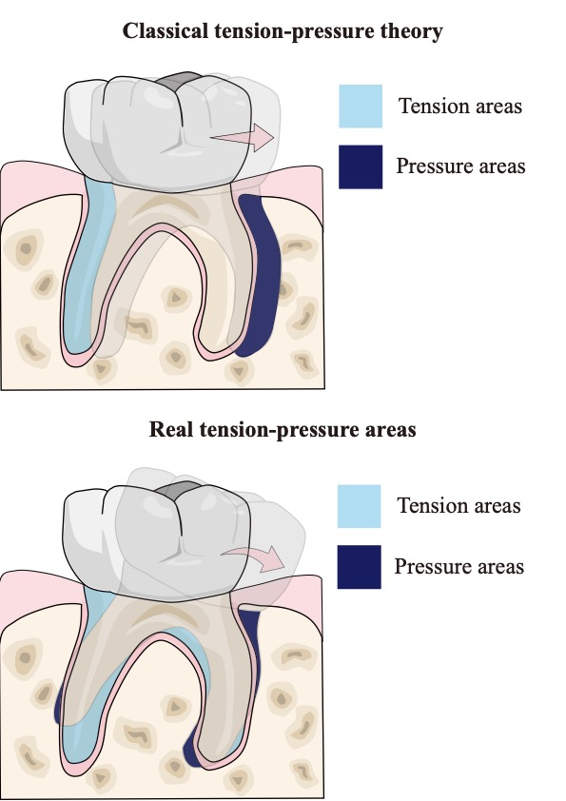
When the tooth moves mesially, classical tension-pressure theory claims that pressure and tension areas are the mesial and distal root areas. However, pure mesial body movement hardly exists, so the OTM is a mixture of body movement and angular movement. In this condition, the real tension-pressure areas are not distributed in two opposite sides, but actually dispersed, adjacent and widely connected in both mesial and distal sides.

