**Aggregation of magnetic nanoparticles functionalized with *trans*-resveratrol in aqueous solution**

*Thi-Nga Nguyen1,2,3, Quang-Hung Tran4, Clarence Charnay5, Xavier Dumail5, Corinne Reibel5, Guillaume Cazals6, Gilles Valette6, Christian Jay-Allemand1, Ferial Terki2, Luc P. R. Bidel7*

*1UMR IATE, University of Montpellier, Institut Agro, INRAE, F-34060 Montpellier, France.*

*2PhyMedExp UMR CNRS 9214 – Inserm U1046, 34295 Montpellier Cedex 05, France.*

*3Institute of Natural Products Chemistry, Vietnam Academy of Science and Technology, 18 Hoang Quoc Viet, 100000 Hanoi, Vietnam.*

*4eV-Technologies, 2 Esplanade Anton Philips, Bâtiment 5, 14460 Colombelles, France.*

*5Institut Charles Gerhardt UMR 5253 CNRS-UM, Université de Montpellier, F-34095 Montpellier, France.*

*6IBMM UMR5247, CNRS, ENSCM, Université de Montpellier, Place Eugène Bataillon, 34095 Montpellier Cedex 5, France*

*7UMR AGAP, University of Montpellier, CIRAD, INRAE, Institut Agro, Montpellier, France.*

Corresponding: [luc.bidel@inrae.fr](mailto:luc.bidel@inrae.fr)

## **Supporting information**

***S1. Silanization of trans-resveratrol***



Figure S1: Transmittance spectra as a function of the wavenumber of the reaction process at 7 hours and 3 days recorded by attenuated total reflection of the infrared spectrometer.



Figure S2: Structure of silanized t*rans*-resveratrol and their numbering of the carbon skeletons: 1, 2, 3 corresponding to the silane derivatives binds covalently to the three, two, and one hydrogen bonding sites of the *trans*-resveratrol molecule, respectively. Arrows show the key C-H correlations on the HMBC of compounds 2 and 3.

***S2. Dynamic light scattering measurement***

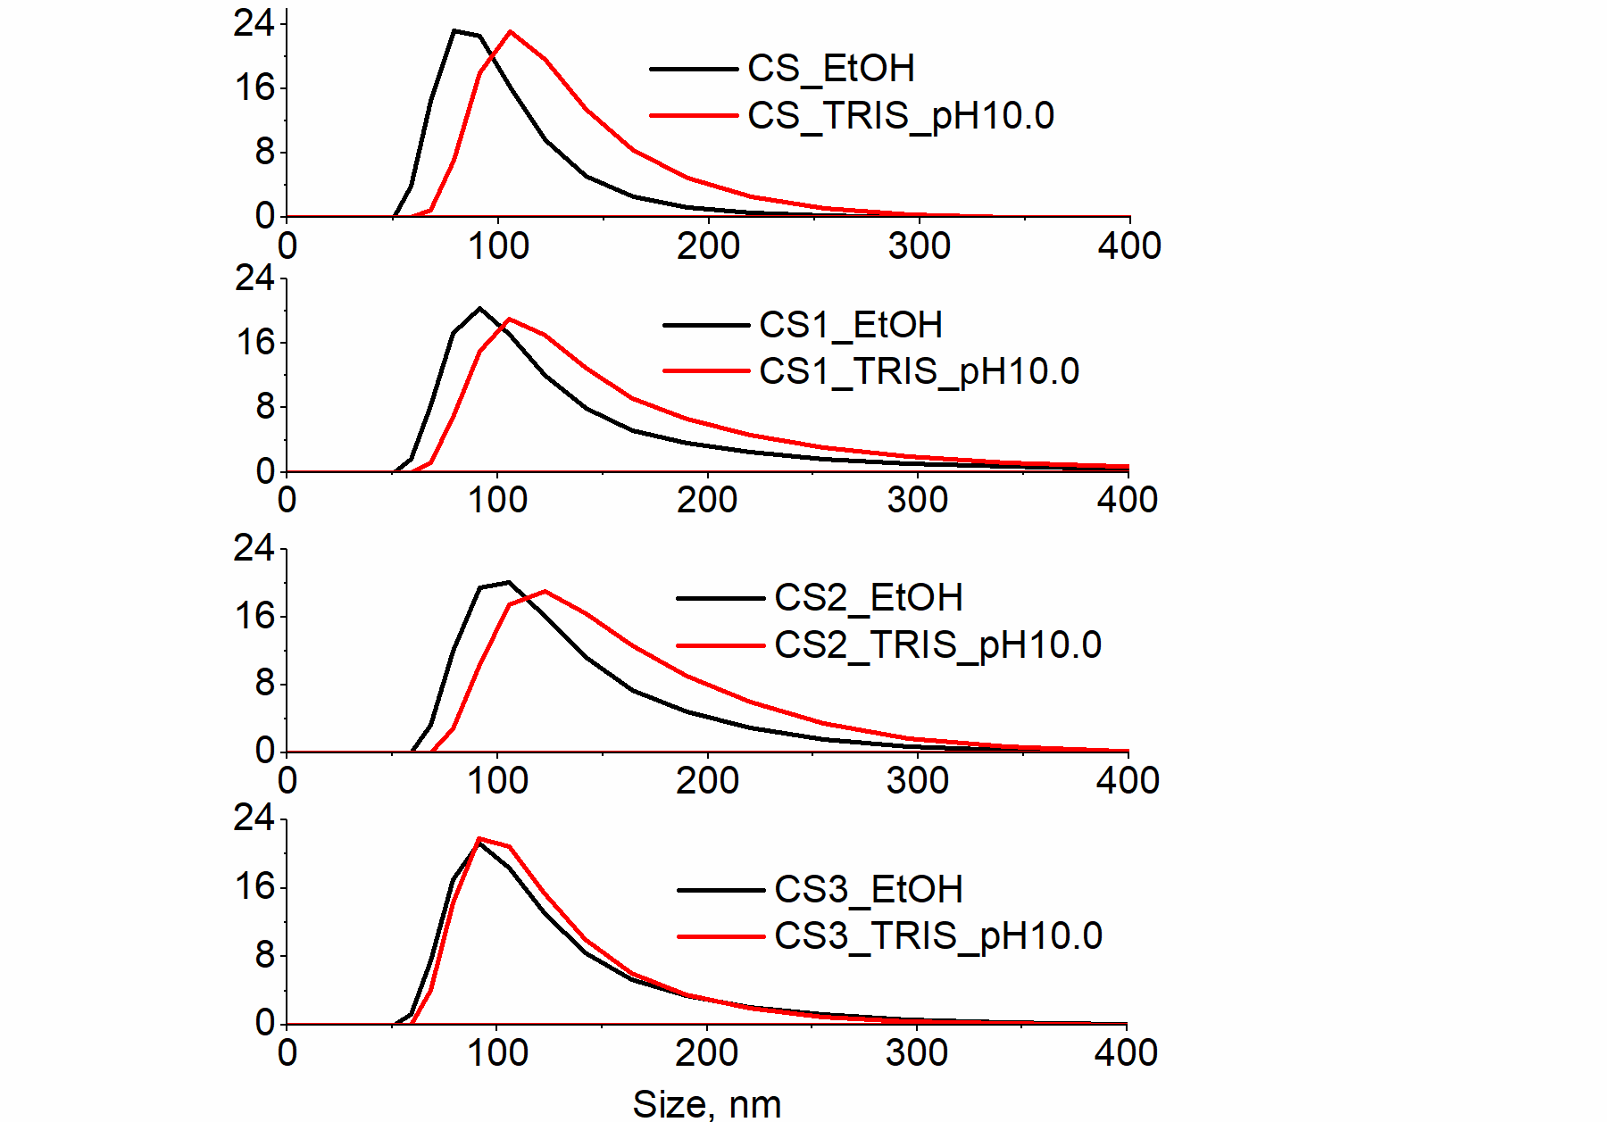

Figure S3: Size distribution of nanoparticles in absolute ethanol and in TRIS buffer at pH 10.0.

*S3. Zeta potential measurement*

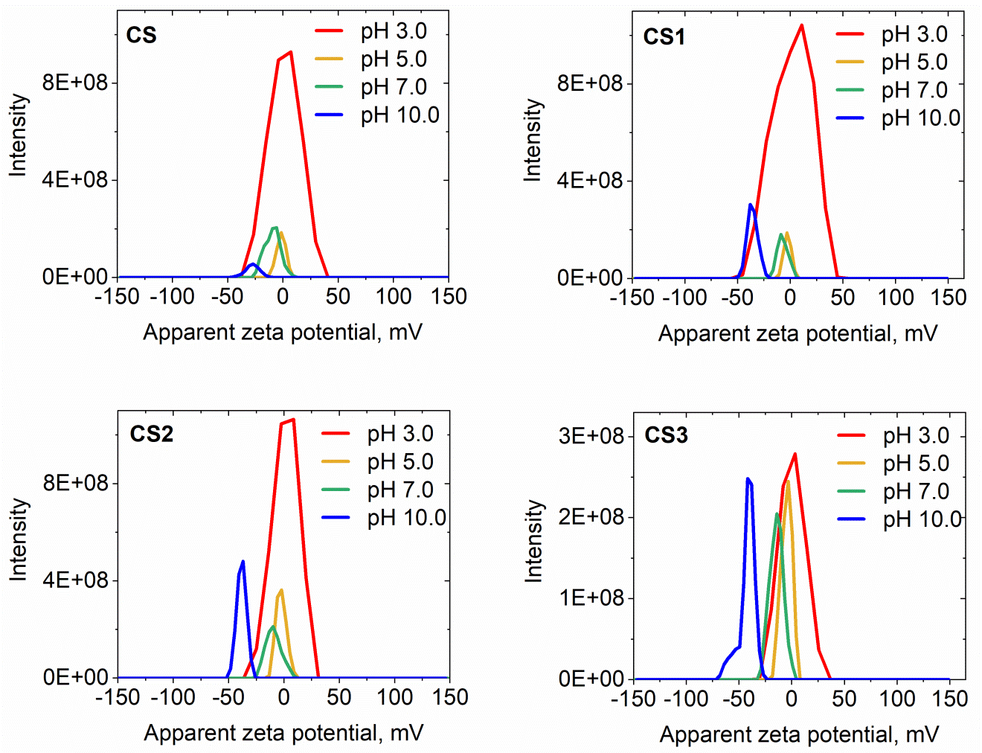

Figure S4: Distribution of zeta potential of nanoparticles at different pH.

***S4.******Extinction******Cross-section***

**Table S1**: The parameters of the Rayleigh-Gans-Debye model $A_{s}(λ)=W.λ^{-n}$ deduced from the linear fitting of the logarithm of extinction as a function of the logarithm of the wavelength.

|  |  |  |  |
| --- | --- | --- | --- |
| pH | Compound | W | n |
| 3.0 | **CS1** | 8.68 | 1.14 |
| **CS2** | 0.86 | 0.77 |
| **CS3** | 10.65 | 1.17 |
| 5.0 | **CS1** | 9.65 | 1.15 |
| **CS2** | 23.70 | 1.26 |
| **CS3** | 60.79 | 1.42 |
| 7.0 | **CS1** | 298.61 | 1.60 |
| **CS2** | 378.79 | 1.60 |
| **CS3** | 2618.78 | 1.81 |
| 10.0 | **CS1** | 59006.52 | 2.39 |
| **CS2** | 19760.59 | 2.19 |
| **CS3** | 233292.08 | 2.57 |

***S5. Appendix NMR spectra of compound 1, 2, and 3***

Figure S5: NMR spectra of compound 1, 2, and 3

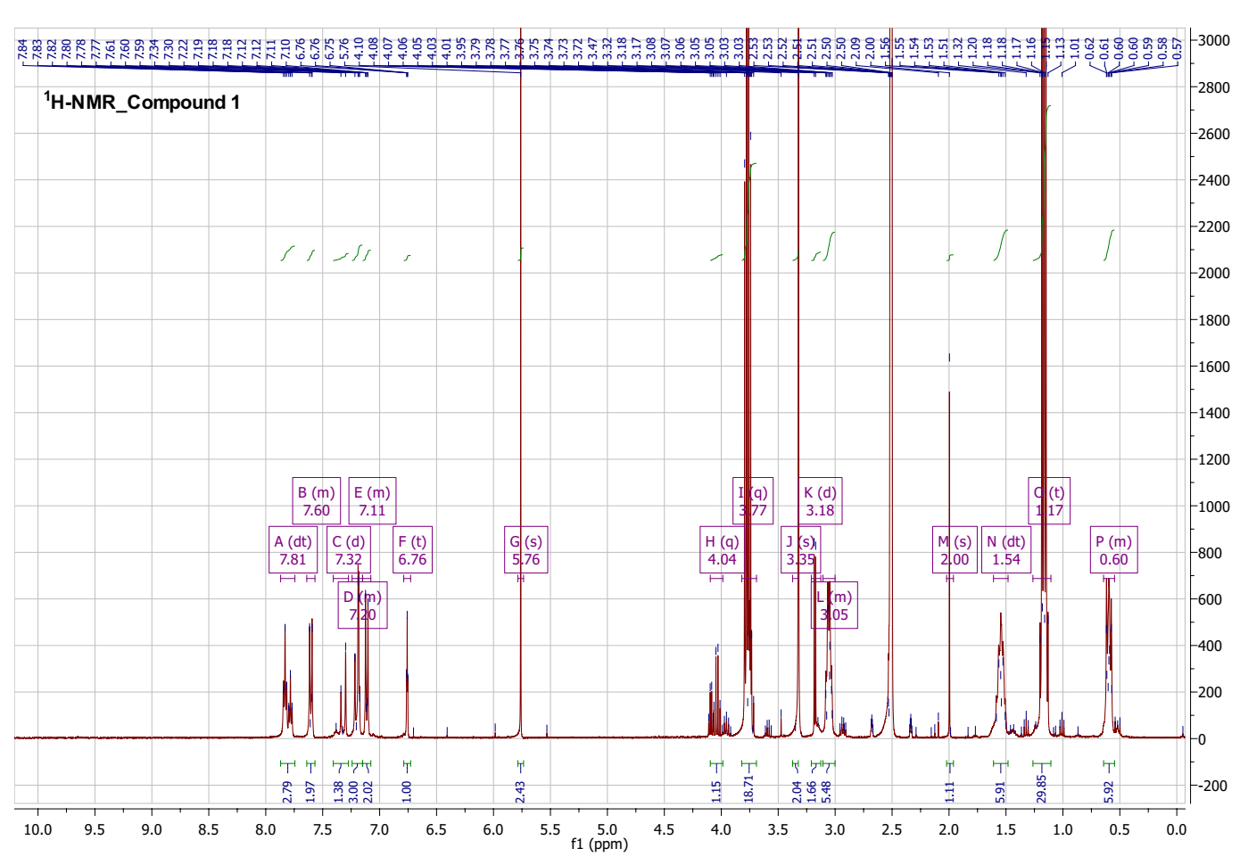

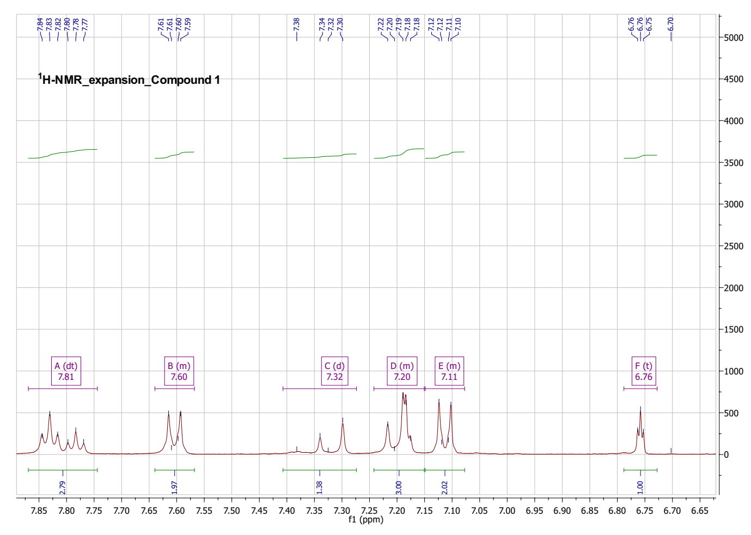

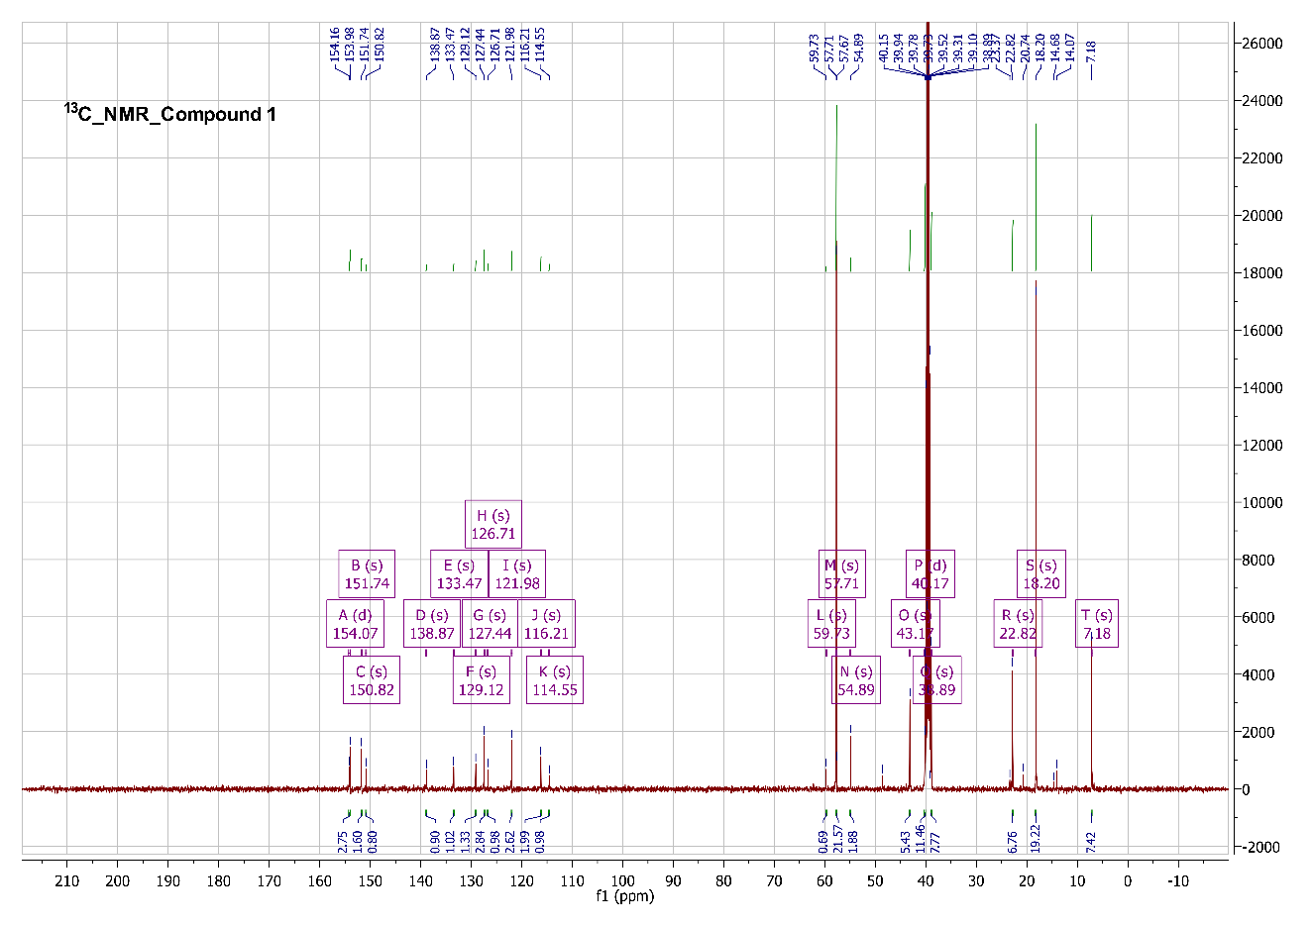

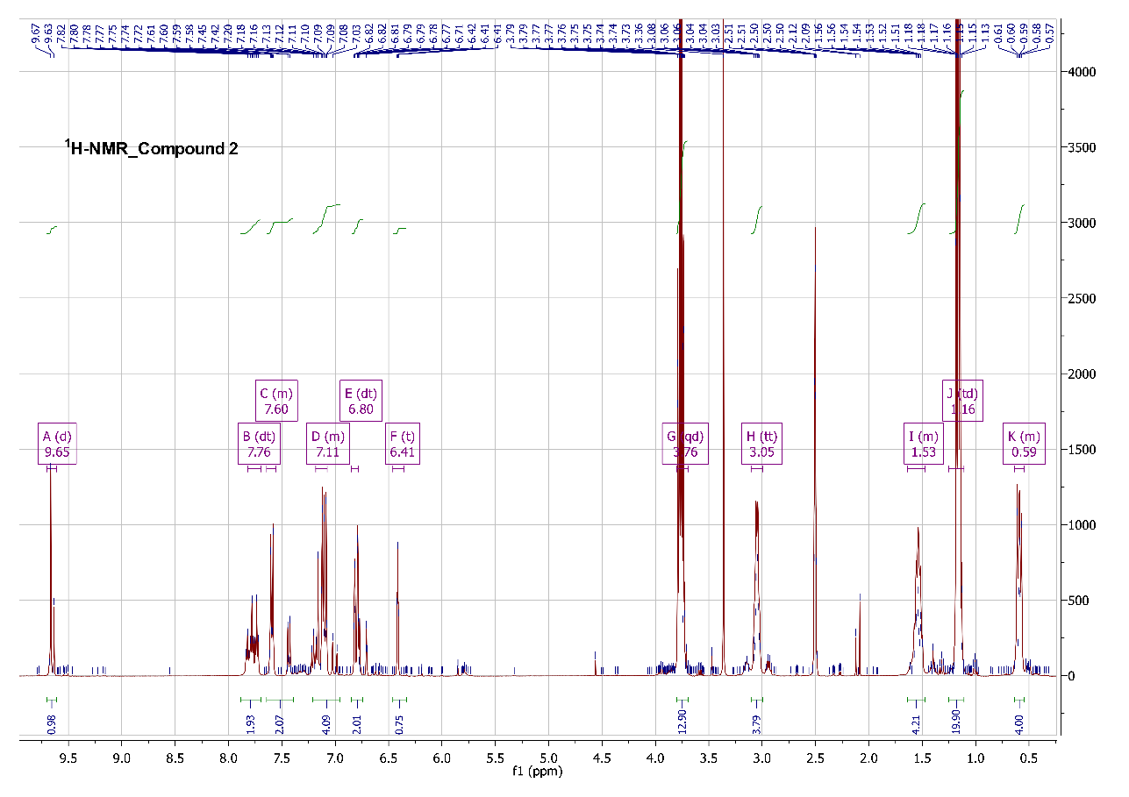

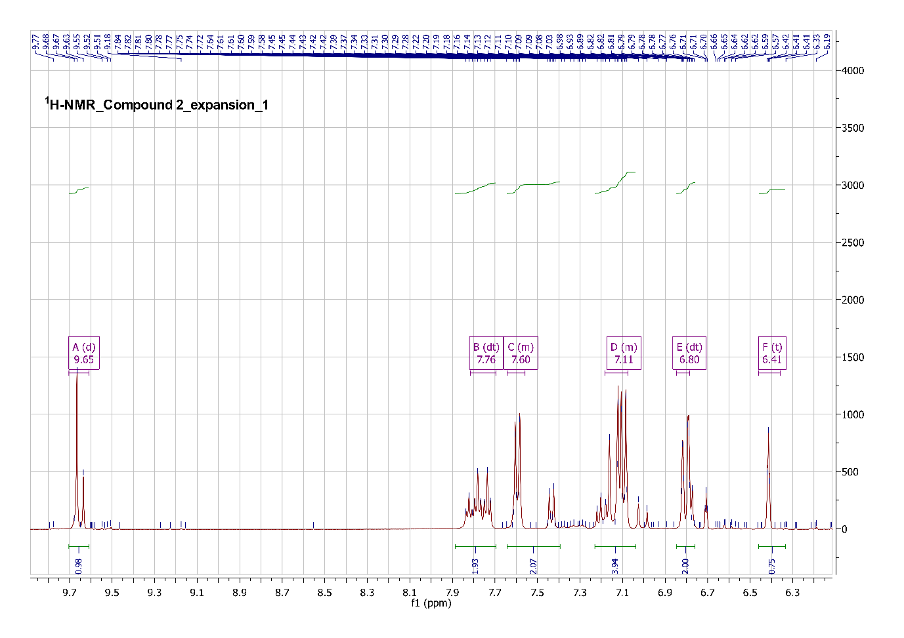

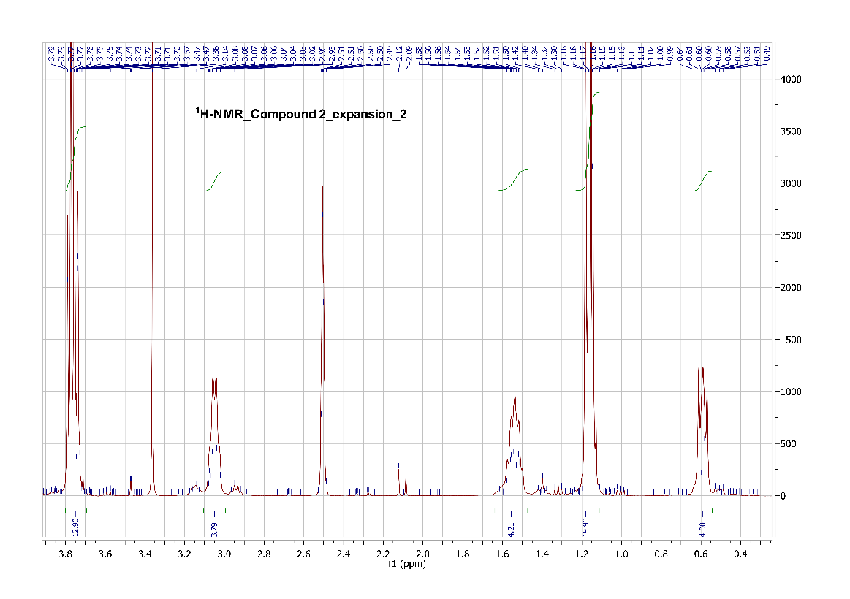

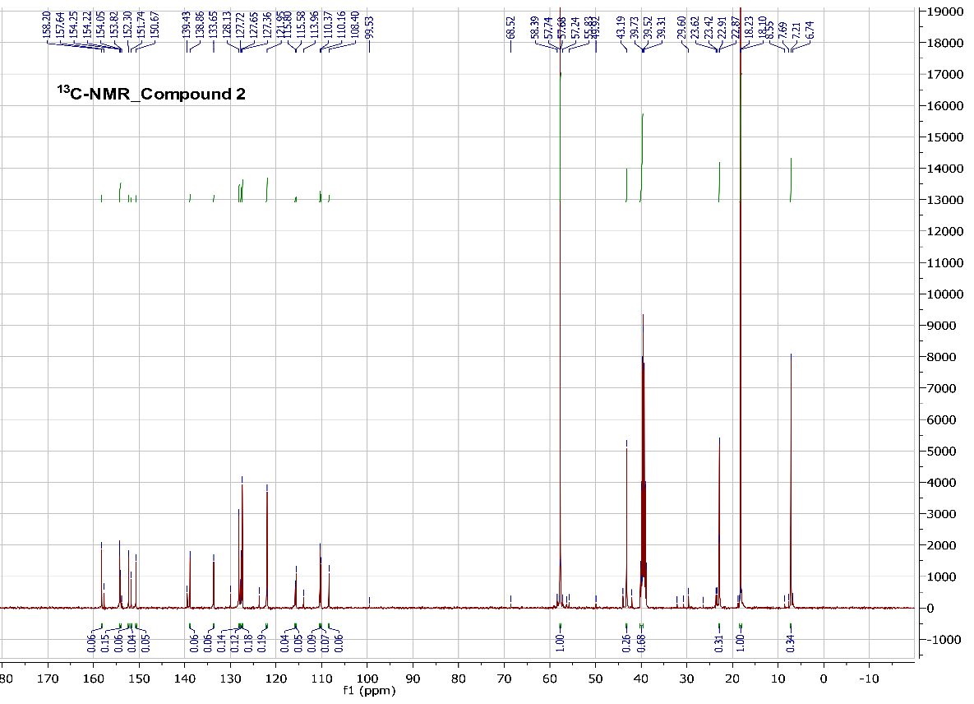

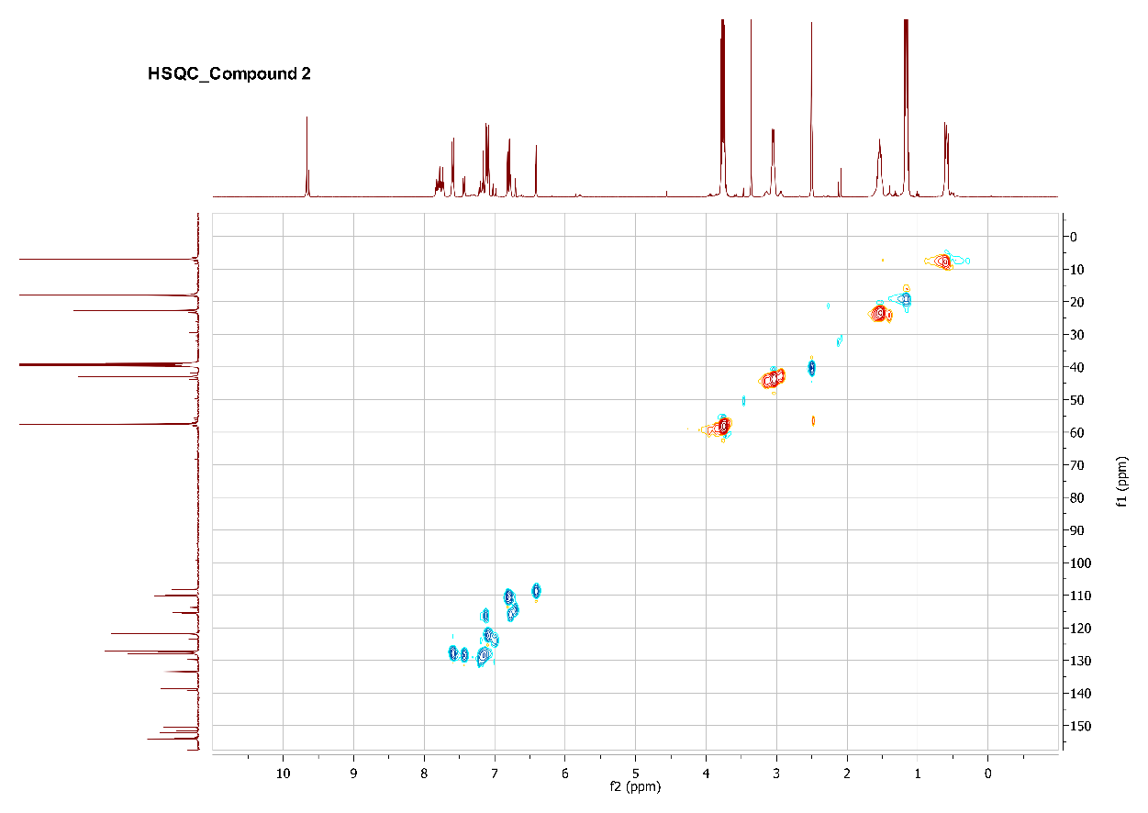

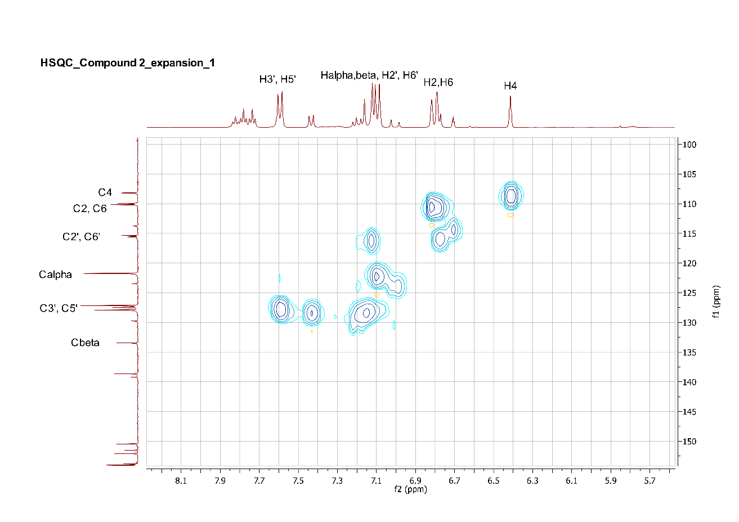

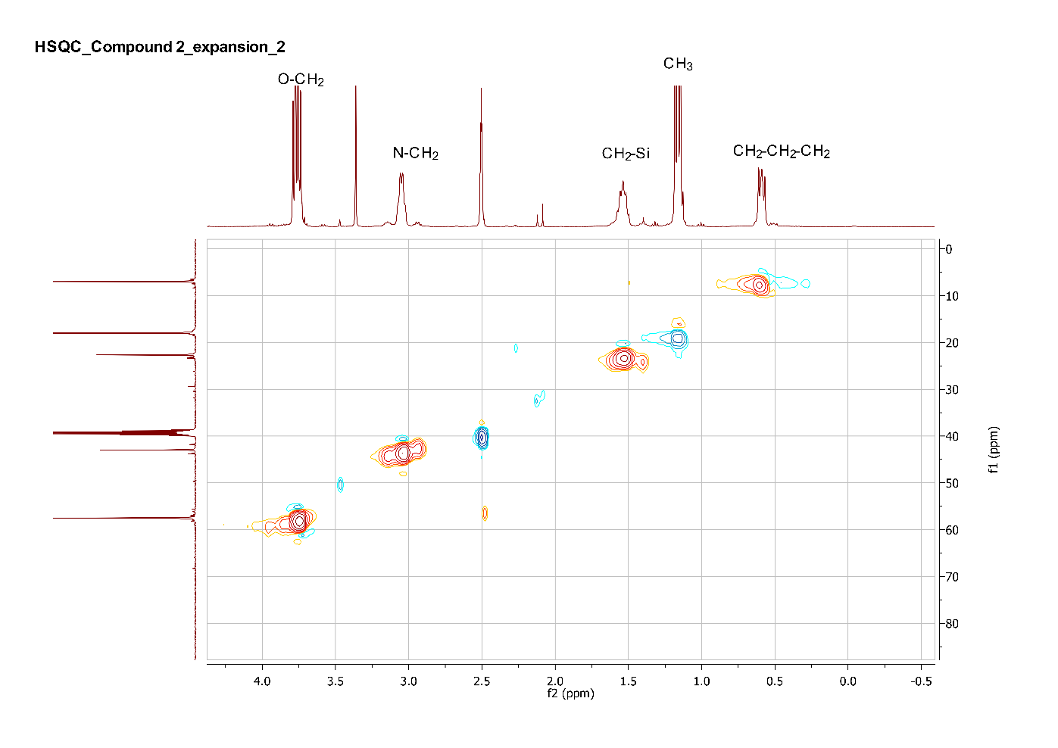

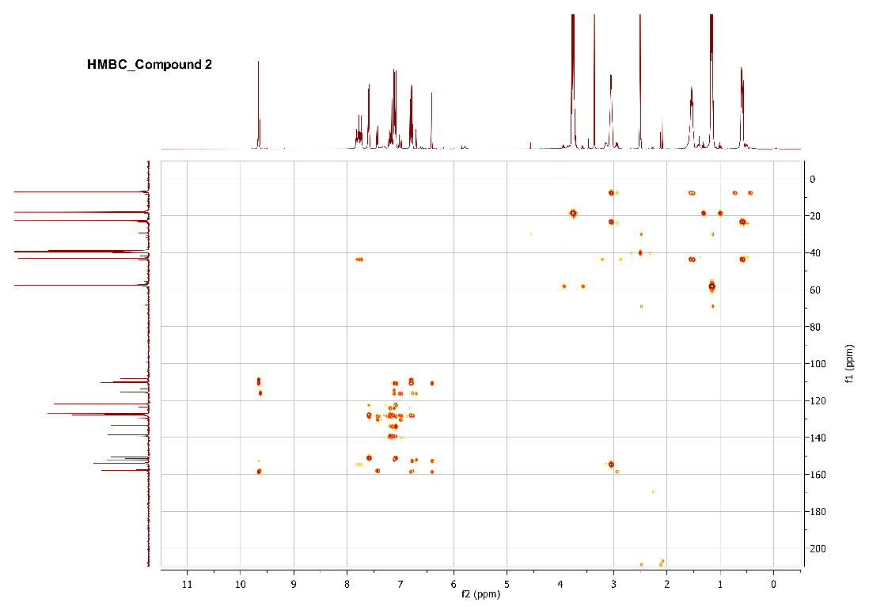

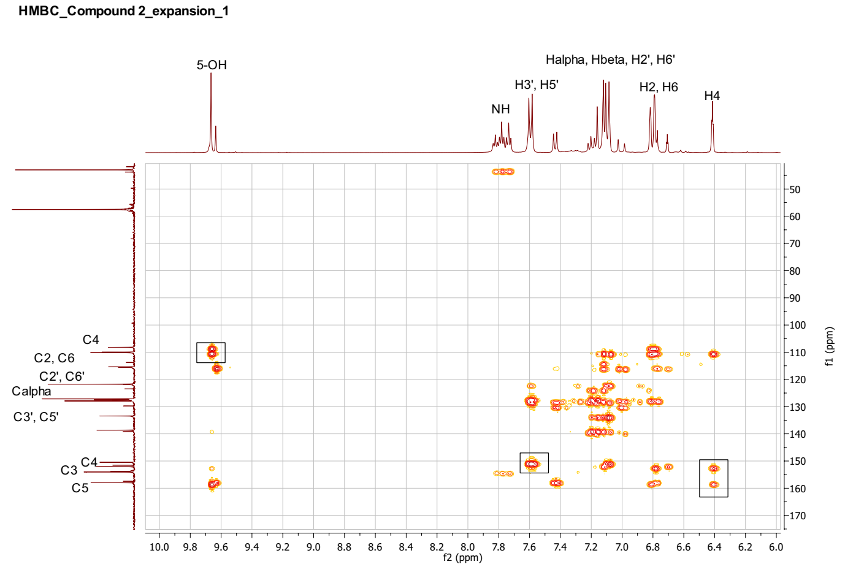

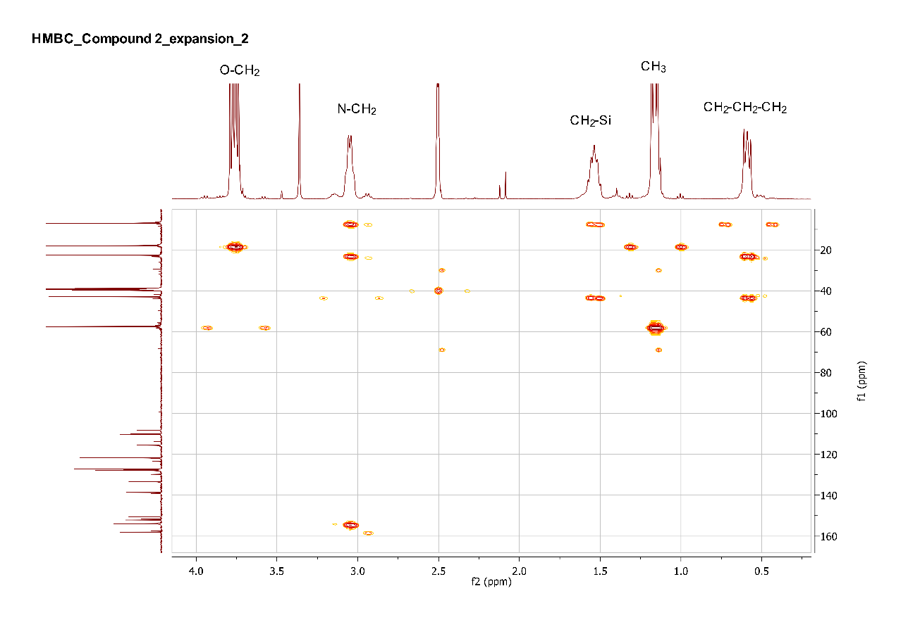

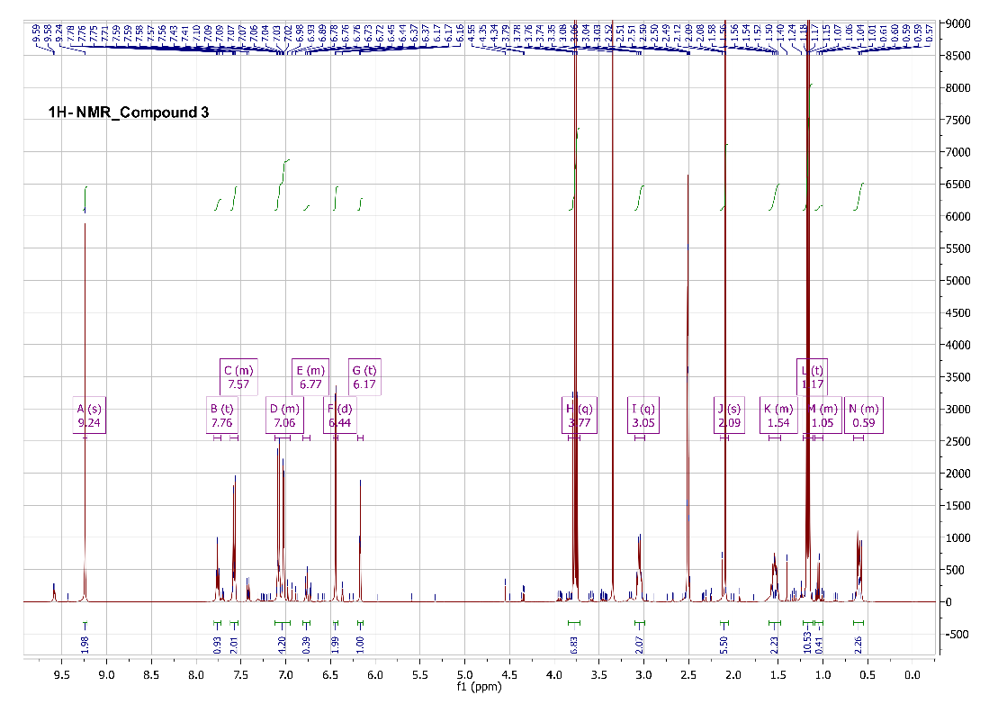

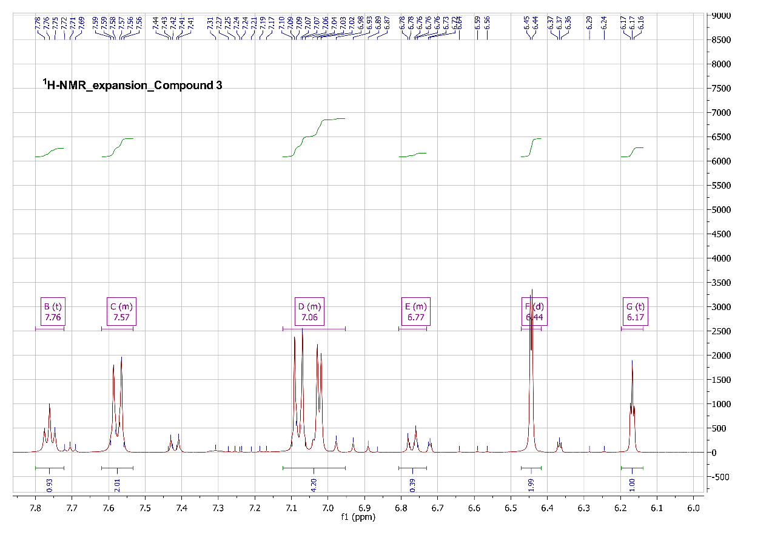

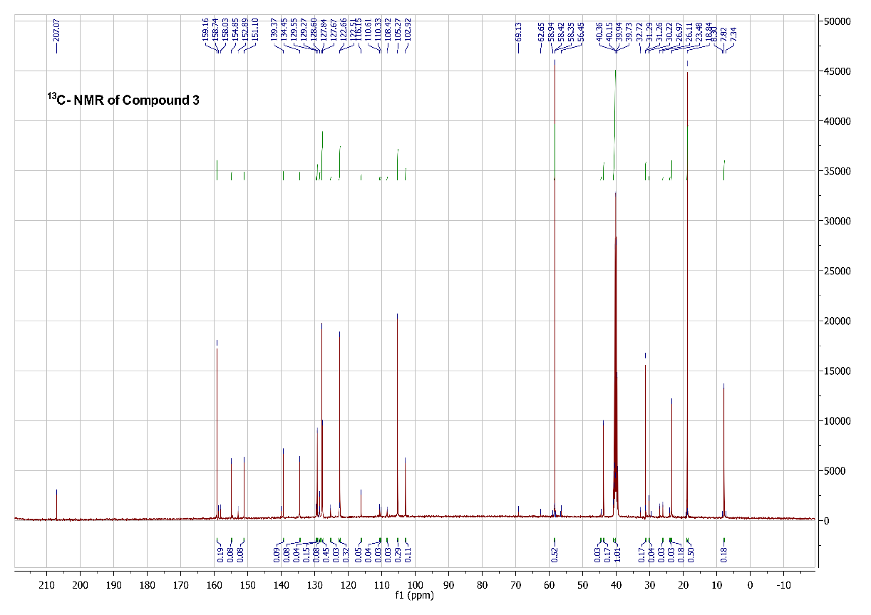

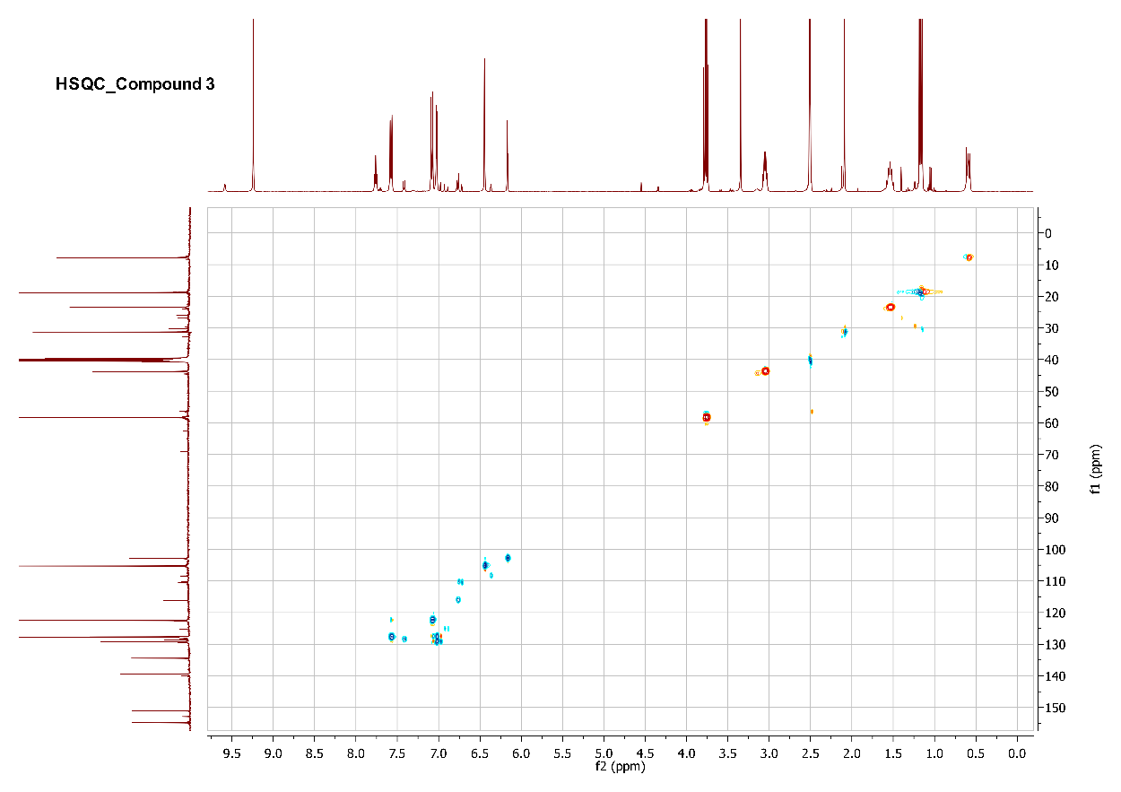

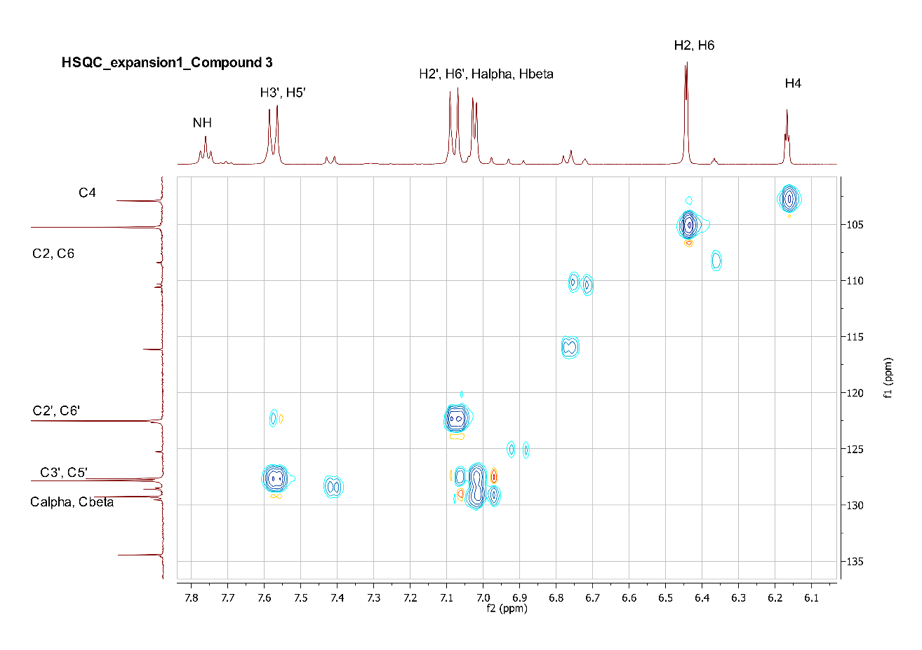

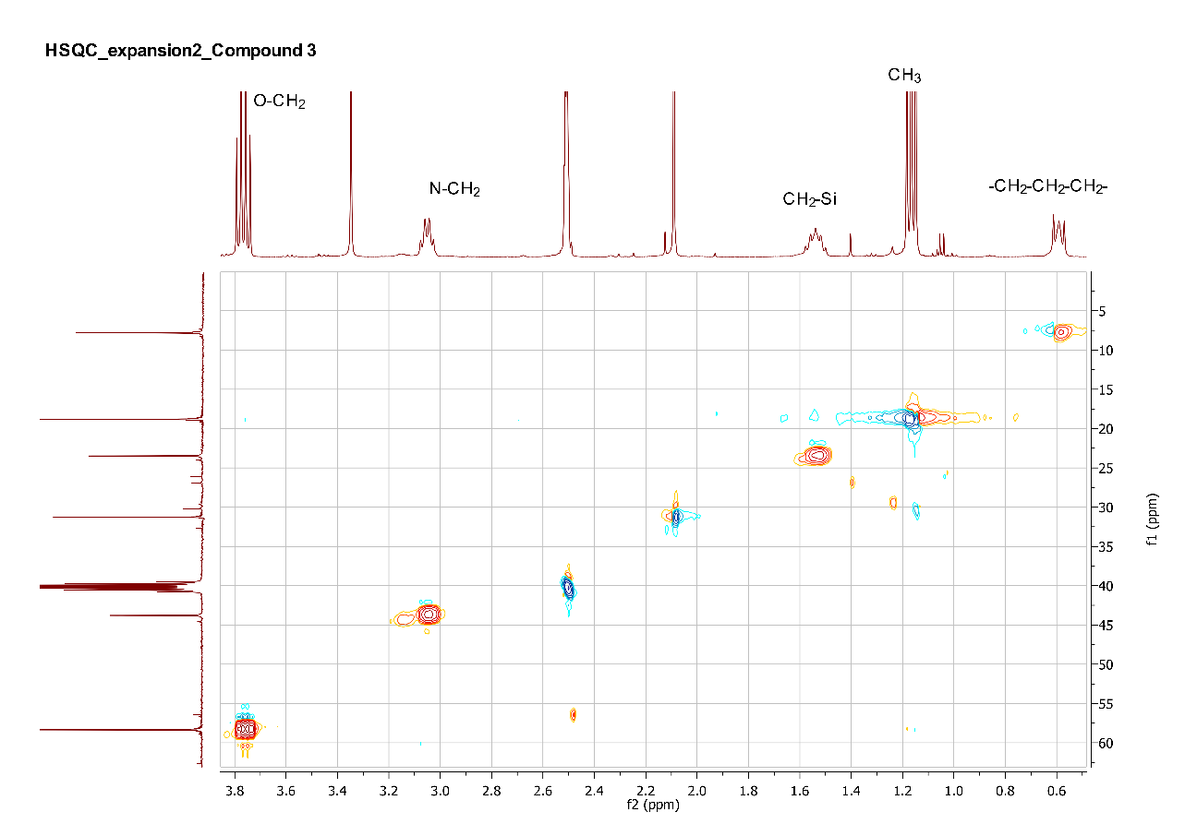

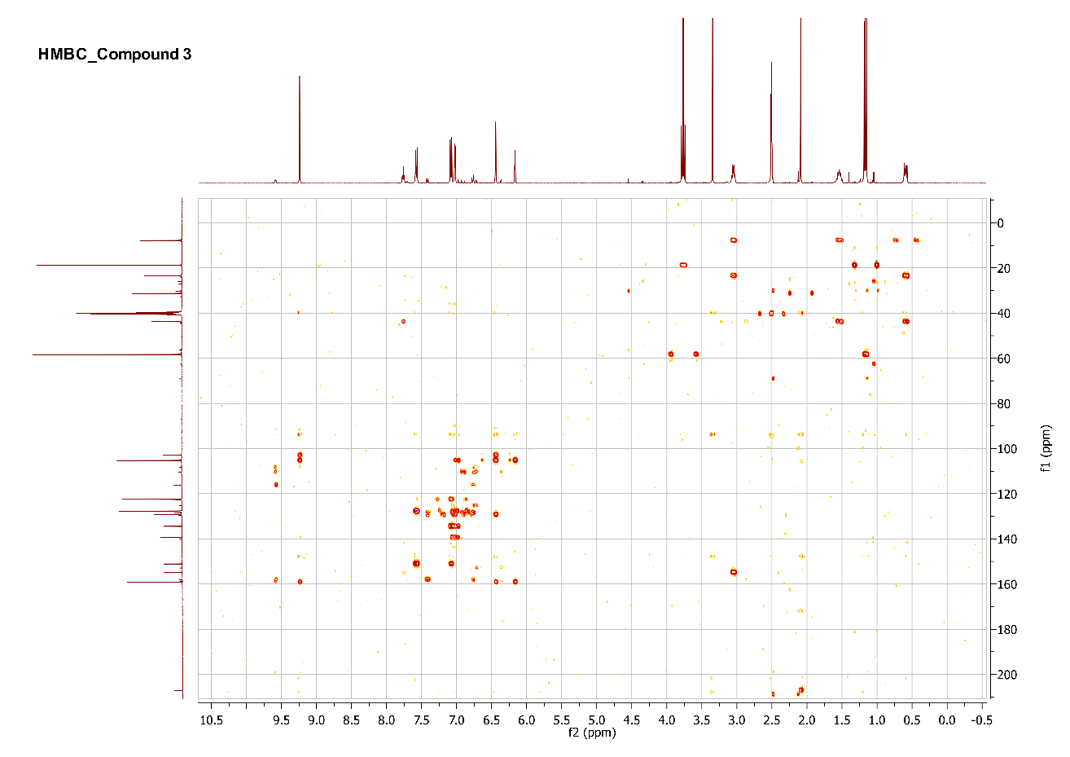

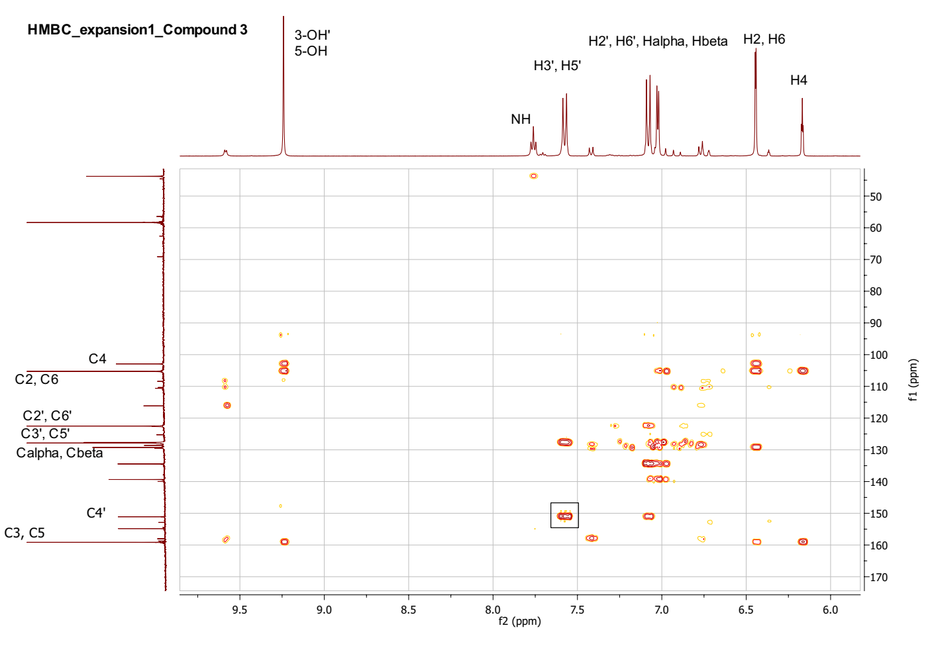

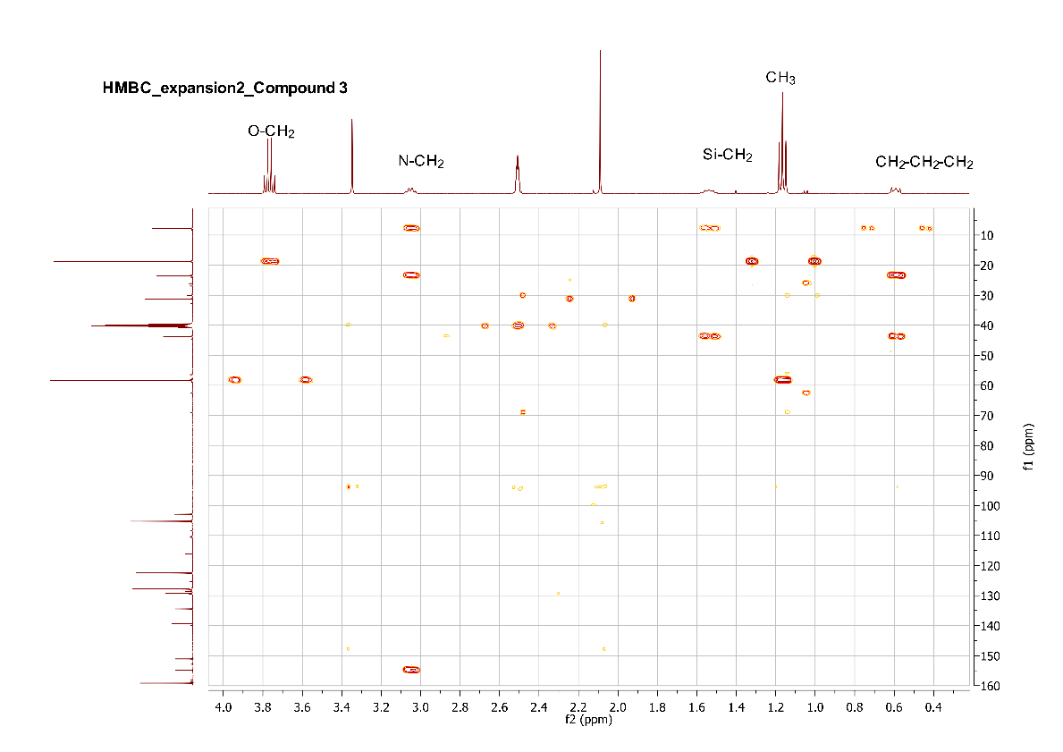

**S6. Mass spectroscopy of compound** **1, 2, and** **3**.

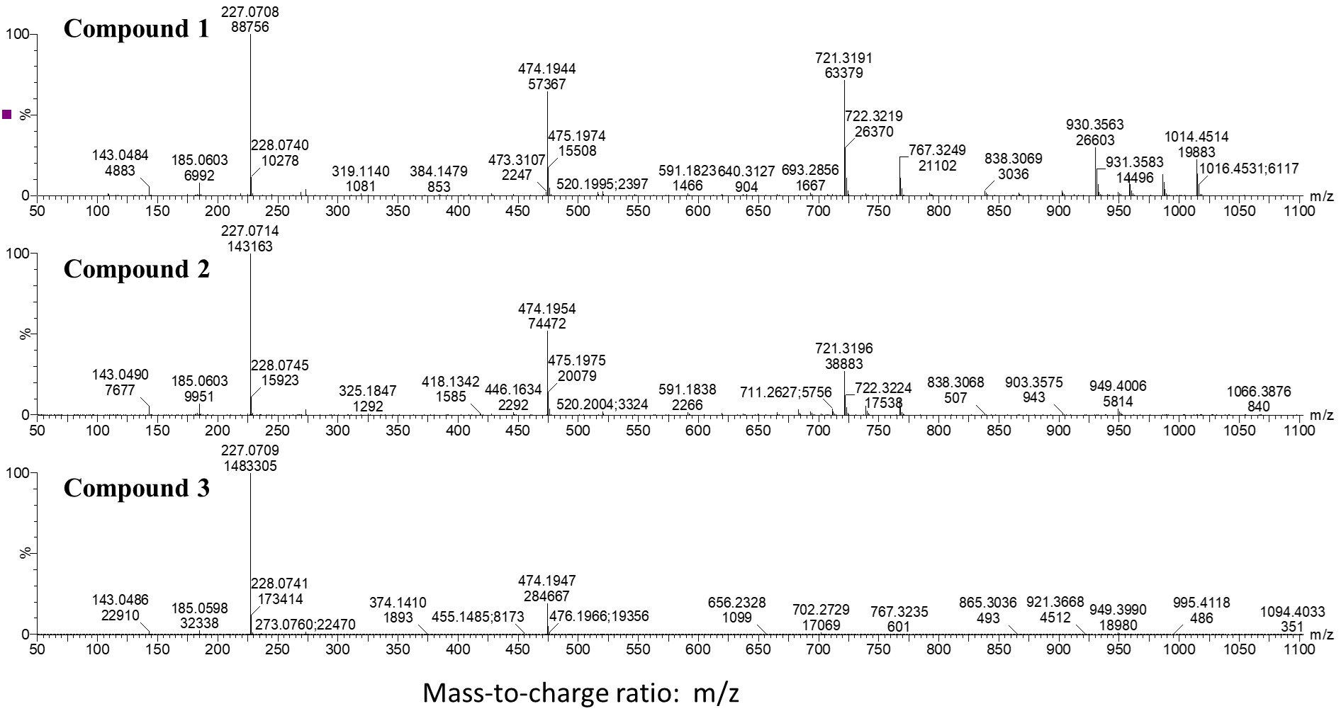

**MALDI-TOF Compound** **1**

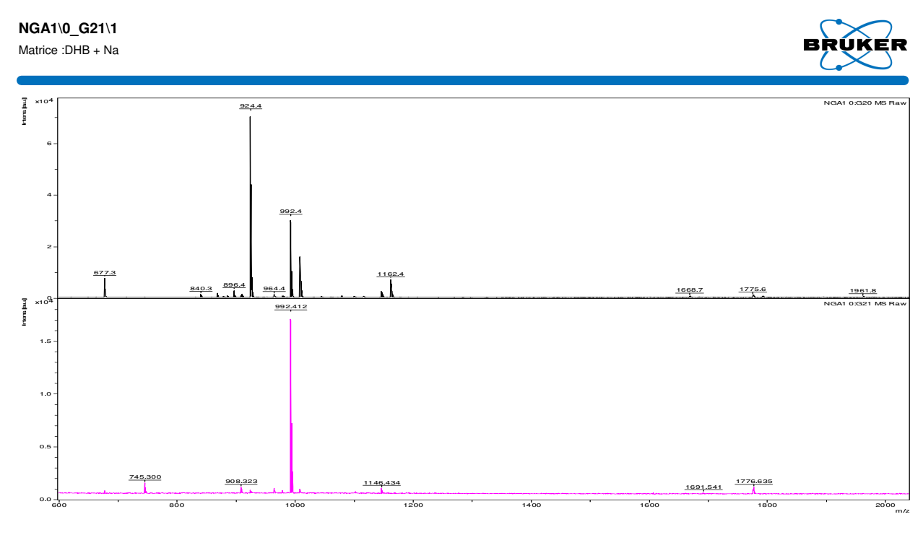

**MALDI-TOF Compound** **2**

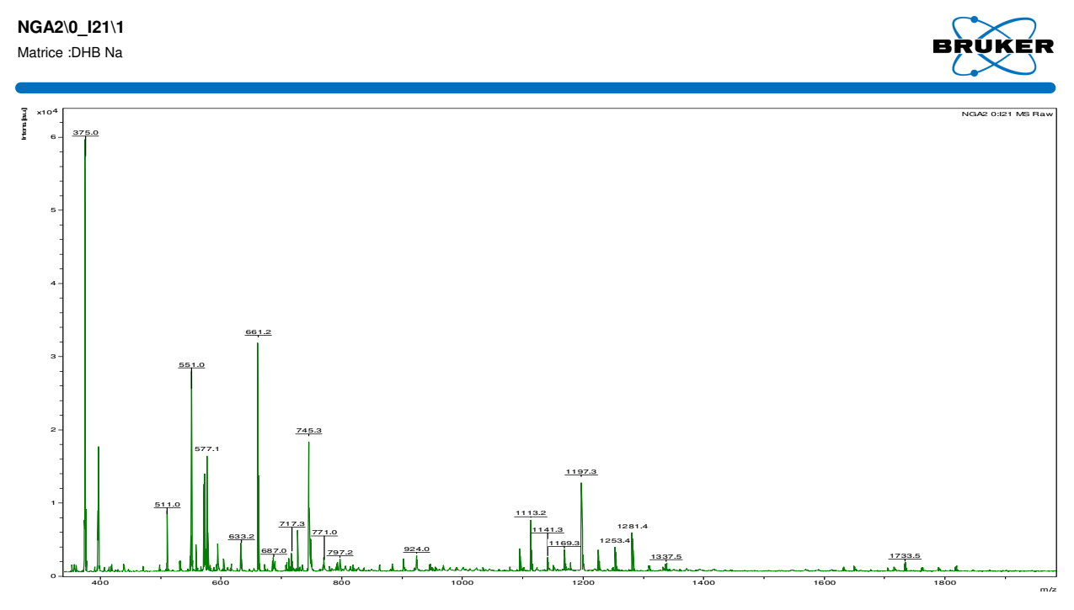

**MALDI-TOF Compound** **3**

