Supplementary Information

Multi-locus genotype-based modeling reveals that rising temperatures stabilize the flowering date of winter wheat

Yong He, Wei Xiong, Pengcheng Hu, Yinglong Xu, Chenyang Hao, Ron DePauw, Bangyou Zheng, Daiqing Huang, Gerrit Hoogenboom, Laura Dixon, Andrew Juan Challinor

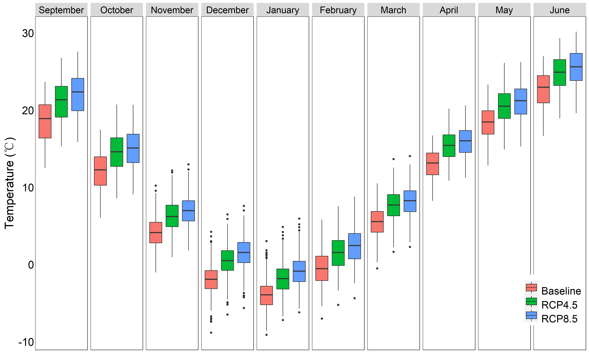
Supplementary Figure 1│Distribution of mean monthly air temperature of wheat growing-season at 16 locations of the Northern China Winter Wheat Region (NCWWR) under baseline (1981–2010), RCP4.5 and RCP8.5 projected climates (2036–2065) of the 16 locations of the Northern China Winter Wheat Region (NCWWR). Boxes show the median, an upper and lower hinge corresponding to the 25th and 75th percentiles of the distribution (first and third quartiles) and the whiskers, which show data dispersion up to 1.5 times the inter-quantile range; filled black circles are outliers.
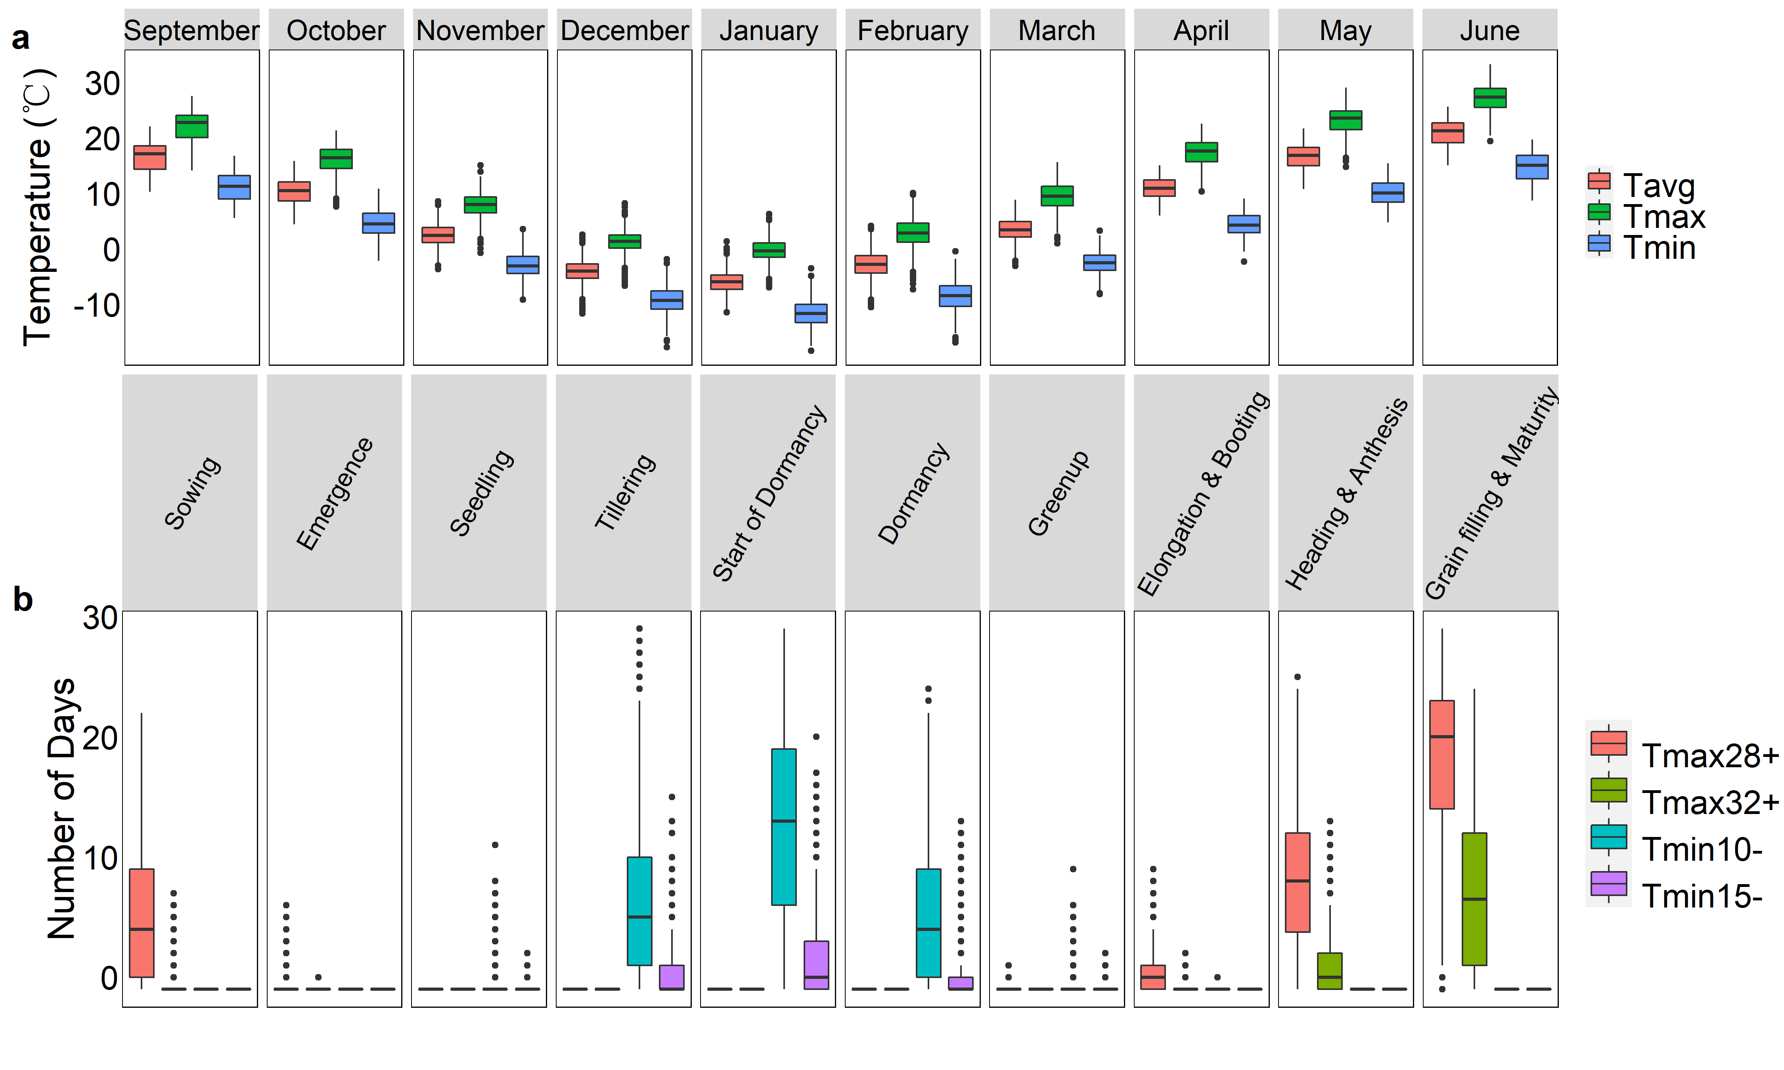
Supplementary Figure 2│Variation in monthly air temperature of growing-season at 16 locations of the Northern China Winter Wheat Region (NCWWR) for the period 1961–2015. a, Boxplot of averaged monthly temperature (Tavg), maximum temperature (Tmax), and minimum temperature (Tmin). b, Boxplot of averaged number of days with daily maximum temperature over 28 °C (Tmax28+), daily maximum temperature over 32 °C (Tmax32+), daily minimum temperature less than -10 °C (Tmin10-), and daily minimum temperature less than -15 °C (Tmin15-) for each month. Boxes in a and b show the median, an upper and lower hinge corresponding to the 25th and 75th percentiles of the distribution (first and third quartiles) and the whiskers, which show data dispersion up to 1.5 times the inter-quantile range; filled black circles are outliers.

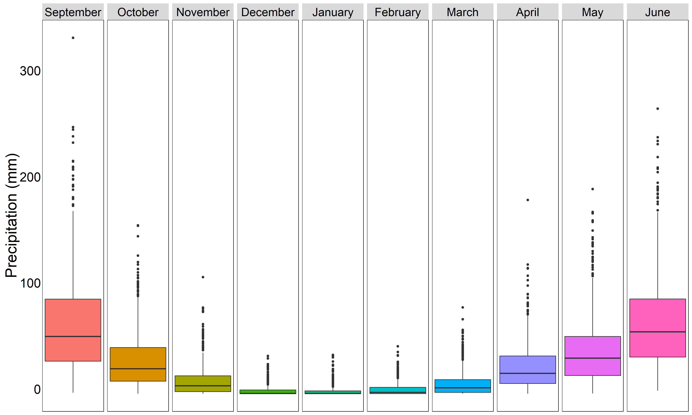
Supplementary Figure 3│Variation in monthly accumulated precipitation of growing-season at 16 locations of the Northern China Winter Wheat Region (NCWWR) for the period 1961–2015. Boxes show the median, an upper and lower hinge corresponding to the 25th and 75th percentiles of the distribution (first and third quartiles) and the whiskers, which show data dispersion up to 1.5 times the inter-quantile range; filled black circles are outliers.

Supplementary Table 1. Allelic characterization of varieties for vernalization (VRN) and photoperiod (PDP) loci
Variety | Vrn-A1 | Vrn-B1 | Vrn-B3 | Vrn-D1 | Ppd-A1 | Ppd-B1 | Ppd-D1
CA9722 | vrn-A1 | vrn-B1 | vrn-B3 | vrn-D1 | Ppd-A1b | Ppd-B1b | Ppd-D1a
Dongfanghong 3 | vrn-A1 | vrn-B1 | vrn-B3 | vrn-D1 | Ppd-A1b | Ppd-B1b | Ppd-D1b
Zhongyou 206 | vrn-A1 | vrn-B1 | vrn-B3 | vrn-D1 | Ppd-A1b | Ppd-B1b | Ppd-D1a
Zhongmai 175 | vrn-A1 | vrn-B1 | vrn-B3 | vrn-D1 | Ppd-A1b | Ppd-B1b | Ppd-D1a
Fengkang 2 | vrn-A1 | vrn-B1 | vrn-B3 | vrn-D1 | Ppd-A1b | Ppd-B1b | Ppd-D1a
Fengkang 7 | vrn-A1 | vrn-B1 | vrn-B3 | vrn-D1 | Ppd-A1b | Ppd-B1b | Ppd-D1a
Fengkang 8 | vrn-A1 | vrn-B1 | vrn-B3 | vrn-D1 | Ppd-A1b | Ppd-B1b | Ppd-D1a
Jing 411 | vrn-A1 | vrn-B1 | vrn-B3 | vrn-D1 | Ppd-A1b | Ppd-B1b | Ppd-D1a
Jing 9428 | vrn-A1 | vrn-B1 | vrn-B3 | vrn-D1 | Ppd-A1b | Ppd-B1b | Ppd-D1a
Jingdong 1 | vrn-A1 | vrn-B1 | vrn-B3 | vrn-D1 | Ppd-A1a | Ppd-B1b | Ppd-D1a
Jingdong 12 | vrn-A1 | vrn-B1 | vrn-B3 | vrn-D1 | Ppd-A1b | Ppd-B1b | Ppd-D1a
Jingdong 17 | vrn-A1 | vrn-B1 | vrn-B3 | vrn-D1 | Ppd-A1b | Ppd-B1b | Ppd-D1a
Jingdong 22 | vrn-A1 | vrn-B1 | vrn-B3 | vrn-D1 | Ppd-A1b | Ppd-B1b | Ppd-D1a
Jingdong 6 | vrn-A1 | vrn-B1 | vrn-B3 | vrn-D1 | Ppd-A1b | Ppd-B1b | Ppd-D1a
Jingdong 8 | vrn-A1 | vrn-B1 | vrn-B3 | vrn-D1 | Ppd-A1b | Ppd-B1b | Ppd-D1a
Jingshuang 10 | vrn-A1 | vrn-B1 | vrn-B3 | vrn-D1 | Ppd-A1b | Ppd-B1b | Ppd-D1a
Jingshuang 12 | vrn-A1 | vrn-B1 | vrn-B3 | vrn-D1 | Ppd-A1b | Ppd-B1b | Ppd-D1a
Jingshuang 16 | vrn-A1 | vrn-B1 | vrn-B3 | vrn-D1 | Ppd-A1b | Ppd-B1b | Ppd-D1a
Jingshuang 9 | vrn-A1 | vrn-B1 | vrn-B3 | vrn-D1 | Ppd-A1b | Ppd-B1b | Ppd-D1a
Jiahongmai | vrn-A1 | vrn-B1 | vrn-B3 | vrn-D1 | Ppd-A1b | Ppd-B1b | Ppd-D1b
Lanhuamai | vrn-A1 | vrn-B1 | vrn-B3 | vrn-D1 | Ppd-A1b | Ppd-B1b | Ppd-D1a
Nongda 139 | vrn-A1 | vrn-B1 | vrn-B3 | vrn-D1 | Ppd-A1b | Ppd-B1b | Ppd-D1a
Nongda 146 | vrn-A1 | vrn-B1 | vrn-B3 | vrn-D1 | Ppd-A1b | Ppd-B1b | Ppd-D1a
Nongda 183 | vrn-A1 | vrn-B1 | vrn-B3 | vrn-D1 | Ppd-A1b | Ppd-B1b | Ppd-D1b
Nongda 211 | vrn-A1 | vrn-B1 | vrn-B3 | vrn-D1 | Ppd-A1b | Ppd-B1b | Ppd-D1a
Nongda 212 | vrn-A1 | vrn-B1 | vrn-B3 | vrn-D1 | Ppd-A1b | Ppd-B1b | Ppd-D1a
Nongda 311 | vrn-A1 | vrn-B1 | vrn-B3 | vrn-D1 | Ppd-A1a | Ppd-B1b | Ppd-D1b
Nongda 3432 | vrn-A1 | vrn-B1 | vrn-B3 | vrn-D1 | Ppd-A1b | Ppd-B1b | Ppd-D1a
Nongda 36 | vrn-A1 | vrn-B1 | vrn-B3 | vrn-D1 | Ppd-A1b | Ppd-B1b | Ppd-D1b
Beijing 10 | vrn-A1 | vrn-B1 | vrn-B3 | vrn-D1 | Ppd-A1b | Ppd-B1b | Ppd-D1a
Beijing 15 | vrn-A1 | vrn-B1 | vrn-B3 | vrn-D1 | Ppd-A1b | Ppd-B1b | Ppd-D1a
Beijing 8 | vrn-A1 | vrn-B1 | vrn-B3 | vrn-D1 | Ppd-A1b | Ppd-B1b | Ppd-D1a
Huabei 187 | vrn-A1 | vrn-B1 | vrn-B3 | vrn-D1 | Ppd-A1a | Ppd-B1b | Ppd-D1b
Yuandong 822 | vrn-A1 | vrn-B1 | vrn-B3 | vrn-D1 | Ppd-A1b | Ppd-B1b | Ppd-D1a
Lvhan 328 | vrn-A1 | vrn-B1 | vrn-B3 | vrn-D1 | Ppd-A1b | Ppd-B1b | Ppd-D1a
Zhoumai 18 | vrn-A1 | vrn-B1 | vrn-B3 | vrn-D1 | Ppd-A1b | Ppd-B1b | Ppd-D1a
Dabaimang | vrn-A1 | vrn-B1 | vrn-B3 | Vrn-D1-spring | Ppd-A1b | Ppd-B1b | Ppd-D1b
Dahongmang | vrn-A1 | vrn-B1 | vrn-B3 | Vrn-D1-spring | Ppd-A1b | Ppd-B1b | Ppd-D1b
Dingxian 72 | vrn-A1 | vrn-B1 | vrn-B3 | vrn-D1 | Ppd-A1b | Ppd-B1b | Ppd-D1b
Xiaokouhong | vrn-A1 | vrn-B1 | vrn-B3 | Vrn-D1-spring | Ppd-A1b | Ppd-B1b | Ppd-D1b
Xiaomaimang | vrn-A1 | vrn-B1 | vrn-B3 | vrn-D1 | Ppd-A1b | Ppd-B1b | Ppd-D1b
Daimanghongmai | vrn-A1 | vrn-B1 | vrn-B3 | Vrn-D1-spring | Ppd-A1b | Ppd-B1b | Ppd-D1b
Yan'an 11 | vrn-A1 | vrn-B1 | vrn-B3 | vrn-D1 | Ppd-A1b | Ppd-B1b | Ppd-D1b
Zaoyangmai | vrn-A1 | vrn-B1 | vrn-B3 | vrn-D1 | Ppd-A1b | Ppd-B1b | Ppd-D1b
Jinmai 8 | vrn-A1 | vrn-B1 | vrn-B3 | vrn-D1 | Ppd-A1a | Ppd-B1b | Ppd-D1a
Youmangbai 4 | vrn-A1 | vrn-B1 | vrn-B3 | vrn-D1 | Ppd-A1b | Ppd-B1b | Ppd-D1b
Youmangbaifu J | vrn-A1 | vrn-B1 | vrn-B3 | vrn-D1 | Ppd-A1b | Ppd-B1b | Ppd-D1b
Youmangbaifu L | vrn-A1 | vrn-B1 | vrn-B3 | Vrn-D1 | Ppd-A1b | Ppd-B1b | Ppd-D1b
Jimai 22 | vrn-A1 | vrn-B1 | vrn-B3 | vrn-D1 | Ppd-A1b | Ppd-B1b | Ppd-D1a
Zhuoludongmai | vrn-A1 | vrn-B1 | vrn-B3 | vrn-D1 | Ppd-A1b | Ppd-B1b | Ppd-D1b
Yannong 19 | vrn-A1 | vrn-B1 | vrn-B3 | vrn-D1 | Ppd-A1b | Ppd-B1b | Ppd-D1a
Yanda 1817 | vrn-A1 | vrn-B1 | vrn-B3 | vrn-D1 | Ppd-A1a | Ppd-B1b | Ppd-D1b
Niuzhijia | vrn-A1 | vrn-B1 | vrn-B3 | Vrn-D1-spring | Ppd-A1b | Ppd-B1b | Ppd-D1b
Baiqiumai | vrn-A1 | vrn-B1 | vrn-B3 | vrn-D1 | Ppd-A1b | Ppd-B1b | Ppd-D1b
Baiqimai | vrn-A1 | vrn-B1 | vrn-B3 | Vrn-D1-spring | Ppd-A1b | Ppd-B1b | Ppd-D1b
Shixin 828 | vrn-A1 | vrn-B1 | vrn-B3 | vrn-D1 | Ppd-A1a | Ppd-B1b | Ppd-D1a
Bima 1 | vrn-A1 | vrn-B1 | vrn-B3 | vrn-D1 | Ppd-A1b | Ppd-B1b | Ppd-D1a
Panshiwumang | vrn-A1 | vrn-B1 | vrn-B3 | vrn-D1 | Ppd-A1b | Ppd-B1b | Ppd-D1b
Hongpidongmai | vrn-A1 | vrn-B1 | vrn-B3 | vrn-D1 | Ppd-A1a | Ppd-B1b | Ppd-D1b
Honglaomai | vrn-A1 | vrn-B1 | vrn-B3 | vrn-D1 | Ppd-A1b | Ppd-B1b | Ppd-D1b
Hongliang 4 | vrn-A1 | vrn-B1 | vrn-B3 | vrn-D1 | Ppd-A1b | Ppd-B1b | Ppd-D1a
Hongjinmai | vrn-A1 | vrn-B1 | vrn-B3 | vrn-D1 | Ppd-A1b | Ppd-B1b | Ppd-D1b
Hongmai | vrn-A1 | vrn-B1 | vrn-B3 | vrn-D1 | Ppd-A1b | Ppd-B1b | Ppd-D1b
Laomai | vrn-A1 | vrn-B1 | vrn-B3 | vrn-D1 | Ppd-A1b | Ppd-B1b | Ppd-D1a
Liangxing 99 | vrn-A1 | vrn-B1 | vrn-B3 | vrn-D1 | Ppd-A1b | Ppd-B1b | Ppd-D1a
Hengguan 35 | vrn-A1 | vrn-B1 | vrn-B3 | Vrn-D1-spring | Ppd-A1b | Ppd-B1b | Ppd-D1a
Lunxuan 518 | vrn-A1 | vrn-B1 | vrn-B3 | vrn-D1 | Ppd-A1b | Ppd-B1b | Ppd-D1a
Lunxuan 987 | vrn-A1 | vrn-B1 | vrn-B3 | vrn-D1 | Ppd-A1b | Ppd-B1b | Ppd-D1a
Han 6172 | vrn-A1 | vrn-B1 | vrn-B3 | vrn-D1 | Ppd-A1b | Ppd-B1b | Ppd-D1a
Mingxian 169 | vrn-A1 | vrn-B1 | vrn-B3 | vrn-D1 | Ppd-A1b | Ppd-B1b | Ppd-D1b
Changfeng 1 | vrn-A1 | vrn-B1 | vrn-B3 | vrn-D1 | Ppd-A1b | Ppd-B1b | Ppd-D1a
Changzhi 6406 | vrn-A1 | vrn-B1 | vrn-B3 | vrn-D1 | Ppd-A1b | Ppd-B1b | Ppd-D1a
Shanxibaimai | vrn-A1 | vrn-B1 | vrn-B3 | vrn-D1 | Ppd-A1b | Ppd-B1b | Ppd-D1a
Mahuaban | vrn-A1 | vrn-B1 | vrn-B3 | vrn-D1 | Ppd-A1b | Ppd-B1b | Ppd-D1b
Zhongmai 998 | vrn-A1 | vrn-B1 | vrn-B3 | vrn-D1 | Ppd-A1b | Ppd-B1b | Ppd-D1a
Zhongyou 9507 | vrn-A1 | vrn-B1 | vrn-B3 | vrn-D1 | Ppd-A1b | Ppd-B1b | Ppd-D1a
PH82-2-2 | vrn-A1 | vrn-B1 | vrn-B3 | vrn-D1 | Ppd-A1b | Ppd-B1b | Ppd-D1a
Yumai 35 | vrn-A1 | vrn-B1 | vrn-B3 | Vrn-D1-spring | Ppd-A1b | Ppd-B1b | Ppd-D1a
Yumai 49 | vrn-A1 | vrn-B1 | vrn-B3 | vrn-D1 | Ppd-A1b | Ppd-B1b | Ppd-D1a
Yumai 66 | vrn-A1 | vrn-B1 | vrn-B3 | vrn-D1 | Ppd-A1b | Ppd-B1b | Ppd-D1a
Shanmai 150 | vrn-A1 | vrn-B1 | vrn-B3 | Vrn-D1-spring | Ppd-A1b | Ppd-B1b | Ppd-D1a
Jinan 17 | vrn-A1 | vrn-B1 | vrn-B3 | vrn-D1 | Ppd-A1b | Ppd-B1b | Ppd-D1a
Gaoyou 503 | vrn-A1 | vrn-B1 | vrn-B3 | Vrn-D1-spring | Ppd-A1a | Ppd-B1b | Ppd-D1a
Taiyuan 136 | vrn-A1 | Vrn-B1 | vrn-B3 | vrn-D1 | Ppd-A1a | Ppd-B1b | Ppd-D1a
Qi 79-2060 | vrn-A1 | vrn-B1 | vrn-B3 | vrn-D1 | Ppd-A1b | Ppd-B1b | Ppd-D1b
Kenong 2009 | vrn-A1 | vrn-B1 | vrn-B3 | vrn-D1 | Ppd-A1b | Ppd-B1b | Ppd-D1a
Gaocheng 8901 | vrn-A1 | vrn-B1 | vrn-B3 | Vrn-D1-spring | Ppd-A1b | Ppd-B1b | Ppd-D1a
Gaoyou 5766 | vrn-A1 | vrn-B1 | vrn-B3 | vrn-D1 | Ppd-A1b | Ppd-B1b | Ppd-D1a
Gaoyou 5218 | vrn-A1 | vrn-B1 | vrn-B3 | vrn-D1 | Ppd-A1b | Ppd-B1b | Ppd-D1a
Shiluan 02-1 | vrn-A1 | vrn-B1 | vrn-B3 | vrn-D1 | Ppd-A1b | Ppd-B1b | Ppd-D1a
Lunxuan 061 | vrn-A1 | vrn-B1 | vrn-B3 | vrn-D1 | Ppd-A1b | Ppd-B1b | Ppd-D1a
Yuanfeng 175 | vrn-A1 | vrn-B1 | vrn-B3 | vrn-D1 | Ppd-A1b | Ppd-B1b | Ppd-D1a
Xinong 509 | vrn-A1 | vrn-B1 | vrn-B3 | Vrn-D1-spring | Ppd-A1b | Ppd-B1b | Ppd-D1a
Xinong 529 | vrn-A1 | vrn-B1 | vrn-B3 | vrn-D1 | Ppd-A1b | Ppd-B1b | Ppd-D1a
Henong 58-3 | vrn-A1 | vrn-B1 | vrn-B3 | vrn-D1 | Ppd-A1b | Ppd-B1b | Ppd-D1a
Shiyou 17 | vrn-A1 | vrn-B1 | vrn-B3 | Vrn-D1-spring | Ppd-A1b | Ppd-B1b | Ppd-D1a
Shiyou 20 | vrn-A1 | vrn-B1 | vrn-B3 | vrn-D1 | Ppd-A1b | Ppd-B1b | Ppd-D1a
Shi 4366 | vrn-A1 | vrn-B1 | vrn-B3 | vrn-D1 | Ppd-A1b | Ppd-B1b | Ppd-D1a
Jimai 738 | vrn-A1 | vrn-B1 | vrn-B3 | Vrn-D1-spring | Ppd-A1b | Ppd-B1b | Ppd-D1a
Jimai U80 | vrn-A1 | vrn-B1 | vrn-B3 | vrn-D1 | Ppd-A1b | Ppd-B1b | Ppd-D1a

