Table S1. Patient and Transplantation Characteristics
Characteristic | Value (n=17)
Age, yr, median (range) | 39 (7~51)
Sex, n (%)
Male | 10 (59)
Female | 7 (41)
Diseases, n (%)
AML | 7 (41)
ALL | 3 (18)
MDS/MDS-MPN | 5 (29)
SAA | 1 (6)
Granulocytic sarcoma | 1 (6)
KPS before HSCT, median (range) | 92 (90-95)
Donor/HLA match, n (%)
Matched related | 12(71)
Mismatched related | 4 (24)
Matched unrelated | 1 (6)
Conditioning Regimen
ATG+Flu+Cy±Ara-C | 2 (12)
Bu+Flu+IDA± CTX+ATG | 9 (53)
DAC+Bu+Flu+ATG+IDA+CTX | 6 (35)
GVHD prophylaxis
CsA +MTX ± MMF | 9 (53)
FK506 + MTX ± MMF | 8 (47)
MNC,×10⁸/L, median (range) | 8 (3-17)
CD34⁺ cells,×10⁶/L, median (range) | 2.4 (1.1-5.2)

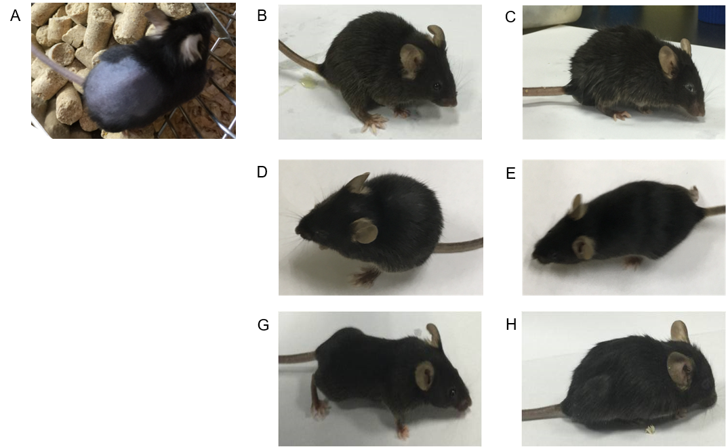

Figure S1. The appearances of mice in different groups. The WT mice received allo-HSCT at day 25 (A); the WT mice received allo-HSCT at day 3 (B); the CGD mice received allo-HSCT at day 3 (C); the WT mice injected with anti-Gr1Ab (D) or without (E) after allo-HSCT at day 5; the CGD mice rescued with BSO (G) or without (H) after allo-HSCT at day 3.The mice were randomly selected from each group. These results are representative of at least 3 independent experiments with greater than 5 mice in each group.

Table S2. Overall survival of different groups
Group | Median survival time | P value
Group 1: CGD allo-HSCT | 4 days | —
Group 2: CGD (PBS group) | 9 days | P<0.01(comparing to Group 1)
Group 3: WT (PBS group) | 12 days | NS(comparing to Group 2)
Group 4: CGD (BM group) | Survival | P<0.001(comparing to Group 1)
Group 5: WT (BM group) | Survival | NS(comparing to Group 4)
Group 6: CGD (T cell group) | 7 days | NS(comparing to Group 1)*
Group 7: WT (T cell group) | 9 days | P<0.01(comparing to Group 6)
Group 8: CGD (TCD group) | 9 days | P<0.01(comparing to Group 1)
Group 9: WT (TCD group) | 9 days | NS(comparing to Group 8)
NS: No statistic difference.
* Only the CGD mice of the T cell group had nearly the same survival rate as that of CGD mice receiving allo-HSCT

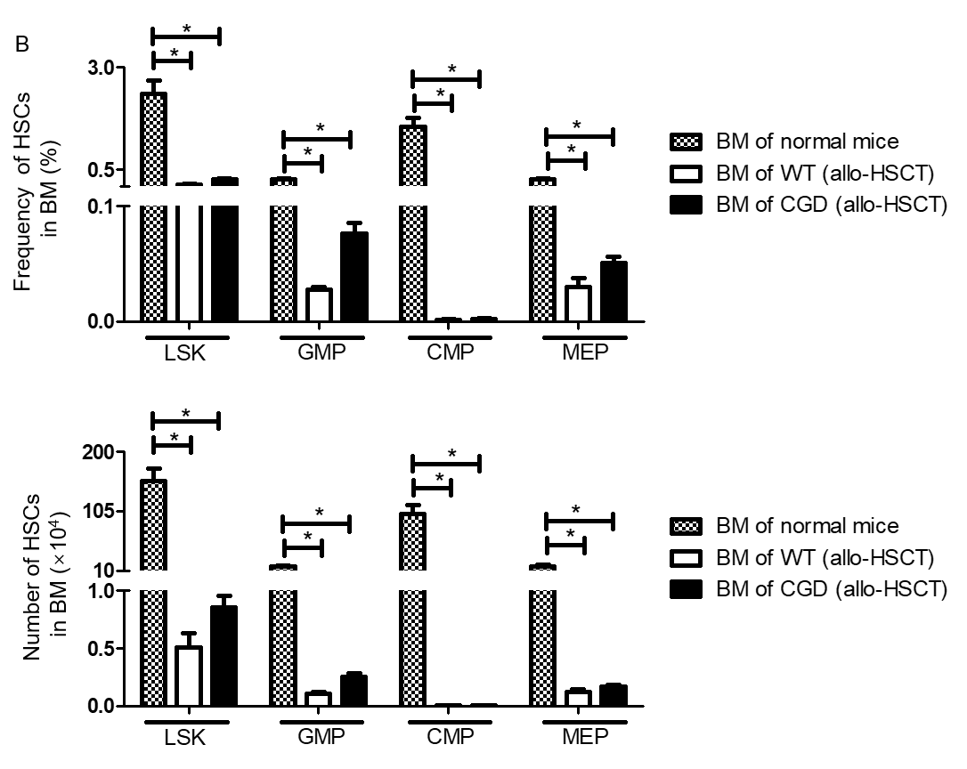
Figure S2. The frequencies and absolute number of hematopoietic stem cells during hyperacute GVHD development. LSK cells (Lin⁻Sca-1⁺c-Kit⁺ cells), CMP(CD34⁺ CD16/32^{int} cells), MEP(CD34⁻ CD16/32⁻ cells) and GMP(CD34⁺ CD16/32⁺ cells) in the BM of CGD and WT mice were measured at day 3 after allo-HSCT. The control group consisted of age- and gender-matched normal mice. (A) The frequencies; (B) The absolute number; (C) The gating strategy of hematopoietic stem cells are shown. Data are expressed as mean ± standard error (SE). *P<0.05.

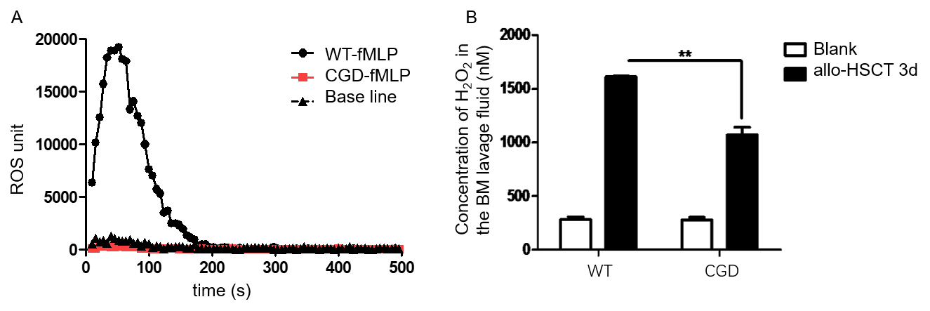
Figure S3. Oxidative stress determination. (A) Bone marrow-derived CD11b⁺Gr1⁺ cells (1×10⁶) from WT or CGD mice were stimulated with 100nM fMLP. (B) ROS production was evaluated by the use of chemiluminescence. ROS production in the BM of CGD mice receiving allo-HSCT for 3 days was significantly lower than that of C57BL/6 mice. Data are means ± SD of n = 3 mice. **p <0.001.

Table S3. The levels of multiple cytokines associated with T cells in the serum of recipients at day 3 after allo-HSCT.
cytokines in the serum | I  (WT control, mean, pg/mL) | II  (CGD suffering hyperacute GHVD, mean, pg/mL) | III  (CGD rescued by BSO, mean, pg/mL) | P value  (I VS II) | P value  (II VS III) | P value  (I VS III)
IL-10 | 24.2 | 63.8 | 23.2 | 0.0002 | 0.0015 | ns
IL-1β* | 4.6 | 68.2 | 5.0 | < 0.0001 | 0.0001 | ns
IL-2* | 11.0 | 47.3 | 15.4 | 0.0023 | 0.0041 | ns
IL-4 | 9.5 | 18.9 | 10.0 | 0.0064 | 0.0034 | ns
IL-5 | 84.3 | 33.8 | 77.7 | 0.0014 | 0.0013 | ns
IL-6* | 63.3 | 986.5 | 29.2 | 0.0002 | 0.0002 | 0.0134
IL-22 | 32.8 | 1545.3 | 38.0 | 0.0004 | 0.0004 | ns
IL-9 | 6.2 | 8.7 | 6.9 | ns | ns | ns
IL-13* | 6.7 | 22.0 | 6.4 | 0.0099 | 0.0117 | ns
IL-27* | 11.8 | 43.0 | 8.5 | 0.0038 | 0.0002 | ns
IL-23 | 5.8 | 4.8 | 4.3 | ns | ns | ns
IFN-γ* | 268.7 | 1646.0 | 1625.7 | 0.0025 | ns | 0.0007
IL-12p70* | 6.7 | 65.7 | 6.8 | 0.0009 | 0.0016 | ns
GM-CSF* | 5.3 | 24.0 | 6.0 | 0.0116 | 0.0131 | ns
TNF-a* | 23.7 | 249.3 | 14.3 | < 0.0001 | 0.0001 | ns
IL-17A* | 5.8 | 27.7 | 6.3 | 0.0118 | 0.0010 | ns
IL-18* | 15.7 | 816.0 | 24.3 | 0.0001 | < 0.0001 | ns
* Cytokines up-regulated by more than 3 fold in the serum of CGD mice with hyperacute GVHD phenotype when compared with WT control.

