Title: Does digital technology reduce health disparity? Investigating difference of depression stemming from socioeconomic status among Chinese older adults
Author Note: Aruhan, PhD student¹, Zhaohua Deng, PhD¹*, Xiang Wu, PhD¹
¹ School of Medicine and Health Management, Huazhong University of Science and Technology, Wuhan, China.
*Corresponding author: Zhaohua Deng*, School of Medicine and Health Management, Tongji Medical College, Huazhong University of Science and Technology, Wuhan 430030, China. Email: zh-deng@hust.edu.cn. Tel: +8619945036079
Declarations:
Ethics approval and consent to participate: Not applicable. Consent for publication: Not applicable. Competing interests: None.
Availability of data and materials: Dataset from the China Health and Retirement Longitudinal Study (CHARLS) http://charls.pku.edu.cn/ .
Funding: This study was supported by the Fundamental Research Funds for the Central Universities (award no. 2019WKZDJC004).
Authors’ Contributions: Aruhan (AR), Dr. Zhaohua Deng (ZD), and Dr. Xiang Wu (XW) conceived the study. AR and XW organized the data and conducted the statistical analysis. AR drafted the first version of the manuscript, WX reviewed the data. ZD and XW provided feedback on and contributed to subsequent versions of the manuscript.
Acknowledgments: The authors are grateful to Dr. Ruoxi Wang at School of Medicine and Health Management, Huazhong University of Science & Technology, who gave valuable advices on this paper.
Additional file:
Socioeconomic status and depression
When we replacing variable “father’s education” with “mother’s education” to indicate parental education, model 1 is specified as
$$Doutcome=β_{0}+β_{1}{edu}_{mother}+β_{2}{srh}_{childhood}+β_{3}edu+ β_{4}income$$
$$+ β_{5}hukou +β_{6-8}control variables+e$$
where $β_{1},β_{2},β_{3},β_{4}, and β_{5}$ determine the effects of SES.

Table 1. OLS analysis and quantile regression estimation for model 1
Variables | Dependent variable: depression
 | OLS | Quantile regression  regression
 |  | 0.5 | 0.6 | 0.7 | 0.8 | 0.9
 | (1) | (2) | (3) | (4) | (5) | (6)
Individual socioeconomic status
Mother's education | -0.224 | -0.234 | -0.268 | -0.371 | -0.406 | -0.481
 | (0.130) | (0.173) | (0.202) | (0.253) | (0.320) | (0.355)
SHR-16 | -0.445*** | -0.457*** | -0.482*** | -0.565*** | -0.645*** | -0.681***
 | (0.055) | (0.062) | (0.072) | (0.086) | (0.102) | (0.128)
Education | -0.845*** | -0.814*** | -1.010*** | -1.290*** | -1.860*** | -0.934**
 | (0.173) | (0.244) | (0.253) | (0.387) | (0.319) | (0.443)
Income | -0.666*** | -0.629*** | -0.761*** | -0.861*** | -1.100*** | -1.300***
 | (0.047) | (0.056) | (0.060) | (0.076) | (0.090) | (0.100)
Hukou | -0.302* | -0.228 | -0.269 | -0.369* | -0.241 | -0.174
 | (0.164) | (0.168) | (0.202) | (0.220) | (0.298) | (0.353)
Other
Age | 0.017** | 0.008 | 0.010 | 0.007 | 0.012 | 0.040**
 | (0.007) | (0.008) | (0.009) | (0.011) | (0.013) | (0.017)
Gender | -1.290*** | -1.230*** | -1.310*** | -1.950*** | -2.180*** | -2.650***
 | (0.133) | (0.155) | (0.181) | (0.221) | (0.248) | (0.310)
Marital | -1.400*** | -1.340*** | -1.530*** | -1.860*** | -1.970*** | -2.620***
 | (0.162) | (0.218) | (0.238) | (0.318) | (0.287) | (0.421)
Constant | 16.100*** | 15.100*** | 18.100*** | 22.100*** | 27.100*** | 31.000***
 | (0.746) | (0.886) | (0.979) | (1.210) | (1.420) | (1.660)
Observations | 8,821 | 8,821 | 8,821 | 8,821 | 8,821 | 8,821
R² | 0.110
Pseudo R² |  | 0.597 | 0.598 | 0.596 | 0.610 | 0.604
Note. ª standardize coefficients are reported; standard errors in parentheses.
^{b} ***p < 0.01, **p < 0.05, *p < 0.1.
Moderating effect of digital technology
We use model 2 to investigate the moderating effect of digital technology usage including Internet usage and mobile phone usage, respectively. Table 2 shows the estimation of interaction effect of SES and mobile phone usage.

Table 2. OLS analysis and quantile regression estimation for model 2 (mobile phone usage)
Variables | Dependent variable: depression
 | OLS | Quantile regression  regression
 |  | 0.5 | 0.6 | 0.7 | 0.8 | 0.9
 | (1) | (2) | (3) | (4) | (5) | (6)
Individual socioeconomic status
Father's education | -0.203 | -0.260* | -0.388** | -0.180 | -0.067 | -0.185
 | (0.132) | (0.144) | (0.171) | (0.193) | (0.228) | (0.297)
SRH-16 | -0.442*** | -0.446*** | -0.510*** | -0.547*** | -0.650*** | -0.676***
 | (0.055) | (0.062) | (0.074) | (0.085) | (0.098) | (0.121)
Education | -0.563** | -0.550* | -0.557 | -0.802 | -1.290*** | -0.846*
 | (0.228) | (0.308)* | (0.355) | (0.499) | (0.446) | (0.507)
Income | -0.632*** | -0.620*** | -0.764*** | -0.871*** | -1.180*** | -1.310***
 | (0.064) | (0.076) | (0.086) | (0.111) | (0.125) | (0.144)
Hukou | -0.377 | -0.254 | -0.206 | -0.387 | -0.408 | -0.109
 | (0.239) | (0.227) | (0.279) | (0.319) | (0.400) | (0.523)
Digital technology usage

Mobile phone usage | 1.210* | 1.260 | 1.140 | 0.764 | 0.250 | 0.088
 | (0.671) | (0.868) | (0.944) | (1.260) | (1.290) | (1.590)
Other
Age | 0.019*** | 0.007 | 0.012 | 0.017 | 0.020 | 0.039**
 | (0.007) | (0.008) | (0.009) | (0.011) | (0.013) | (0.016)
Gender | -1.350*** | -1.320*** | -1.460*** | -1.980*** | -2.210*** | -2.660***
 | (0.133) | (0.160) | (0.183) | (0.218) | (0.239) | (0.300)
Marital | -1.280*** | -1.300*** | -1.400*** | -1.820*** | -1.920*** | -2.610***
 | (0.165) | (0.205) | (0.248) | (0.310) | (0.284) | (0.408)
Interaction effect
Mobile phone usage * education | -0.561* | -0.667 | -0.894* | -0.786 | -0.908 | -0.190
 | (0.331) | (0.491) | (0.505) | (0.757) | (0.594) | (0.797)
Phone usage * income | -0.053 | -0.030 | 0.004 | 0.045 | 0.106 | 0.050
 | (0.083) | (0.095) | (0.111) | (0.135) | (0.152) | (0.192)
Mobile phone usage * hukou | 0.026 | -0.136 | -0.242 | -0.230 | 0.214 | -0.404
 | (0.318) | (0.312) | (0.379) | (0.415) | (0.518) | (0.703)
Constant | 15.400*** | 14.700*** | 17.600*** | 20.900*** | 26.500*** | 30.800***
 | (0.839) | (0.992) | (1.140) | (1.420) | (1.560) | (1.940)
Observations | 8,853 | 8,853 | 8,853 | 8,853 | 8,853 | 8,853
R² | 0.110
Pseudo R² |  | 0.595 | 0.596 | 0.596 | 0.610 | 0.602
Note. ª standardize coefficients are reported; standard errors in parentheses.
Notes: ^{b} ***p < 0.01, **p < 0.05, *p < 0.1.

Figure 1. Effects of individual socioeconomic status on depression in older Chinese adults
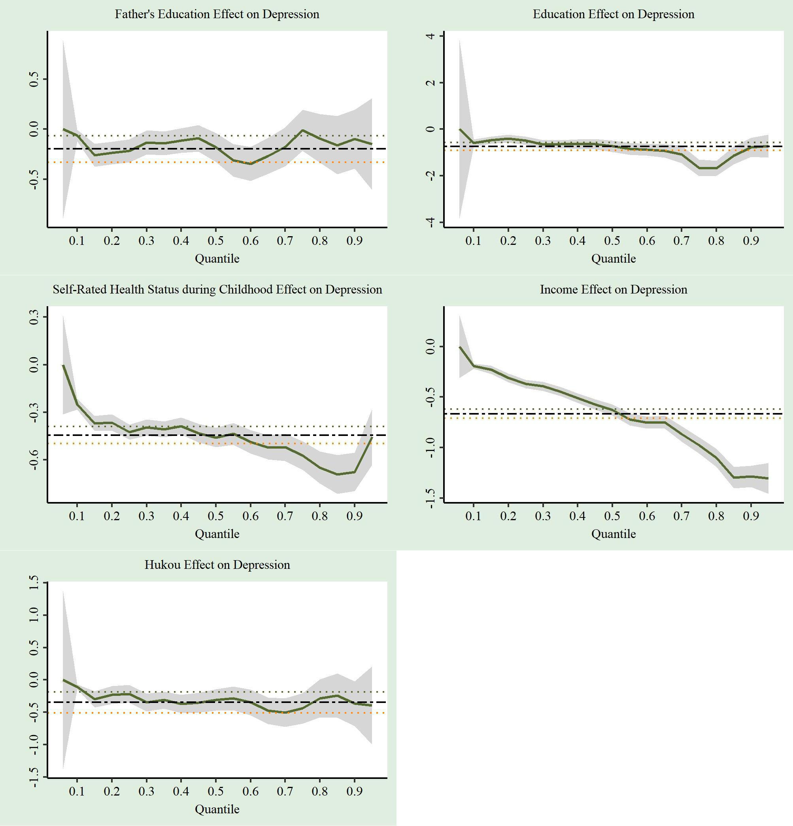
Note. The group shows the effects of individual socioeconomic status measures on depression CES-D score quantiles (green solid line). The x-axis is labeled with the quantile level at which the effects are estimated. The y-axis refers to the effect. The 95% confidence intervals of the effects on quantile are in the shaded area. The black dashed line refers the OLS effect of individual socioeconomic status at the mean CES-D scores.

