Green coffee extract blockades haloperidol-induced catalepsy and contralateral rotations induced by apomorphine after unilateral 6-OHDA lesion on striatum
Graziella Rigueira Molska, Lyvia Izaura Gomes Paula-Freire, Marna Eliana Sakalem, Daniele Oliveira Köhn, Giuseppina Negri, Elisaldo Araújo Carlini, Fúlvio Rieli Mendes

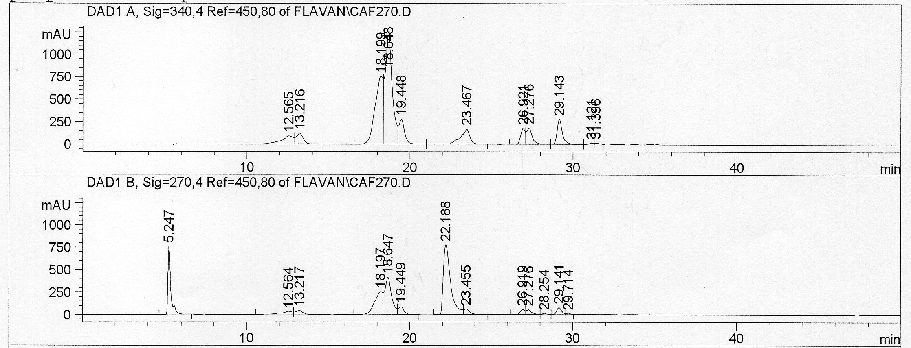
c
b
a
Retention time (min) | HPLC/DAD λ_{max} (nm) | Constituents found
5.2 | 300sh -330 | caffeic acid
12.5 | 300sh -330 | 3-O-(E)-caffeoylquinic acid
13.2 | 300sh -330 | 1-O- feruloylquinic acid
18.1 | 300sh -330 | 5-O-(E)-caffeoylquinic acid
18.6 | 300sh -330 | 4-O-(E)-caffeoylquinic acid
19.4 | 300sh -330 | 5-O- feruloylquinic acid
22.1 | 272 | caffeine
23.4 | 300sh -330 | 3-O-(E)-feruloylquinic acid
26.9 | 300sh -330 | 5-O-(E)-feruloylquinic acid
27.2 | 300sh -330 | 3.4-di-O-(E)-caffeoylquinic acid
28.2 | 300sh -330 | 3.5-di-O-(E)-caffeoylquinic acid
29.1 | 330 | 4.5-di-O-(E)- caffeoylquinic acid

Supplementary Data S2 Chromatograms containing the peaks of the constituents present in the coffee extract (CE). (a): 340 nm; (b): 270 nm; (c) Main components found in CE in the wavelength 240-400nm.

