**Supplementary Information for**

**A health and food-system analysis of Brexit-related policy approaches**

F. Freund, M. Springmann*

Correspondence to: marco.springmann@ndph.ox.ac.uk

Contents

Supplementary Methods 2

Table S1. 4

Table S2. 5

Table S3. 7

Table S4. 11

Table S5. 14

Table S6. 15

Supplementary Display Items 16

Figure S1. 16

Figure S2. 17

Figure S3. 18

References 19

Supplementary Methods

***Agriculture-economic analysis***

We used the Modular Applied General Equilibrium Tool (MAGNET) for the agriculture-economic analysis. MAGNET is a multi-regional, applied computable general equilibrium (CGE) model based on microeconomic theory 1. The model is solved by finding a price vector that simultaneously clears all factor, goods, and service markets. Different regions in the model are linked via trade flows subject to border policies as well as transportation costs. International trade is governed by the Armington assumption which allows for modelling intra-industrial trade flows in line with observed trade data. The model comprises information on agricultural, industrial and service sectors and is able to capture the interactions between these sectors.

Whilst MAGNET is a model for the whole economy, it has a clear focus on agriculture. It expands the classical economic framework of the Global Trade Analysis Project (GTAP) (Hertel, 1997) with respect to land use and land supply, the production of feed and energy crops, and the modelling of agricultural policies. There is also a factor market segmentation between agricultural and non-agricultural factors to account for the observable gap between remuneration of factors in those sectors 2.

Household demand is modelled with a non-homothetic Constant Differences in Elasticities (CDE) demand function. This specific form – in contrast to homothetic functions – allows for more realistic non-constant marginal budget shares. Estimates of real (PPP-corrected) GDP per capita were used to account for the observed effects that income elasticities of many food items tend to shrink as income growth 3. The model includes compensated own-price elasticities, as well as cross-price and income elasticities. We used income elasticities that, for food commodities, were in line with estimates of the Food and Agriculture Organization of the United Nations (FAO), and we updated the compensated own-price elasticities to the most recent estimates 4.

The supply side of the economy is modelled by nested Constant Elasticities of Substitution (CES) functions. Goods and services are produced with a combination of primary production factors (land, labour, capital and natural resources) as well as with domestic and imported intermediates. The production structure therefore resembles the information of input-output tables. The nesting structure allows for different levels of substitutability between different primary production factors and between different intermediates at each nesting level. In contrast to the basic GTAP model, MAGNET provides a more flexible production structure that also allows for substitutability between specific primary factors and specific intermediates. In an agricultural context this allows, e.g., to model the substitutability between land and fertilizer inputs. Substitution takes place when relative prices change and the degree of substitutability at each stage of the production structure depends on the respective substitution elasticities.

Land is an important production factor for agricultural activities. In MAGNET, the total amount of land available is not exogenous as in most CGE models, but there is a dynamic land-supply function which is based on information from the IMAGE model 5. In IMAGE, total land supply for each region is determined by potential crop productivity and land availability on a resolution of 5x5 arcminutes. The supply curve depends on total land supply, current agricultural area, current land price, and estimated price elasticity of land supply. These elasticities reflect regional differences in the endowment of suitable agricultural land. The price elasticity of land supply is small in regions where most of the area suitable for agriculture is in use, with little expansion occurring at high price changes. In contrast, in regions with a large reserve of suitable agricultural land, such as Sub-Saharan Africa and some regions in South America, the price elasticity of land supply is larger, with expansion of agricultural land occurring at smaller price changes 1. A nested land-use structure accounts for the differences in substitutability of the various types of land use 5,6. For example, the ease of transforming land used for pasture into land used for sugar crops production is different from transforming land used for wheat cultivation into land used for oilseeds production.

The model aggregation resolves 19 countries and regions (Table S1), each with 34 different products (Table S2). The agricultural products represented as explicitly as possible given the data provided by GTAP. The 26 agricultural sectors include primary agriculture such as animal husbandry, wheat production and raw milk, processing sectors such as meat production and dairy, as well as sectors for bio energy (bio diesel and bio ethanol). We aggregated the remaining manufacturing and service sectors into one aggregate each, in line with the agricultural focus of our analysis.

MAGNET features a baseline projection that accounts for changes in key economic variables up to the year 2030. Projections of changes in biophysical yields of crops and pastures that account for changes in climate and land use were adapted from the IMAGE integrated-assessment model, and projections of changes in real GDP and population were adopted from the shared socio-economic development pathways developed by the modelling community 7. For the main analysis, we used a middle-of-the-road development pathway (SSP2).

Table S1.

Regional aggregation.



Table S2.

Sectoral aggregation

|  |  |  |
| --- | --- | --- |
| MAGNET aggregate | Description | GTAP sectors |
| pdr | Paddy rice | pdr |
| wht | Wheat | wht |
| gro | Cereal grains nec | gro |
| v_f | Vegetables, fruit, nuts | v_f |
| osd | Oil seeds | osd |
| c_b | Sugar cane, sugar beet | c_b |
| pfb | Other agriculture | pfb |
| ocr | Crops nec | ocr |
| ctl | Sheep,goats,horses (live) | n.a. |
| oap | Pigs (live) | n.a. |
| pltry | Poultry sector (live) | n.a. |
| bfctl | Cattle (live) | n.a. |
| rmk | Raw milk | rmk |
| wol | Wool, silk-worm cocoons | wol |
| cmt | Meat: sheep, goats, horse | n.a. |
| omt | Pig meat | n.a. |
| poum | Poultry meat | n.a. |
| BFCMT | Beef meat | n.a. |
| mil | Dairy products | mil |
| pcr | Processed rice | pcr |
| sgr | Sugar and molasses | sgr |
| vol | Vegetable oils and fats | vol |
| ofd | Processed food | ofd |
| frs | Forestry | frs |
| fsh | Wild fish | fsh |
| coa | Coal | coa |
| oil | Crude oil | oil |
| gas | Gas | gas |
| othind | Other industry | oxt, tex, wap, lea, lum, ppp, nmm, i_s, nfm, fmp, ele, eeq, ome, mvh, otn, omf, cns |
| p_c | Petroleum, coal products | p_c |
| chm | Chemical,rubber, other plastic prods | chm |
| ely | Electricity | ely |
| gdt | Gas manufacture, distribution | gdt |
| ser | Services | wtr, trd, afs, whs, cmn, ofi, ins, rsa, obs, ros, osg, edu, hht, dwe |
| trans | Transport sector | otp, wtp, atp |
| feed | Animal feed | n.a. |
| cvol | Crude vegetable oil | n.a. |
| biog | Biogasoline | n.a. |
| biod | Biodiesel | n.a. |
| fert | fertilizer | n.a. |
| ftfuel | ftfuel 2nd gen biofuel | n.a. |
| eth | ethanol 2nd gen biofuels | n.a. |
| lsug | ligno sugar | n.a. |
| pe | pe biochemical | n.a. |
| pla | pla biochemical | n.a. |
| f_chem | mixed fossil biochemical sector | n.a. |
| ely_c | electricity from coal | n.a. |
| ely_g | electricity from gas | n.a. |
| ely_n | electricty from nuclear | n.a. |
| ely_h | electricty from hydro | n.a. |
| ely_w | electricty from wind and solar | n.a. |
| bioe | bioelectricity 2nd gen | n.a. |
| res | residue sector | n.a. |
| pel | pellet sector | n.a. |
| plan | Plantation | n.a. |
| Diad | Aquaculture | n.a. |
| Fishp | Fish processing | n.a. |
| bfchem | bioplastics | n.a. |
| ddgs | Biogasoline byproduct | n.a. |
| oilcake | Oil cake byproduct of cvol used as animal feed | n.a. |
| r_pdr | residue pdr | n.a. |
| r_wht | residue wheat | n.a. |
| r_gro | residue gro | n.a. |
| r_osd | residue osd | n.a. |
| r_ocr | residue ocr | n.a. |
| r_frs | residue frs | n.a. |
| r_v_f | residue v_f | n.a. |
| fishm | fish meal | n.a. |

Note: Sectors with “n.a“ are not part of the GTAP data base and are MAGNET specific sectors. See https://www.gtap.agecon.purdue.edu/databases/contribute/detailedsector.asp for a detailed description of sectors.

***Representation of import tariffs***

For the “Hard Brexit” scenario, we used the most recent information on tariffs to be applied on UK imports provided by the UK Government, denoted as UK Global Tariffs (UKGT). The UKGT are similar to and replace the EU’s Most Favoured Nations (MFN) tariffs after the Brexit transition period has ended at the end of 2020. The UKGT apply to all countries the UK has no explicit trade agreement with. The UK has renegotiated EU trade agreements with a range of countries (Table S3) for which UKGT do not apply. For EU imports from the UK, we apply the tariffs from the EU’s MFN scheme. In addition to MFN tariffs, non-tariff measured that are associated with border checks and differences in regulation between the EU and the UK are introduced. Here we adopt estimates provided by Dhingra and colleagues 8. We used the Tariff Analytical and Simulation Tool for Economists (TASTE) provided by the GTAP network to aggregate the information for 11,830 HS8 tariff lines to the model’s sectoral representation.

Table S3.

Countries for which the UK has renegotiated EU trade agreements



***Representation of agriculture subsidies***

For the scenario on agricultural subsidy reform, we relied on subsidy data provided by the OECD for the year 2017. The data has been standardised and processed for use in CGE-based policy analyses in line with GTAP specifications, including a focus on budgetary transfers and mapping of payment categories.

Subsidies in the GTAP dataset are based on information provided by the OECD in their database on Producer Support Estimates (PSE). The PSE data are composed of estimates of Market Price Support (MPS) and budgetary transfers. The MPS estimates consist of policies that alter the national prices of agricultural products and are mostly comprised of border policies such as tariffs. To avoid double counting with tariffs already included in the database, these measures are not included in the GTAP support dataset. The scenario analysis therefore focuses on changes in budgetary transfers in particular.

Budgetary transfers in the PSE dataset are differentiated by different categories. These include (i) payments based on output; (ii) payments based on inputs; (iii) payments based on current or non-current (e.g. historical) area/animal number/returns/investments distinguished whether production is required or not; (iv) payments on non-commodity criteria; and (v) miscellaneous payments. To be consistent with the GTAP database, the categories have been converted into the standard GTAP categories 6 of (i) output payments; (ii) intermediate input payments; (iii) land-based payments; (iv) capital-based payments; and (v) labour-based payments.

PSE estimates also provide information on the degree of decoupling of payments, which are preserved in the converted dataset. The degree of coupling/decoupling is a measure of how far payments are tied to the production of a specific agricultural good. With respect to coupling, the subsidies in the PSE database are grouped into the several categories, including Single Commodity Transfers (SCT), Group Commodity Transfers (GCT), All Commodity Transfers (ACT), and Other Transfers to Producers (OTP). SCT are tied to a specific commodity, whereas ACT and GCT apply to a broader set of commodities, and OTP are provided without requiring production. In the GTAP database, decoupled payments are introduced by equalizing the payment rates for production factors in all eligible agricultural sectors. Thus, the payments introduce no incentive to switch production factors between the eligible sectors, and the associated change in output is minimal.

In the modelling environment, the general representation of agricultural subsidies (*PAY*) is then based on the introduction of tax wedges between agents and market prices:

$$PAY=PS∙QO-PM∙QO$$

$$=PM∙(1+t_{o})∙QO-PM∙QO$$

where *QO* is output and *PS* is the price payed by the agent (i.e., the farmer) including taxes/subsidies, and *PM* is the associated market price. The tax variable *t0* is calibrated such that payments (*PAY*) based on outputs match the support estimates from the OECD database that are based on output. Similar formulas apply for the case of input and factor-use subsidies. For example, if payments are provided based on crop area as in category (ii), then land-subsidy rates are calibrated accordingly 6.

When model parameters are shocked in a policy simulation, this causes quantities (e.g., *QO*) and/or prices (e.g., *PM*) to change endogenously. This would normally also affect the level of agricultural subsidies, but MAGNET allows to exogenize subsidy payments by endogenously shifting tax rates such that a predetermined subsidy level can be achieved. The procedure follows the following equation:

$$\left(PM∙QO\right)∙t=100∙d_PAY-PAY\left(qo+pm\right).$$

where lower (upper) case variables indicate percentage changes (level) variables. The ‘tax-shifter’ *t* is endogenously determined allowing that exogenously specified changes in the support budget (*d_PAY*) are reached while correcting for endogenous changes in quantities and market prices (as indicated in the second term on the right-hand side of the equation). Similar equations apply to subsidies on inputs and production factors 1.

In our policy simulations, we changed overall support payments (*PAY*) proportionally and used the remaining subsides for supporting healthier and more environmentally friendly agricultural products. For that purpose, payments were directed to the production of low-emitting and nutrition-sensitive horticultural products, including fruits, vegetables, legumes, and nuts. Technically, this was achieved by increasing output subsidies for that group.

***Linkage to production and consumption-based assessments***

We linked MAGNET with a health assessment to analyse the consequences of Brexit-related policies for public health in the UK. For that purpose, we used MAGNET’s estimates of percentage changes in consumption, applied those to baseline consumption data, and used those in a comparative risk assessment of dietary and weight-related risk factors to estimate changes in mortality. We estimated baseline food consumption by adopting estimates of food availability from the FAO’s food balance sheets, and adjusting those for the amount of food wasted at the point of consumption 9,10.

Food balance sheets report on the amount of food that is available for human consumption 10. They reflect the quantities reaching the consumer, but do not include waste from both edible and inedible parts of the food commodity occurring in the household. As such, the amount of food actually consumed may be lower than the quantity shown in the food balance sheet depending on the degree of losses of edible food in the household, e.g. during storage, in preparation and cooking, as plate-waste, or quantities fed to domestic animals and pets, or thrown away.

We followed the waste-accounting methodology developed by the FAO to account for the amount of food wasted at the household level that was not accounted for in food availability estimates 9. Table S4 provides and overview of the parameters used in the calculation.

For each commodity and region, we estimated food consumption by multiplying food availability data with conversion factors (*cf*) that represent the amount of edible food (e.g. after peeling) and with the percentage of food wasted during consumption (*1-wp(cns)*). For roots and tubers, fruits and vegetables, and fish and seafood, we also accounted for the differences in wastage between the proportion that is utilised fresh (*pctfrsh*) and the proportion that utilised in processed form (*pctprcd*). The equation used for each food commodity and region was: $Consumption=Availability∙\frac{pct_{frsh}}{100}∙cf_{frsh} ∙\left(1-\frac{wp\left(cns_{frsh}\right)}{100}\right)$

$$+ Availability∙\frac{pct_{prcd}}{100}∙cf_{prcd}∙\left(1-\frac{wp\left(cns_{prcd}\right)}{100}\right)$$

Table S4.

Percentage of food wasted during consumption (cns), and percentage of

processed utilisation (pctprcd). The percentage of fresh utilisation is calculated as 1-pctprcd.

Conversion factors to edible portions of foods are provided below the table.



***Health analysis***

We estimated the mortality and disease burden attributable to dietary and weight-related risk factors by calculating population impact fractions (PIFs) which represent the proportions of disease cases that would be avoided when the risk exposure was changed from a baseline situation to a counterfactual situation. For calculating PIFs, we used the general formula 11,12:

|  |  |  |
| --- | --- | --- |
|  |  |  |

where $RR\left(x\right)$ is the relative risk of disease for risk factor level $x$, $P\left(x\right)$ is the number of people in the population with risk factor level $x$ in the baseline scenario, and $P^{'}\left(x\right)$ is the number of people in the population with risk factor level $x$ in the counterfactual scenario. We assumed that changes in relative risks follow a dose-response relationship, and that PIFs combine multiplicatively, i.e. $PIF=1-\prod_{i}{(1-PIF_{i})}$ where the *i*’s denote independent risk factors 11,12.

The number of avoided deaths due to the change in risk exposure of risk *i*, *Δdeaths*i, was calculated by multiplying the associated PIF by disease-specific death rates, *DR*, and by the number of people alive within a population, *P*:

|  |  |  |
| --- | --- | --- |
|  | $$Δdeaths_{i}(r,a,d)=PIF_{i}(r,d)∙DR(r,a,d)∙P(r,a)$$ |  |

where PIFs are differentiated by region *r* and disease/cause of death *d*; the death rates are differentiated by region, age group *a*, and disease; the population groups are differentiated by region and age group; and the change in the number of deaths is differentiated by region, age group and disease.

We used publicly available data sources to parameterize the comparative risk analysis. Mortality and population data were adopted from the Global Burden of Disease project 13. Baseline data on the weight distribution in each country were adopted from a pooled analysis of population-based measurements undertaken by the NCD Risk Factor Collaboration 14 and projected forward based on the statistical relationship between calorie availability and body weight 15.

The relative risk estimates that relate the risk factors to the disease endpoints were adopted from meta-analyses of prospective cohort studies for dietary weight-related risks 16–23. In line with the meta-analyses, we included non-linear dose-response relationships for fruits and vegetables, nuts and seeds, and fish, and assumed linear dose-response relationships for the remaining risk factors. As our analysis was primarily focused on mortality from chronic diseases, we focused on adults aged 20 year or older, and we adjusted the relative-risk estimates for attenuation with age based on a pooled analysis of cohort studies focussed on metabolic risk factors 24, in line with other assessments 25,26. Table S5 provides an overview of the relative-risk parameters used.

The selection of risk-disease associations used in the health analysis was supported by available criteria used to judge the certainty of evidence, such as the Bradford-Hill criteria used by the Nutrition and Chronic Diseases Expert Group (NutriCoDE) 26, the World-Cancer-Research-Fund criteria used by the Global Burden of Disease project 27, as well as NutriGrade (Table S6) 28. The certainty of evidence supporting the associations of dietary risks and disease outcomes as used here were graded as moderate or high with NutriGrade 16,20,21, and/or assessed as probable or convincing by the Nutrition and Chronic Diseases Expert Group 26, and by the World Cancer Research 29. The certainty of evidence grading in each case relates to the general relationship between a risk factor and a health outcome, and not to a specific relative-risk value.

For the different Brexit scenarios, we calculated uncertainty intervals associated with changes in mortality based on standard methods of error propagation and the confidence intervals of the relative risk parameters. For the error propagation, we approximated the error distribution of the relative risks by a normal distribution and used that side of deviations from the mean which was largest. This method leads to conservative and potentially larger uncertainty intervals as probabilistic methods, such as Monte Carlo sampling, but it has significant computational advantages, and is justified for the magnitude of errors dealt with here (<50%) (see e.g. IPCC Uncertainty Guidelines).

Table S5.

Relative risk parameters (mean and low and high values of 95% confidence intervals) for dietary risks and weight-related risks.



Table S6.

Overview of existing ratings on the certainty of evidence for a statistically significant association between a risk factor and a disease endpoint. The ratings include those of the Nutrition and Chronic Diseases Expert Group (NutriCoDE), the World Cancer Research Fund, and NutriGrade.



Supplementary Display Items

Figure S1.

Percentage changes in agricultural imports, exports, production, and demand for different combination of Brexit approaches.

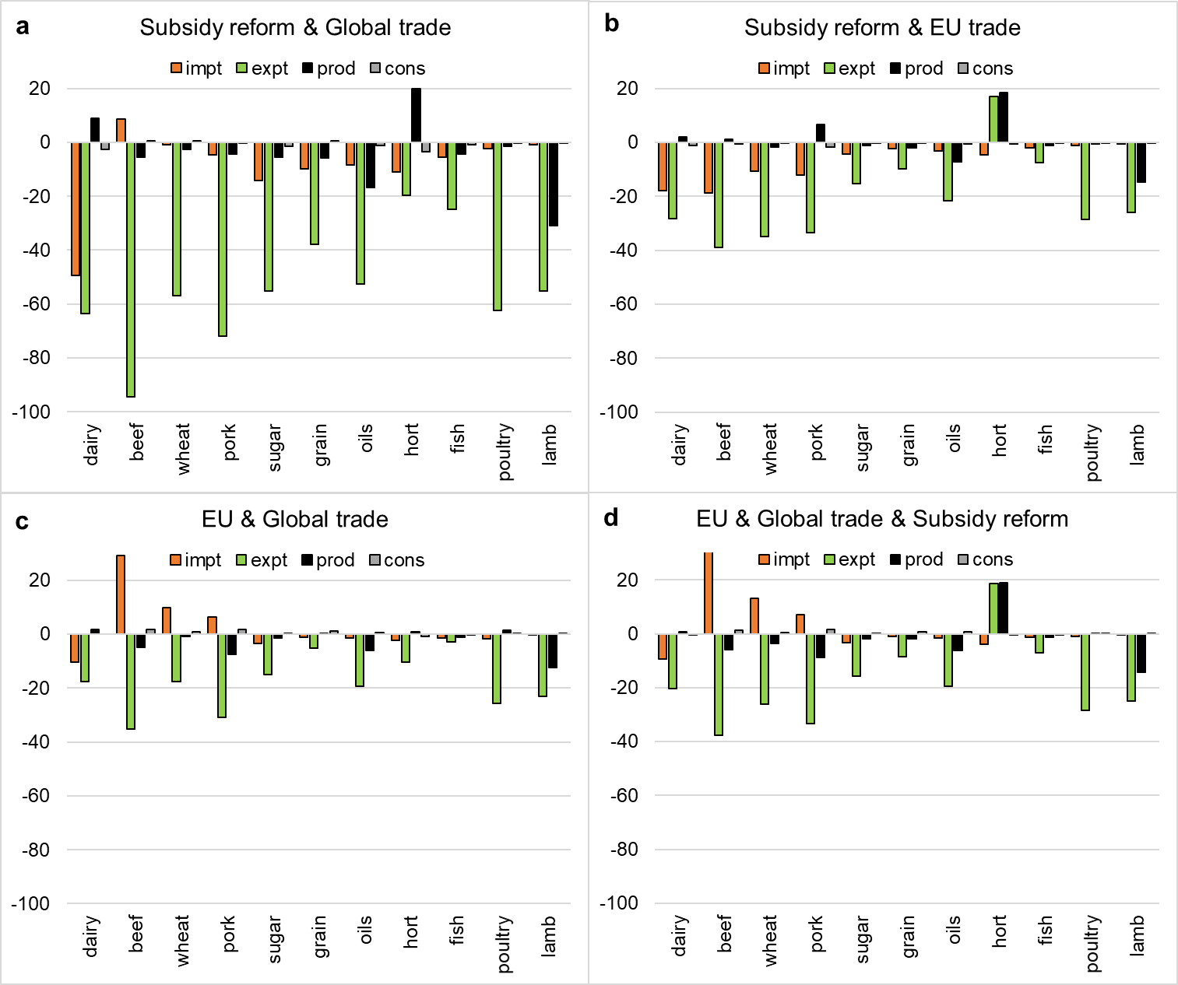

Figure S2.

Change in food consumption per person (g/d) by food group and Brexit policy.

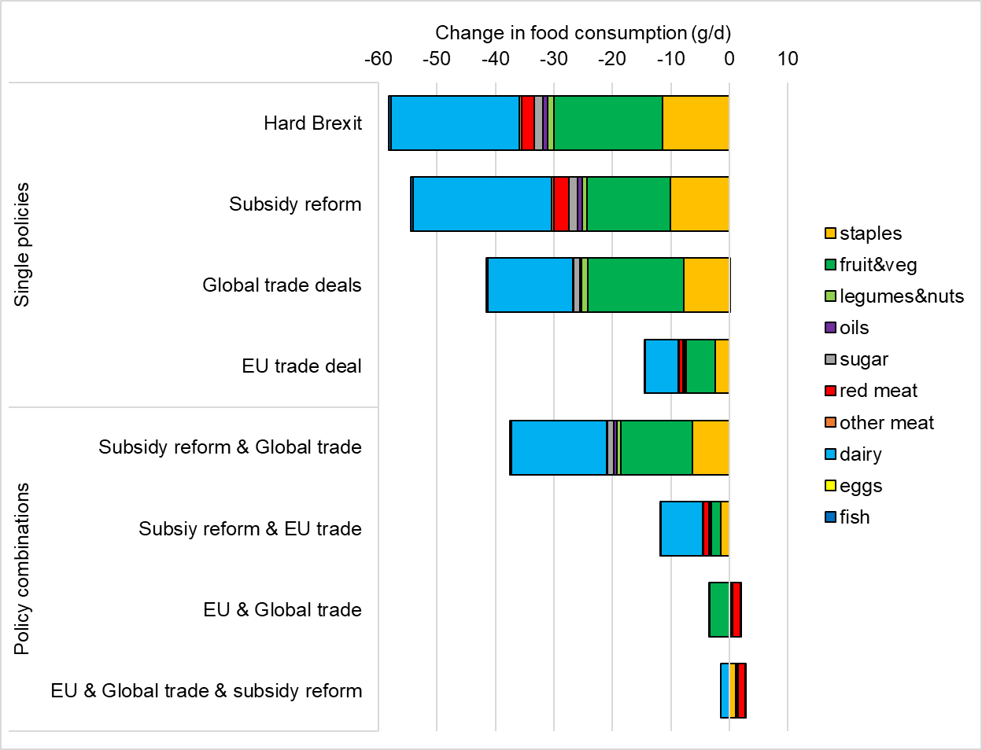

Figure S3.

Number of attributable deaths by Brexit policy and cause of deaths. The causes of deaths include coronary heart disease (CHD), stroke, cancer, type-2 diabetes mellitus (T2DM), and respiratory disease.

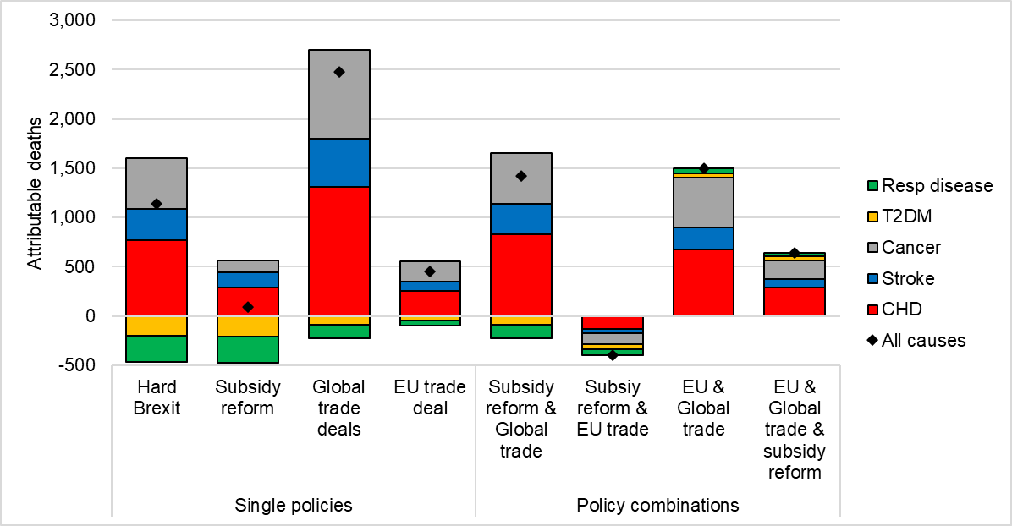

References

1. Woltjer, G. B. *et al.* *The MAGNET model: Module description*. (2014).

2. Keeney, R. & Hertel, T. W. *GTAP-AGR: A Framework for Assessing the Implications of Multilateral Changes in Agricultural Policies*. (2005).

3. Haque, M. O. *Income Elasticity and Economic Development - Methods and Applications*. (Springer US, 2005). doi:10.1007/b105193.

4. Green, R. *et al.* The effect of rising food prices on food consumption: systematic review with meta-regression. *BMJ* **346**, f3703 (2013).

5. van Meijl, H., van Rheenen, T., Tabeau, A. & Eickhout, B. The impact of different policy environments on agricultural land use in Europe. *Agriculture, Ecosystems & Environment* **114**, 21–38 (2006).

6. Huang, H. Agricultural Domestic Support. in *Global Trade, Assistance, and Production: The GTAP 8 Data Base* (eds. G, B. N., Aguiar, A. & McDougall, R.) (Global Trade Analysis Project (GTAP), 2013).

7. Riahi, K. *et al.* The Shared Socioeconomic Pathways and their energy, land use, and greenhouse gas emissions implications: An overview. *Global Environmental Change* **42**, 153–168 (2017).

8. Dhingra, S. *et al.* The costs and benefits of leaving the EU: trade effects. *Economic Policy* **32**, 651–705 (2017).

9. Gustavsson, J., Cederberg, C., Sonesson, U., Van Otterdijk, R. & Meybeck, A. *Global food losses and food waste: extent, causes and prevention*. (2011).

10. Food and Agriculture Organization of the United Nations. *Food balance sheets: a handbook*. (2001).

11. Murray, C. J. L., Ezzati, M., Lopez, A. D., Rodgers, A. & Vander Hoorn, S. Comparative quantification of health risks: conceptual framework and methodological issues. *Population Health Metrics* **1**, 1 (2003).

12. Murray, C. J. L. *et al.* GBD 2010: design, definitions, and metrics. *Lancet* **380**, 2063–2066 (2012).

13. GBD 2017 Causes of Death Collaborators *et al.* Global, regional, and national age-sex-specific mortality for 282 causes of death in 195 countries and territories, 1980–2017: a systematic analysis for the Global Burden of Disease Study 2017. *The Lancet* **392**, 1736–1788 (2018).

14. NCD Risk Factor Collaboration (NCD-RisC). Trends in adult body-mass index in 200 countries from 1975 to 2014: a pooled analysis of 1698 population-based measurement studies with 19·2 million participants. *The Lancet* **387**, 1377–1396 (2016).

15. Springmann, M., Godfray, H. C. J., Rayner, M. & Scarborough, P. Analysis and valuation of the health and climate change cobenefits of dietary change. *PNAS* **113**, 4146–4151 (2016).

16. Bechthold, A. *et al.* Food groups and risk of coronary heart disease, stroke and heart failure: A systematic review and dose-response meta-analysis of prospective studies. *Critical Reviews in Food Science and Nutrition* **59**, 1071–1090 (2019).

17. Afshin, A., Micha, R., Khatibzadeh, S. & Mozaffarian, D. Consumption of nuts and legumes and risk of incident ischemic heart disease, stroke, and diabetes: a systematic review and meta-analysis. *Am. J. Clin. Nutr.* **100**, 278–288 (2014).

18. Aune, D. *et al.* Nut consumption and risk of cardiovascular disease, total cancer, all-cause and cause-specific mortality: a systematic review and dose-response meta-analysis of prospective studies. *BMC medicine* **14**, 207 (2016).

19. Aune, D. *et al.* Fruit and vegetable intake and the risk of cardiovascular disease, total cancer and all-cause mortality–a systematic review and dose-response meta-analysis of prospective studies. *International Journal of Epidemiology* (2016).

20. Schwingshackl, L. *et al.* Food groups and risk of colorectal cancer. *International Journal of Cancer* **142**, 1748–1758 (2018).

21. Schwingshackl, L. *et al.* Food groups and risk of type 2 diabetes mellitus: a systematic review and meta-analysis of prospective studies. *European Journal of Epidemiology* **32**, 363–375 (2017).

22. Zheng, J. *et al.* Fish consumption and CHD mortality: an updated meta-analysis of seventeen cohort studies. *Public Health Nutrition* **15**, 725–737 (2012).

23. Global BMI Mortality Collaboration *et al.* Body-mass index and all-cause mortality: individual-participant-data meta-analysis of 239 prospective studies in four continents. *The Lancet* **388**, 776–86 (2016).

24. Singh, G. M. *et al.* The Age-Specific Quantitative Effects of Metabolic Risk Factors on Cardiovascular Diseases and Diabetes: A Pooled Analysis. *PLOS ONE* **8**, e65174 (2013).

25. GBD 2017 Risk Factor Collaborators *et al.* Global, regional, and national comparative risk assessment of 84 behavioural, environmental and occupational, and metabolic risks or clusters of risks for 195 countries and territories, 1990-2017: a systematic analysis for the Global Burden of Disease Stu. *Lancet* **392**, 1923–1994 (2018).

26. Micha, R. *et al.* Etiologic effects and optimal intakes of foods and nutrients for risk of cardiovascular diseases and diabetes: Systematic reviews and meta-analyses from the Nutrition and Chronic Diseases Expert Group (NutriCoDE). *PLOS ONE* **12**, e0175149 (2017).

27. GBD 2017 Diet Collaborators *et al.* Health effects of dietary risks in 195 countries, 1990-2017: a systematic analysis for the Global Burden of Disease Study 2017. *The Lancet* **0**, (2019).

28. Schwingshackl, L. *et al.* Perspective: NutriGrade: A Scoring System to Assess and Judge the Meta-Evidence of Randomized Controlled Trials and Cohort Studies in Nutrition Research. *Advances in Nutrition: An International Review Journal* **7**, 994–1004 (2016).

29. World Cancer Research Fund/American Institute for Cancer Research. Diet, Nutrition, Physical Activity and Cancer: A Global Perspective. Continuous Update Project Expert Report. (2018).