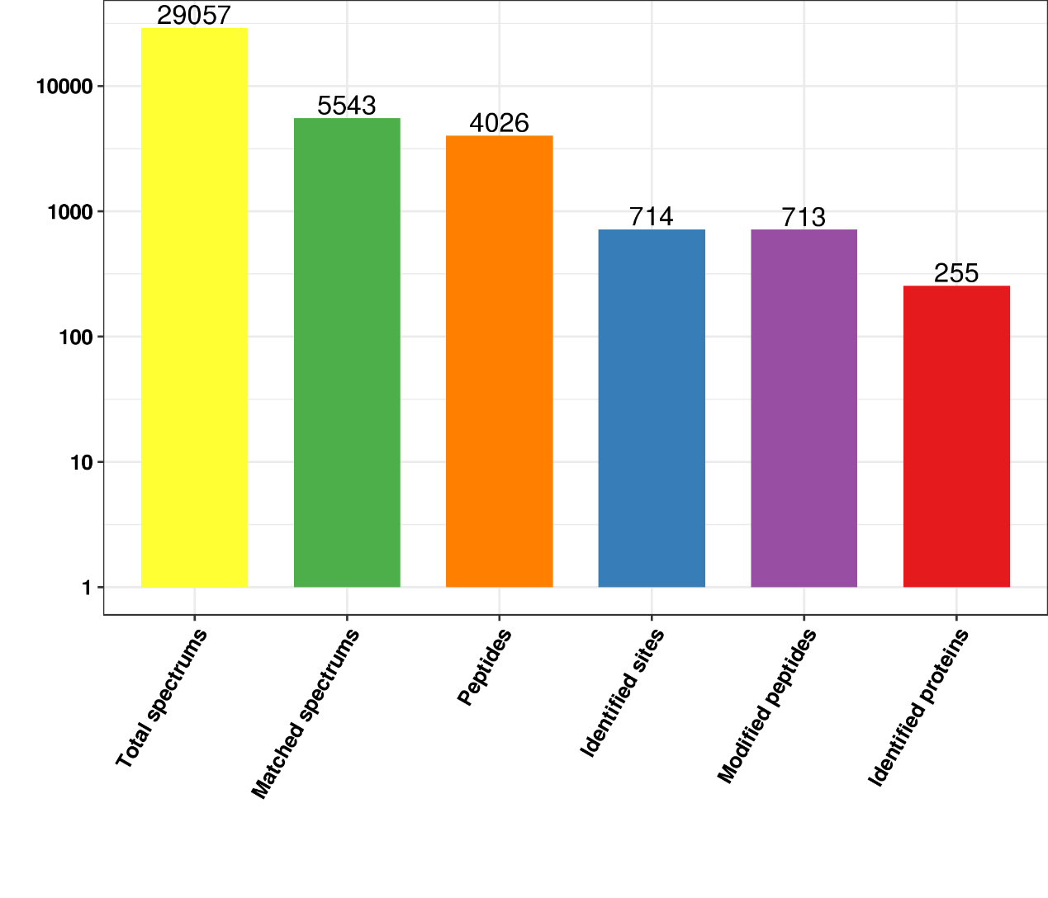Figure S1. The MS/MS spectra of examples of malonyl peptides

