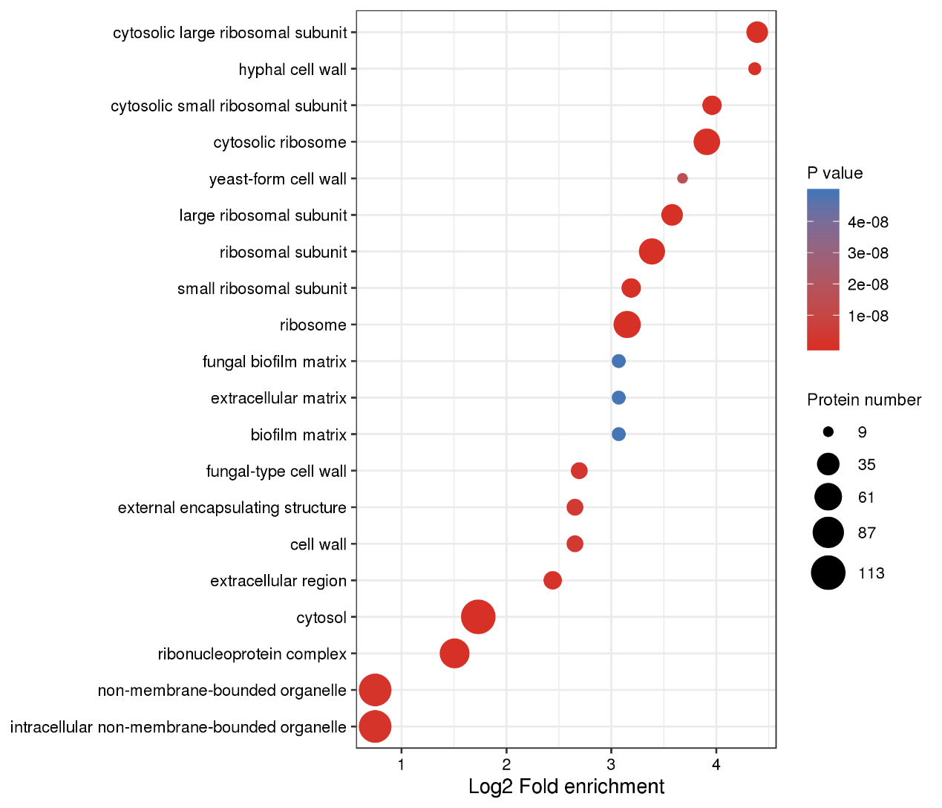
Figure S2. GO-based enrichment analysis in S. sanghuang

