Supplementary information

EXCEPTIONAL PARALLELISMS CHARACTERIZE THE EVOLUTIONARY TRANSITION TO LIVE BIRTH IN PHRYNOSOMATID LIZARDS

Saúl F. Domínguez-Guerrero^{1,2,3*}, Fausto R. Méndez-de la Cruz², Norma L. Manríquez-Morán⁴, Mark E. Olson², Patricia Galina-Tessaro⁵, Diego M. Arenas-Moreno^{2,3}, Adán Bautista-del Moral², Adriana Benítez-Villaseñor^{2,3}, Héctor Gadsden⁶, Rafael A. Lara-Reséndiz^{5,7}, Carlos A. Maciel-Mata⁴, Francisco J. Muñoz-Nolasco^{2,3}, Rufino Santos-Bibiano^{2,3}, Jorge H. Valdez-Villavicencio⁸, Guillermo A. Woolrich-Piña⁹ and Martha M. Muñoz¹.

This document includes:
Supplementary Figures…………………………………………………………………..…2
Supplementary Figure 1…………………………………………………………...2
Supplementary Figure 2…………………………………………………………...4
Supplementary Figure 3…………………………………………………………...5
Supplementary Tables............................................................................................................6
Supplementary Table 1…………….………………………………………………6
Supplementary Table 2…………….……………………………………...……….8
Supplementary Table 3……………..……………………………………….……..9
Supplementary Table 4…………………………………………………….……..10
Supplementary Table 5…………………………………………………….……..11

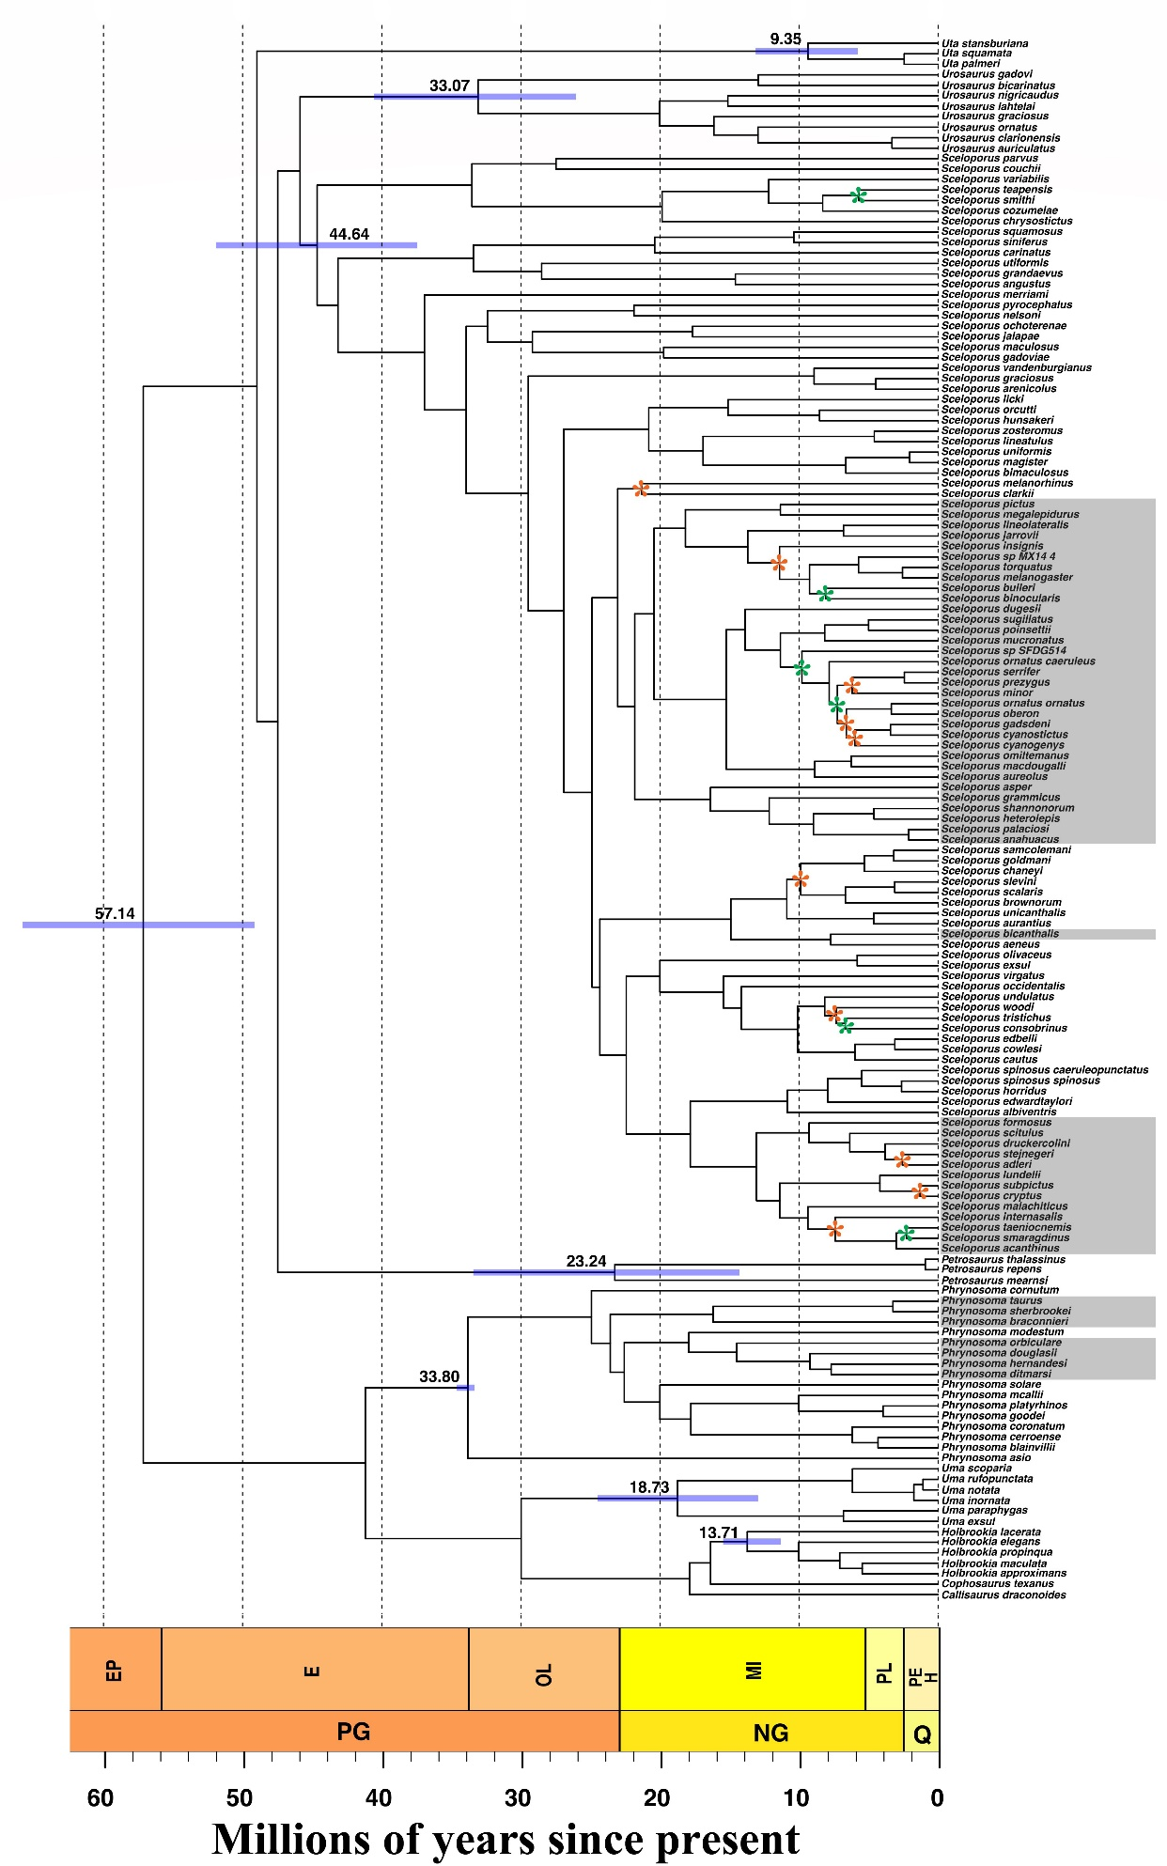
Supplementary Figure 1. Time-calibrated phylogeny for phrynosomatid lizards. Gray shading denotes viviparous species. Blue bars show the confidence interval for the estimated ages of crown groups and the mean ages in the phylogeny. Nodes that have not asterisks represents node values with posterior probability (PP) >0.8, orange asterisks represent node values with PP between 0.79- 0.5, and green asterisks represents node values with PP <0.5. Geologic periods are given by the following abbreviations: PG=Paleogene, NG=Neogene, and Q=Quaternary. Geologic epochs are given by the following abbreviations: EP=Paleocene, E=Eocene, OL=Oligocene, MI=Miocene, PL=Pliocene, PE=Pleistocene, and H=Holocene.

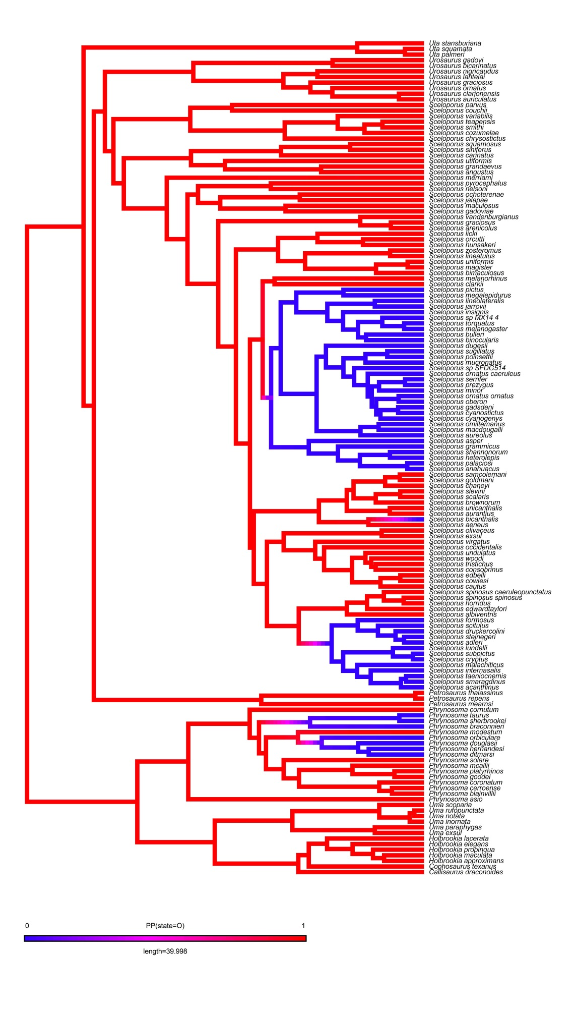
Supplementary Figure 2. Stochastic character mapping of parity mode of phrynosomatid lizards. Red color represent oviparity and blue color represents viviparity.
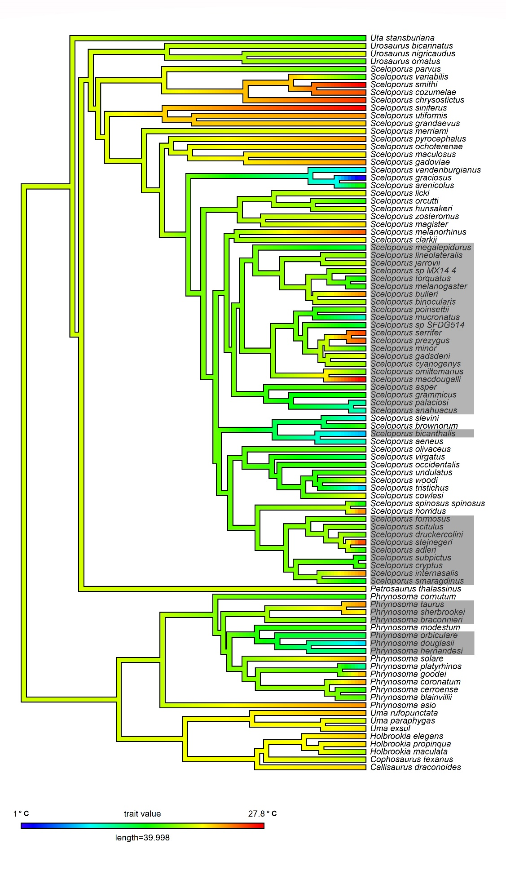
Supplementary Figure 3. Ancestral state reconstruction of mean annual temperature for phrynosomatid lizards. Gray shading corresponds to viviparous species.

Supplementary Table 1. Intersexual comparison of field body temperature (T_{b}), preferred body temperature (T_{pref}), critical thermal minimum (CT_{min}) and critical thermal maximum (CT_{max}) of phrynosomatid lizards. The physiological traits are given in degrees Celsius (±1s.e.). The numbers in parentheses denote the sample size. The last row shows t-tests comparing traits among sexes.

Species | Mean T_{b} |  | Mean T_{pref} |  | Mean CT_{min} |  | Mean CT_{max}
 | Females | Males | Females | Males | Females | Males | Females | Males
Callisaurus draconoides | 39 ± 0.53 (16) | 38.99 ± 0.73 (12) | 34.32 ± 1.03 (15) | 35.11 ± 1.04 (12) | 12.45 ± 0.45 (2) | 13.46 ± 0.68 (8) | 42.65 ± 1.05 (2) | 43.22 ± 0.1 (5)
Petrosaurus thalassinus | 36.39 ± 0.41 (11) | 34.28 ± 0.9 (9) | 31.54 ± 0.67 (11) | 30.57 ± 1.16 (9) | 17.07 ± 0.4 (10) | - | 39.2 (1) | 39.66 ± 0.41 (8)
Phrynosoma cerroense | 36.2 ± 0.75 (5) | 37.2 ± 2.01 (3) | 35.4 ± 0.68 (8) | 33.95 ± 0.29 (3) | 8 ± 0.3 (8) | 7.6 ± 0.49 (2) | 42.1 ± 0.54 (4) | 40.2 (1)
Phrynosoma orbiculare | 31.89 ± 1.57 (10) | 29.95 ± 1.58 (12) | 31.54 ± 0.7 (10) | 31.21 ± 0.42 (12) | 4.82 ± 0.3 (9) | 4.25 ± 0.33 (10) | 37.71 ± 0.28 (9) | 37.94 ± 0.38 (10)
Phrynosoma sherbrookei | 35.4 ± 2.6 (2) | 33.37 ± 0.76 (7) | 33.74 ± 0.53 (2) | 37.23 ± 0.2 (7) | 13.6 ± 0.2 (2) | 11.6 ± 0.53 (7) | - | 43.13 ± 0.64 (7)
Sceloporus adleri | 30.4 ± 0.58 (24) | 31.45 ± 0.9 (17) | 32.85 ± 0.41 (20) | 30.84 ± 2.82 (7) | - | 9.56 ± 0.52 (7) | - | 39.01 ± 0.74 (7)
Sceloporus brownorum | 37.44 ± 0.6 (14) | 33.45 ± 0.8 (6) | 33.96 ± 0.45 (13) | 35.69 ± 0.24 (6) | 11.17 ± 0.57 (7) | 11.75 ± 0.25 (2) | 42.4 ± 0.2 (2) | 42.57 ± 0.03 (3)
Sceloporus bulleri | 31.37 ± 1.35 (6) | 32.62 ± 1.3 (6) | 32.46 ± 0.84 (9) | 31.23 ± 0.79 (9) | 15.08 ± 1.08 (5) | 15.48 ± 1.08 (4) | 37.5 ± 0.86 (4) | 37.22 ± 0.6 (5)
Sceloporus grammicus | 32.18 ± 0.42 (45) | 31.73 ± 0.57 (35) | 32.89 ± 0.53 (49) | 33.31 ± 0.32 (43) | 10.03 ± 0.35 (43) | 10.54 ± 0.33 (34) | 39.97 ± 0.26 (34) | 39.93 ± 0.28 (30)
Sceloporus hunsakeri | 34.42 ± 0.7 (6) | 33.75 ± 1.55 (2) | 34.5 ± 0.48 (3) | 33.06 ± 1.62 (2) | 17.12 ± 0.84 (4) | - | 38.95 ± 0.45 (2) | 39.95 ± 0.15 (2)
Sceloporus jarrovii | 35.64 ± 0.66 (9) | 35.37 ± 2.85 (3) | 32.04 ± 0.33 (7) | 32.14 ± 0.44 (2) | 15.51 ± 0.42 (7) | 11.5 ± 0.2 (2) | 39.8 ± 1.1 (3) | 39.05 ± 1.45 (2)
Sceloporus licki | 33.73 ± 0.95 (6) | 33.1 ± 0.32 (3) | 32.21 ± 1.05 (6) | 33.32 ± 0.77 (3) | 17.48 ± 0.45 (4) | 15.9 (1) | 38 ± 0.3 (2) | 40 ± 0.2 (2)
Sceloporus magister | 38.3 ± 1.7 (2) | 33.3 (1) | 34.91 ± 0.65 (3) | 34.84 ± 0.32 (2) | 10.55 ± 0.65 (2) | 10.4 (1) | 40.2 (1) | 39.2 (1)
Sceloporus minor | 27.47 ± 1.3 (10) | 28.04 ± 1.71 (7) | 32.37 ± 0.33 (9) | 32.74 ± 0.52 (7) | 10 ± 0.7 (5) | 9.18 ± 0.81 (5) | 37.17 ± 0.62 (3) | 37.17 ± 0.44 (7)
Sceloporus megalepidurus | 28.26 ± 1.08 (7) | 27.49 ± 1.07 (7) | 33.87 ± 0.48 (6) | 33.49 ± 0.13 (7) | 9.03 ± 0.78 (3) | 9.08 ± 0.41 (6) | 39.25 ± 0.35 (2) | 39.37 ± 0.27 (7)
Sceloporus melanogaster | 29.6 ± 0.79 (11) | 33.9 ± 1 (2) | 32.8 ± 0.52 (11) | 32.3 ± 0.53 (2) | 8.5 ± 0.28 (7) | 8.7 ± 0.95 (2) | 38 ± 0.45 (6) | 37.1 ± 1 (2)
Sceloporus mucronatus | 30.44 ± 1.05 (10) | 32.61 ± 0.89 (7) | 33.85 ± 0.38 (10) | 34.18 ± 0.58 (9) | 5.28 ± 0.42 (6) | 7 ± 0.7 (3) | - | 37.62 ± 0.49 (6)
Sceloporus occidentalis | 34.35 ± 0.66 (14) | 33.26 ± 0.51 (17) | 34.96 ± 1.03 (5) | 32.28 ± 1.32 (10) | 8.5 (1) | 11.03 ± 0.46 (9) | 37.1 (1) | 38.72 ± 0.58 (5)
Sceloporus parvus | 34 ± 0.4 (5) | 32.34 ± 0.63 (8) | 31.47 ± 1.28 (5) | 33.32 ± 0.52 (9) | 12.93 ± 0.84 (3) | 13.85 ± 0.71 (4) | 39.9 (1) | 40.42 ± 0.32 (5)
Sceloporus pyrocephalus | 34.82 ± 0.47 (6) | 36.73 ± 0.65 (11) | 33.57 ± 0.68 (5) | 33.9 ± 0.62 (10) | 16.6 ± 0.4 (2) | 16.13 ± 0.41 (7) | - | 41.21 ± 0.54 (7)
Sceloporus torquatus | 33.31 ± 0.4 (54) | 33.38 ± 0.36 (53) | 33.13 ± 0.31 (61) | 33.24 ± 0.27 (55) | 9.1 ± 0.29 (46) | 8.52 ± 0.27 (54) | 39.38 ± 0.27 (43) | 39.08 ± 0.23 (45)
Sceloporus vandenburgianus | 32.12 ± 0.55 (29) | 32.61 ± 0.31 (42) | 33.83 ± 0.74 (10) | 34.75 ± 0.6 (14) | 6.3 ± 0.7 (2) | 6.9 ± 0.36 (11) | - | 38.83 ± 0.43 (10)
Sceloporus variabilis | 26.15 ± 0.95 (8) | 29.93 ± 0.72 (10) | 32.84 ± 0.37 (8) | 34.92 ± 0.68 (6) | 10 ± 0.5 (3) | 9.94 ± 0.3 (7) | 39.6 ± 0.49 (3) | 41.1 ± 0.41 (7)
Sceloporus zoosteroumus | 34.3 ± 1.18 (4) | 33.75 ± 0.91 (8) | 33.11 ± 1.08 (3) | 34.3 ± 1.71 (6) | 11.55 ± 0.55 (4) | 11.1 ± 1.1 (2) | - | 40.68 ± 0.52 (5)
Uta stansburiana | 32.66 ± 0.79 (13) | 33.66 ± 1.24 (9) | 34.32 ± 0.41 (11) | 35.3 ± 0.84 (6) | 9.73 ± 1.27 (3) | 8.73 ± 0.76 (6) | 41.35 ± 0.55 (2) | 40.03 ± 0.95 (3)
All | 33.19 ± 0.66 (25) | 33.05 ± 0.51 (25) | 33.3 ± 0.22 (25) | 33.49 ± 0.32 (25) | 11.27 ± 0.76 (24) | 10.53 ± 0.63 (23) | 39.49 ± 0.39 (19) | 39.7 ± 0.34 (25)
t-test | t=0.172, df= 48, p=0.86 |  | t=-0.482, df=48, p=0.63 |  | t=0.742, df=45, p=0.46 |  | t=-0.407, df=42, p=0.69

Supplementary Table 2. Summary of the model fits for the different evolutionary models tested in this study for each physiological, morphological, and life history trait in phrynosomatid lizards. O= oviparous and V= viviparous. BM is a single-peak, single-rate Brownian motion model. OU1 is a single-peak, single-rate Ornstein-Uhlenbeck model. OUM is a two-peak, single-rate Ornstein-Uhlenbeck model. Models with better support are shown in bold. These analyses were conducted with 500 simulations across our maximum clade credibility tree. For the best-fitting model, we provide the rate of stochastic trait evolution (σ2), and the resulting evolutionary optimal trait value(s) (θ) unless the best-fitting model was the BM model.

Trait | BM |  | OU1 |  | OUM |  | Best-fitting model
 | ∆AICc | Weight | ∆AICc | Weight | ∆AICc | Weight | σ2 | θ
Critical thermal minimum  n= 36 O and 27 V | 21.19 | <0.001 | 8.88 | 0.001 | 0 | 0.99 | 19.8 | 13 O and 9.95 V
Body temperature  n= 63 O and 38 V | 21.4 | <0.001 | 6.8 | 0.03 | 0 | 0.97 | 0.5537 | 34.9 O and 29.7 V
Preferred body temperature  n=48 O and 32 V | 16.23 | <0.001 | 2.72 | 0.2 | 0 | 0.8 | 0.3959 | 34.6 O and 31.9 V
Critical thermal maximum  n= 40 O and 27 V | 14.5 | <0.001 | 3.81 | 0.13 | 0 | 0.87 | 0.5238 | 41.9 O and 37.6 V
Mass-specific metabolic rate  n= 59 O and 36 V | 8.15 | 0.01 | 2 | 0.27 | 0 | 0.72 | 1.49e-06 | 0.02 O and 0.011 V
Adult body mass  n= 74 O and 42 V | 0 | 0.43 | 0.097 | 0.41 | 1.96 | 0.16 | 0.0045 | -
Adult body size  n= 74 O and 42 V | 1.44 | 0.26 | 0 | 0.53 | 1.84 | 0.21 | 0.0006 | 61.1 both
Offspring mass  n= 54 O and 23 V | 2.19 | 0.2 | 0 | 0.6 | 2.15 | 0.2 | 0.0031 | 0.83 both
Offspring size  n= 40 O and 25 V | 4.81 | 0.06 | 0 | 0.68 | 1.88 | 0.26 | 0.0004 | 26.4 both
Annual fecundity  n= 65 O and 36 V | 15.25 | <0.001 | 5.39 | 0.06 | 0 | 0.94 | 0.005 | 9.7 O and 3.9 V
Mass-specific production  n= 54 O and 23 V | 28.9 | <0.001 | 10.04 | 0.006 | 0 | 0.99 | 0.223 | 1.01 O and 0.42 V

Supplementary Table 3. Summary of the model fits for the different evolutionary models tested in this study for each physiological, morphological and life history trait in phrynosomatid lizards. O= oviparous and V= viviparous. BM is a single-peak, single-rate Brownian motion model. OU1 is a single-peak, single-rate Ornstein-Uhlenbeck model. OUM is a two-peak, single-rate Ornstein-Uhlenbeck model. Models with better support are shown in bold. These analyses were conducted performing one simulation across 500 individually-sampled trees from the posterior distribution. For the best-fitting model, we provide the rate of stochastic trait evolution (σ2), and the resulting evolutionary optimal trait value(s) (θ) unless the best-fitting model was the BM model.

Trait | BM |  | OU1 |  | OUM |  | Best-fitting model
 | ∆AICc | Weight | ∆AICc | Weight | ∆AICc | Weight | σ2 | θ
Critical thermal minimum  n= 36 O and 27 V | 24.3 | <0.001 | 8.9 | 0.01 | 0 | 0.99 | 26.9 | 13 O and 9.98 V
Body temperature  n= 63 O and 38 V | 24.9 | <0.001 | 7.2 | 0.02 | 0 | 0.98 | 1.98 | 34.8 O and 29.8 V
Preferred body temperature  n=48 O and 32 V | 19.2 | <0.001 | 3.5 | 0.15 | 0 | 0.85 | 0.737 | 34.6 O and 31.95 V
Critical thermal maximum  n= 40 O and 27 V | 20.4 | <0.001 | 4.9 | 0.08 | 0 | 0.92 | 2.2 | 41.8 O and 37.8 V
Mass-specific metabolic rate  n= 59 O and 36 V | 12.9 | 0.001 | 3.1 | 0.17 | 0 | 0.82 | 7.6e-06 | 0.02 O and 0.011 V
Adult body mass  n= 74 O and 42 V | 3 | 0.14 | 0 | 0.61 | 1.7 | 0.26 | 0.016 | 8.43 both
Adult body size  n= 74 O and 42 V | 4.7 | 0.06 | 0 | 0.66 | 1.7 | 0.28 | 0.001 | 61.1 both
Offspring mass  n= 54 O and 23 V | 2.8 | 0.15 | 0 | 0.64 | 2.1 | 0.21 | 0.003 | 0.83 both
Offspring size  n= 40 O and 25 V | 9 | 0.008 | 0 | 0.72 | 2 | 0.27 | 4.36 | 26.7 both
Annual fecundity  n= 65 O and 36 V | 17.7 | <0.001 | 3.9 | 0.12 | 0 | 0.88 | 0.008 | 9.8 O and 4 V
Mass-specific production  n= 54 O and 23 V | 30.8 | <0.001 | 10.5 | 0.005 | 0 | 0.99 | 0.66 | 1.01 O and 0.43 V

Supplementary Table 4. Phylogenetic general least squares (PGLS) between morphological and life history traits, and between thermal physiological traits and thermal environment in phrynosomatid lizards. O= oviparous and V= viviparous. CT_{min}= critical thermal minimum, T_{b}= field-body temperature, T_{pref}= preferred body temperature, CT_{max}= critical thermal maximum, and MAT= mean annual temperature. The sample size for each analysis is given in parentheses.
Trait (n) | Slope±SE | Intercept±SE | df | p
Body mass ~ Body size (18 O and 12 V) | 0.2883±0.02 | 1.5218±0.03 | 28 | 0
Body mass ~ Body size + parity mode (18 O and 12 V) | 0.2886±0.02 | 1.522±0.03 | 27 | 0.86
Body mass ~ Body size * parity mode (18 O and 12 V) | 0.2833±0.03 | 1.5265±0.03 | 26 | 0.7
Clutch/litter size ~ SVL females (64 O and 36 V) | 1.1321±0.18 | -1.2362±0.34 | 98 | <0.001
Clutch/litter size ~ SVL females + parity mode (64 O and 36 V) | 1.116±0.18 | -1.1991±0.33 | 97 | 0.09
Clutch/litter size ~ SVL females * parity mode (64 O and 36 V) | 1.046±0.24 | -1.0742±0.45 | 96 | 0.7
SVL neonates ~ SVL females (39 O and 25 V) | 0.2893±0.07 | 0.9064±0.13 | 62 | <0.001
SVL neonates ~ SVL females + parity mode (39 O and 25 V) | 0.291±0.07 | 0.9024±0.13 | 61 | 0.7
SVL neonates ~ SVL females * parity mode (39 O and 25 V) | 0.311±0.1 | 0.8661±0.18 | 60 | 0.8
CT_{min} ~ MAT (36 O and 26 V) | 0.354±0.07 | 5.639±2.6 | 60 | 0
CT_{min} ~ MAT + parity mode (36 O and 26 V) | -1.395±1.4 | 5.943±2.6 | 59 | 0.3
CT_{min} ~ MAT * parity mode (36 O and 26 V) | -0.206±0.13 | 3.542±3 | 58 | 0.12
T_{b} ~ MAT (55 O and 37 V) | 0.165±0.04 | 31.49±1.8 | 90 | 0
T_{b} ~ MAT + parity mode (55 O and 37 V) | -2.118±0.87 | 31.88±1.7 | 89 | 0.02
T_{b} ~ MAT * parity mode (55 O and 37 V) | -0.164±0.07 | 30.52±1.8 | 88 | 0.02
T_{b} ~ MAT (55 O) | 0.230±0.04 | 30.30±1.6 | 53 | 0
T_{b} ~ MAT (37 V) | 0.055±0.06 | 30.69±2.6 | 35 | 0.38
T_{pref} ~ MAT (48 O and 32 V) | 0.019±0.04 | 32.24±1.5 | 78 | 0.6
T_{pref} ~ MAT + parity mode (48 O and 32 V) | -0.927±0.8 | 31.41±1.5 | 77 | 0.25
T_{pref} ~ MAT * parity mode (48 O and 32 V) | -0.164±0.07 | 32.88±1.6 | 76 | 0.02
T_{pref} ~ MAT (48 O) | 0.094±0.04 | 32.78±1.46 | 46 | 0.03
T_{pref} ~ MAT (32 V) | -0.078±0.06 | 34.6±2.3 | 30 | 0.19
CT_{max} ~ MAT (37 O and 26 V) | 0.032±0.05 | 41.29±2 | 61 | 0.52
CT_{max} ~ MAT + parity mode (37 O and 26 V) | -1.295±1.09 | 41.55±1.98 | 60 | 0.24
CT_{max} ~ MAT * parity mode (37 O and 26 V) | -0.164±0.09 | 39.82±2.2 | 59 | 0.08
Supplementary Table 5. Comparison of evolutionary and optimal regressions of thermal physiological traits in response to thermal variables, life-history traits, and body size. Values for phylogenetic half-life (t_{1/2}) in millions of years (phrynosomatid tree length= 57.14 millions of years) for each thermal physiological trait also are included in the table. MAT= mean annual temperature, MTWQ= mean temperature of the warmest quarter, and MTCQ= mean temperature of the coldest quarter. O= oviparous, and V= viviparous. The sample size for each analysis is given in parentheses.
 |  |  |  | Evolutionary |  | Optimal
Response traits | Predictor traits | Parity mode (n) | t_{1/2} | Intercept ± SE | Slope ± SE | Intercept ± SE | Slope ± SE | R² | AICc
Critical thermal minimum | MAT | O (36) | 0 | 6.12 ± 1.6 | 0.359 ± 0.08 | 6.12 ± 1.6 | 0.359 ± 0.08 | 0.35 | 184.02
 |  | V (26) | 0 | 4.06 ± 1.7 | 0.345 ± 0.09 | 4.06 ± 1.7 | 0.345 ± 0.09 | 0.35 | 130.5
Critical thermal minimum | MTWQ | O (36) | 0 | 6.9 ± 2.6 | 0.25 ± 0.1 | 6.9 ± 2.6 | 0.25 ± 0.1 | 0.14 | 194.6
 |  | V (26) | 0 | 3.98 ± 2 | 0.307 ± 0.1 | 3.98 ± 2 | 0.307 ± 0.1 | 0.27 | 133.5
Critical thermal minimum | MTCQ | O (36) | 0 | 8.78 ± 0.9 | 0.3 ± 0.06 | 8.78 ± 0.9 | 0.3 ± 0.06 | 0.41 | 180.51
 |  | V (26) | 0 | 5.53 ± 1.4 | 0.31 ± 0.09 | 5.53 ± 1.4 | 0.31 ± 0.09 | 0.32 | 132
Field-body temperature | MAT | O (55) | 13.8 | 30.55 ± 1.06 | 0.219 ± 0.05 | 30.55 ± 1.06 | 0.326 ± 0.07 | 0.28 | 238.1
 |  | V (37) | 8.5 | 30.39 ± 1.1 | 0.0608 ± 0.06 | 30.39 ± 1.1 | 0.0772 ± 0.08 | 0.02 | 156.7
Field-body temperature | MTWQ | O (55) | 10.6 | 28.07 ± 1.4 | 0.2682 ± 0.05 | 28.07 ± 1.4 | 0.3627 ± 0.07 | 0.33 | 233.6
 |  | V (37) | 6.4 | 28.83 ± 1.2 | 0.1307 ± 0.06 | 28.83 ± 1.2 | 0.1559 ± 0.07 | 0.13 | 152.7
Field-body temperature | MTCQ | O (55) | 16.5 | 32.73 ± 0.8 | 0.1491 ± 0.04 | 32.73 ± 0.8 | 0.2401 ± 0.06 | 0.2 | 245
 |  | V (37) | 7.6 | 31.53 ± 0.9 | -0.0116 ± 0.06 | 31.53 ± 0.9 | -0.0144 ± 0.07 | 0.001 | 157.6
Preferred body temperature | MAT | O (48) | 0.8 | 33.19 ± 0.9 | 0.0779 ± 0.04 | 33.19 ± 0.9 | 0.0795 ± 0.05 | 0.06 | 189.4
 |  | V (32) | 13.8 | 34.57 ± 1.2 | -0.0946 ± 0.06 | 34.57 ± 1.2 | -0.1411 ± 0.09 | 0.07 | 133.3
Preferred body temperature | MTWQ | O (48) | 0.8 | 31.35 ± 1.2 | 0.1346 ± 0.05 | 31.35 ± 1.2 | 0.1374 ± 0.05 | 0.14 | 184
 |  | V (32) | 15.3 | 34.74 ± 1.31 | -0.0869 ± 0.06 | 34.74 ± 1.31 | -0.1352 ± 0.09 | 0.07 | 133.6
Preferred body temperature | MTCQ | O (48) | 0.6 | 34.34 ± 0.5 | 0.0249 ± 0.03 | 34.34 ± 0.5 | 0.0253 ± 0.03 | 0.01 | 191.8
 |  | V (32) | 13.7 | 34.02 ± 0.96 | -0.0775 ± 0.05 | 34.02 ± 0.96 | -0.1151 ± 0.08 | 0.06 | 133.8
Critical thermal maximum | MAT | O (37) | 17.8 | 40.67 ± 1.5 | 0.0581 ± 0.07 | 40.67 ± 1.5 | 0.0969 ± 0.1 | 0.02 | 176.1
 |  | V (26) | 8.8 | 40.07 ± 1.4 | -0.033 ± 0.08 | 40.07 ± 1.4 | -0.0425 ± 0.1 | 0.007 | 119.9
Critical thermal maximum | MTWQ | O (37) | 20 | 38.43 ± 1.9 | 0.1414 ± 0.07 | 38.43 ± 1.9 | 0.2506 ± 0.13 | 0.09 | 173
 |  | V (26) | 8.9 | 39.6 ± 1.6 | -0.0044 ± 0.07 | 39.6 ± 1.6 | -0.0057 ± 0.09 | 0.0001 | 120
Critical thermal maximum | MTCQ | O (37) | 15.5 | 41.95 ± 1 | -0.0121 ± 0.06 | 41.95 ± 1 | -0.0189 ± 0.09 | 0.001 | 176.8
 |  | V (26) | 8.7 | 40.25 ± 1.1 | -0.0538 ± 0.07 | 40.25 ± 1.1 | -0.0688 ± 0.09 | 0.02 | 119.4

