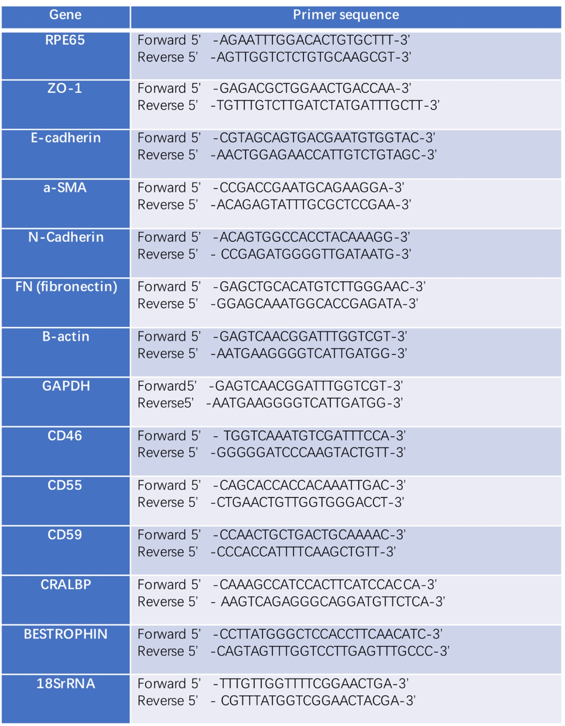
Additional file 1 Table S1: Primer sequences used for RT-PCR.
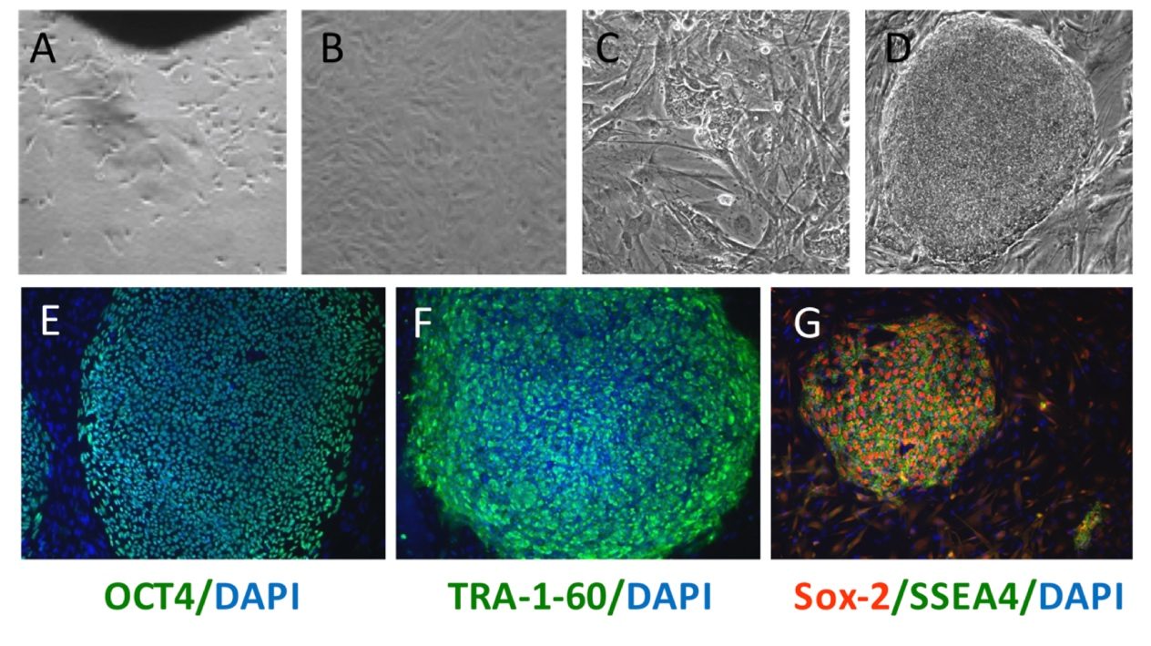
Additional file 2 Figure S1: Morphological changes of the cells in the reprogramming process from human dermal fibroblast to hiPSCs: (A) Human skin tissues were cultured in vitro; (B) Confluent human fibroblast cells cotransfected with Oct3/4, Klf4,Sox2, and c-Myc; (C) At day 30, tightly packed dome-like colonies were picked up, trypsinized and replated onto mouse embryonic fibroblasts (MEFs), noted as passage 0; (D) iPSC colony expanded on MEFs with distinguished margin. (E-G) Identification of hiPSCs: The hiPS cell lines expressed pluripotency genes OCT4, TRA-1-60, Sox-2 and SSEA4.

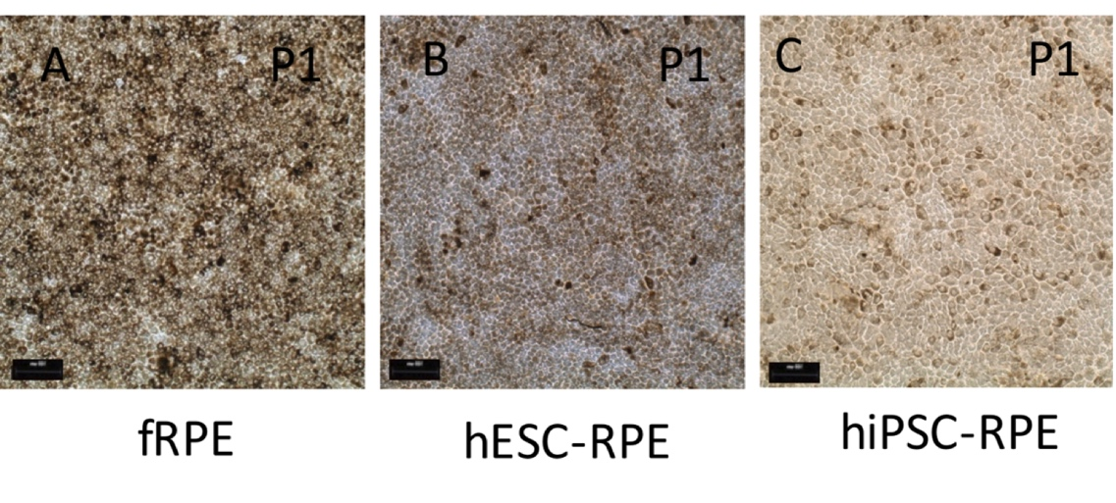
Additional file 3 Figure S2: Morphology of fetal-RPE, hESC-RPE and hiPSC-RPE (A) Micrograph of fRPE cells (P1 Day 28) showed heavy pigmentation with cobblestone-shaped morphology; (B-C) hESC-RPE (P1 Day 28). (B) and hiPSC-RPE (P1 Day 28)(C) exhibited the typical morphology and structural characteristics as those of fRPE. hiPSC-RPE cells of the same passage number and culturing duration showed less pigmentation, while fRPE showed robust pigmentation. (scale bar: 100 μm）

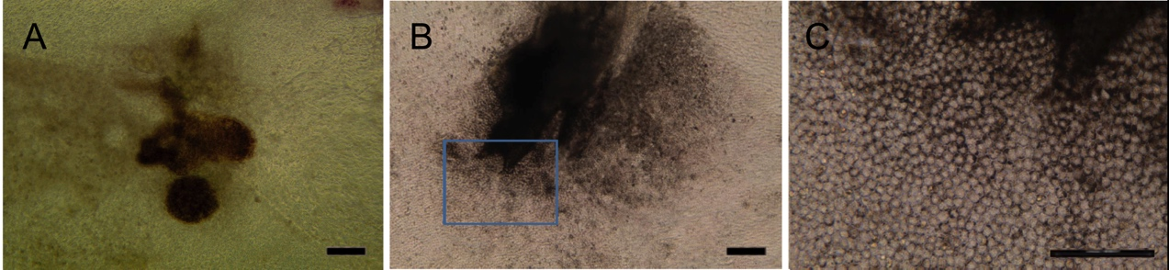
Additional file 4 Figure S3: Differentiation of RPE from hESCs: (A) Pigmented cluster arose from differentiating hESCs after 2-4 weeks. Manually dissected pigmented clusters from differentiated hESCs were replated on Matrigel as P0. RPE cells started to migrate outside of the pigments colony 2 to 3 days after being replated on Matrigel-coated plate; (B) RPE cells kept expanding and formed a monolayer of pigmented cells with cobblestone morphology. (C) Magnified micrograph showed the pigmented cells with cobblestone morphology. (scale bar: 100 μm）

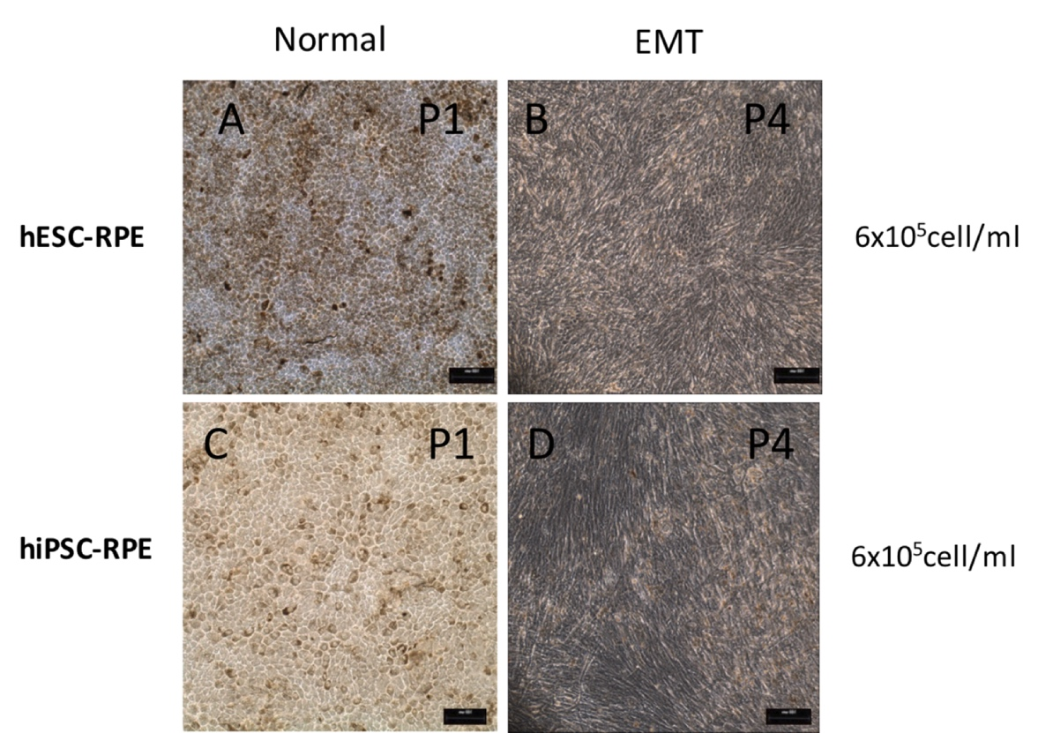
Additional file 5 Figure S4: Morphology of H9-RPE and iPS-RPE before and after EMT : After culturing P1 hESC-RPE cells for 28 days, hESC-RPE (P1 D28)(A) exhibited the typical cobblestone morphology abundant pigmentation, while hiPSC-RPE (P1 D28)(C) showed less pigmentation; after being passaged at a density of 6x10⁵ cells/ml 3 times, hESC-RPE (P4 D28)(B) and hiPSC-RPE (P4 D28)(D) showed less pigmentation and some cells started to exhibit a fibroblast-like morphology.

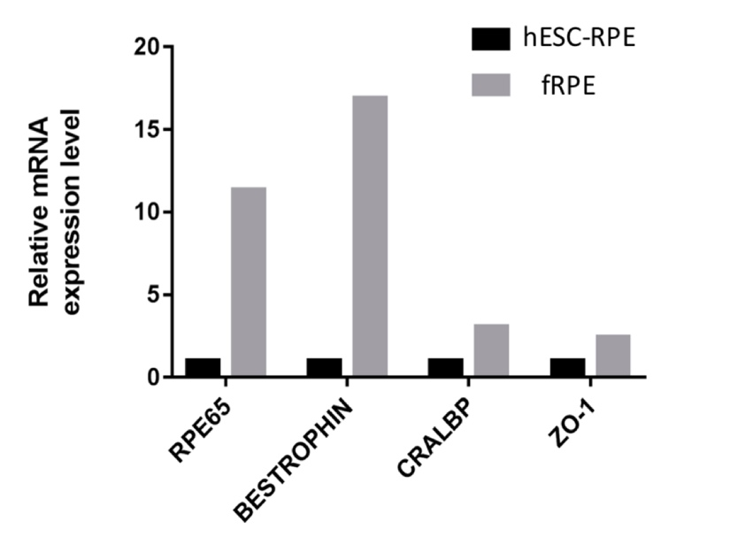
Additional file 6 Figure S5: Characterization of differentiated RPE cells and fRPE cells evaluated by RT-qPCR. The mRNA expression levels of RPE65, Bestrophin, CRALBP and ZO-1 in hESC-RPE cells (P1, Day 28) were weaker than those of fRPE cells in general (P1, Day 28)

