Population Size and Human-Grivet Monkeys (Chlorocebus aethiops) Conflict in Zegie Peninsula, Bahir Dar, Ethiopia
Yibelu Yitayih^{*1}, Dessalegn Ejigu² and Misganaw Mola¹
¹Mizan Tepi University, College of Natural and Computational Science, Department of Biology, P.O. Box 121., Tepi Ethiopia
²Bahir Dar University, College of Science, Department of Biology, P.O. Box 79, Bahir Dar, Ethiopia
¹Mizan Tepi University, College of Natural and Computational Science, Department of Biology, P.O. Box 121., Tepi Ethiopia
Email: Yibelu Yitayih* - yibeluyitayih@gmail.com ; Dessalegn Ejigu – kidu2003@gmail.com; Misganaw Mola - misganawmola@gmail.com
* Corresponding author

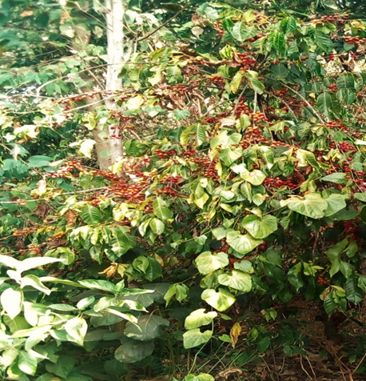
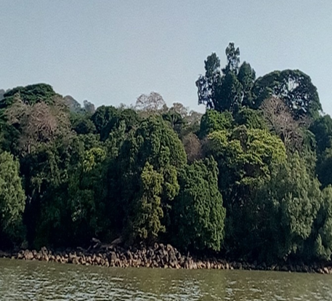
a. Agricultural area b. Lakeshore habitat
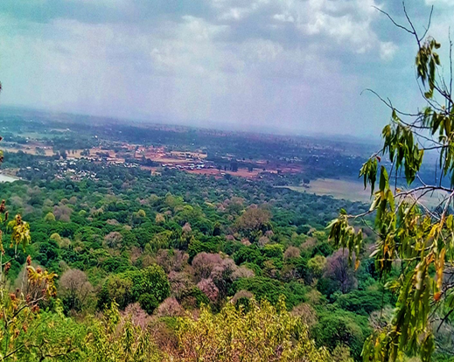
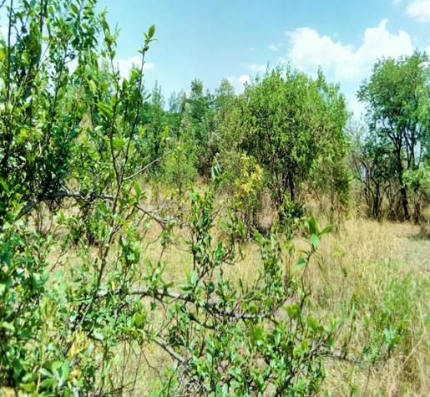
c. Tree dominated forest habitat d. Shrub habitat
Plate1. Different types of habitat in the study area

