High fructose and streptozotocin induced diabetic impairments are mitigated by Indirubin-3-hydrazone via downregulation of PKR pathway in Wistar rats
Mary Priyanka Udumula^{1#}, Sureshbabu Mangali ^{1#}, Jaspreet Kalra^{1#}, Deepika Dasari¹, Srashti Goyal¹, Vandana Krishna¹, Srivarsha Reddy Bollareddy¹, Dharamrajan Sriram¹, Arti Dhar^{1*}, Audesh Bhat^{2*}
¹Department of Pharmacy, Birla Institute of Technology and Sciences (BITS) Pilani, Hyderabad Campus, Jawahar Nagar, Shameerpet, Hyderabad, Telangana-500078, India.
²Centre for Molecular Biology, Central University of Jammu, UT Jammu and Kashmir-184311, India
*Authors for correspondence:
Dr. Arti Dhar
Department of Pharmacy, Birla Institute of Technology and Sciences Pilani, Hyderabad, Jawahar Nagar, Shameerpet, Hyderabad,
Andhra Pradesh 500078, India
Tel. 04066303647 / +919505563087
E-mail: artidhar@hyderabad.bits-pilani.ac.in

Dr. Audesh Bhat
Centre for Molecular Biology
Central University of Jammu
UT of Jammu and Kashmir, India-184311
+91-9419532912
E-mail: abhat@cujammu.ac.in

Suppl. Table 1: AST, HDL and Triglyceride levels in blood serum of rats.
Biochemical parameter | Control | HF+STZ | HF+STZ+IHZ | IHZ
AST | 10.59 units/L ±0.0821 | 41.15 units/L ±1.11*** | 30.21 units/L ±0.9%%% | 13.2 units/L ±0.118
HDL | 24 mg/dL ±1.8 | 6 mg/dL ±2.7*** | 11 mg/dL ±1.7%%% | 23 mg/dL ±2.91
Triglycerides | 13.55 mg/dL ±2.9 | 105.78 mg/dL ±16.59*** | 90.06 mg/dL ±10.03 | 18.32 mg/dL ±4.2
Data presented here is of day 42 of the study. ***P< 0.001 versus respective control, %%%P<0.001 versus respective HF+STZ Data is expressed as mean ± SD of n=6 animals for each group. AST = Aspartate Transaminase, HDL = high density lipoproteins, HF = High Fructose, STZ = Streptozotocin, IHZ = Indirubin Hydrazone.
Suppl. Table 2: TG/HDL and TC/HDL RATIOS
Biochemical parameter | Control | HF+STZ | HF+STZ+IHZ | IHZ
TG/HDL | 0.54 | 17.6 | 8.18 | 1.5
TC/HDL | 3.7 | 102.1 | 38.2 | 2.73
HDL = High-density lipoproteins, TC = total cholesterol, TG = triglyceride

Suppl. Fig. 1: Full length western blots of PKR, JNK, and β-actin protein expression of the main figure 2d. Please note that full length membranes with edges could not be provided as the membrane was cut before incubation with the selected antibodies.
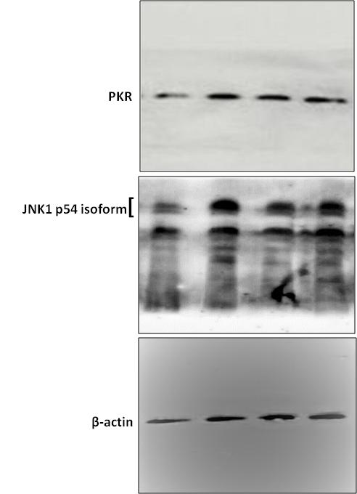

Suppl. Fig. 2: Full length western blots of PKR, JNK, and β-actin protein expression of the main figure 5d. Please note that full length membranes with edges could not be provided as the membrane was cut before incubation with the selected antibodies.
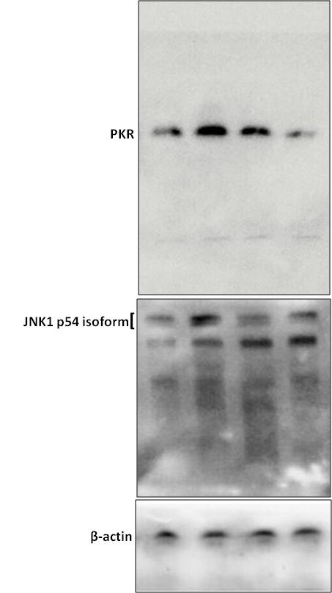

Suppl. Fig. 3: Full length western blots of PKR, JNK, and actin protein expression shown in the main figure 6h. Please note that full length membranes with edges could not be provided as the membrane was cut before incubation with the selected antibodies.
.
