Reduced levels of hsa-miR-342-5p in plasma are associated with worse cognitive evolution in patients with mild Alzheimer’s disease
Farida Dakterzada¹*, Iván David Benítez ^{2,3}*, Adriano Targa^{2,3}, Albert Lladó⁴, Gerard Torres², Leila Romero¹, David de Gonzalo-Calvo², Anna Moncusí-Moix ^{2,3}, Adria Tort-Merino ⁴, Raquel Huerto¹, Manuel Sánchez-de-la-Torre^{2,5}, Ferran Barbé^{2,3}, Gerard Piñol-Ripoll¹**
1. Unitat Trastorns Cognitius, Clinical Neuroscience Research, Santa Maria University Hospital, IRBLleida, Lleida, Spain.
2. Translational Research in Respiratory Medicine, Hospital Universitari Arnau de Vilanova-Santa Maria, IRBLleida, Lleida, Spain.
3. Centro de Investigación Biomédica en Red de Enfermedades Respiratorias (CIBERES), Madrid, Spain.
4. Alzheimer's disease and other cognitive disorders Unit, Neurology department, IDIBAPS, Hospital Clínic, Barcelona, Spain.
5. Group of Precision Medicine in Chronic Diseases, Hospital Universitari Arnau de Vilanova-Santa Maria, IRBLleida, Lleida, Spain.

* Co-first authors. FD and IDB contributed equally to this study.
** Corresponding author:
Gerard Piñol-Ripoll
Cognitive Disorders Unit
Hospital Universitari Santa Maria.
Rovira Roure nº 44. 25198. Lleida. Spain
Telephone: 34-937-727222. Ext. 173. Fax: 34-976-727366
E-mail: gerard_437302@hotmail.com
Figure 1. Quality control of TaqMan Low Density Array (TLDA) determinations. Number of determinations/missings.
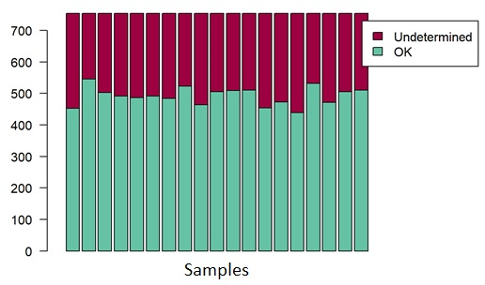
Figure 2. Ct distribution of miRNAs in TLDA cards.
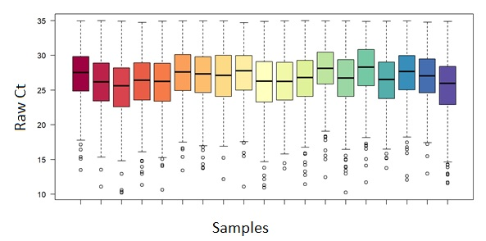
Figure 3. The expression stability of the selected endogenous controls characterized by means of GeNorm and Bestkeeper.
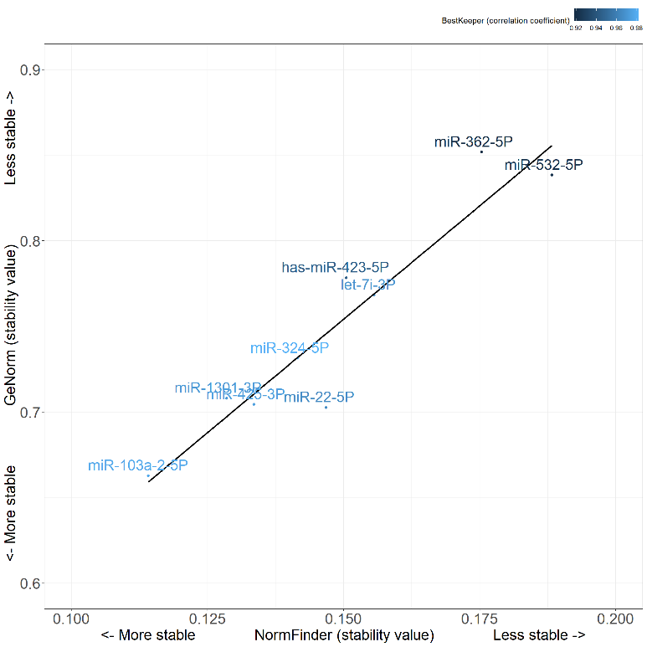

Table 1. miRNAs expressed differentially between FDC and SDC groups in the discovery cohort.
miRNA | Sequence | Fold change | P-value | Correlation with MMSE score at 2 years
hsa-miR-30d-3p | UGUAAACAUCCCCGACUGGAAG | 8.22 | 0.0083 | 0.62
hsa-miR-652-3p | AAUGGCGCCACUAGGGUUGUG | 1.59 | 0.0124 | 0.78
hsa-miR-431-3p | CAGGUCGUCUUGCAGGGCUUCU | 3.01 | 0.0126 | 0.64
hsa-miR-497-5p | CAGCAGCACACUGUGGUUUGU | 1.76 | 0.0137 | 0.38
hsa-miR-196b-3p | UCGACAGCACGACACUGCCUUC | 4.97 | 0.0173 | 0.58
hsa-let-7c-5p | UGAGGUAGUAGGUUGUAUGGUU | 0.04 | 0.0187 | -0.53
hsa-miR-496 | UGAGUAUUACAUGGCCAAUCUC | 0.15 | 0.0229 | -0.59
hsa-miR-483-5p | AAGACGGGAGGAAAGAAGGGAG | 0.50 | 0.0241 | -0.49
hsa-miR-342-5p | AGGGGUGCUAUCUGUGAUUGA | 0.33 | 0.0291 | -0.23
hsa-miR-30e-5p | UGUAAACAUCCUUGACUGGAAG | 2.01 | 0.0355 | 0.41
hsa-miR-153-3p | UUGCAUAGUCACAAAAGUGAUC | 1.69 | 0.0362 | 0.42
hsa-miR-148a-5p | AAAGUUCUGAGACACUCCGACU | 2.83 | 0.0403 | 0.52
hsa-miR-191-3p | GCUGCGCUUGGAUUUCGUCCCC | 1.76 | 0.0404 | 0.49
hsa-miR-193a-3p | AACUGGCCUACAAAGUCCCAGU | 0.10 | 0.0424 | -0.52
hsa-miR-744-3p | CUGUUGCCACUAACCUCAACCU | 4.34 | 0.0471 | 0.45
hsa-miR-27b-5p | AGAGCUUAGCUGAUUGGUGAAC | 1.99 | 0.0491 | 0.41
hsa-miR-25-3p | CAUUGCACUUGUCUCGGUCUGA | 0.53 | 0.0492 | -0.51

Figure 4. Ct distribution of miRNAs in RT-qPCR cohort.
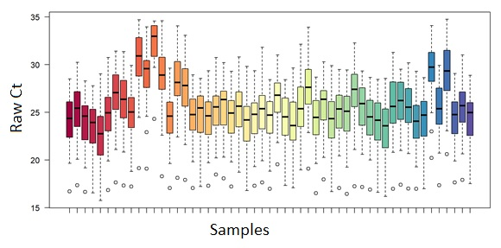
Figure 5. Box plot diagram of the relative expression of miR-342-5p among AD patients with FDC and SDC measured by qRT-PCR. The miR-342-5p level was higher in plasma of patients with SDC than those with FDC (p=0.049).
