Figure S1. Nonlinear relationship between the odds ratio (OR) of intensive care unit (ICU) mortality and the reduction in mean arterial pressure (MAP) within 6 hours (A) and 1 hour (B). Gray area indicates 95% confidence intervals.
(A)
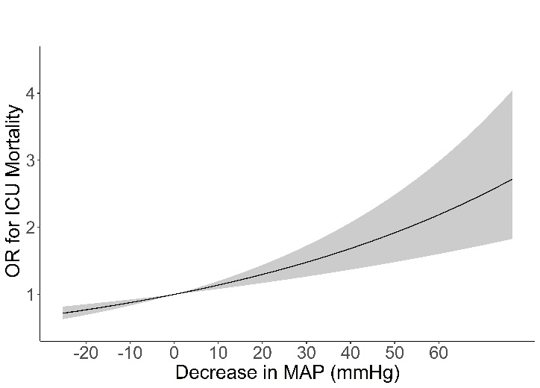
(B)
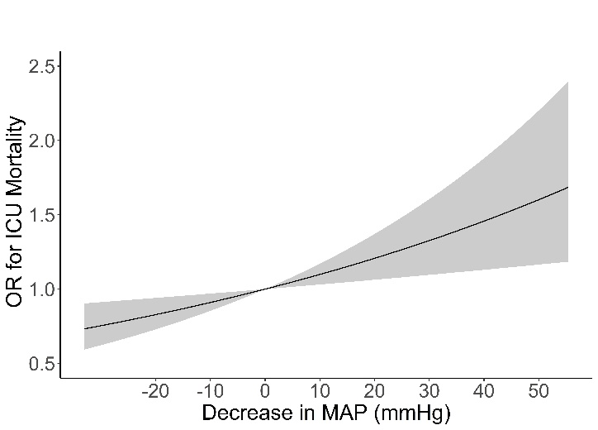
Figure S2. Feature rankings for the deep neural network model in predicting a reduction in mean arterial pressure ≥20 mmHg (A, C) and ≥30 mmHg (B, D) within 6 hours (A, B) and 1 hour (C, D). SBP, systolic blood pressure; MAP, mean arterial pressure; DBP, diastolic blood pressure; BUN, blood urea nitrogen; I/O, input and output; PaO₂, arterial partial pressure of oxygen; FiO₂, fraction of inspired oxygen.
(A)
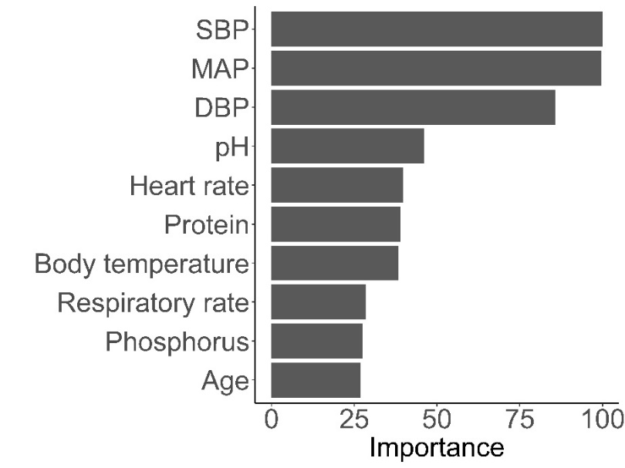
(B)
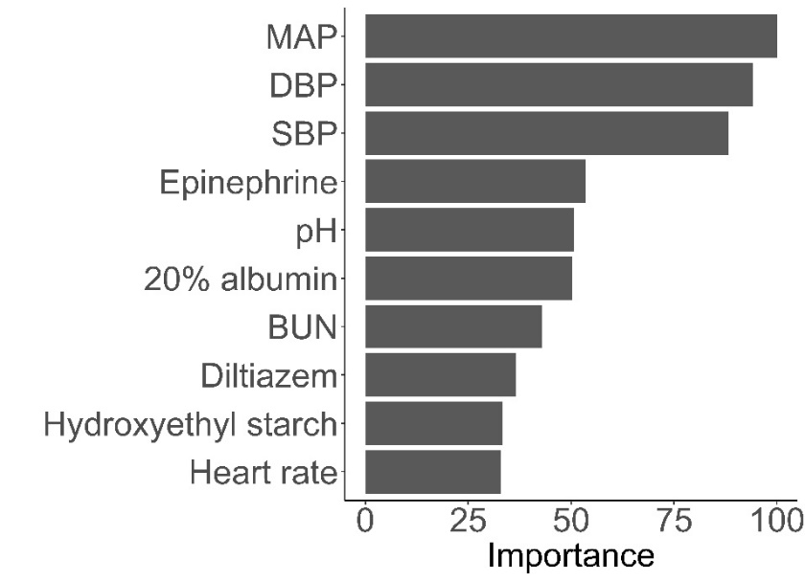

(C)
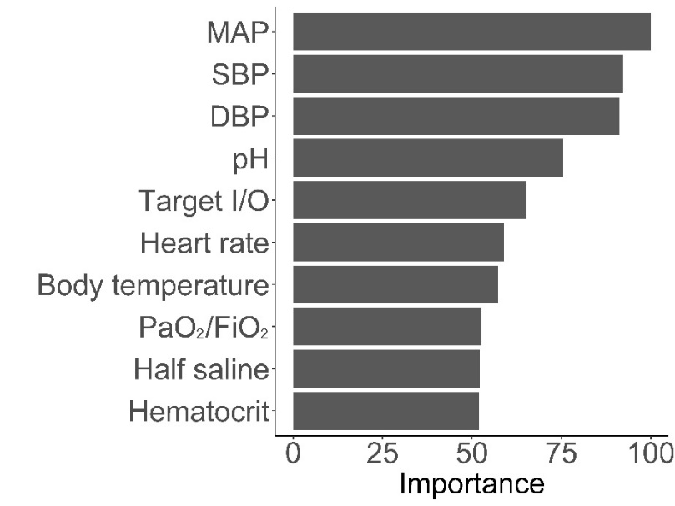
(D)
