Supporting Information
Micro size exclusion chromatography combined with a multiplex protein profiling method for extracellular vesicle protein detection from small sample volumes
Li Sun and David G. Meckes Jr*
Department of Biomedical Sciences, Florida State University College of Medicine, Tallahassee, FL, 32306

Content

Supplementary Figures and Tables 2
Figure S1. qPCR on serial dilution of TotalSeq Oligos. 2
Figure S2. Spike-in oligo into other oligo mixture. 3
Table S1. qPCR primer specify test 4

Figure S3. TotalSeq Protocol test with Biotin-BSA and Streptavidin-Oligo. 5
Figure S4. Dot blot of BSA. 6
Figure S5. Ct value comparison of cDNA from isolated RNA or direct reverse transcription. 7

Supplementary Figures and Tables
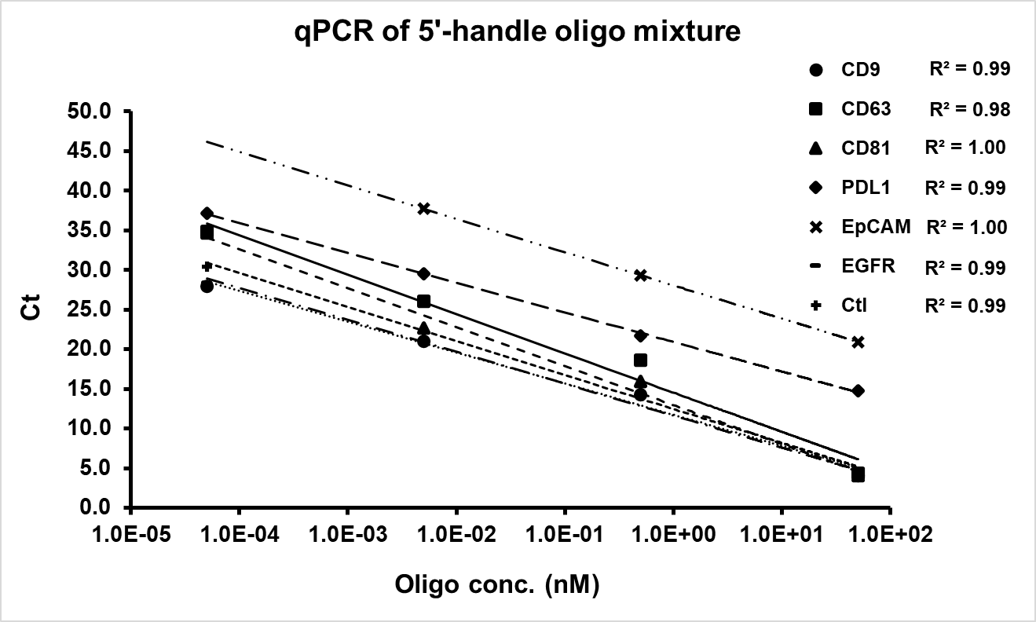
A
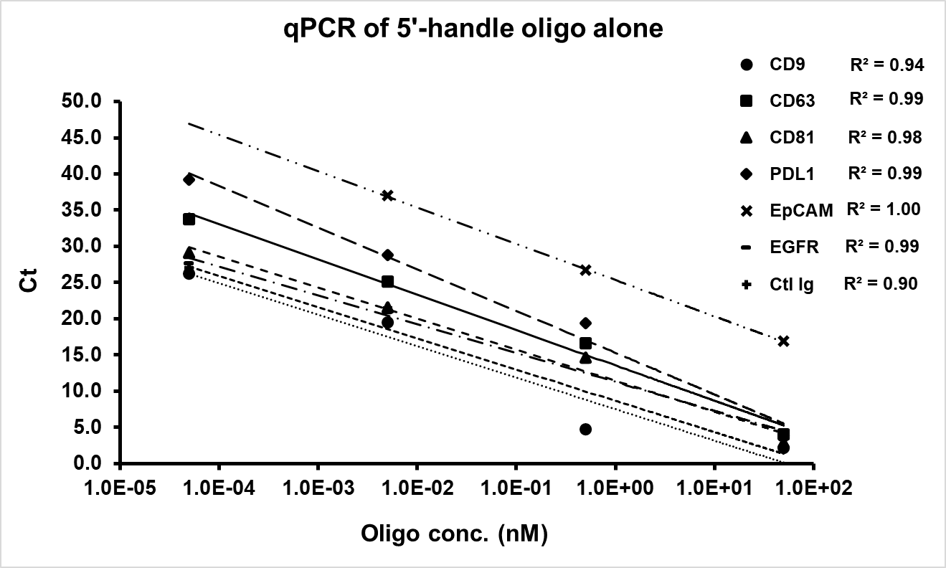

B
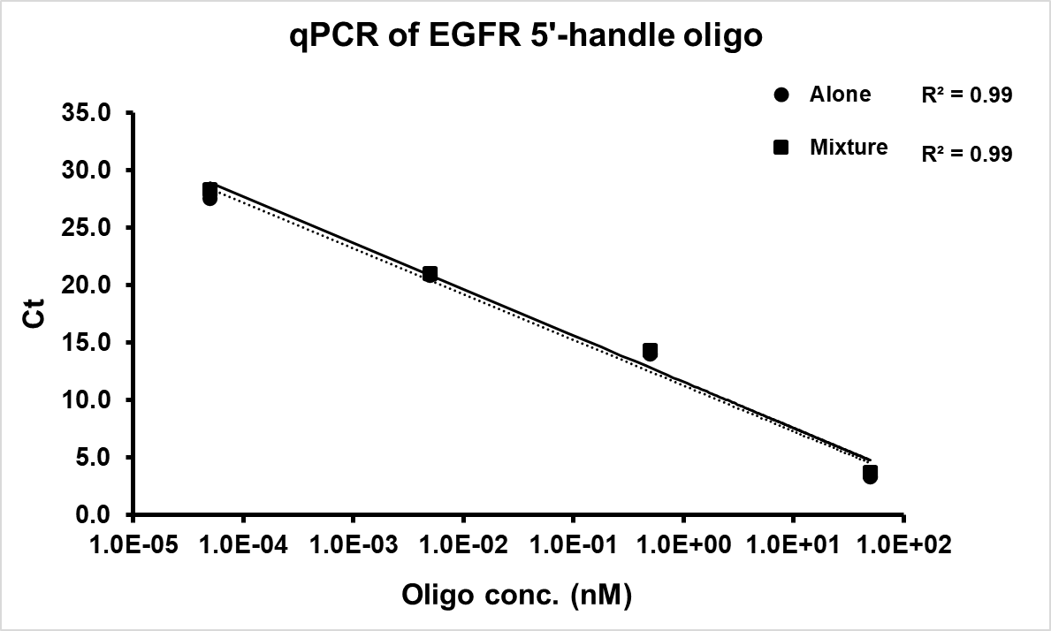
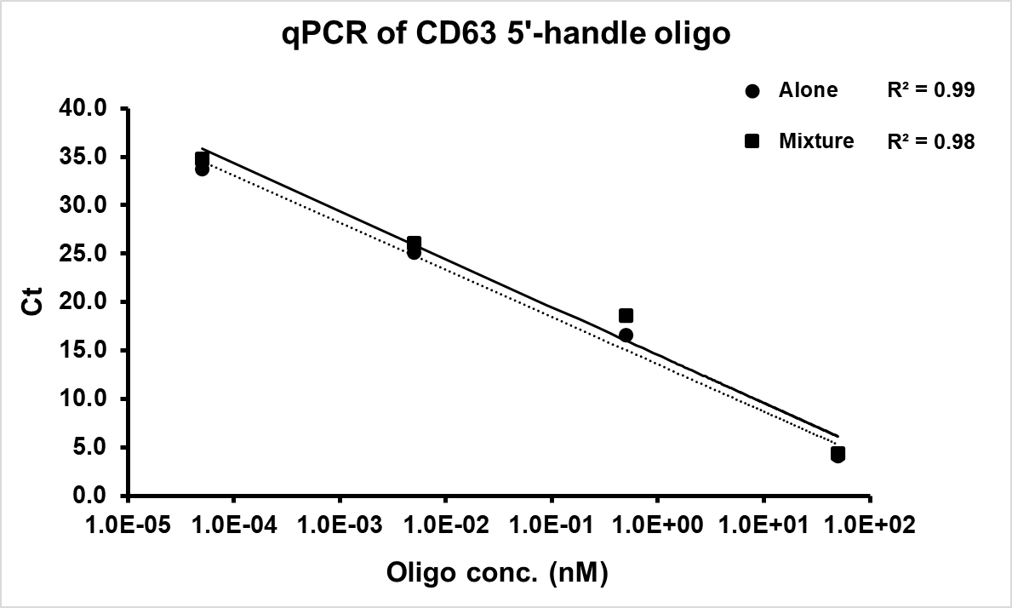

Figure S1. qPCR on serial dilution of TotalSeq Oligos. (A) Ten-fold dilution of seven different TotalSeq Oligos were performed only the ligation and qPCR step. The oligos were either tested alone (left) or in a mixture (right). (B) Two dilution curves from same oligo alone or mixed sample were plotted in the same chart.

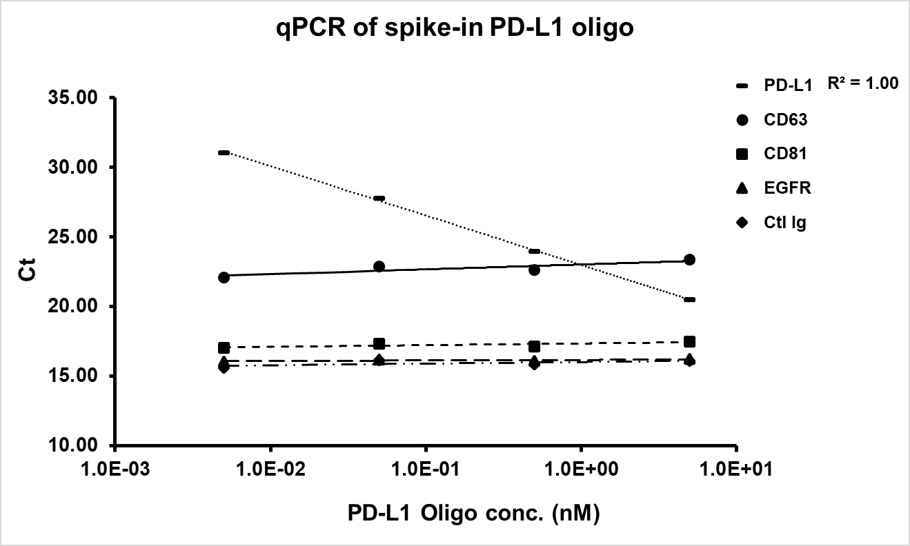
Figure S2. Spike-in oligo into other oligo mixture. Different concentration of PD-L1 oligo were spiked into an equal molar mixture of four other oligos (CD63, CD81, EGFR, Ctl Ig).

Table S1. qPCR primer specify test
 |  | Oligo Sample
 |  | CD9 | CD63 | CD81 | PD-L1 | EpCAM | EGFR | Ctl Ig
qPCR  Primer | CD9 | 4.73 | 34.98 | 35.63 | 34.56 | 32.16 | 36.24 | 34.55
 | CD63 | N.D. | 16.61 | N.D. | N.D. | N.D. | N.D. | N.D.
 | CD81 | N.D. | 37.81 | 14.59 | N.D. | N.D. | N.D. | N.D.
 | PD-L1 | N.D. | N.D. | N.D. | 19.40 | N.D. | N.D. | N.D.
 | EpCAM | N.D. | N.D. | N.D. | N.D. | 26.68 | N.D. | N.D.
 | EGFR | N.D. | 32.92 | 37.17 | 39.19 | N.D. | 14.00 | N.D.
 | Ctl Ig | N.D. | N.D. | N.D. | N.D. | N.D. | N.D. | 4.80
0.5 nM of each oligo sample was tested with all other qPCR primers, Ct value of qPCR was shown in the table. N.D. = not detectable
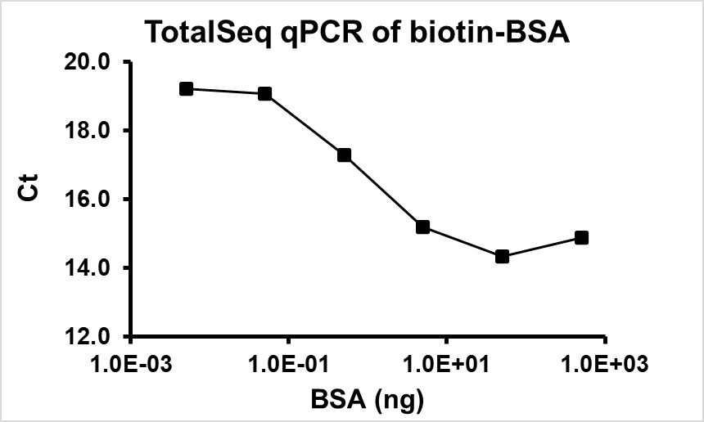
Figure S3. TotalSeq Protocol test with Biotin-BSA and Streptavidin-Oligo. Biotinylated BSA was blotted on the strip as analyte, and probe by oligo conjugated streptavidin. Ct of qPCR was plotted to BSA amount.

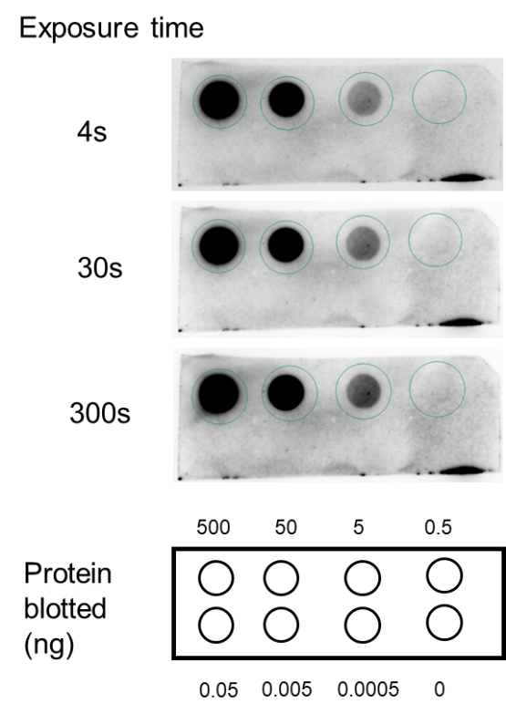
B
A
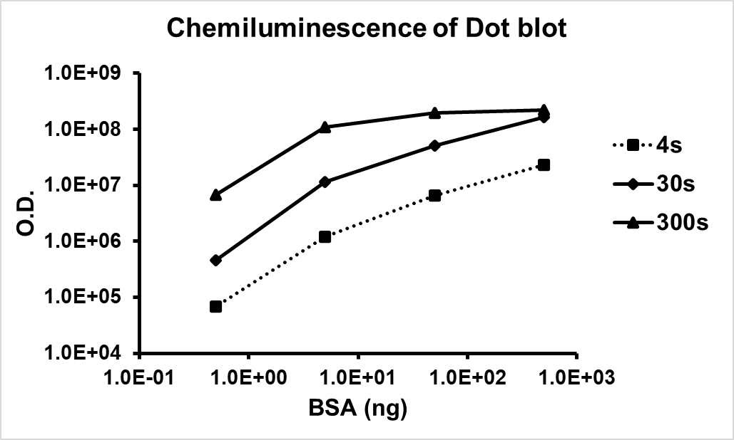

Figure S4. Dot blot of BSA. (A) Serial dilution of biotinylated BSA were blotted on the NC membrane and tested under standard protocol with streptavidin-HRP. The membrane was exposed for 4s, 30s or 5 minutes. (B) The plot shows optical intensity to protein amount.

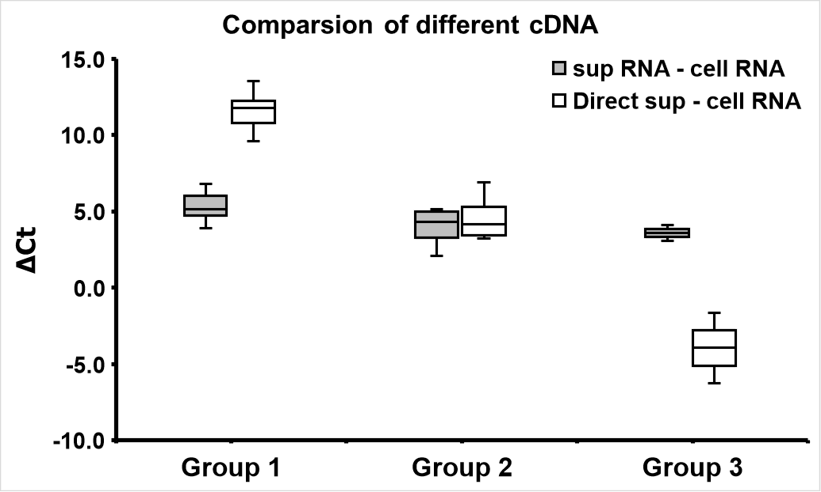
Figure S5. Ct value comparison of cDNA from isolated RNA or direct reverse transcription. Average Ct values of RNAs isolated from cell, RNAs isolated from supernatant and supernatant directly into cDNA were clustered into 3 groups. ΔCt was the difference compared with RNAs isolated from cell.

