I am corresponding author of the manuscript entitled “Synthesis and processing technique to reduce the particle size of ZnO pellet by hybrid vibrational annealing and dry quenching set up” co-authored by “Nirlipta Kar” for publication in the journal “Nature Nanotechnology”.

This is a letter signed by me on behalf of all of us, affirming that the paper has been submitted solely to Nature Nanotechnology and that it is not concurrently under consideration for publication in another journal.

This is author statement for your reference and necessary action.

With my best regards,
Sincerely yours,
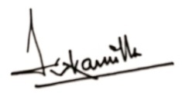
(Prof. Sushanta Kumar Kamilla)
Professor and Head Department of Physics,
Head SOA IPR Cell
Semiconductor Research Laboratory,
Faculty of Engineering and Technology (ITER),
Siksha ‘O’ Anusandhan Deemed to be University

