Conflicts of Interest Statement

Manuscript title:

Synthesis and processing technique to reduce the particle size of ZnO pellet by hybrid vibrational annealing and dry quenching set up

The authors whose names are listed immediately below certify that they have NO affiliations with or involvement in any organization or entity with any financial interest (such as honoraria; educational grants; participation in speakers’ bureaus; membership, employment, consultancies, stock ownership, or other equity interest; and expert testimony or patent-licensing arrangements), or non-financial interest (such as personal or professional relationships, affiliations, knowledge or beliefs) in the subject matter or materials discussed in this manuscript.

Author names:

This statement is signed by all the authors to indicate agreement that the above information is true and correct (a photocopy of this form may be used if there are more than 10 authors):

Author'sname(typed) | Author's signature | Date
Nirlipta Kar | 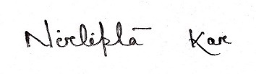 | 12.01.2022
Sushanta Kumar Kamilla | 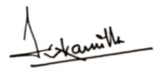 | 12.01.2022

