**Supplementary Information**

Tengfang Kuang1,5, Ran Huang2,5, Wei Xiong1, Yunlan Zuo2, Xiang Han1, Franco Nori3, , Chengwei Qiu4,*, Hui Luo1,*, Hui Jing2,*, Guangzong, Xiao1,*

1 College of Advanced Interdisciplinary Studies, NUDT, Changsha Hunan, 410073, China

2 Department of Physics and Synergetic Innovation Center for Quantum Effects and Applications, Hunan Normal University, Changsha 410081, China

3 Theoretical Quantum Physics Laboratory, RIKEN Cluster for Pioneering Research, Wako-shi, Saitama 351-0198, Japan

4 Department of Electrical and Computer Engineering, National University of Singapore, 4 Engineering Drive 3, Singapore, 117576, Singapore

5 These authors contribute equally to this work

*email: chengwei.qiu@nus.edu.sg; [luohui.luo@163.com](mailto:luohui.luo@163.com); [jinghui73@foxmail.com](mailto:jinghui73@foxmail.com); [xiaoguangzong@nudt.edu.cn](mailto:xiaoguangzong@nudt.edu.cn).

**1. EXPERIMENTAL DETAILS**

The experimental apparatus is constructed with a dual-beam optical tweezer and an active optical cavity. These two systems are vertical to each other around the trapping region as exhibited in Fig. S1.1a. A silica sphere (Fig. S1.1b, diameter 2 μm) is trapped by the dual-beam optical tweezer inside a tiny chamber. Figure S1.1c illustrates the widefield diagram of the experimental setup. The origin of the cylindrical coordinate system is located at the lens’s focal point of the dual-beam optical tweezer. We install the free space laser path of the active cavity to a 3D translation stage. Then, the relative position of the active cavity to the trapped sphere can be adjusted. A balanced photo-detector is installed to monitor the centre of mass displacement of the trapped sphere. We note that this system does not require any external hardware or software to implement feedback control.

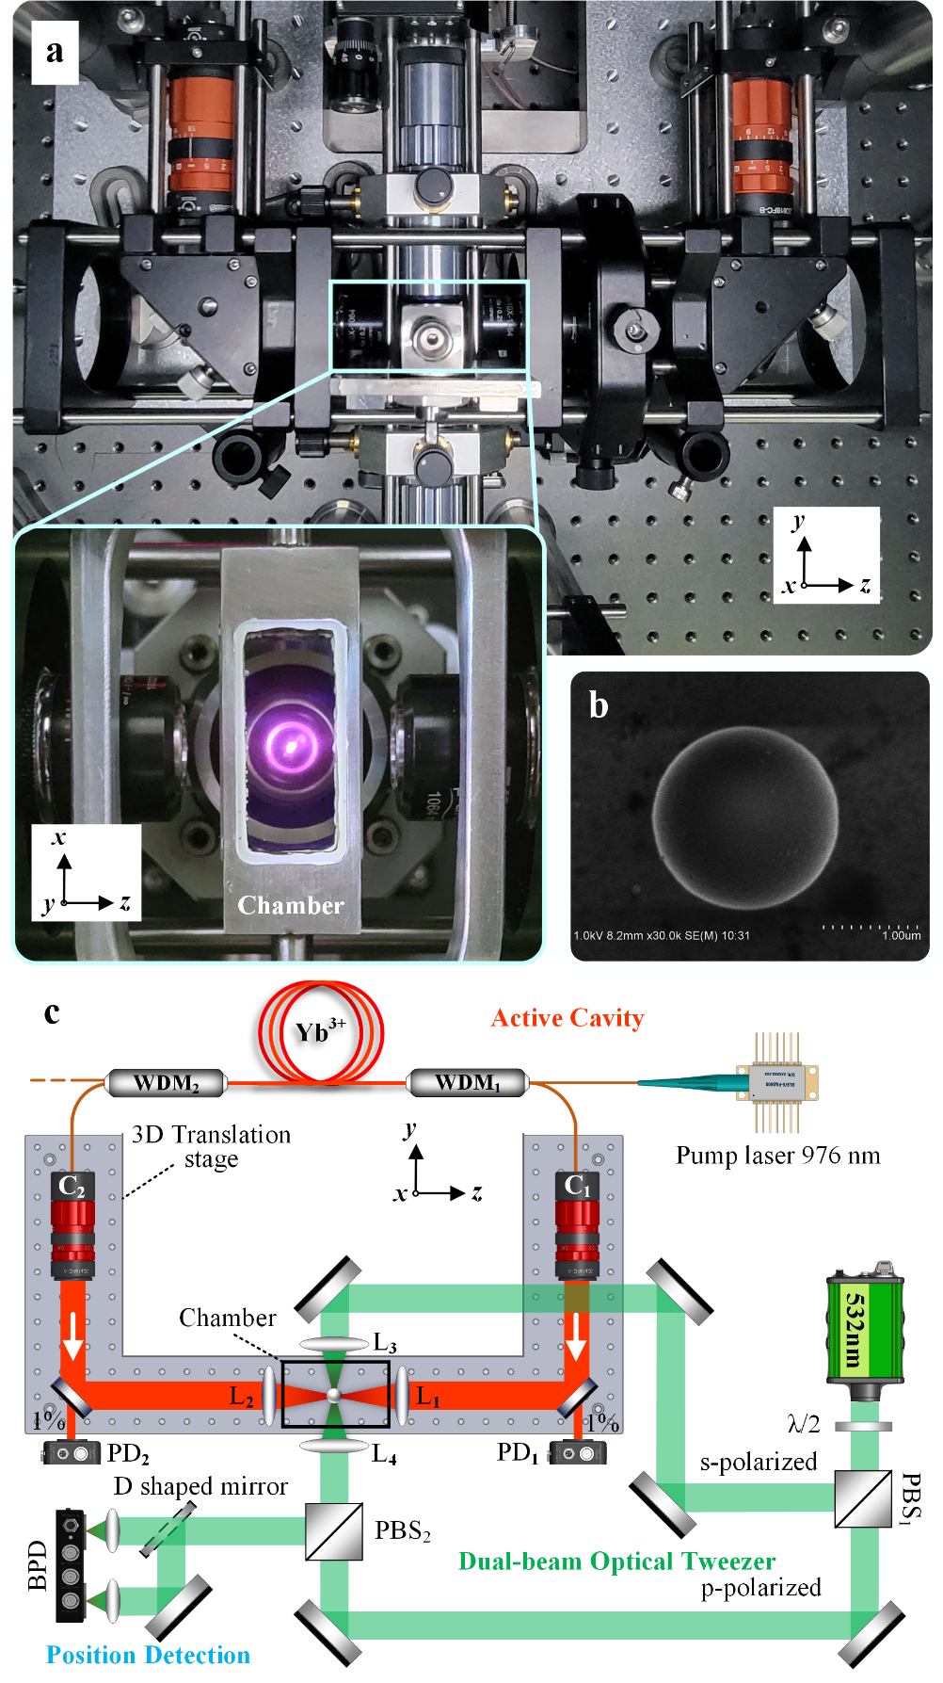

**Figure S1.1. Experimental setup. a,** Image of the experimental setup shown on *yoz* plane. Zoom-in view shows *xoz* plane of the chamber and lenses. The bright dot reveals that the intracavity laser (centre at 1030 nm) is scattered by the trapped sphere. **b,** Scanning electron microscopy (SEM) images of the sphere. **c,** Schematic of the experimental setup composed of a dual-beam optical tweezer (green) and an active cavity (red). WDM - wavelength division multiplexer, C - collimator, PBS - polarizing beam splitter, L1 ~ L4 - objectives, PD - Photodetector, BPD - balanced photodetector.

The dual-beam optical tweezer is shown inside the green frame in Fig. S1.1c. Its trapping power (> 100 mW) is much stronger than that of the active cavity (~ 1 mW), so that it can produce robust restoring force to trap the sphere. The wavelength of the low-noise laser (Laser quantum, Axiom 532) is far away from the absorption spectrum of Yb3+, thus minimizing its influence on the active cavity. We equally split the trapping laser into s- and p- polarized parts by using a λ/2 plate and a PBS1, and focused the s- and p-polarized light onto the sphere through two high-NA objectives L3, L4 (Mitutoyo, M plan apo 100x, NA=0.7). The portion of the s-polarized light scattered from the sphere is channelled by the PBS2 to a beamsplitter whose outputs are then sent to a BPD. Since the sphere alters the spatial distribution of the scattering light, the differential mode signal from the BPD reveals the sphere’s position [S1].

The active cavity comprises a continuous-wave ring-cavity fibre laser emitting along with the clockwise (CW) and counter-clockwise (CCW) directions. We use single-mode Yb-doped fibre (nLIGHT, Yb 1200-6/125, core diameter of 6 μm, cladding diameter of 125 μm) as gain medium, pumped by a single-mode diode-laser at 976 nm through WDM1. The residual part of the pump laser is coupled out of the ring-cavity through WDM2. The emitted lasers, centred at 1030 nm, are expanded to free space by collimators C1 and C2 and then focused onto the trapped sphere using two collimating objective lenses L1 and L2 (NA = 0.25). The lenses are specially coated to enhance transmissivity and reduce their influence on the cavity loss. Collimators C1 and C2 are then used to couple the transmitted light through the trapping region back into the fibre loop. We tune the intracavity laser power (0 ~ 1.2 mW) by adjusting the power of the pump laser. Photodetectors PD1 and PD2 are installed to monitor the CW and CCW laser powers.

* 1. **EXPERIMENTAL RESULT FOR DISSIPATIVE COUPLING**

The size of the trapped sphere (~ 2 μm) is greater than the upper limit for the Rayleigh approximation (~ 200 nm) and is approximately the size of the beam waist of the trapping laser. The scattering is quite strong, leading to a dissipative coupling between the sphere’s position and the cavity field. Figure S1.2a depicts the dependence of the threshold pump power of the ring-cavity fibre laser on the sphere’s position. As seen in the inset of Fig. S1.2a, the intracavity laser power is also modulated by the sphere’s position. These indicate that the cavity loss and sphere’s position are coupled to each other, suggesting the presence of dissipative coupling in this system.

We further observe beat frequency by using the optical heterodyning technique [S2]. A spectrum analyzer (KEYSIGHT, N9030A) is applied to measure the beat frequency signal between the CW and CCW lasers through a 50:50 fibre coupler. The inset of Fig. S1.2b depicts examples of beat frequency measured at various positions of the trapped sphere inside the cavity. As seen in Fig. S1.2b, the cavity resonance frequency is independent of the sphere’s position. This suggests the absence of dispersive coupling in our optomechanical system. Thus, we conclude that our system is governed by dissipative coupling. This is different from all previous optomechanical systems (Table 1) which are governed by dispersive coupling.

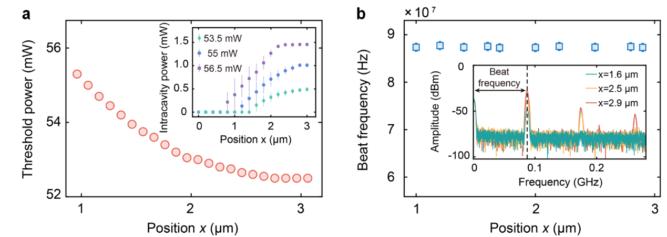

**Figure S1.2. Dissipative optomechanical coupling between the cavity field and the microsphere.** **a,** Dependence of the threshold pump power of the ring-cavity fibre laser on the sphere’s position along the *x* direction indicates that the cavity loss is modulated by the motion of the microsphere. Inset: Intracavity laser power versus sphere’s position *x*. **b,** Beat frequency is independent of sphere’s position. Inset: Beat frequencies measured at various positions of the trapped sphere inside the cavity.

* 1. **RESPONSE OF THE ACTIVE CAVITY**

A major advantage of the active cavity is that it has a narrower linewidth compared to the passive cavity and thus has a longer photon lifetime. This in turn contributes as a mechanical gain to the sphere oscillator. To directly emphasize this advantage, we studied the time evolution of the sphere’s position and optical power when the oscillator experiences coherent dynamics. Results depicted in Fig. S1.3a implies that the phase of the laser power lags behind the oscillator’s motion with a retardation time of around 5 ~ 10 μs.

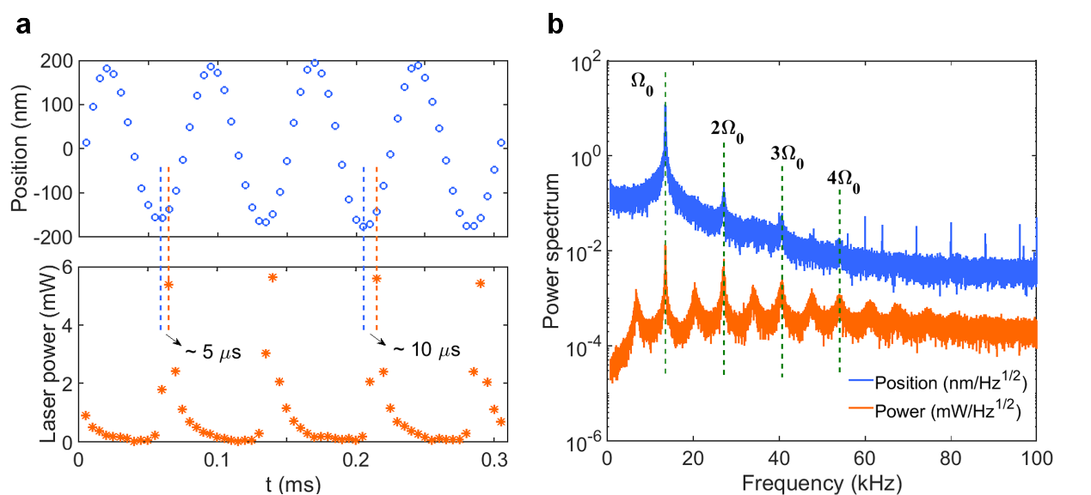

**Figure S1.3. Response of the active cavity.** **a,** Time evolution of sphere’s position and intracavity optical power. **b,** Comparison of the power spectrum of sphere position and intracavity laser power when phonon lasing emerges. The peaks at frequencies greater than 50 kHz are noise from the trapping laser (wavelength, 532 nm).

Figure S1.3b shows power spectra of the sphere’s position and intracavity laser when the oscillator experiences a coherent dynamic. The phonon lasing with high order sidebands occurs due to the strong dissipative optomechanical coupling. Interestingly, we find that the spectrum of the laser power shows lots of sidebands, including half frequency 0.5Ω0 and its multiple components. We attribute that to the nonlinear response of the intracavity optical power to the sphere’s position.

* 1. **POWER SPECTRUM OF OSCILLATOR’S POSITION**

The optical power of dual-beam optical tweezer (wavelength, 532 nm) controls the oscillation frequency of the sphere-oscillator. Thus, we can modulate the phonon laser’s frequency by tuning the trapping power. Figure S1.4 illustrates this capability for three specific trapping powers.

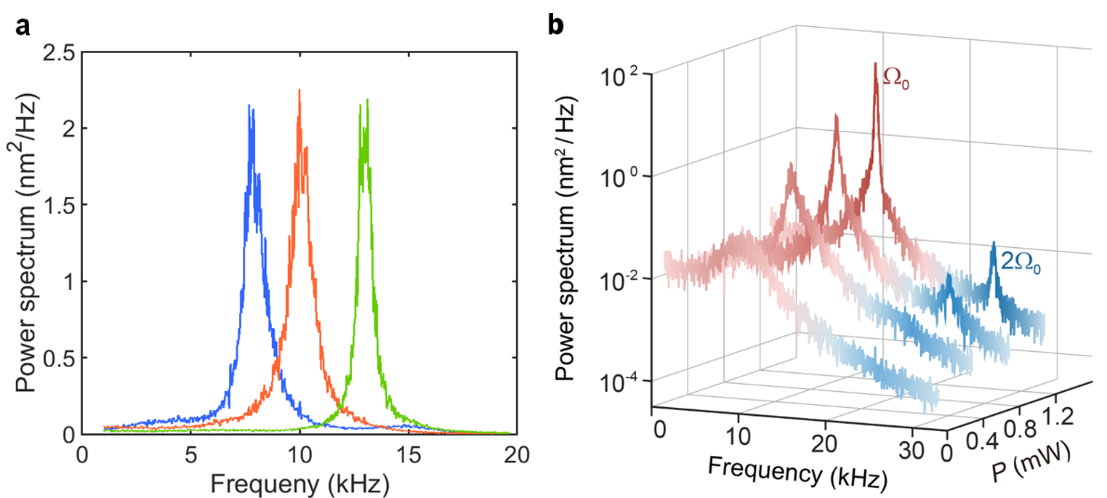

**Figure S1.4. Power spectra of the oscillator’s motion. a,** Tuning of the phonon laser’s frequency by the power of the trapping laser (wavelength 532 nm):300 mW (blue), 325 mW (red) and 350 mW (green). **b,** Phonon power spectra versus oscillation frequency for different intracavity powers of the active cavity (centered at 1030 nm). Phonon laser with double frequency is clearly observed at powers greater than 0.78 mW.

Intriguingly, we observe a nonlinear phonon laser with double frequency . Figure S1.4b shows the power spectra of the oscillator for different intracavity mean powers. By increasing the power, a frequency-doubled component emerges. The intensity of this higher-order sideband is weaker than that of the fundamental frequency . We study the mean phonon population at  by filtering the thermal phonons and the phonons with . It is worth to point out that these nonlinear phonon lasing behaviours featuring multiple frequencies are different from the single-mode phonon lasers or the multi-modephonon lasers, in which only a single oscillating mode can be stimulated into the lasing regime because of the mode competition.

**2. THEORETICAL MODEL**

The dissipative optomechanical system can be described via the Hamiltonian [S3],

 (S2.1)

For the first-order dissipative optomechanical coupling

 (S2.2)

and the Hamiltonian of the system can be written as

 (S2.3)

where  are the annihilation (creation) operators of the cavity field satisfying the commutation relation ; is the cavity detuning with respect to the frequency of the input laser;  and  are the dimensionless position and momentum operators of the oscillator with zero-point motion  and zero-point momentum , respectively, satisfying the commutation relation ;  is the amplitude of the input laser related to the input power *P*in and the input vacuum noise ; and the dissipative coupling constant is .

Using the Heisenberg equations of motion , and adding the corresponding damping and noise terms, the quantum Langevin equations of the system operators are given by:

 (S2.4)

 (S2.5)

 (S2.6)

where the input vacuum noise operator  has zero mean value and delta correlation , and *ξ* is the thermal noise with zero mean value and following correlation function,



where *k*B is the Boltzmann constant. By setting the time derivatives in above equations to 0, we find the steady state of the dynamical variables are:

 (S2.7)

where  in  has been omitted, since  is a real number. The cubic equation for  is given by:

 (S2.8)

with



Now we consider  as the annihilation (creation) operator of the input field satisfying the commutation relation . Hamiltonian Eq. (S2.3) is rewritten as:

 (S2.9)

For , the above Hamiltonian can be written as

 (S2.10)

Hamiltonian Eq. (S2.10) can be rewritten via bosonic operators:

 (S2.11)

We introduce the supermode operators

 (S2.12)

which satisfy the commutation relations:

 (S2.13)

Under the rotating-wave-approximation

 (S2.14)

the Hamiltonian of the system in the supermode picture is given by

 (S2.15)

where

 (S2.16)

We can define the ladder and the population-inversion operators as

 (S2.17)

respectively. Then, the equations of motion of the system can be written as

 (S2.18)

 (S2.19)

 (S2.20)

 (S2.21)

Since , we can adiabatically eliminate the degrees of freedom of the optical modes by setting the time derivatives of the optical components to zero. Then, we obtain the steady-state values of *a*± and *p*,

 (S2.22)

 (S2.23)

 (S2.24)

with



where  is the mean phonon number.

Substitution of equations Eq. (S2.22 - S2.24) into the dynamical equation of b, i.e., equation Eq. (S2.21), results in,

 (S2.25)

where the effective mechanical gain is

 (S2.26)

By setting , and assuming that the phonon laser satisfies the condition of complete inversion such that *δn* ~ *n*+:



we obtain the threshold of the phonon laser with  and ,

 (S2.27)

 (S2.28)

 (S2.29)

**3. NONLINEAR OPTICAL FORCE**

**3.1. OPTICAL FORCE AND OPTICAL DAMPING RATE**

The temporal evolution of a sphere’s position  can be described by a harmonic oscillator,

 (S3.1)

where *m* represents the mass of the oscillator, Ω0 is the natural frequency. The gas damping  for a sphere with a radius *R* is given by [S4]

 (S3.2)

where  is dynamic viscosity of air,  is the Knudsen number, and  is mean free path of gas. *F*th is the Brownian force,  is the optical force from the active cavity along *x*-axis, where  and  are trapping efficiency and trapping power, respectively.

Figure S3.1a shows the intracavity laser power in the active and passive systems, when we adjust the sphere’s position. For the case of the passive system, the photon lifetime is relatively short and thus the optomechanical coupling between the cavity field and the sphere is weak. Result shows that the intracavity laser power *P* is independent of the sphere’s position *x*. Thus, the optical force in the passive setup can be written as, . However, the photon lifetime in the active setup is longer. The sphere in the active setup alters the cavity loss, i.e., dissipative coupling, and hence the intracavity laser power *P* is modulated by the sphere’s position (see Figure S3.1a). As a result, the optical force in the active setup can be written as .

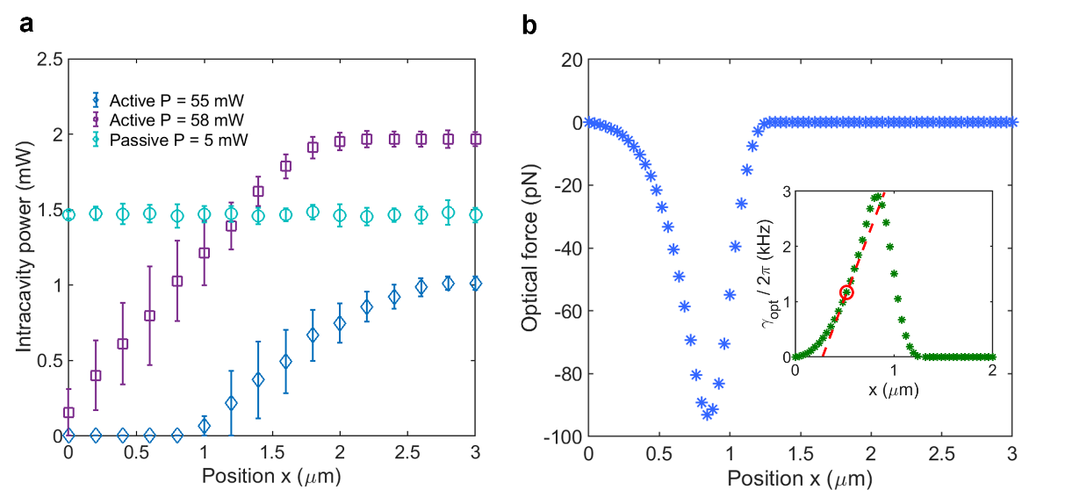

**Figure S3.1. Intracavity laser power and optical force. a,** Experimental result for intracavity laser power as a function of the sphere’s position in the active and passive setups. **b,** Simulation result of optical force and optical damping rate *γ*opt (inset map) in the active cavity. The red-dashed line is the fitted result for a selected working point.

Considering the delay response of the cavity, the trapping power  is a function of time *t*. It can be written as , where  is the retardation when a change in *x* emerges. Applying the Taylor expansion,  can be written as . Then, the optical force  in the Eq. (S3.1) can be written as,

 (S3.3)

The first term on the right-hand side produces a nonlinear optical force, and the second term on the right-hand side provides optical damping, which is proportional to the oscillator’s velocity. Applying Eq. (S3.1) to Eq. (S3.3), the dynamic of the trapped sphere is described as

 (S3.4)

We calculate the optical force  and optical damping rate  by using the physical model given in ref. [S5] and the computational toolbox in ref. [S6]. Figure S3.1b shows an example of changes in these two terms when the oscillator moves along *x-*axis. We observe a strong nonlinear curve when the sphere leaves the original point (*x* = 0). This is in distinct contrast with the conventional optical tweezers where the optical force is approximately linear to the sphere’s position. The inset in Fig. S3.2b illustrates an example of optical damping rate  as a function of sphere’s displacement. The nonlinear response of the optical damping to oscillator’s motion is clearly seen. Once the 3D translation stage is fixed, the optical damping rate  is reduced linearly with the oscillator’s motion. Thus, optical damping term  can be fitted using a linear equation , as the red curve in the inset map. Then, the optical damping force in Eq. (S3.4) can be written as: . The first term on the right-hand side implies a nonlinear modulation signal  which cools the sphere’s motion. Similarly, the second term on the right-hand side implies a linear modulation signal  which amplifies the motion of the trapped sphere. The horizontal ordinate (Position x) can be regarded as the distance between the dual-beam optical tweezer and the active cavity in the experiment. By adjusting the 3D translation stage, appropriate parameters can be selected to realize phonon lasing.

**3.2. PHONON DYNAMIC**

The mean phonon population can be described by using the quantum model given in ref. [S7]:

 (S3.5)

where  is the phonon occupation number of the mode, where  is the phonon annihilation (creation) operator. Mean phonon population  is a measurable parameter. The coefficients are expressed as , , and . *D*t represent diffusion due to optical and gas scattering. The detailed descriptions of the parameters mentioned above can be found in section 3.2.

Taking , the steady-state solution of equation (S3.5) yields,

 (S3.6)

When the oscillator experiences thermal dynamic, the phonon probability distribution can be described by a Boltzmann distribution,

, (S3.7)

where $m$ is the mass of the oscillator, *k*B is Boltzmann constant, and *T* is the temperature.

For the case of coherent dynamic, the phonon probability distribution obeys Gaussian distribution truncated at *n* = 0,

, (S3.8)

where *n*0 is mean phonon population , where .

|  |
| --- |
|  |

**Reference**

1. Li, T., Kheifets, S., Medellin, D., & Raizen, M. G. Measurement of the instantaneous velocity of a Brownian particle. *Science* **328**, 1673-5 (2010).
2. Hui, R. & Sullivan, M. O. Fiber Optic Measurement Techniques. Elsevier 2009.
3. Huang, S. & Chen, A. Improving the cooling of a mechanical oscillator in a dissipative optomechanical system with an optical parametric amplifier. *Phys. Rev. A* **98**, 063818 (2018).
4. Beresnev, S. A., Chernyak, V. G., & Fomyagin, G. A. Motion of a spherical particle in a rarefied gas. *J. Fluid Mech.* **219**, 405–421 (1990).
5. Kuang, T., et al. Optical confinement efficiency in the single beam intracavity optical tweezers. *Opt. Express* **28**, 35734-35747 (2020).
6. Callegari, A., Mijalkov, M., Gököz, A. B., & Volpe, G. Computational toolbox for optical tweezers in geometrical optics. *J. Opt. Soc. Am. B* **32**, B11–B19 (2015).
7. Rodenburg, B., Neukirch, L. P., Vamivakas, A. N., & Bhattacharya, M., Quantum model of cooling and force sensing with an optically trapped nanoparticle. *Optica* **3**, 318-323 (2016).