Suppl. Figures

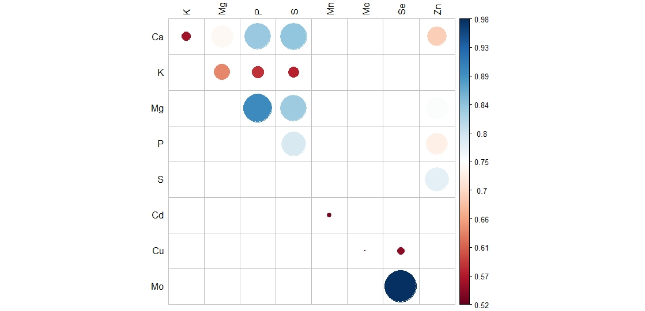
Suppl. Figure 1: Significant correlations between the elemental concentrations in 24 teff flours. Size of the circle represents the significance level, with the larger the circle the lower the p value. All circles represent a p value less than 0.05. Scale on the left is the range of correlations (r).

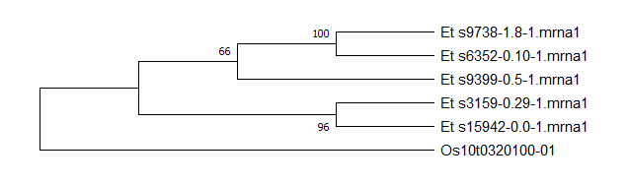
Suppl. Figure 2: Phylogenetic tree showing the relationship between the five teff homologues of the rice F3’H gene Os10t0320100-01

