Low Cerebrospinal Fluid Beta Amyloid1-42 in Patients with Tubercoulous Meningitis
Stroffolini G^{1*}, Guastamacchia G², Audagnotto S¹, Atzori C², Trunfio M¹, Nigra M³, Di Stefano A¹, Di Perri G¹, Calcagno A¹.

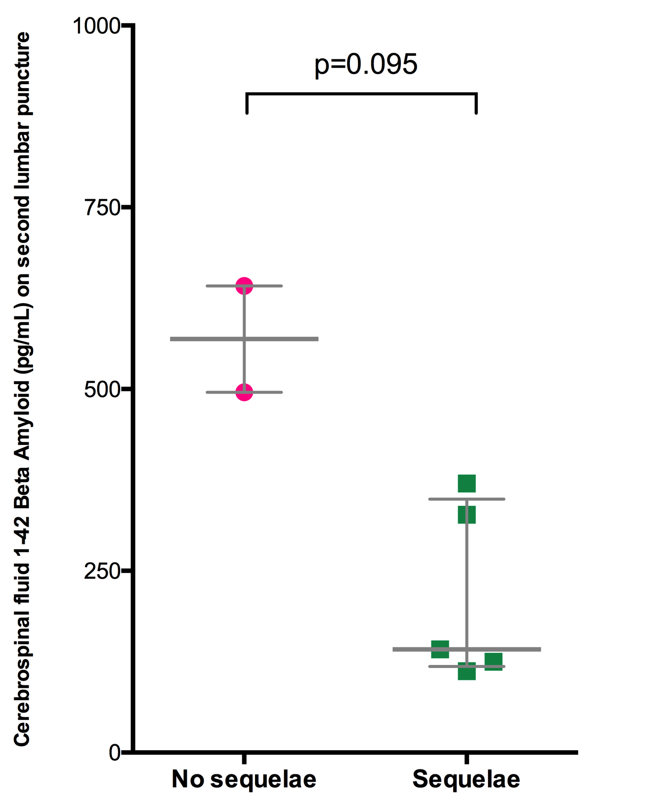
Supplementary figure 1: Beta Amyloid 1-42 and correlation with outcome (p = 0.07)

